Understand_AWS

* EC2 Instances
* VPC
* IAM
* ELB
* Auto Scaling
* Cloud Watch
* EBS
* EFS
* S3
  + Glacier
* Cloud Front
* Lambda
* Images vs. Snapshot vs. Volumes
* RDS
  + Dynamo DB
* Migration (SnowBall)
* Elastic Cache
* Route53
* Note section
  + TroubleShoot
* logs
* Rough

IAM:

Instances:

What is: In nutshell it’s a **virtual machine** in the cloud. It contains the instance type such as CPU/RAM/Graphics/Network/etc.

Why: with the virtual machine EC2 helps to create the instance either a web server instance, DB server instance etc in the cloud. Similar way once we have the physical machine with operating system, RAM, CPU and we can install the servers etc in my laptop.

How: see below

**AMI** helps to get the image what we need by default once the instance is created.

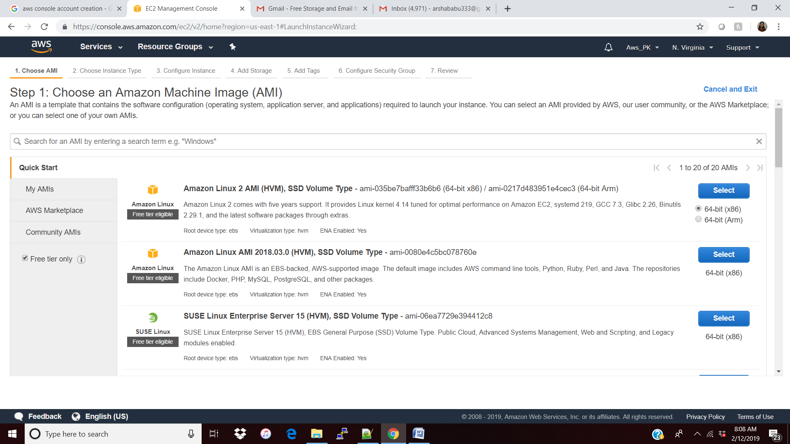

Instance type shows what **RAM and CPU** it uses.

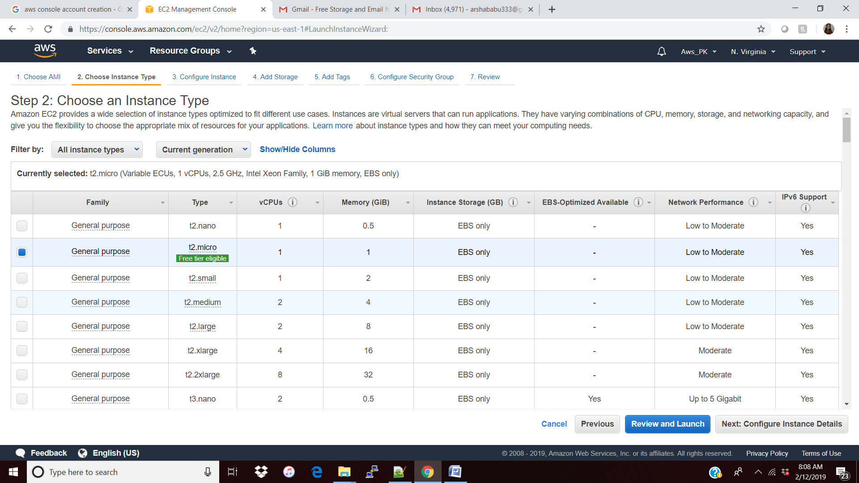

By default the instance will be mapped with the default **VPN and Subnets**

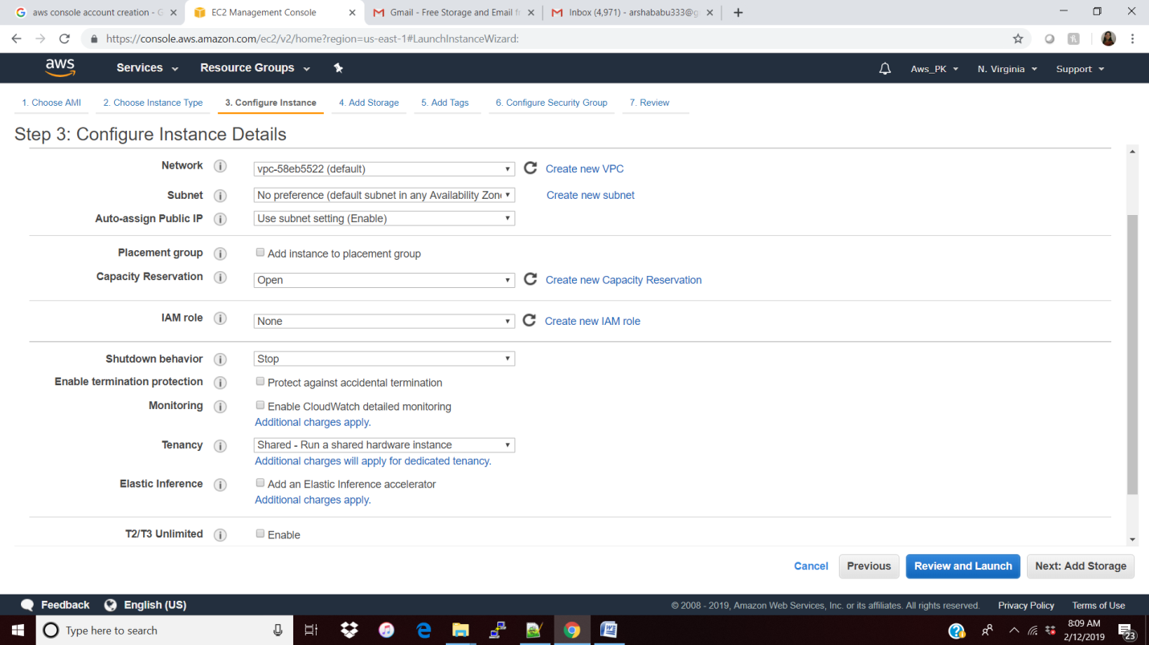

By default we will have the **Root Volume** to support for the operating system which cannot be encrypted and we need to make sure we are selecting the “delete on termination” option.

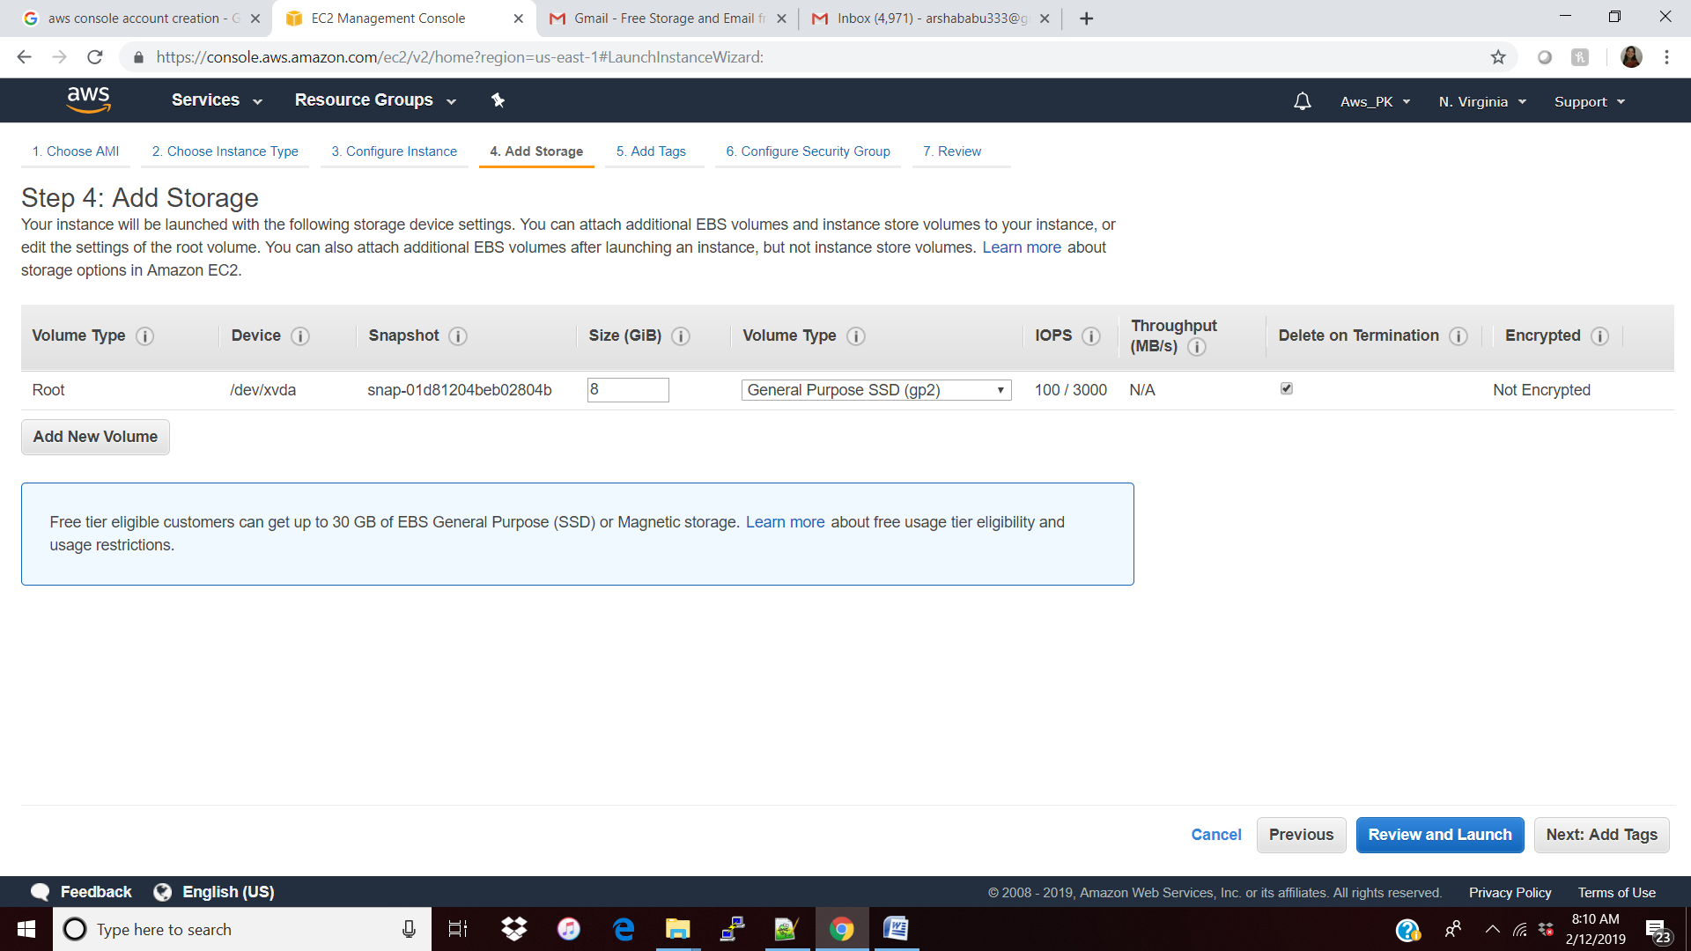

Default Security Group which has all the **traffic in**

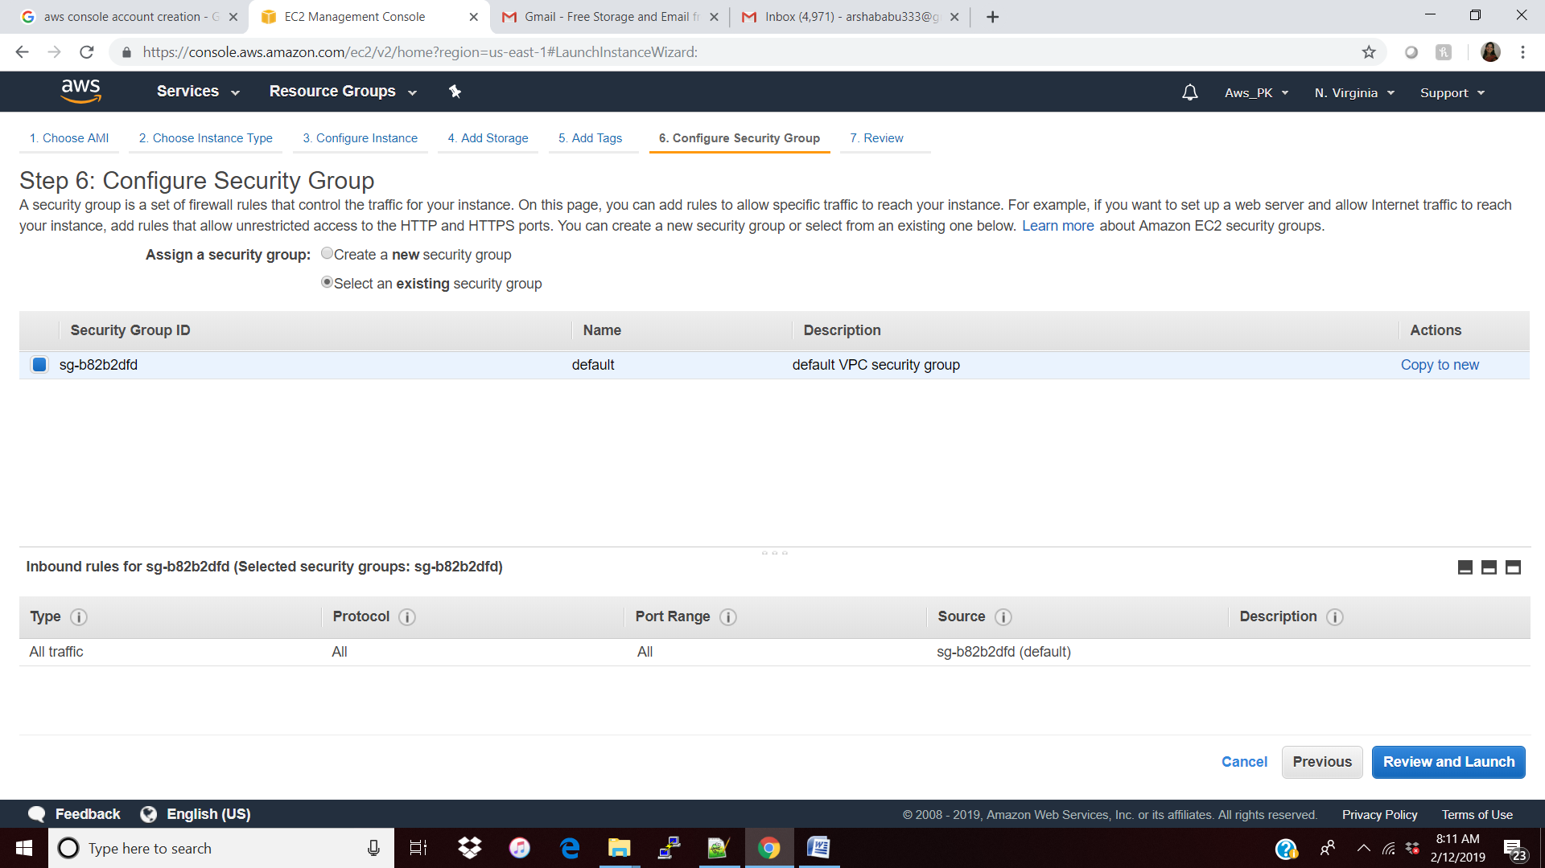

Download the Key and launch the instances.

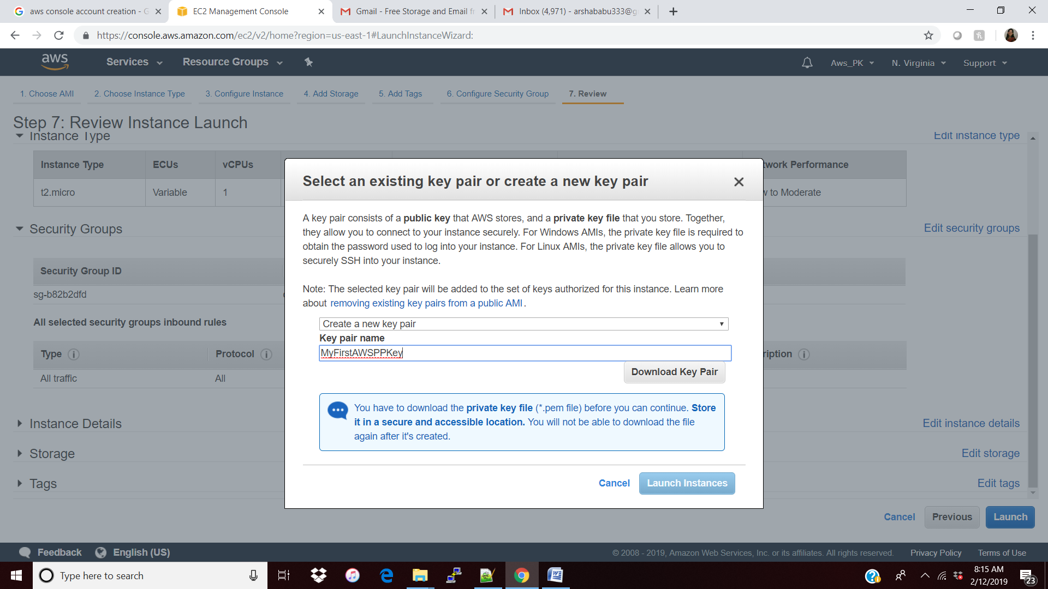

Get the puttyGen and convert the .pem to .ppk file

Click Load ( not Generate)

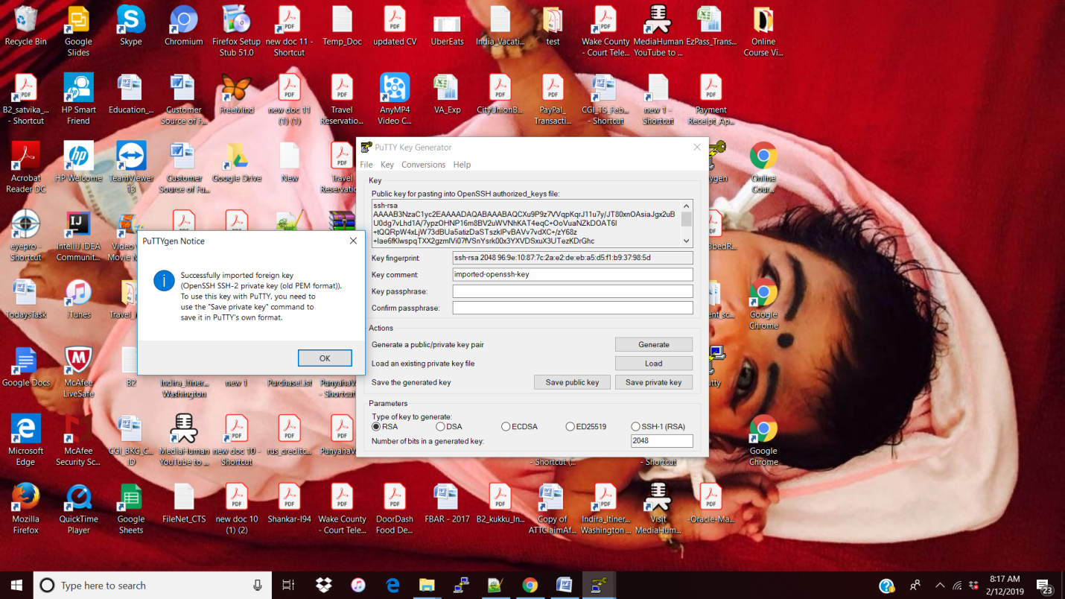

Password is optional ,click Save

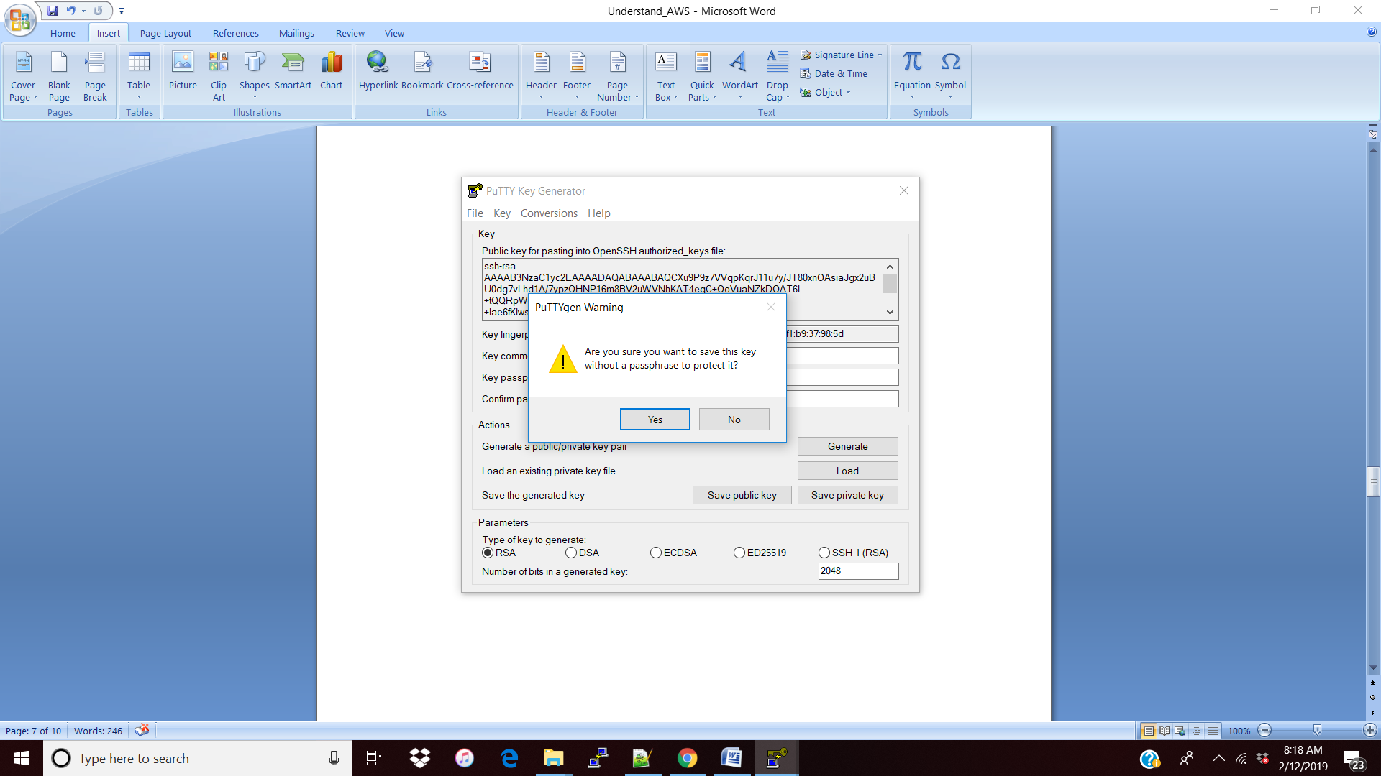

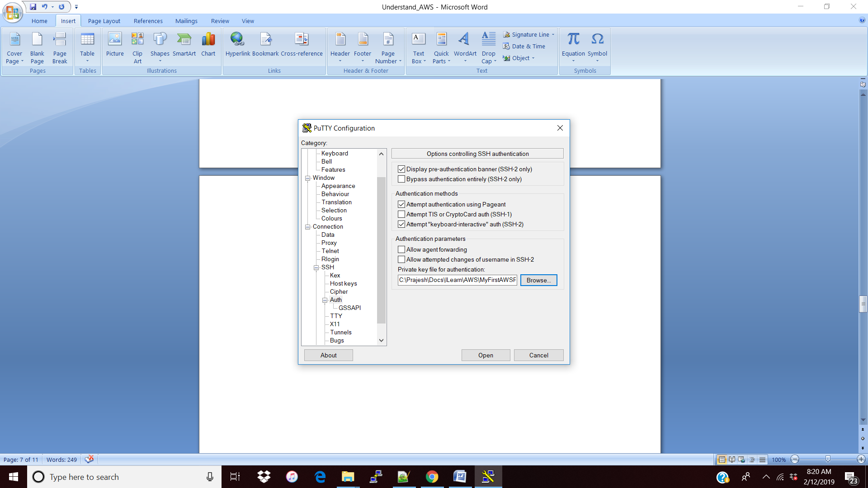

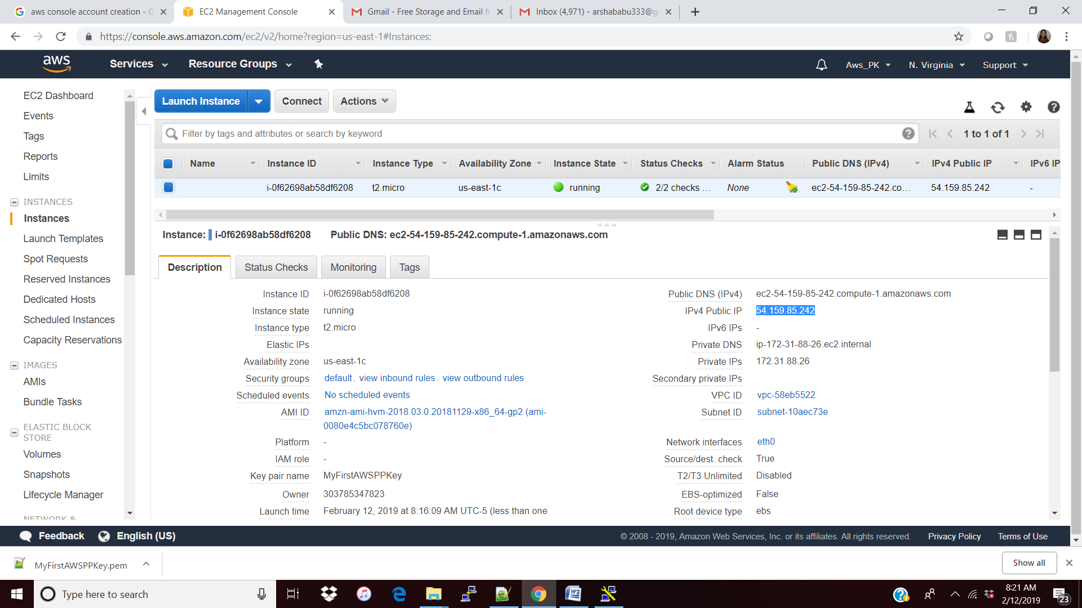

|  |
| --- |
| 3.1 : move as root user : sudo su  3.1 : update configuration : yum update -y  3.3 : install apache server : yum install httpd -y  : create one html and add some text (i.e , hellow world)and save it.  : cd /var/www/html  :ls  :nano index.html  <html><h1> hi</html></h1>  Ctrl + X , yes  3.4 : start service : service httpd start  Chkconfig httpd on (to make apache on when instance restart)  3.5 : Test ur browser http://<IPv4 Public IP>/ |

Note: I faced the connection timed out and below is the troubleshoot which I did.

Solution: when I changed my security group back to my own security group instead of default it works fine. May be the inbound should be all (0.0.0.0)

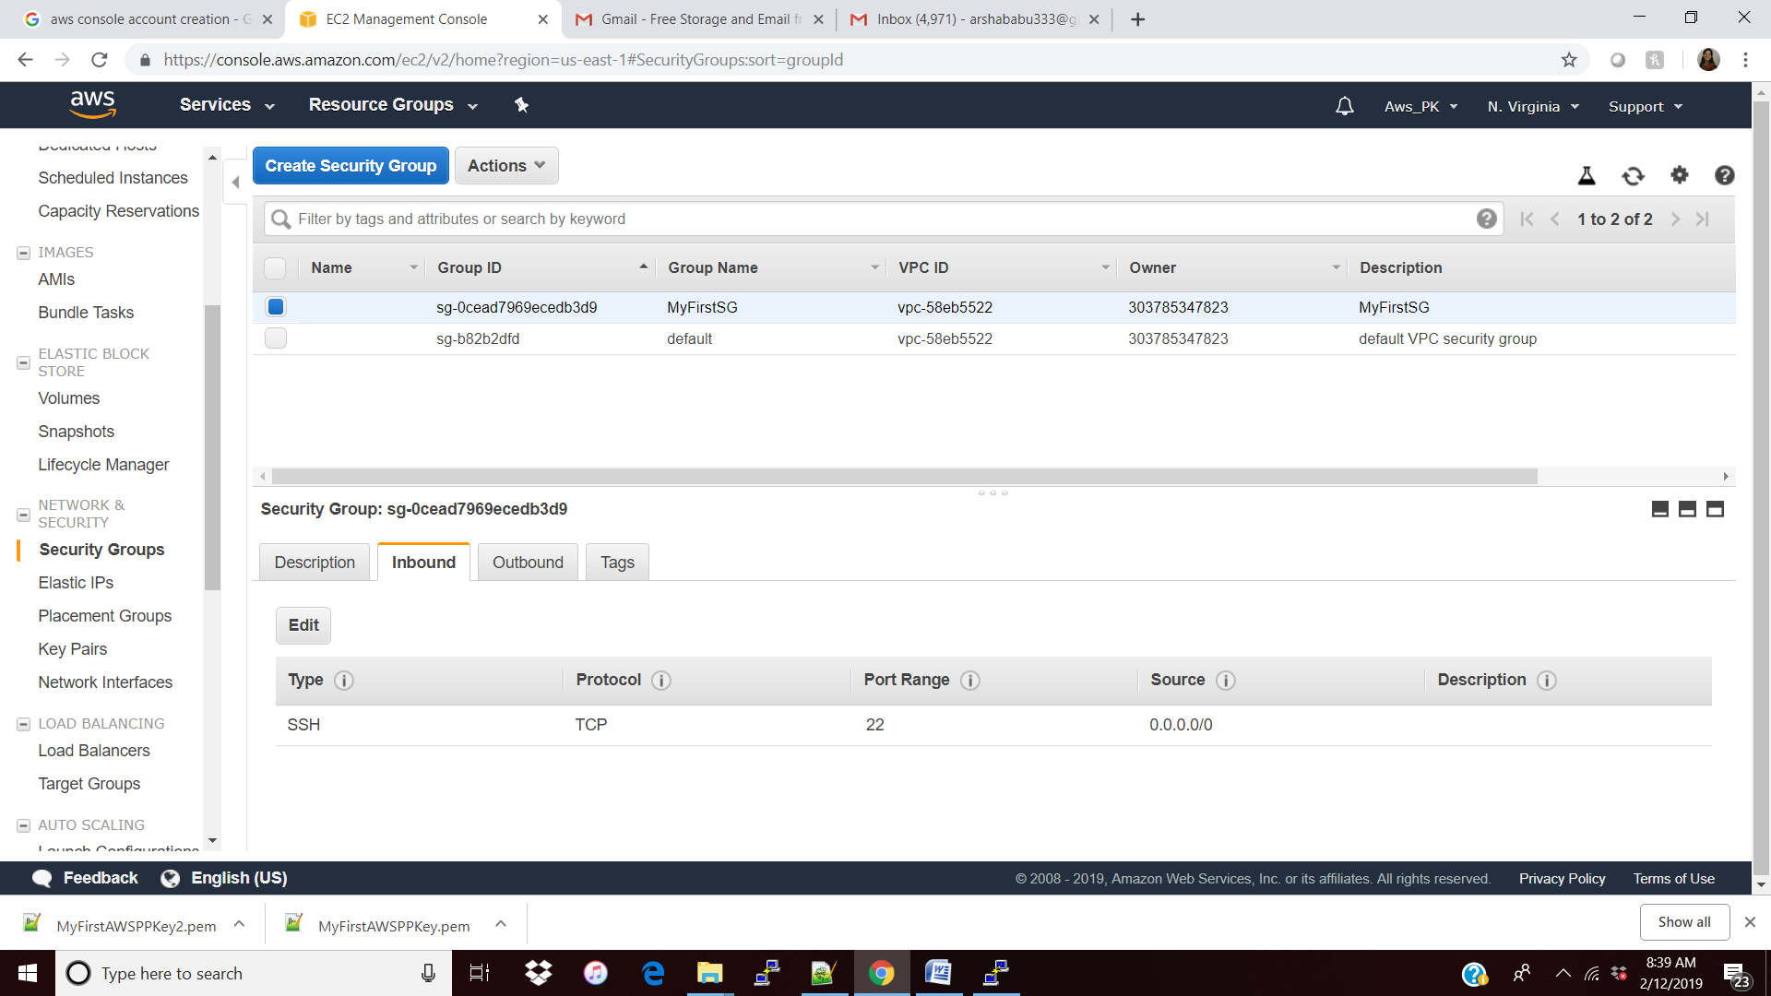

Like above there is no SSH port for 0.0.0.0

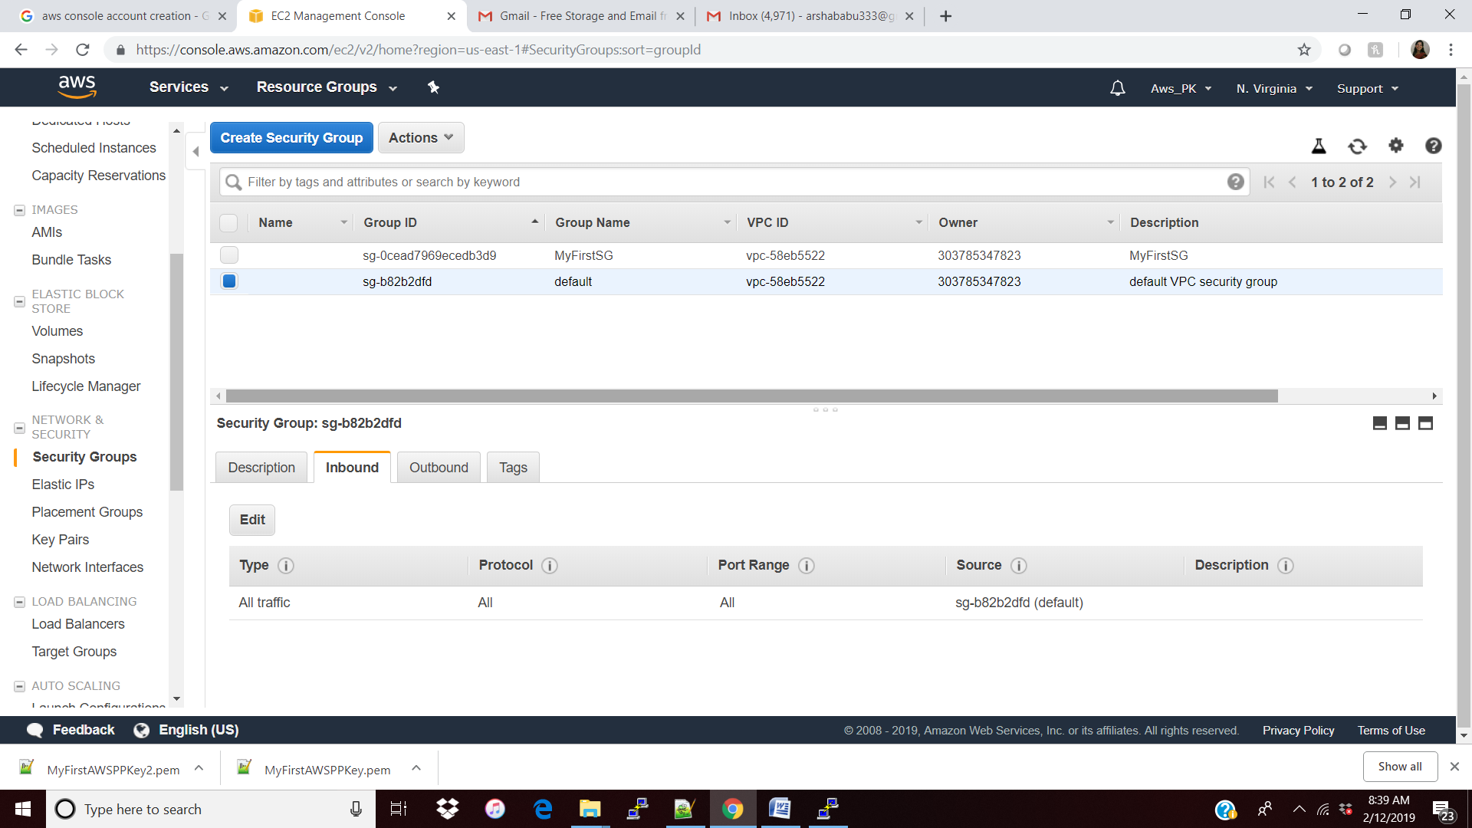

2) also when I hit the browser to test my html , it was failing and the reason is its not having the HTTP is not opened like above so have update the security Group to add the HTTP , then the browser is working fine.

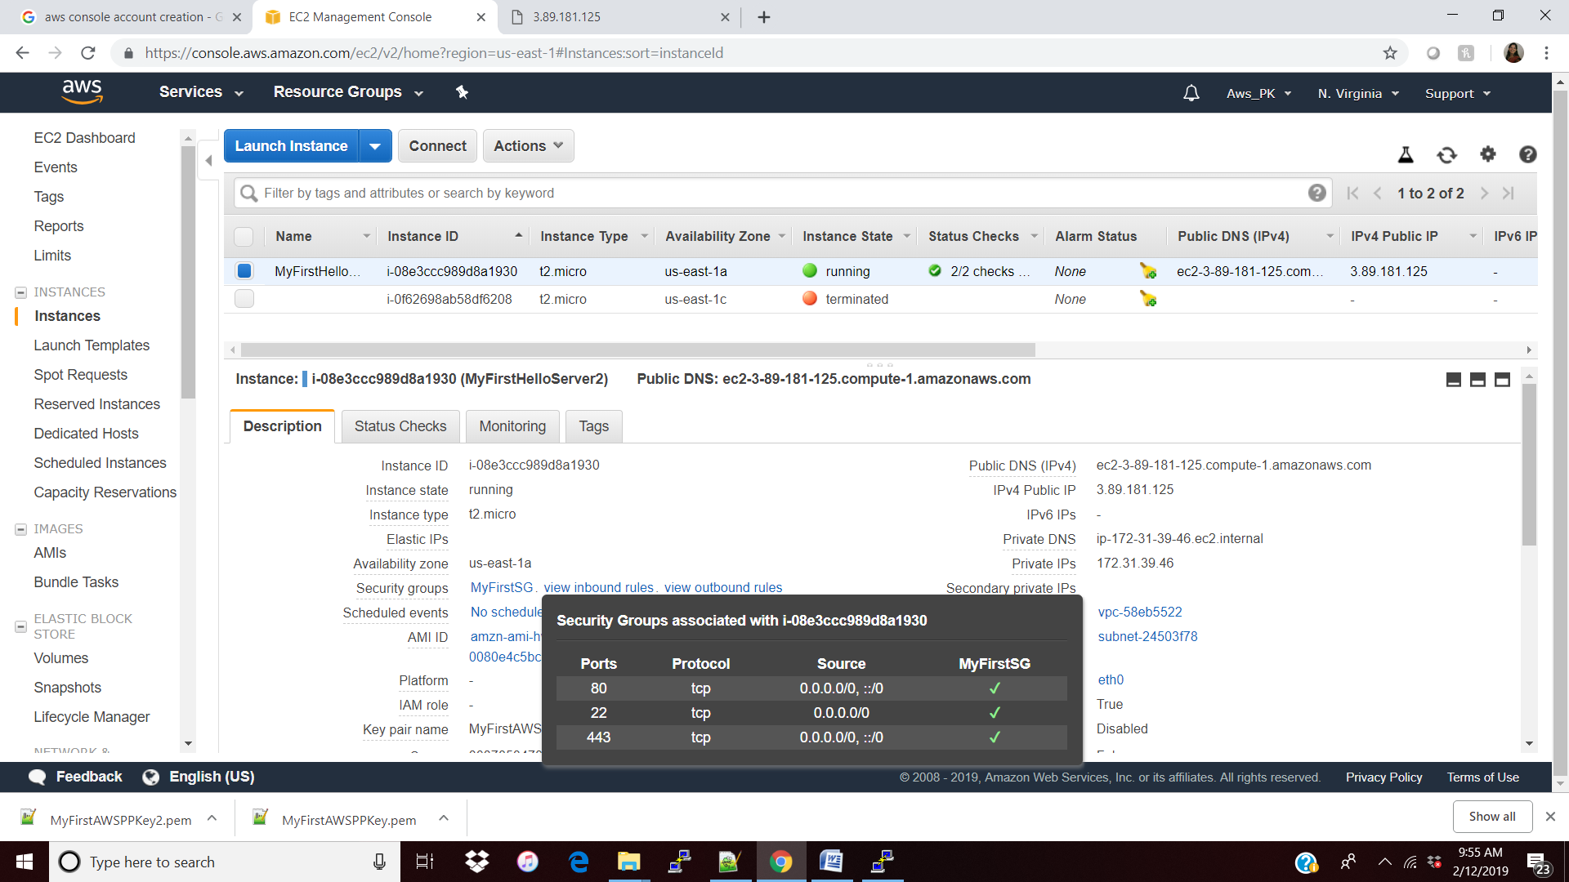

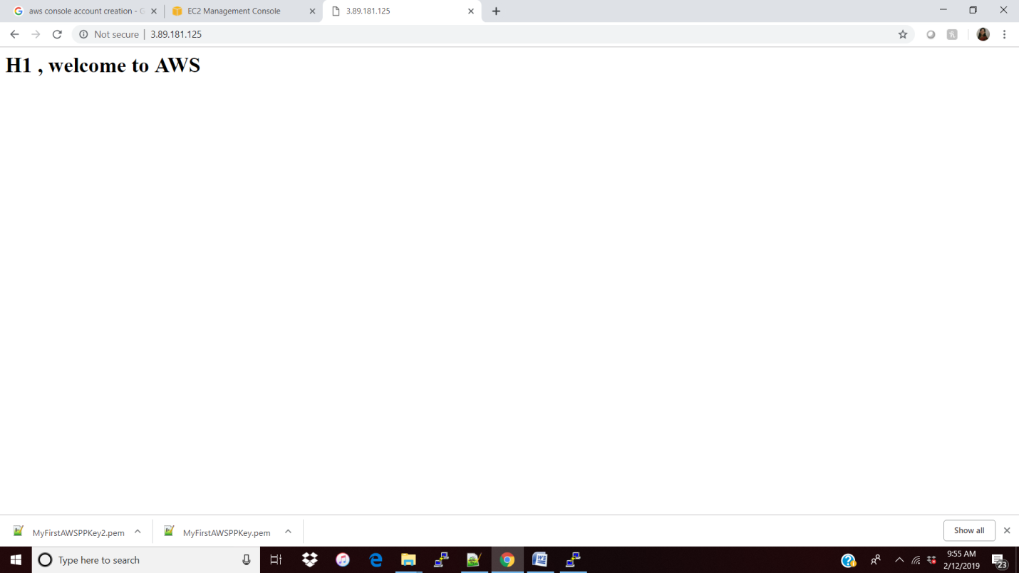

3) also when we are stopping and starting the instance we will have the new IP . not the same <http://3.89.181.125/> and the reason is for the auto scaling , amazon don’t want to hold the same space for us and we are not sure when we will be coming back so don’t want to hold the space till that time. After I restarted the IP changed to 54.224.197.196

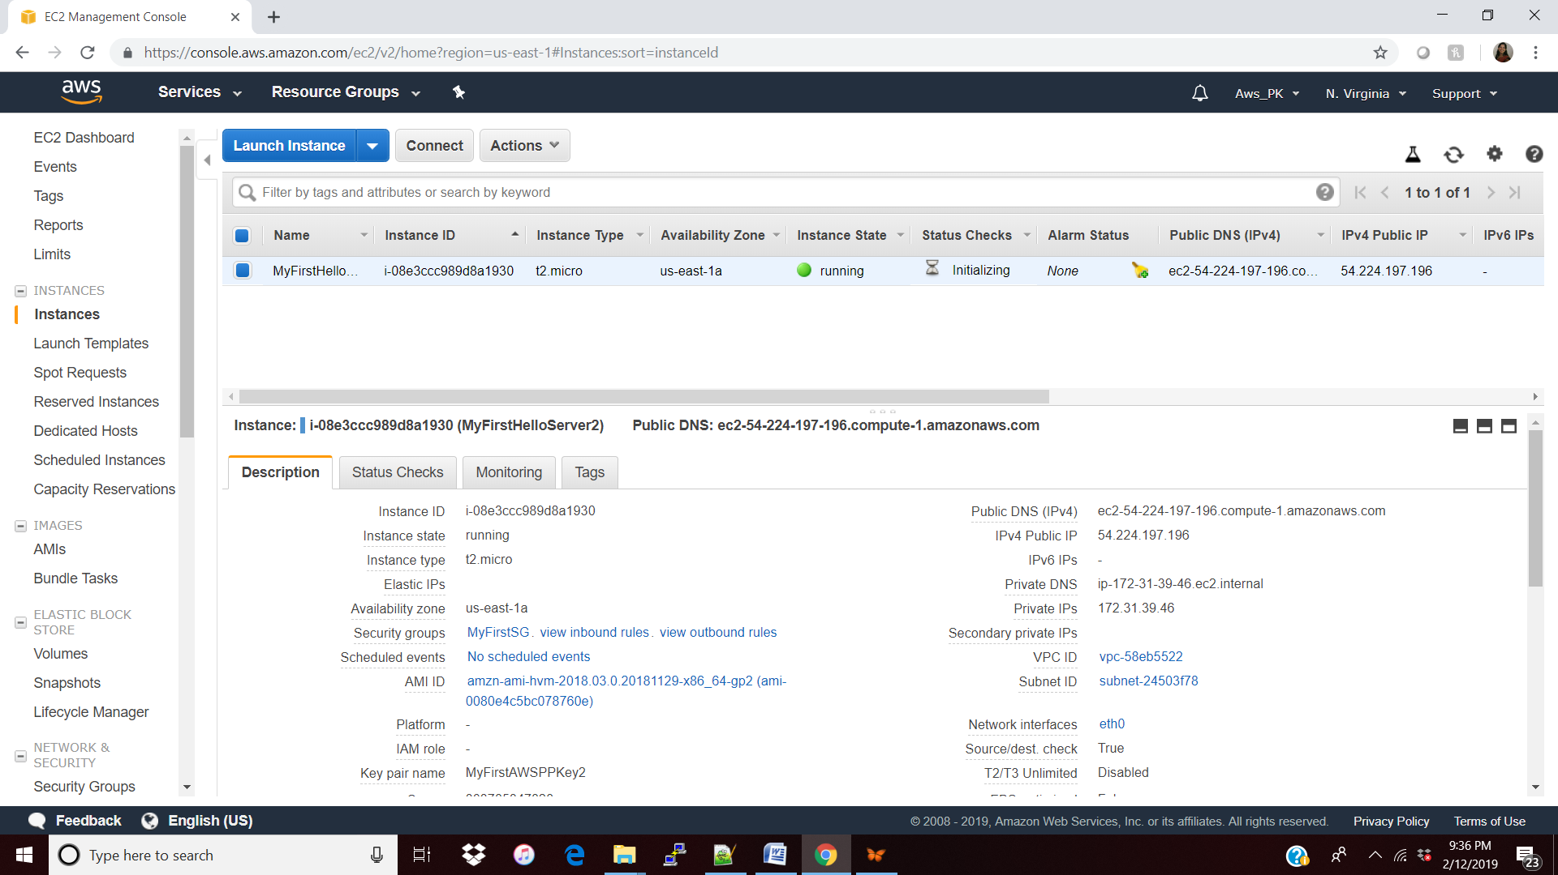

Case: Get the root volume ( encrypted) and use that encrypted root volume in other region.

Flow for the same: Volume 🡪 Snapshot 🡪 Copy 🡪 AMI 🡪 Ec2

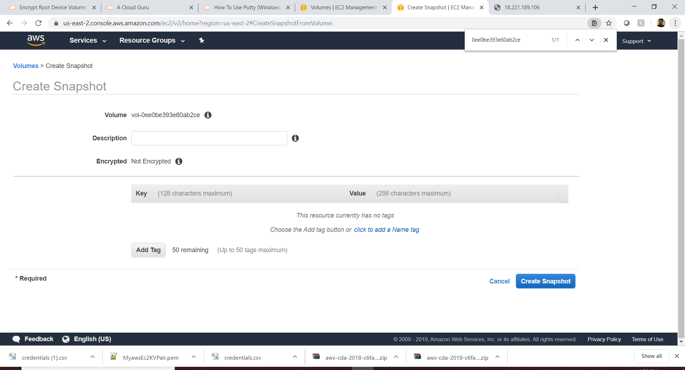

Snapshot(backup) Created from Volume(root) successfully.

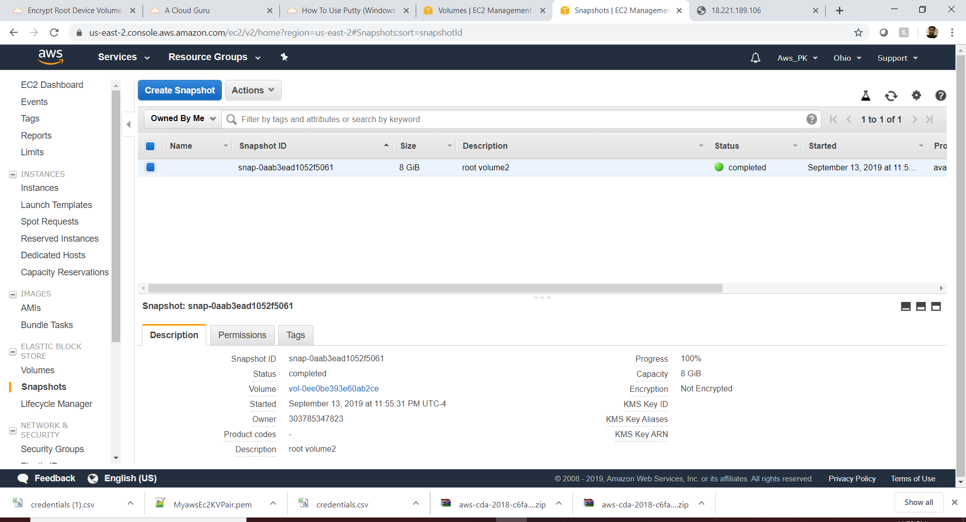

Get the copy from the created snapshot(backup) in other region

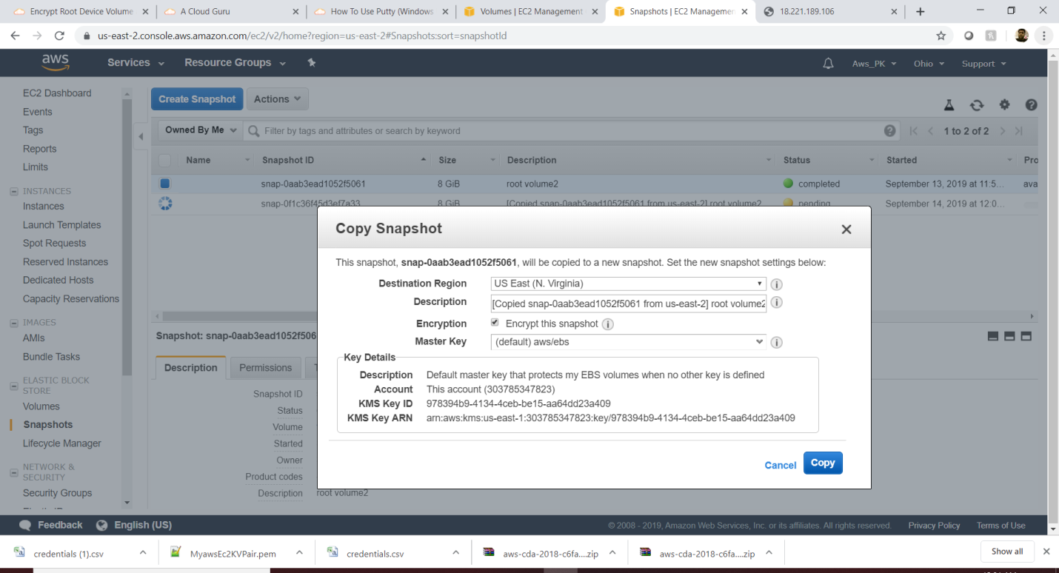

Open region viriginia

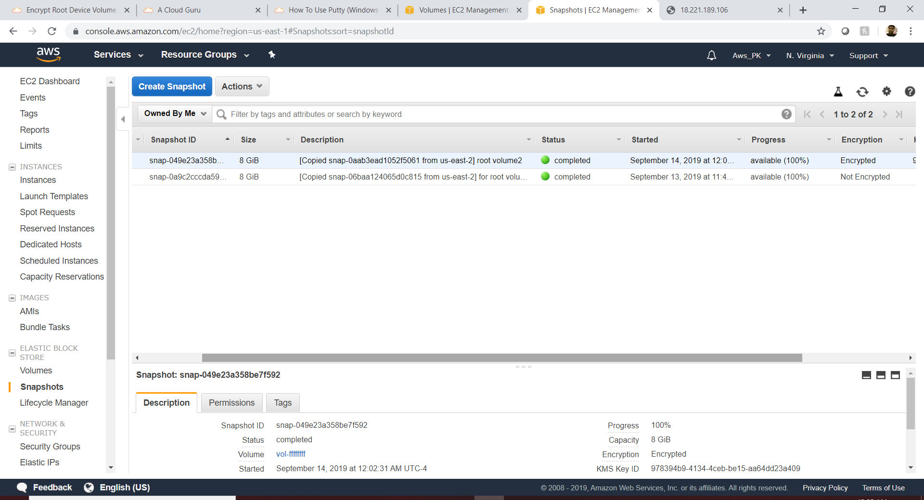

Create image from the encrypted root volume:

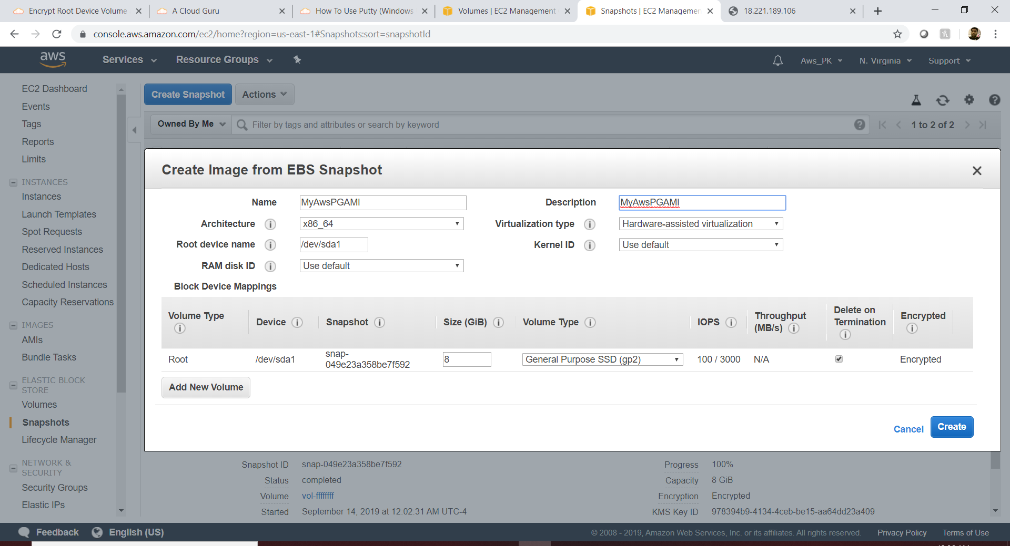

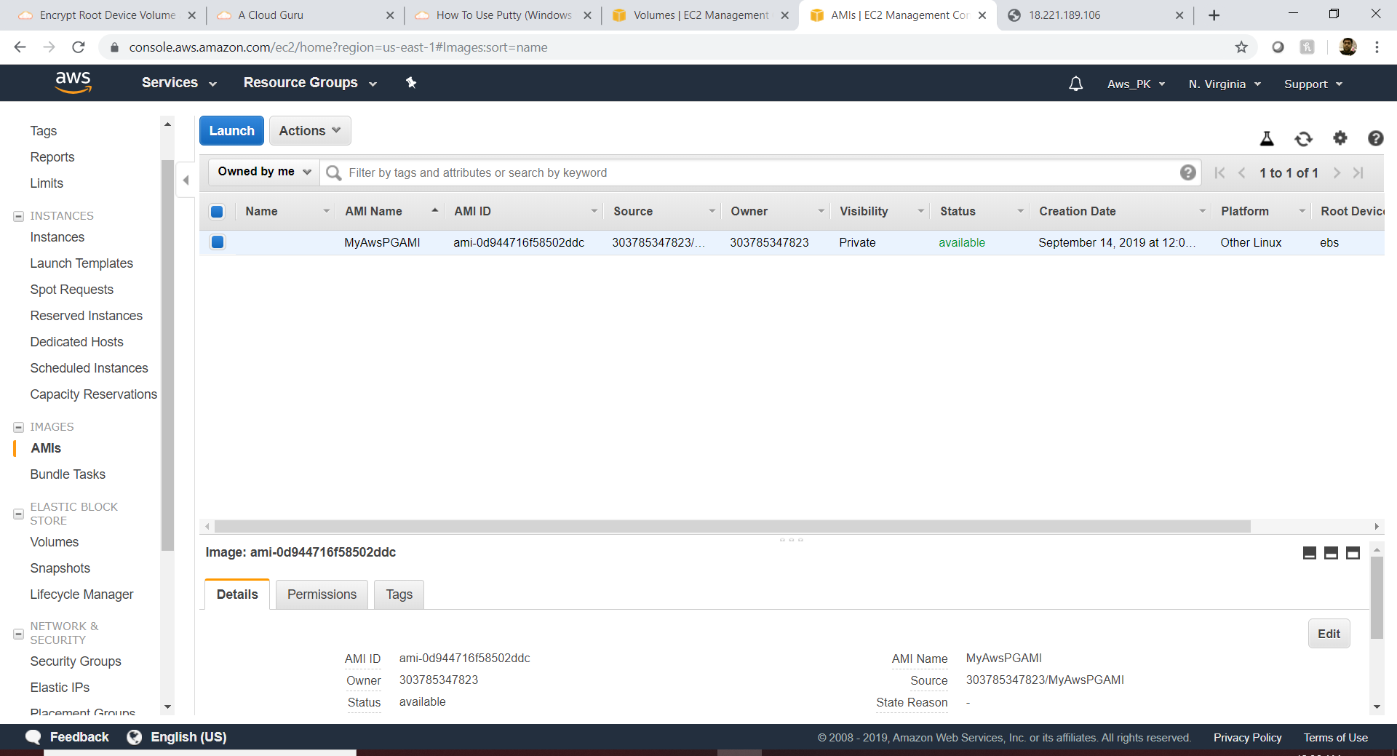

VPC

**What**: VPC is a **virtual** **Private Cloud or it’s a virtual data center in the cloud**, even the EC2 will have the VPC but that is a default one so we will not have any control in the IP address and security group and also by default it will be only **a internet gateway** not the private gateway whereas using VPC we can define our own Internet and **private gateway.**

**Why**: we can define our **own IP address** so we will have the control on the IP address instead of default VPC and **NACL** (Network Access Control List) to make sure which specific IP can access our server.

**How**:

Step 1: Create a VPC per region and declare the IP address

Step 2: Create the Public and private subnet and declare the IP address for each subnet

Step 3: Create the internet Gateway and assign it to the VPC.

Step 4: Create a Route Table and assign the “associated Subnet” and declare the public subnet as enable

Step 5: Test the public browser.

Step 6: Create the NACL as needed w.r.t to the inbound/outbound rules.

Step 7: ICPM port to get the port ping from the public subnet.

Step 8: Create the NAT to get the private subnet to get download the patches.

Step 9: Create the end point to call directly ( to bypass the NAT ) the documents from S3.

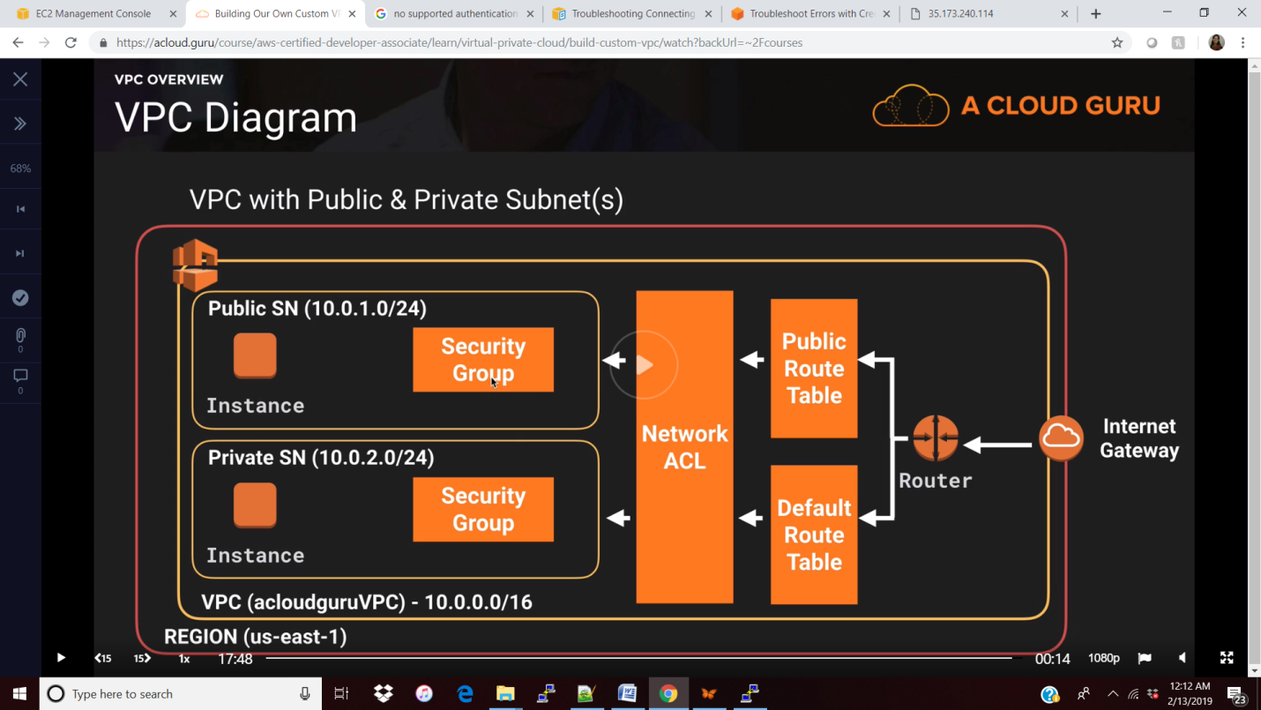

Create VPC

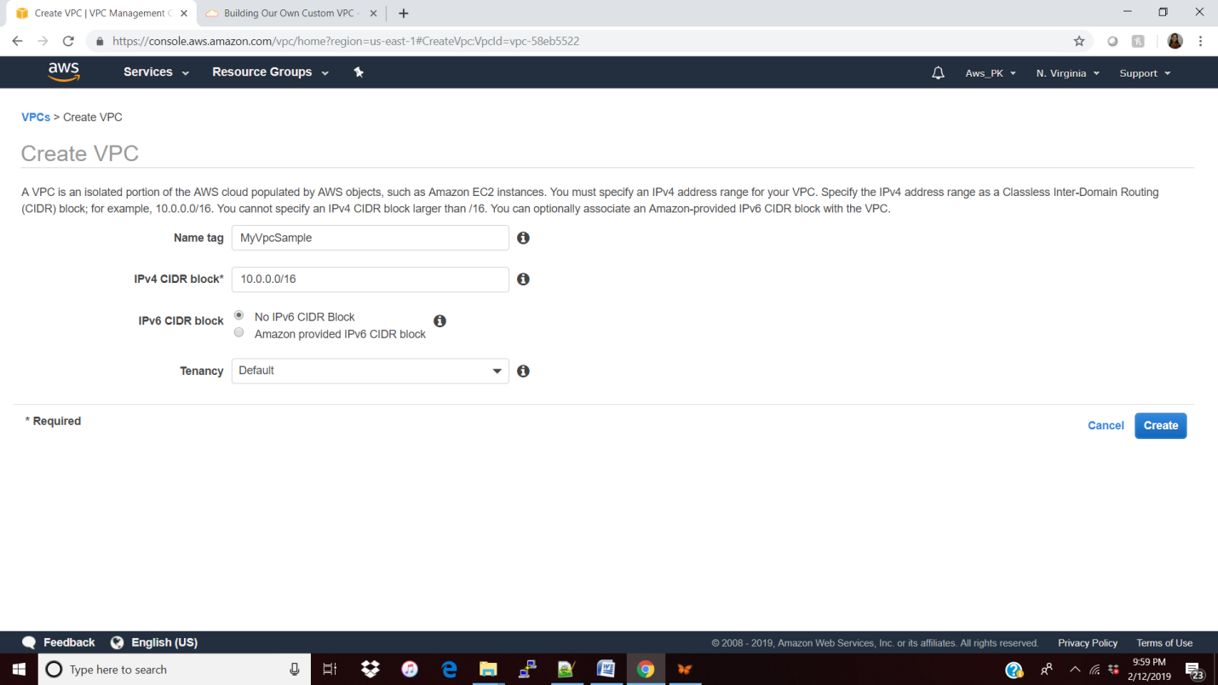

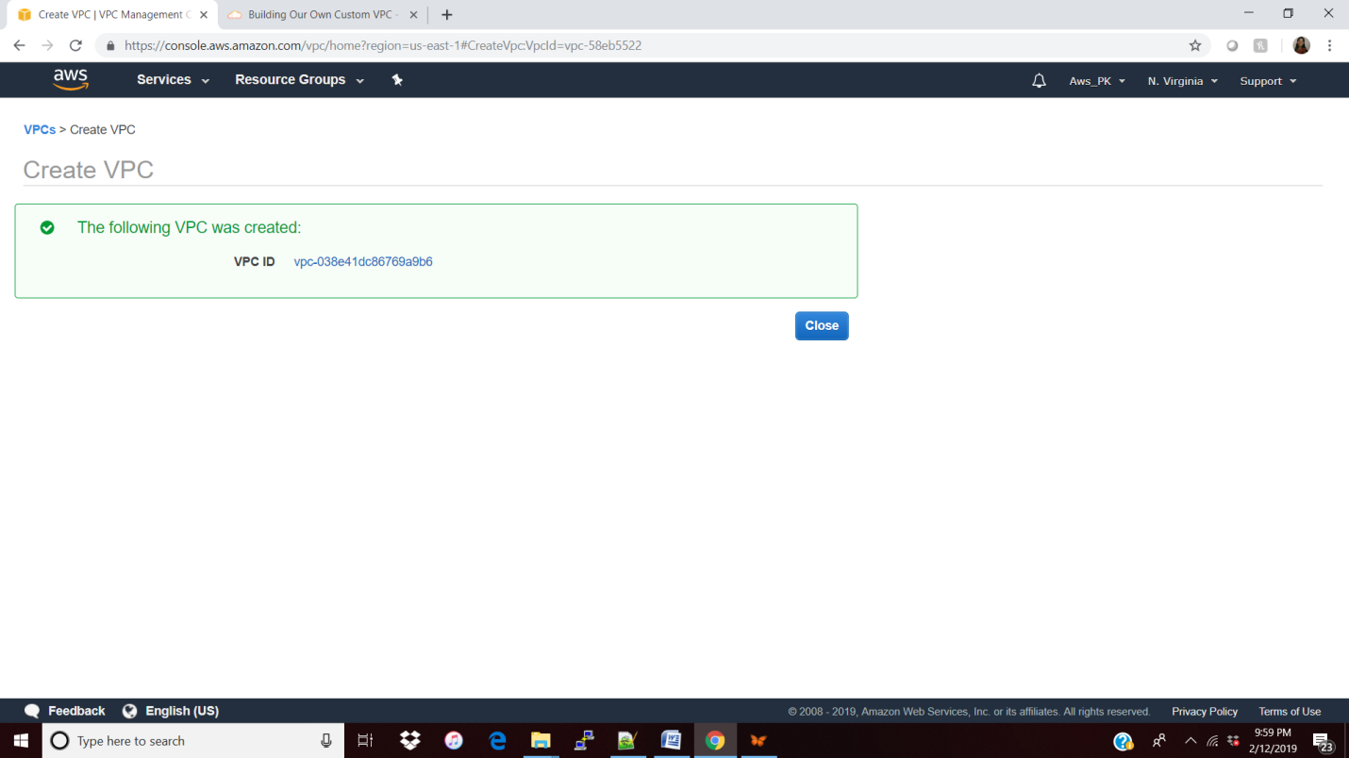

Once u created the customized VPC the default (NACL/SecGroup/RouteTable) will get created apart from subnet.

So Next we must create our needed subnets.

**Create 2 subnets with different A.Z**

Public

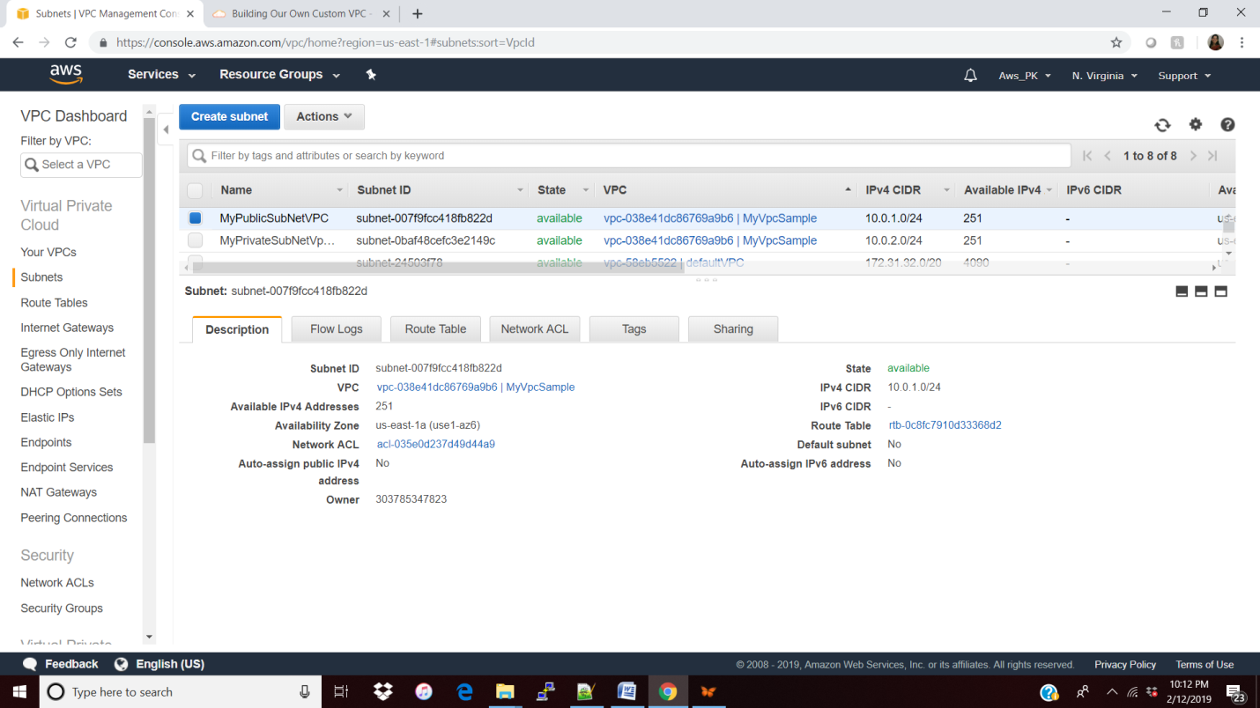

Private

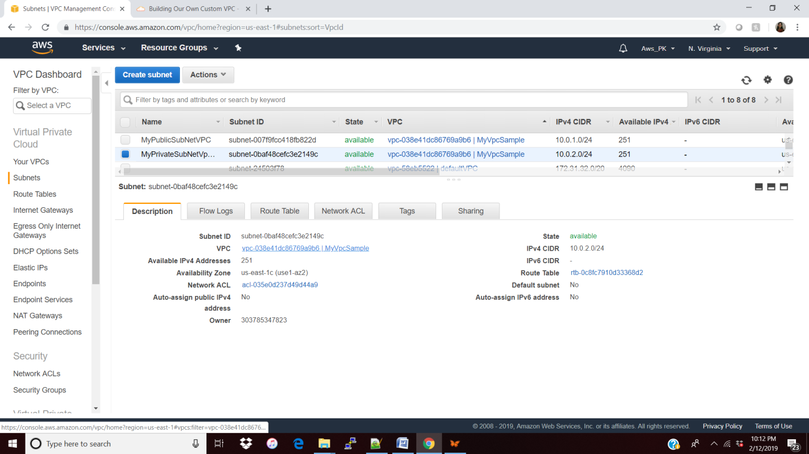

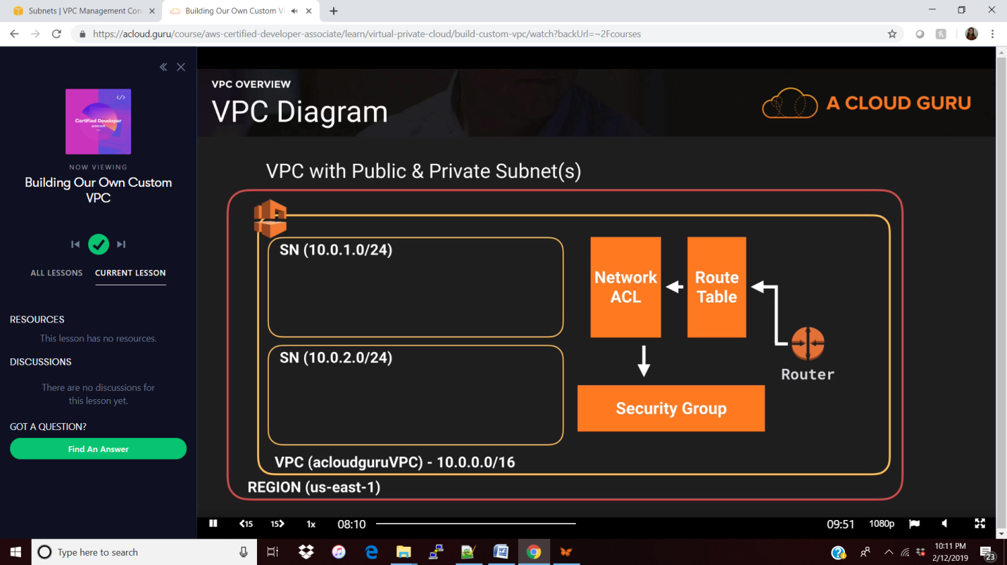

**Create Internet Gateway and attach it to VPC:**

Only one IG for 1 VPC

aws ec2 attach-internet-gateway --vpc-id "vpc-038e41dc86769a9b6" --internet-gateway-id "igw-0033108fcc1884262" --region us-east-1

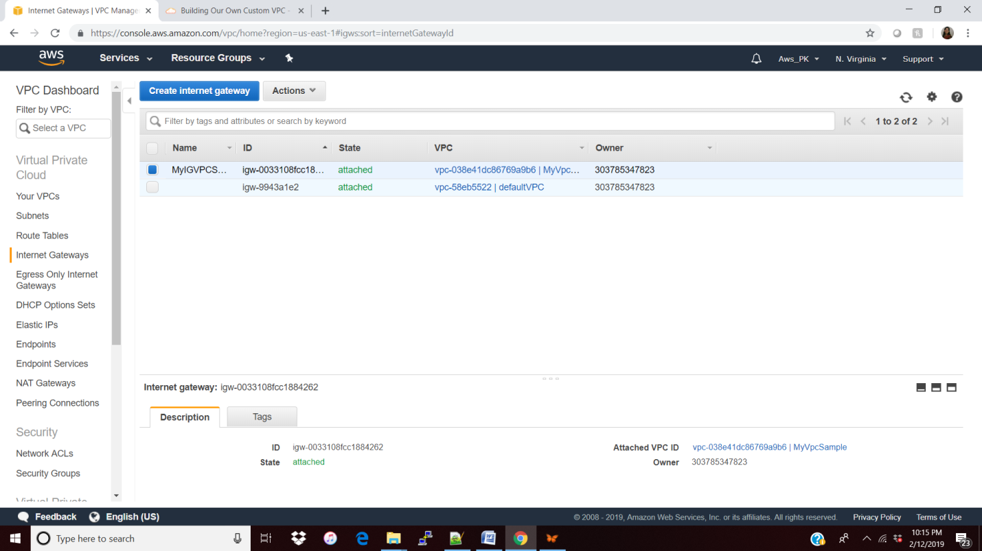

**Create a route Table and map it to VPC**

By default the created subnet will be part of the default route table so we need to set t**he public subnet to associate** with route table.

Note: Once public subnet is associated with this route table that will get removed from the default route table.

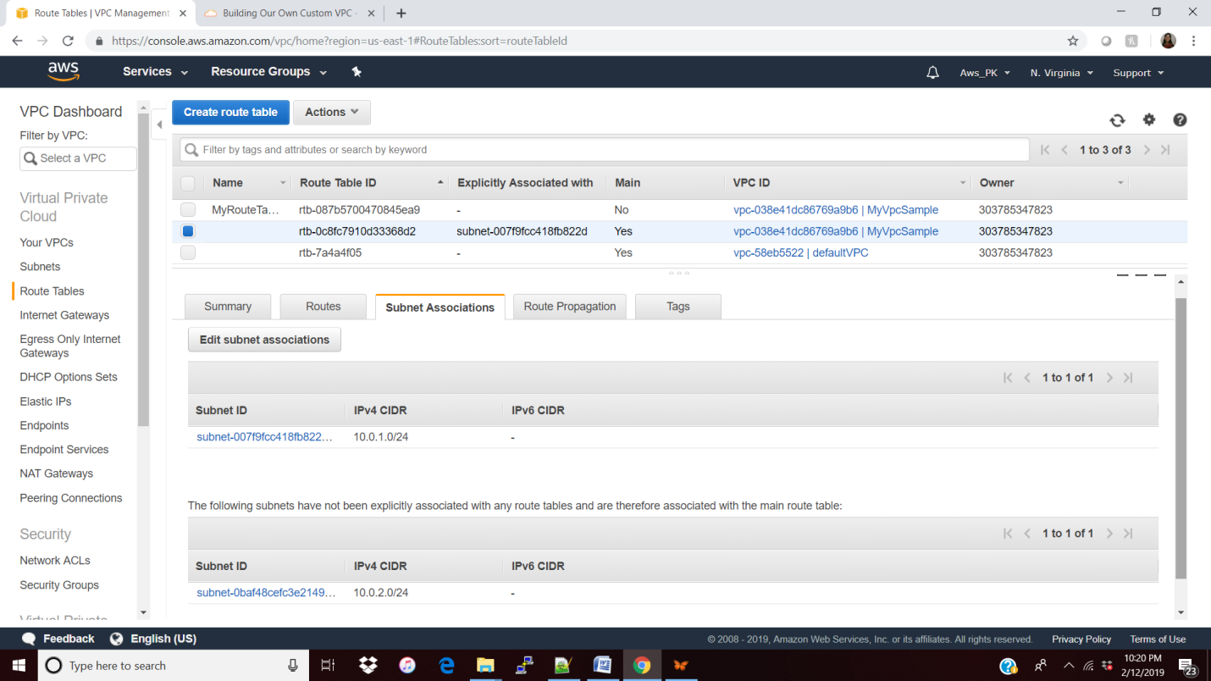

Next is we need to map the internet gateway to the route table to confirm the public subnet is configured to the internet and also add “::00/0” for IPv6.

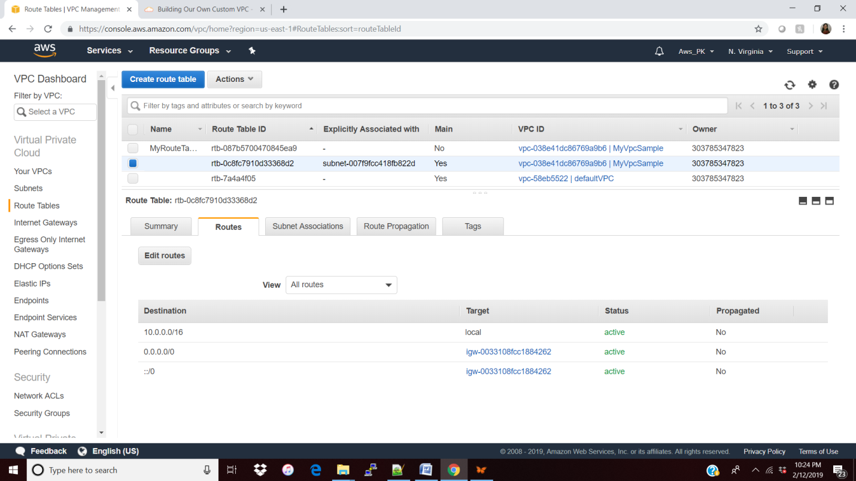

Make the auto Assign Public IP as Yes

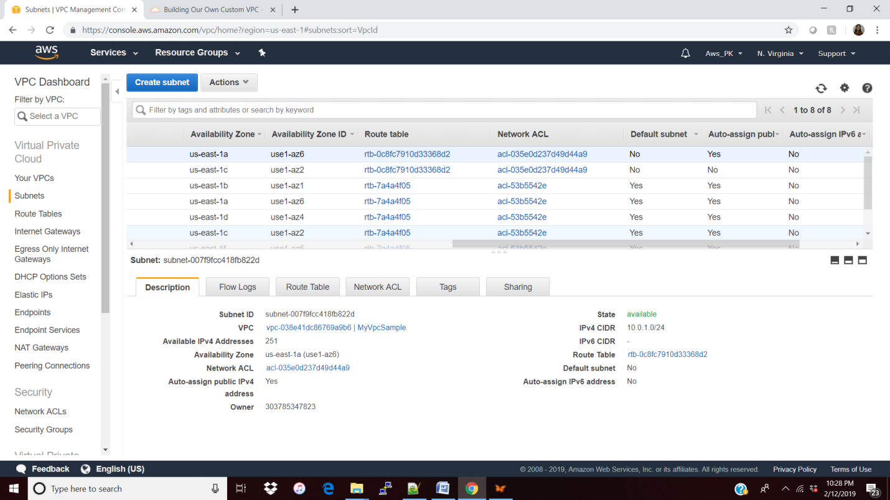

Create 2 Ec2 instance one for public subnet with the security group (SSH and Http)

and other with private subnet with the security group (without open to the outside world 0.0.0.0) see below

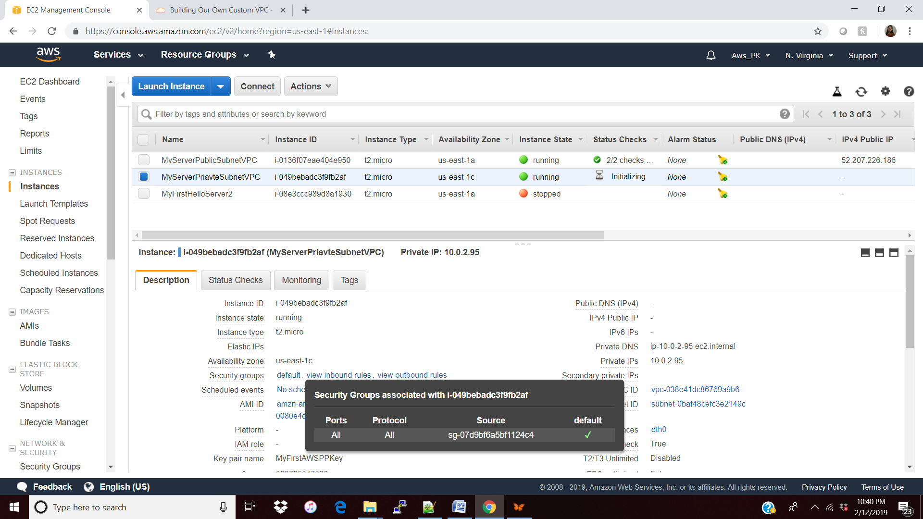

**Communicate the private and public subnet:**

Apply the security group in private subnet which has the ICMP-ipv4 port to public subnet(10.0.1.0/24)

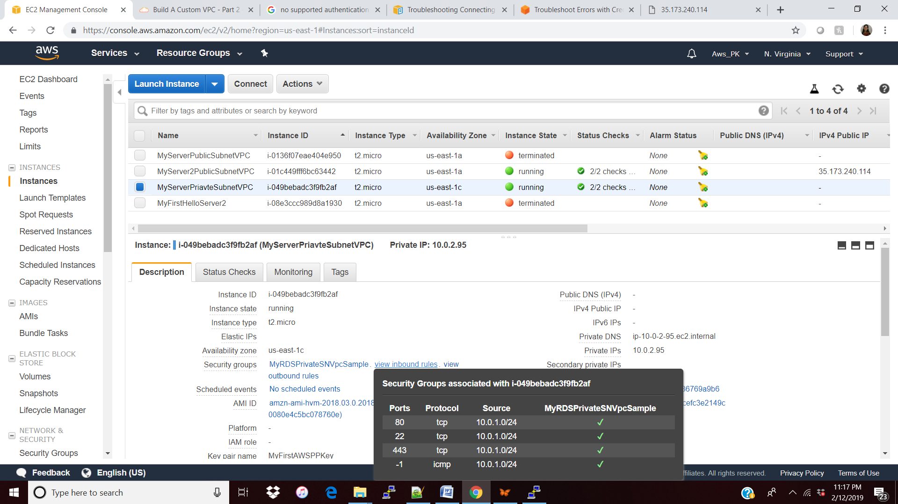

Try ping now, now we can ping the private subnet from public subnet.

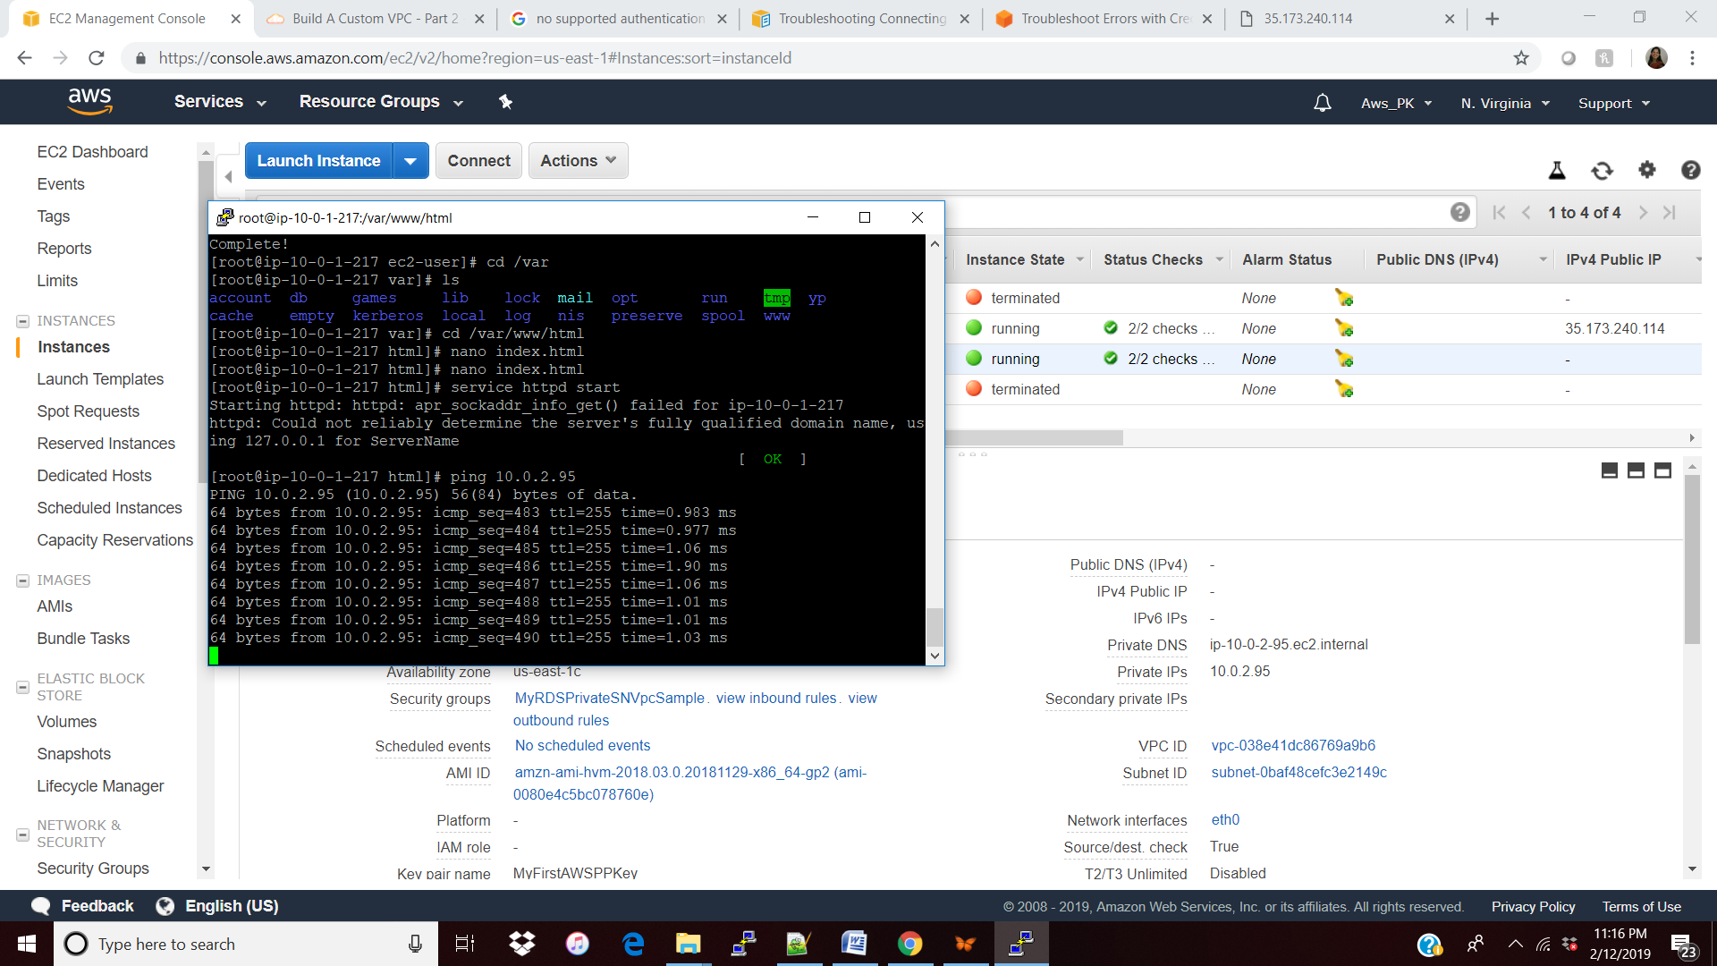

**Now lets try to connect (after ping successful) to private subnet by adding the public key.**

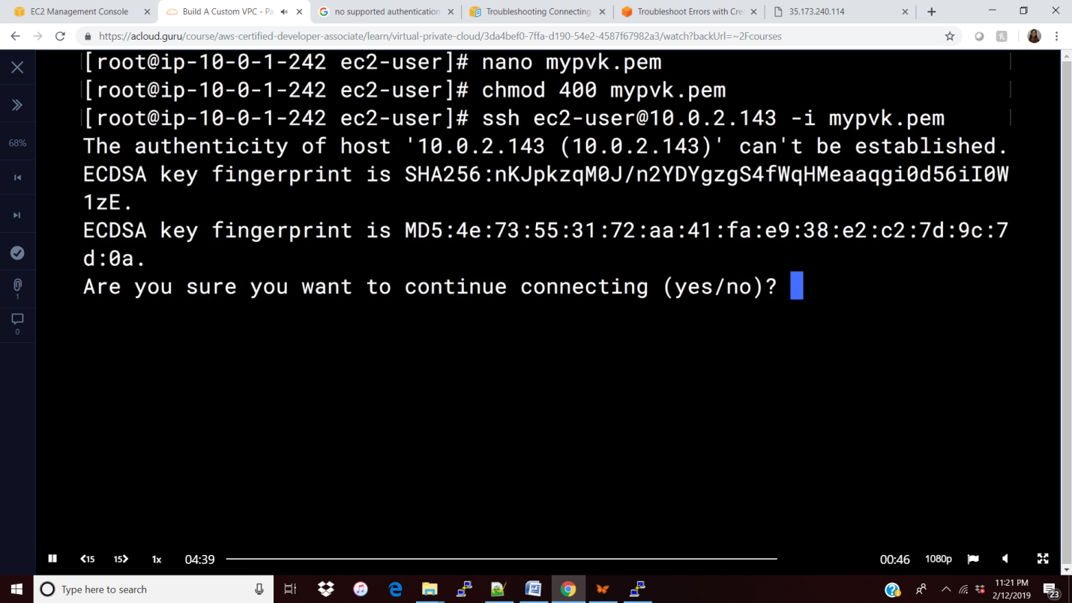

Connected successfully to the private subnet but the updates wont happen because the private subnet is not having any internet connected. So we need to get the NAT help to get the updates done.

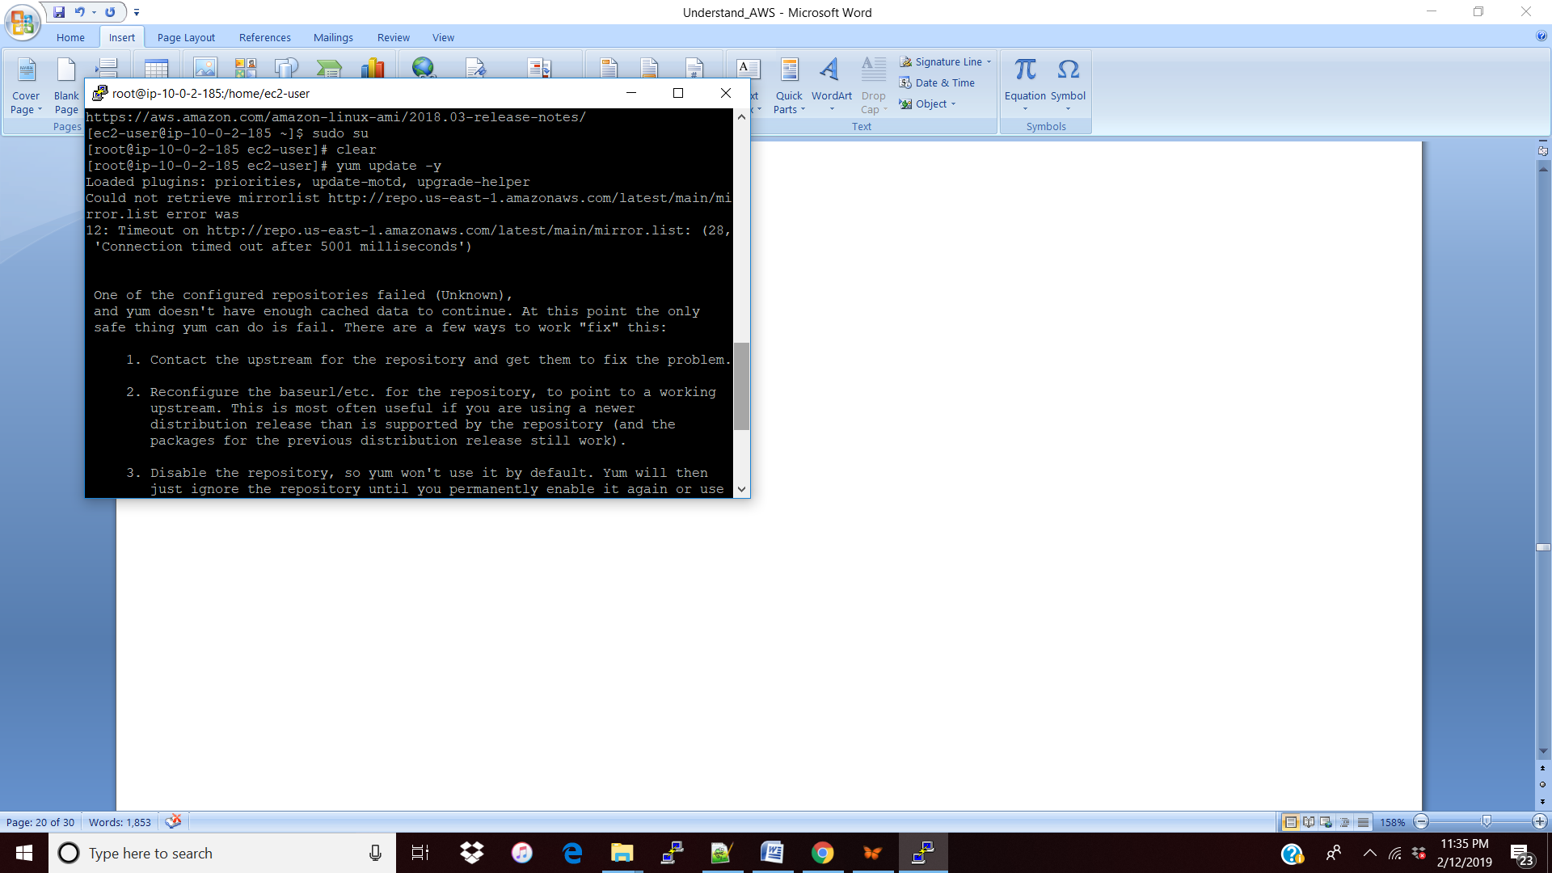

**NAT gateway: Create a Nat with Public Subnet and configure with the default gateway.**

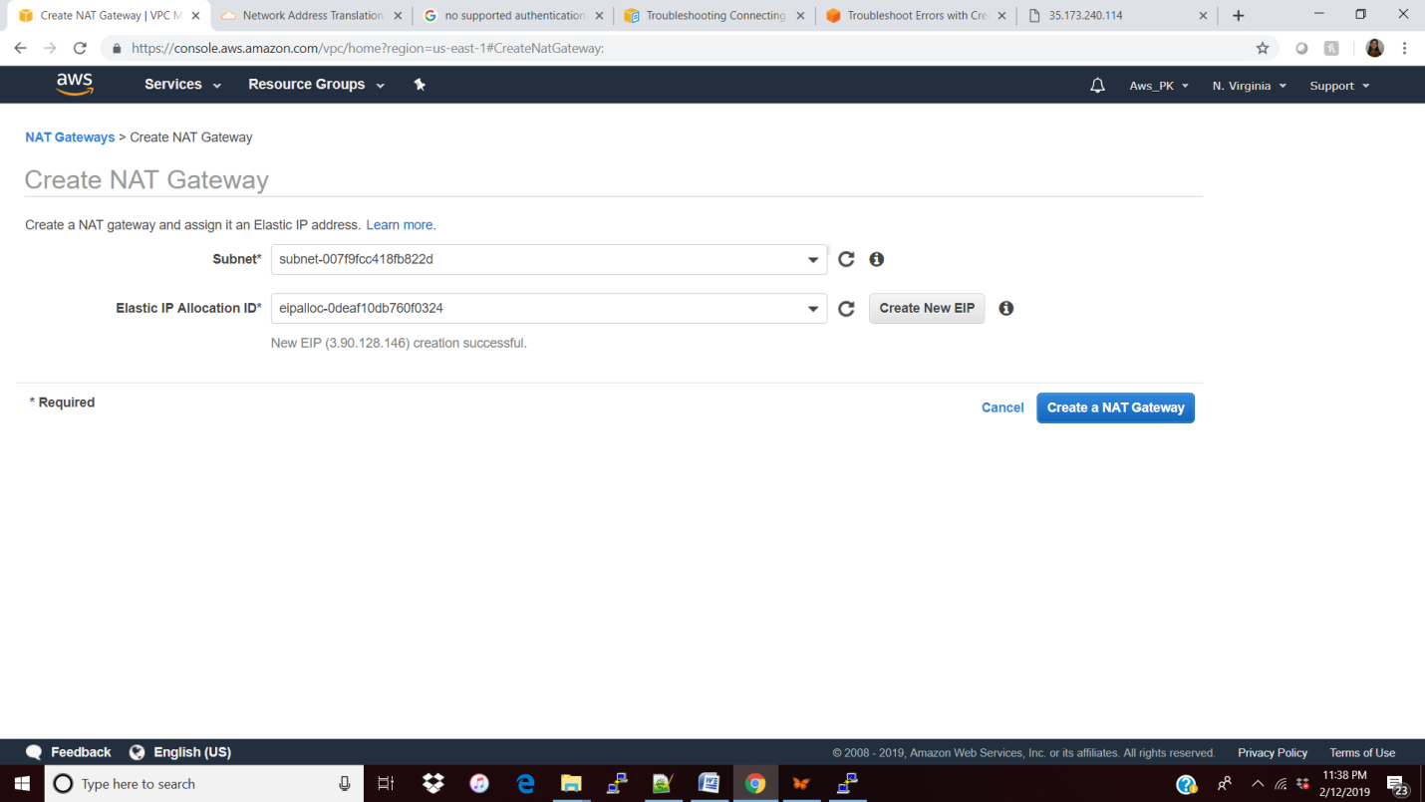

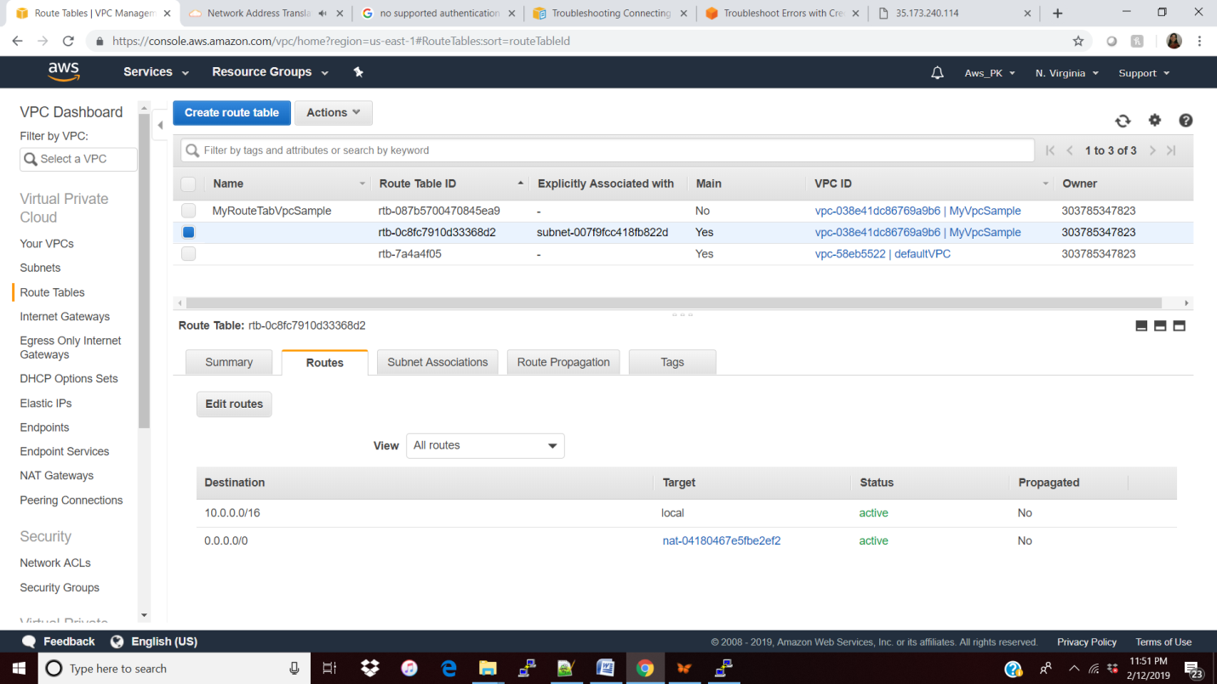

NOTE: Make sure we are not assigning the public subnet to NAT like below and the reason is hence the public subnet is part of NAT now and the public subnet is not available to internet gateway when I hit the public ip in browser its not responding, So the public subnet should be part of Internet gateway.

Once NAT gateway is created in the public subnet (for private subnet) then we have to update the **default route table** ( not our own route table) to that NAT gateway (see below) , So that private subnet can download the things in a NAT using NAT.

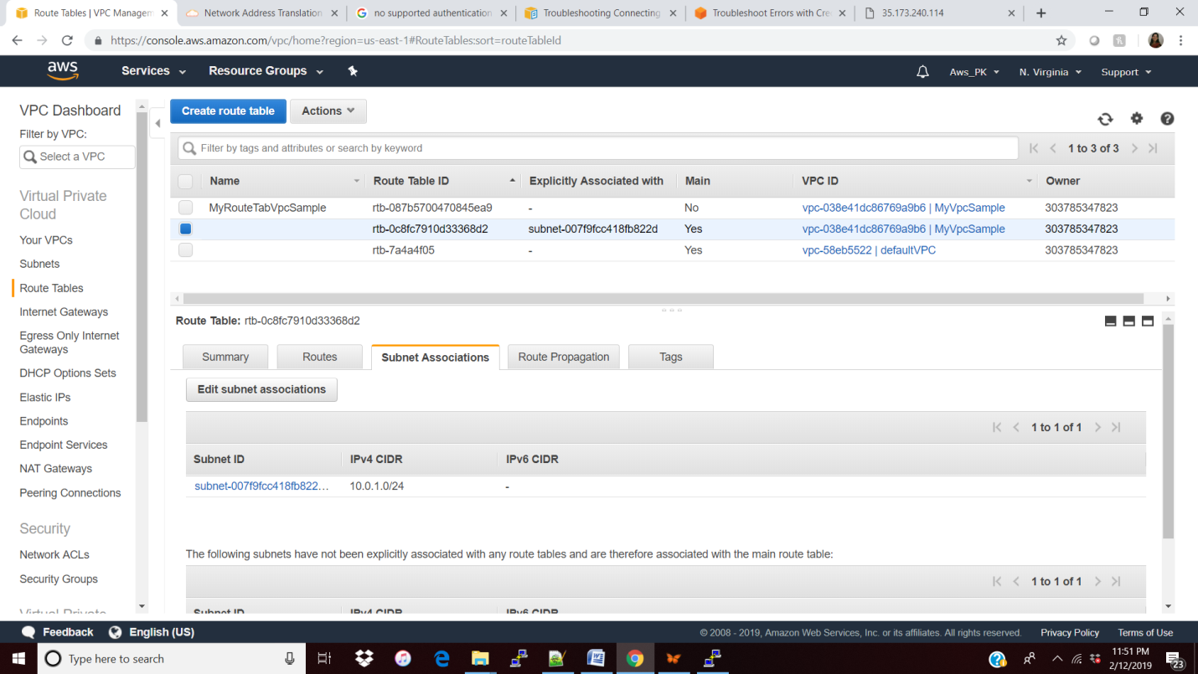

NACL: to control the specific IP address to access in the ec2 instance.

Create our NACL under VPC and assign the public subnet to this NACL and restrict the access for that IP address to that site by applying t he rule.

Below site is working fine because for the default NACL all are ALLOWED as of now.

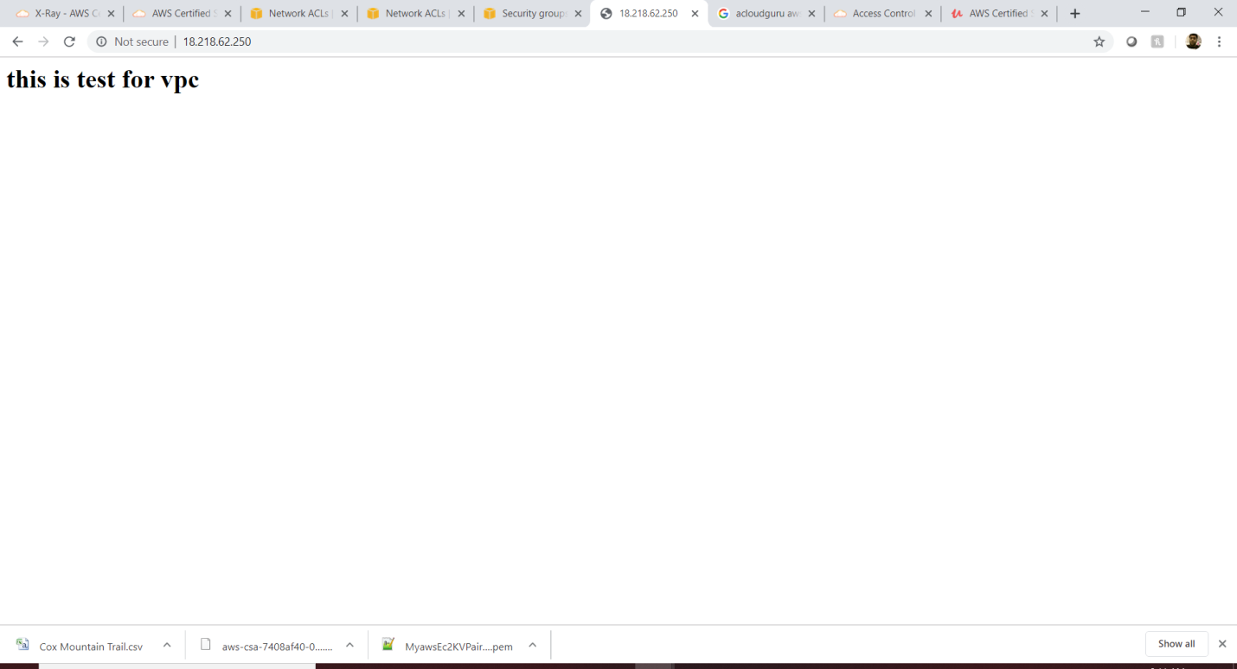

Created our own NACL.

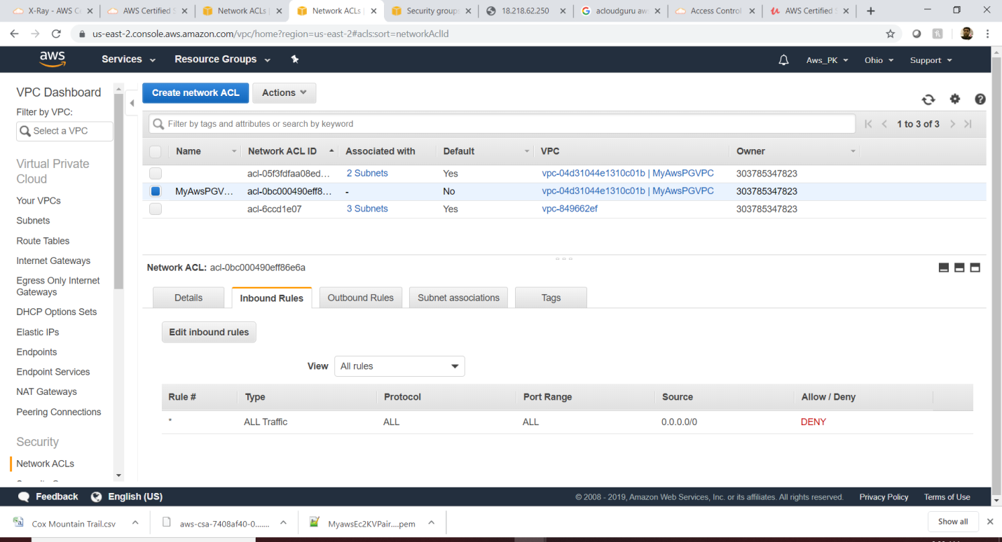

Assigning the public subnet to NACL

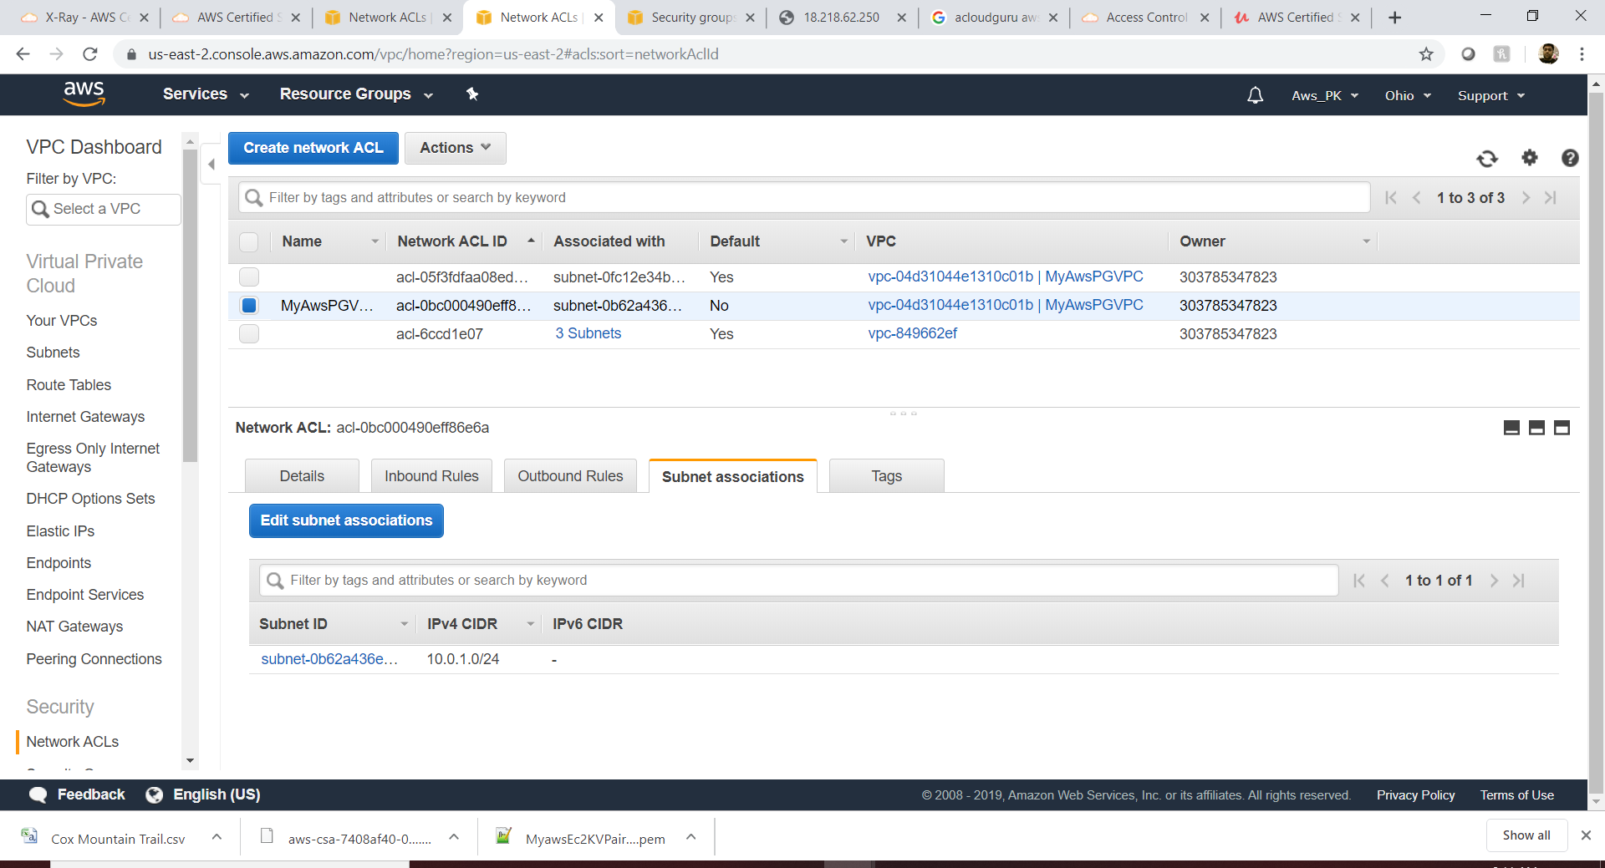

By default all port/ip address is deny in NACL. So site will not able access

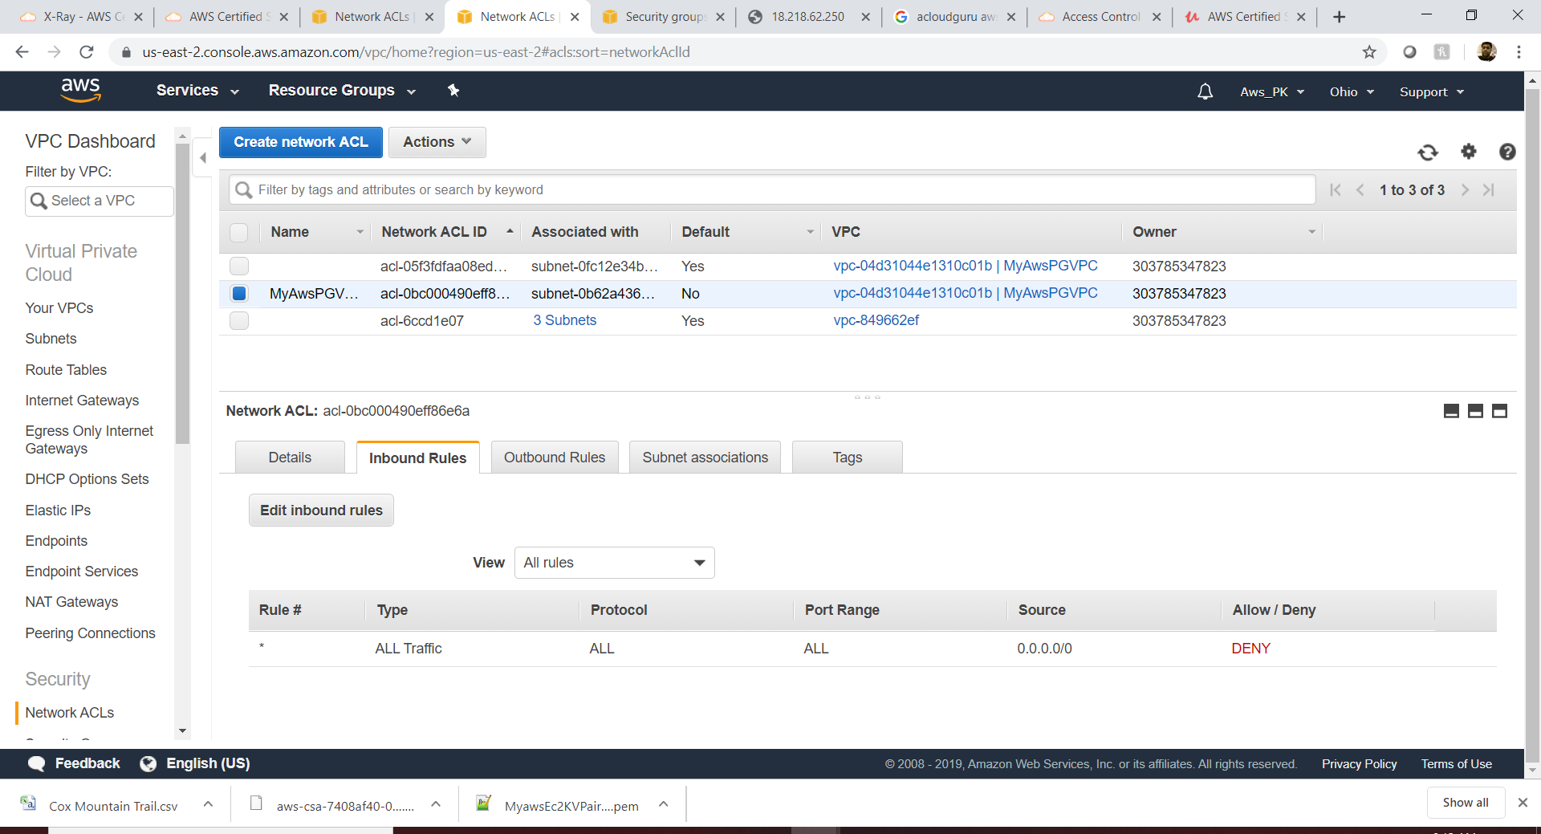

Not connecting

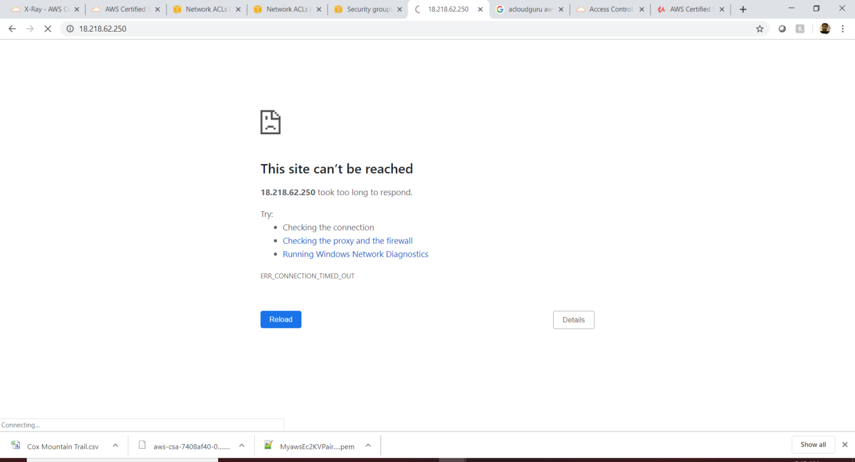

Update the inbound/outbound ports for this NACL.

Note: Have to add the ephemeral port in the outbound as Allow/deny based on the rule#.

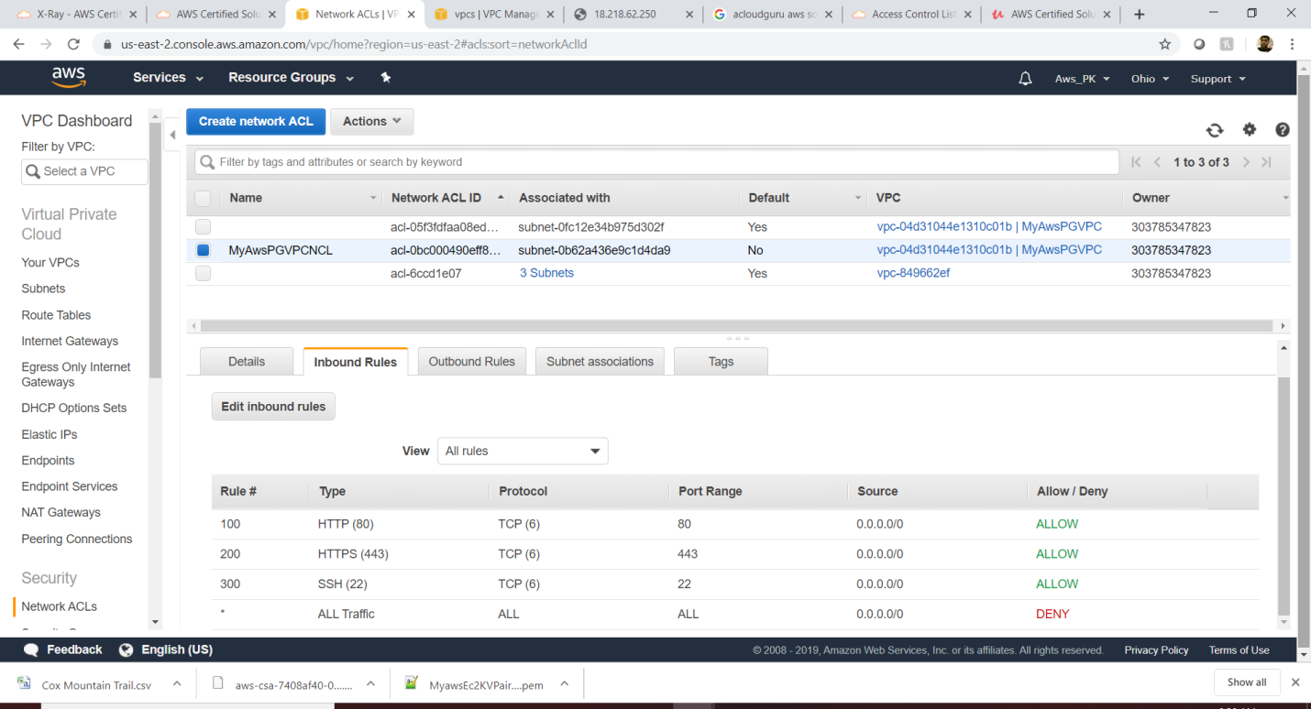

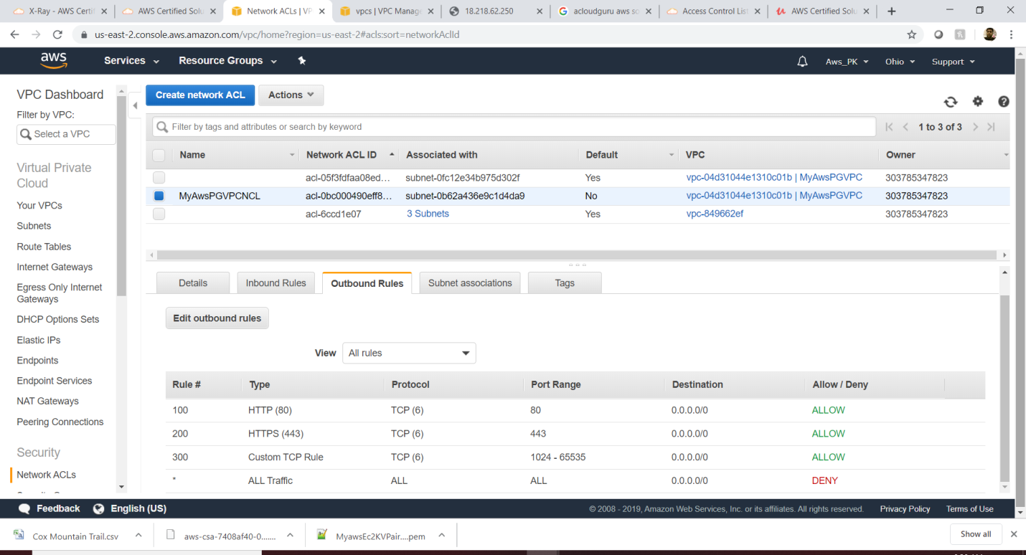

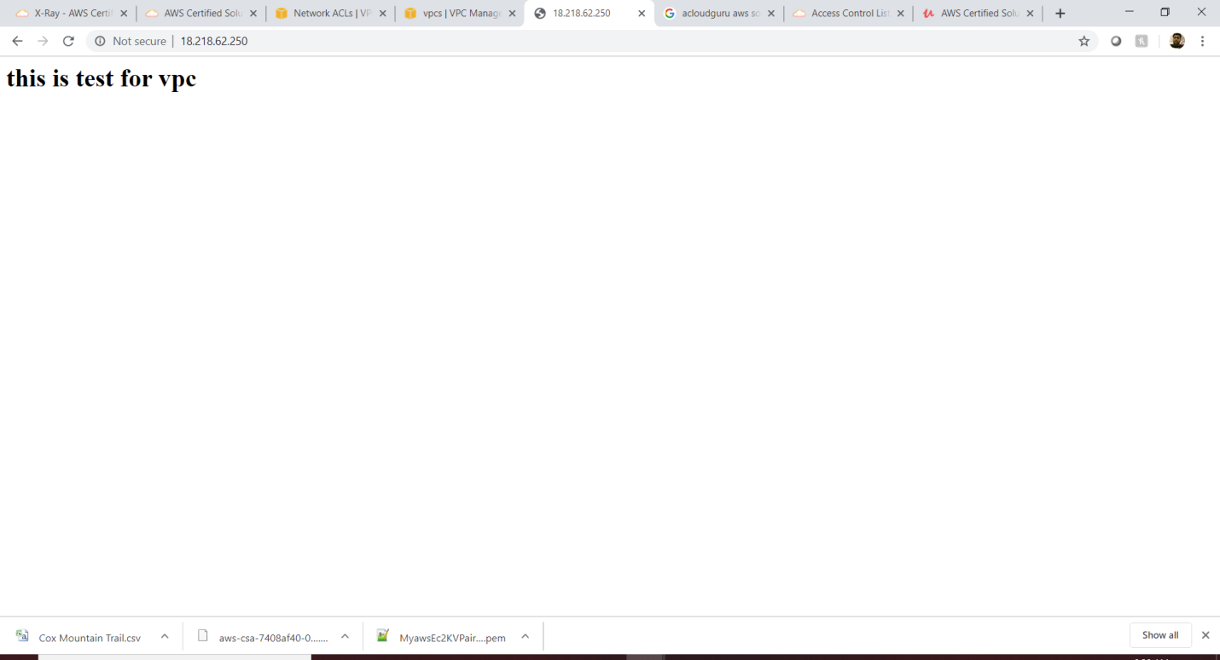

**Note: There is only 1 subnet per A.Z**

**ELB**

[**https://acloud.guru/course/aws-certified-solutions-architect-associate/learn/ec2/8768578c-0510-e435-98ac-beffe33389ab/watch?backUrl=%2Fcourses**](https://acloud.guru/course/aws-certified-solutions-architect-associate/learn/ec2/8768578c-0510-e435-98ac-beffe33389ab/watch?backUrl=%2Fcourses)

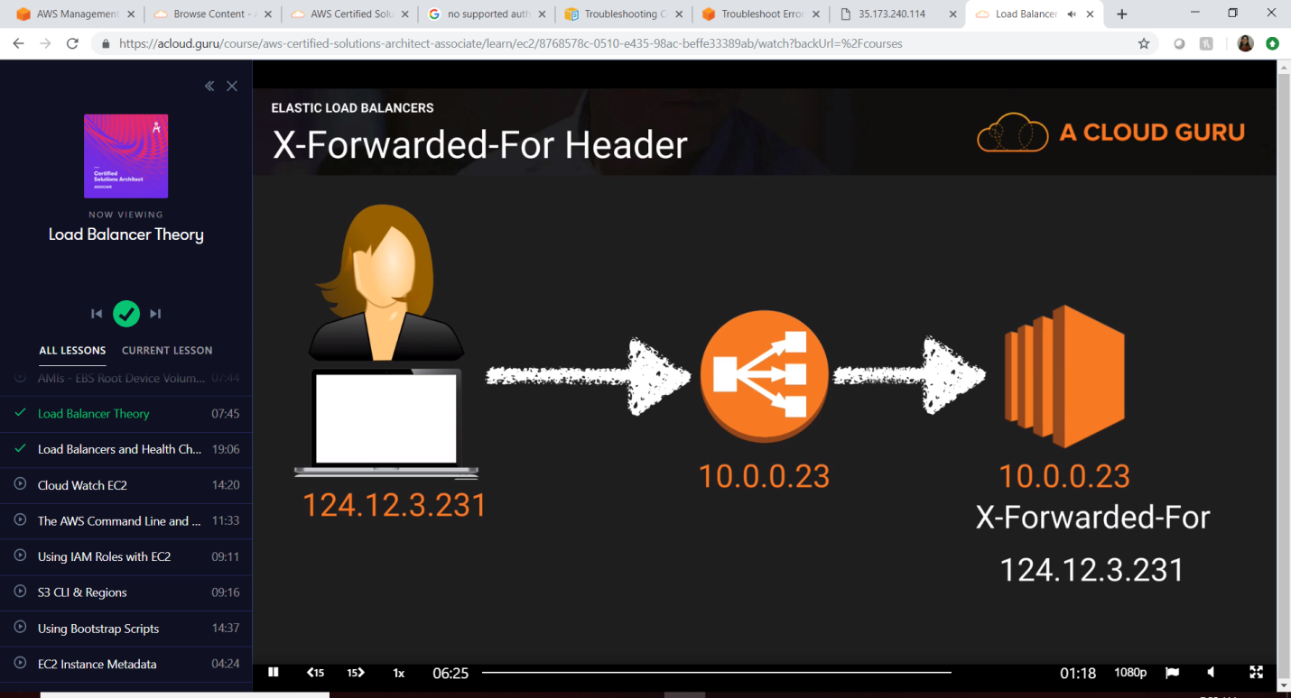

**Create one or more Ec2 instances and make the web server into it.**

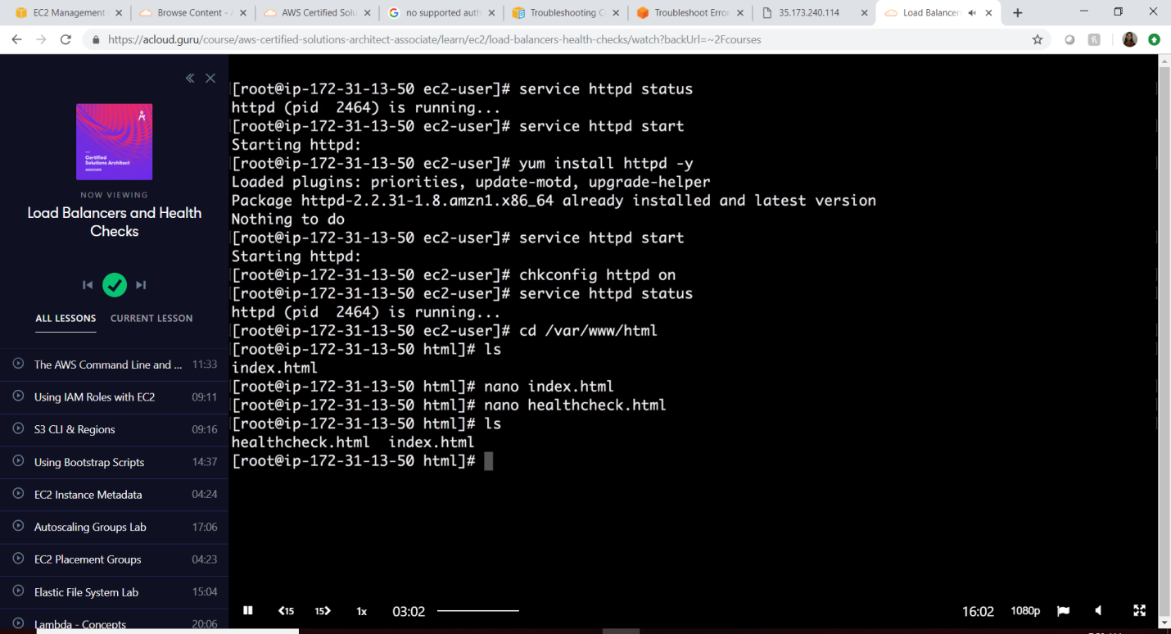

**Classic Load Balancer**

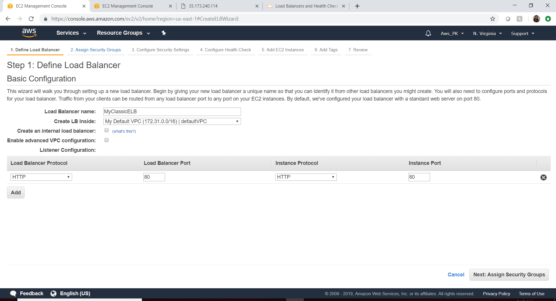

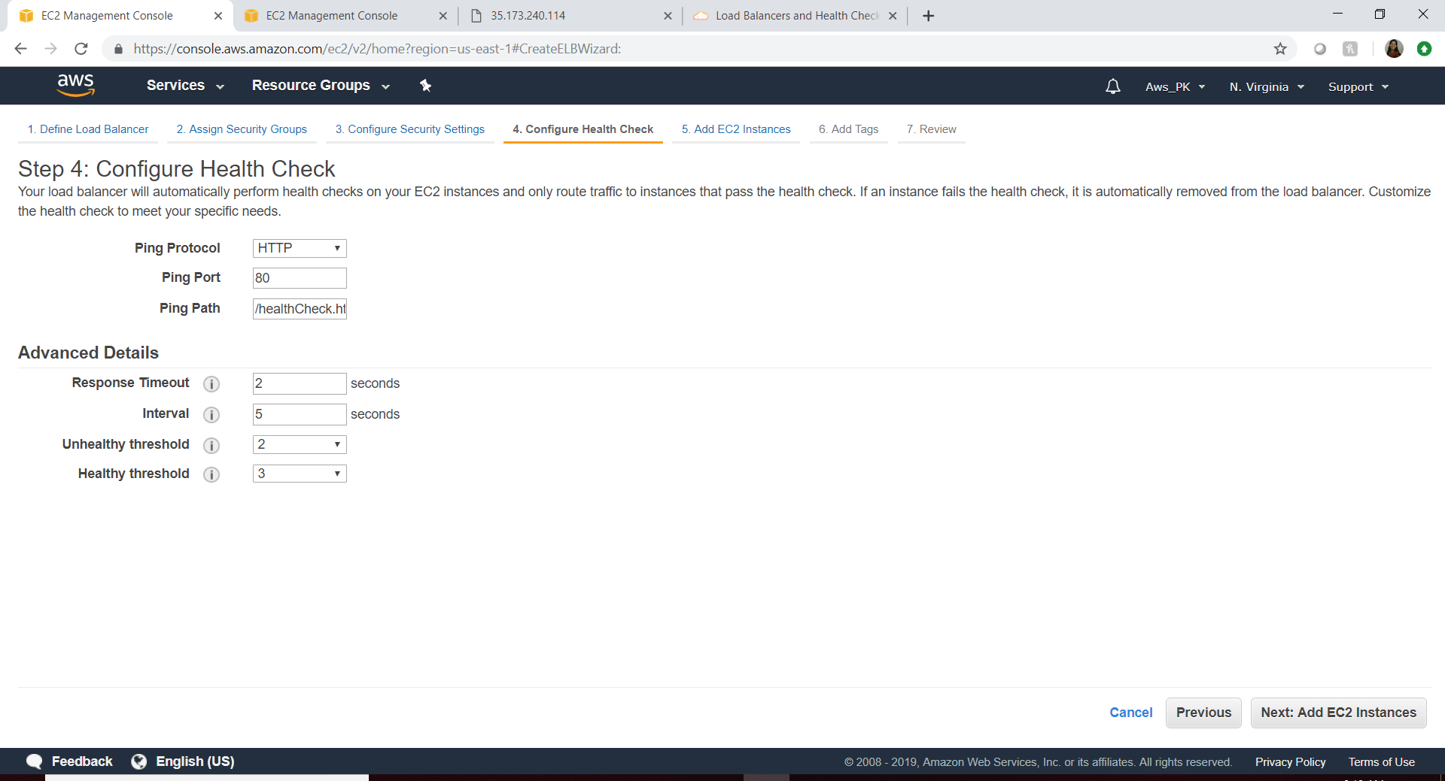

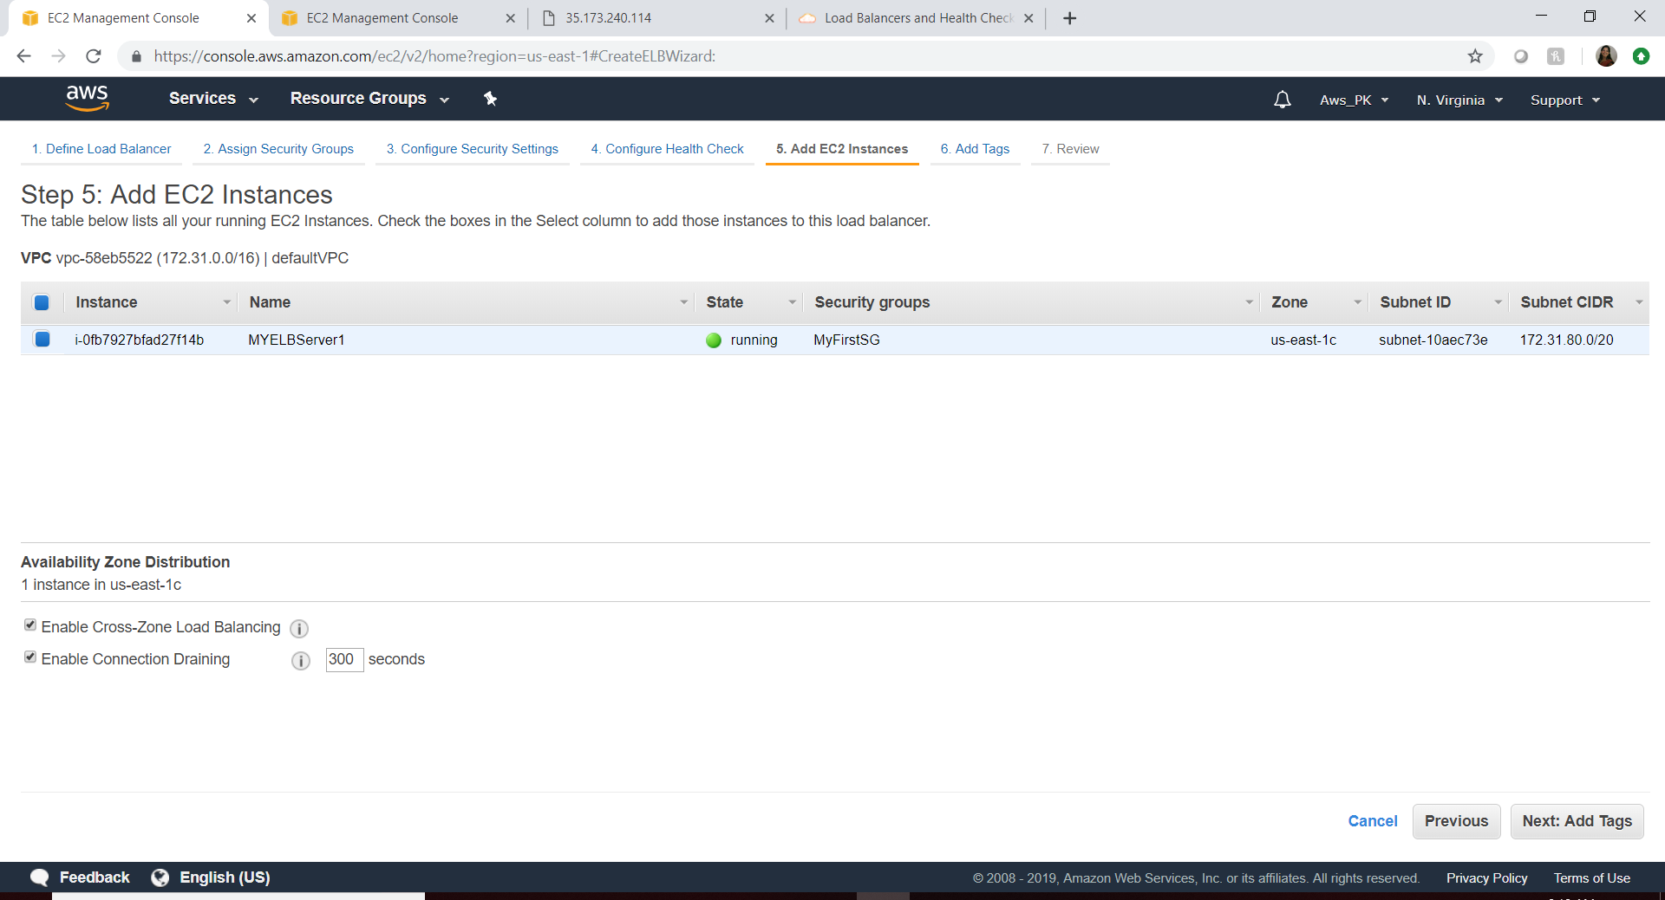

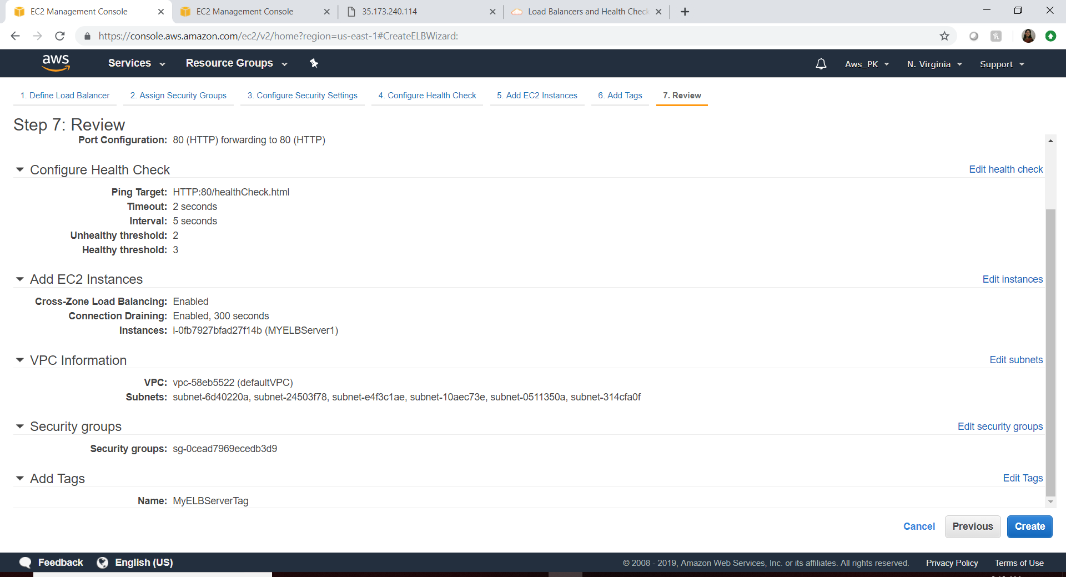

**Main Feature Summary for ELB:**

* **Mapping listeners between the ELB & EC2**
  + **Make sure the EC2 , AZ everything looks valid**
* **EC2 instances**
* **Health Check**
* **Security Group**

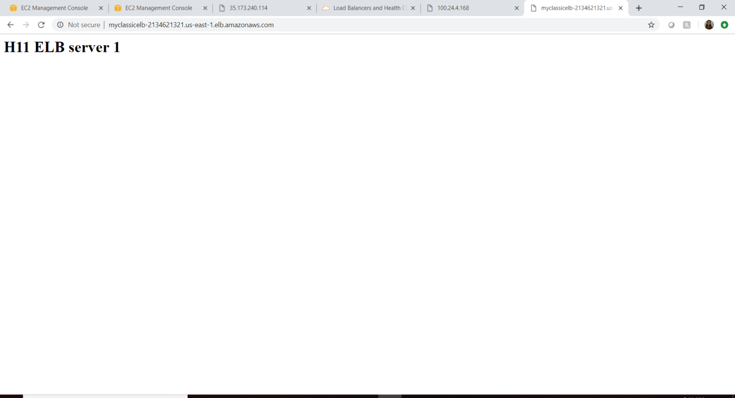

**Remove the healthCheck.html and try again, we will get the error.**

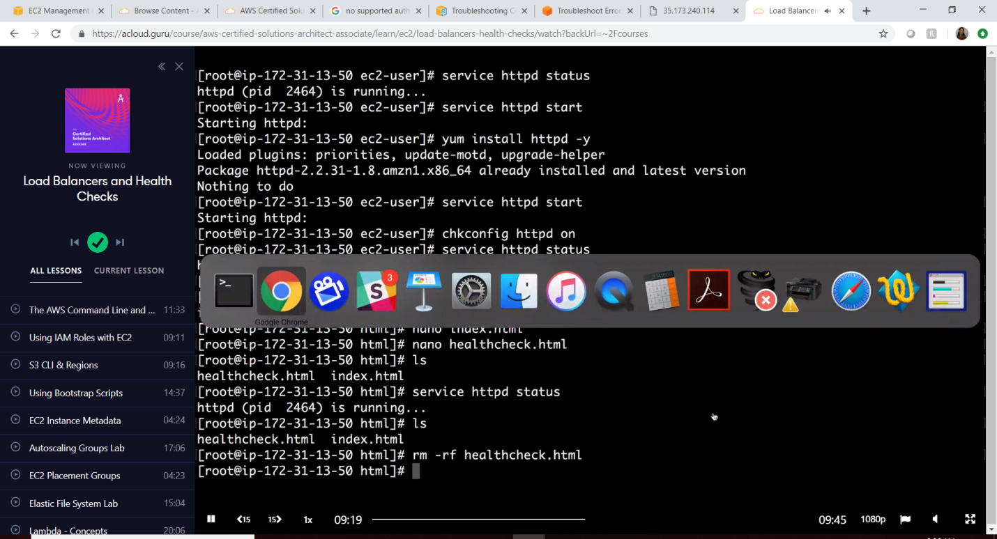

**Application Load Balancer**

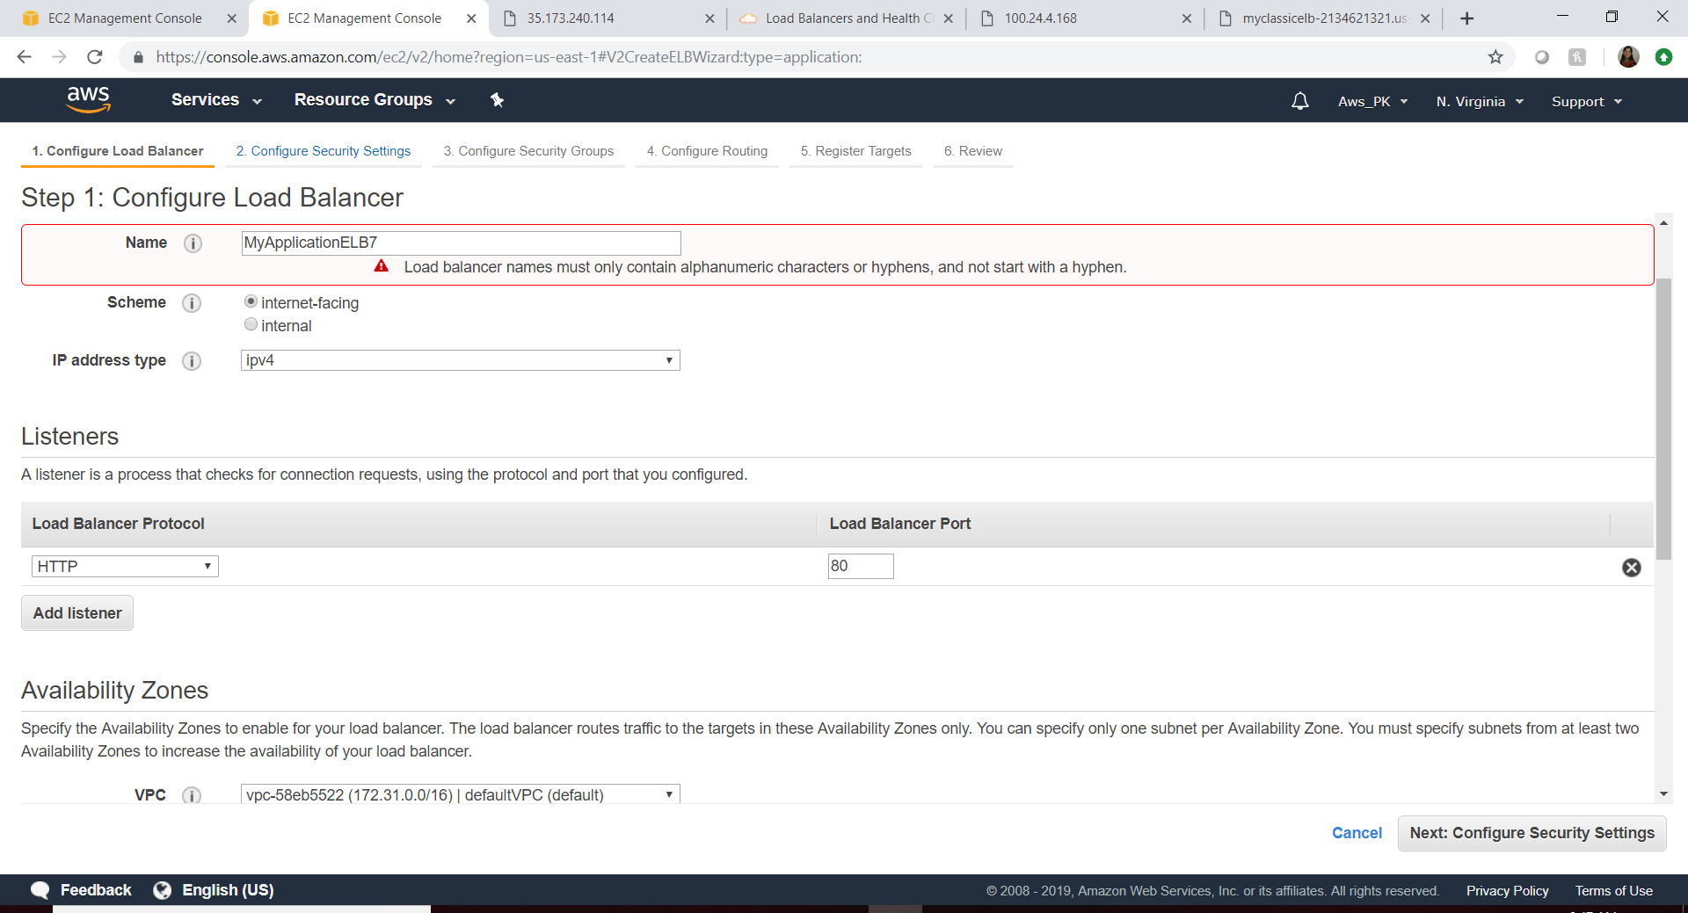

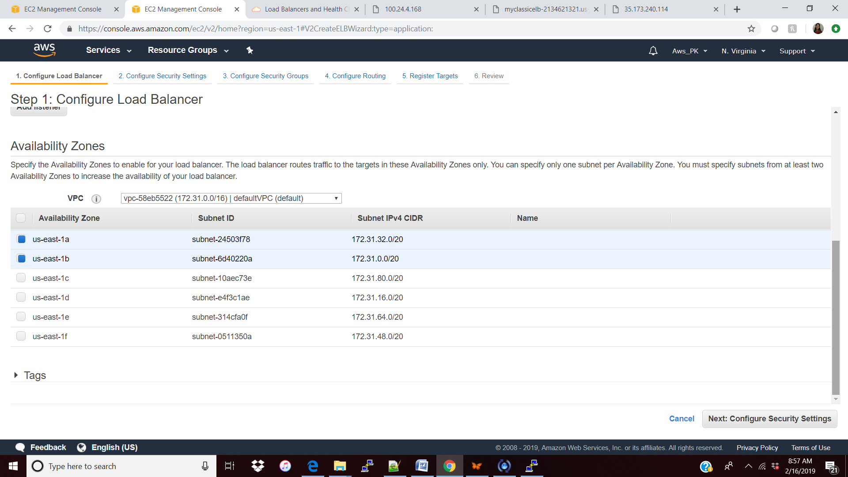

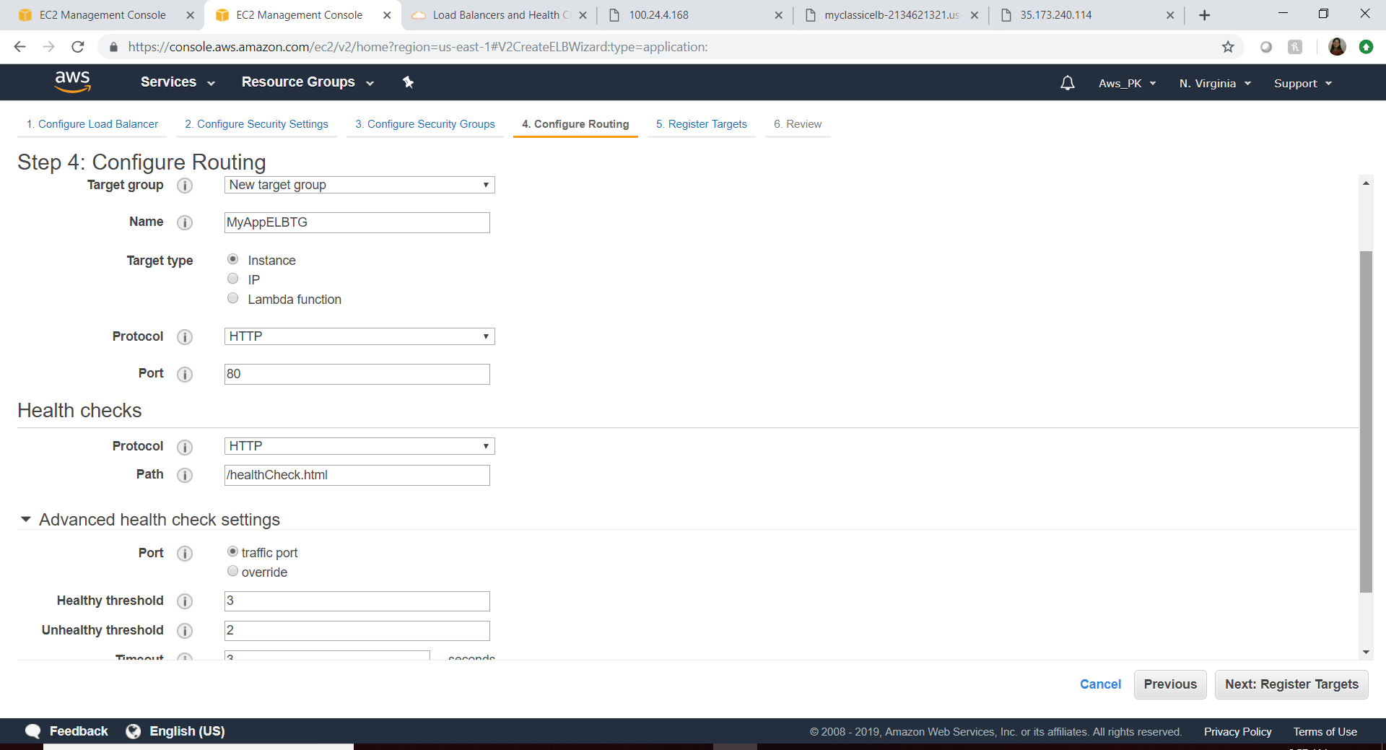

In App LB all the listeners are mapped by Target Group.

We need to have the different port has to be mapped to Target Group (80/8080/443/etc)

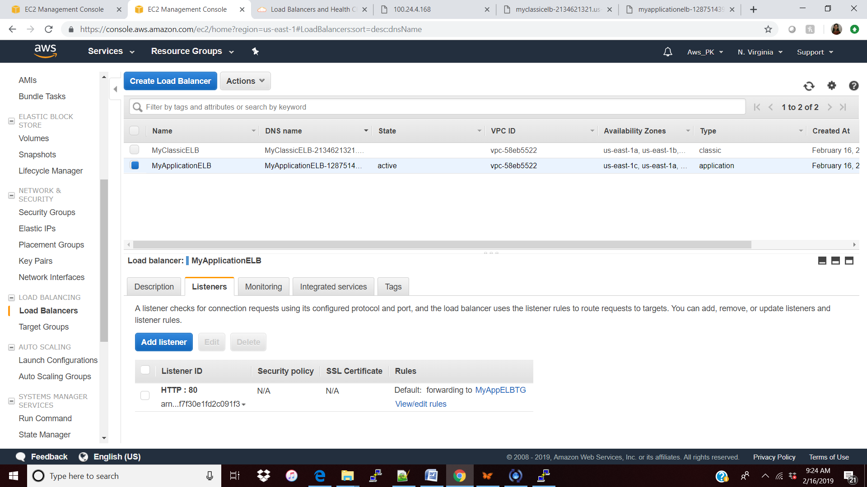

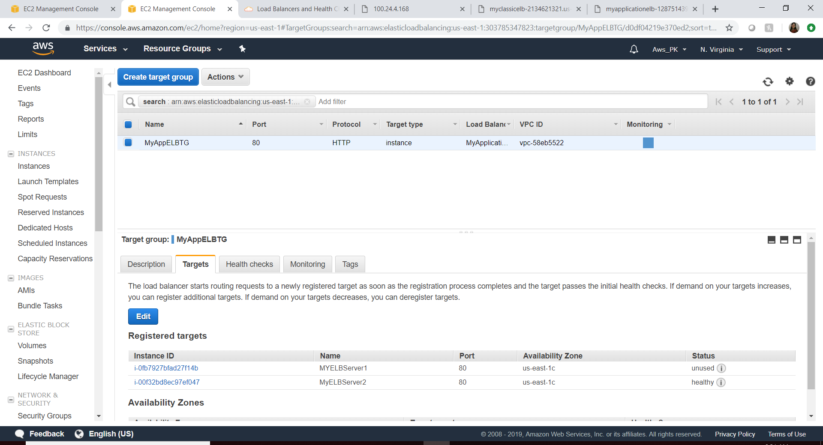

**Note: Application Load balancer can listen to EC2, lambda, IP.**

**Take away: ELB with more than 1 instance.**

**With user session**

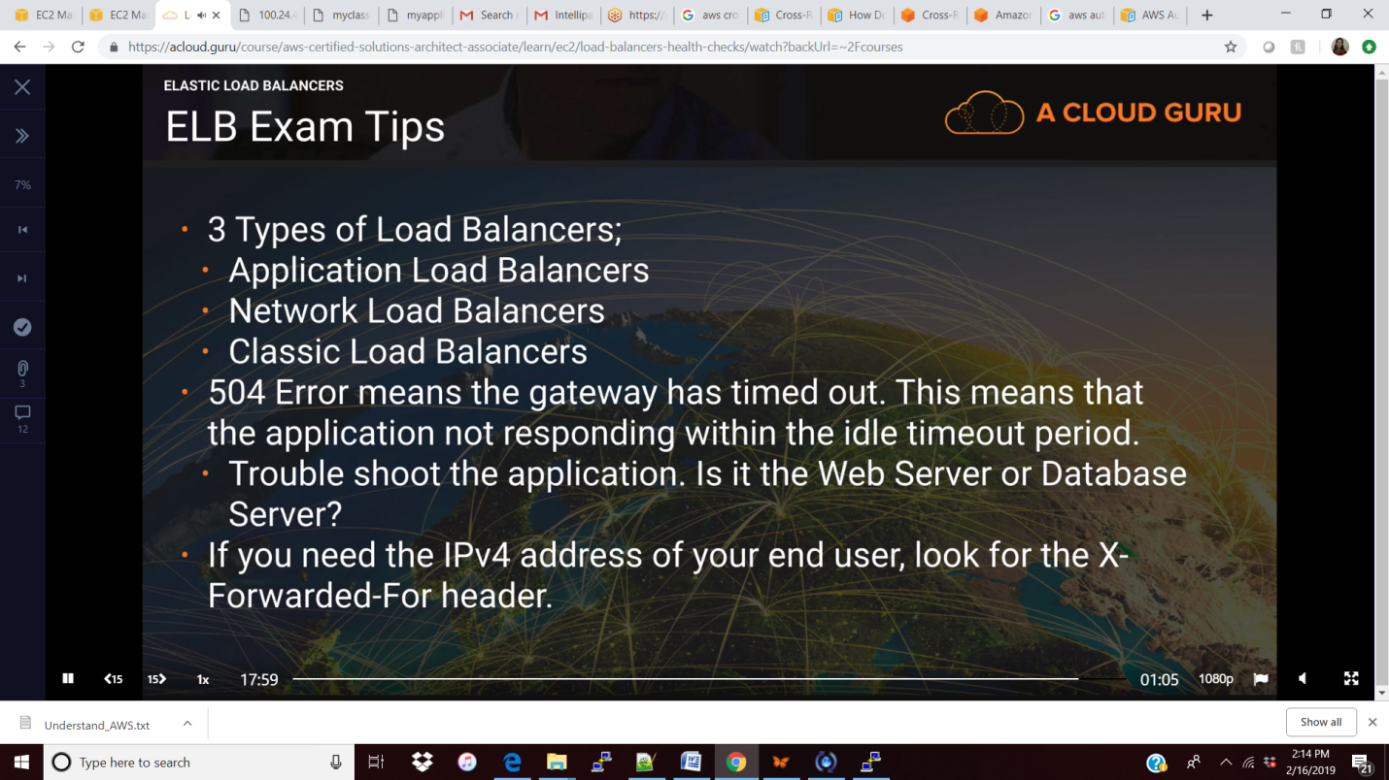

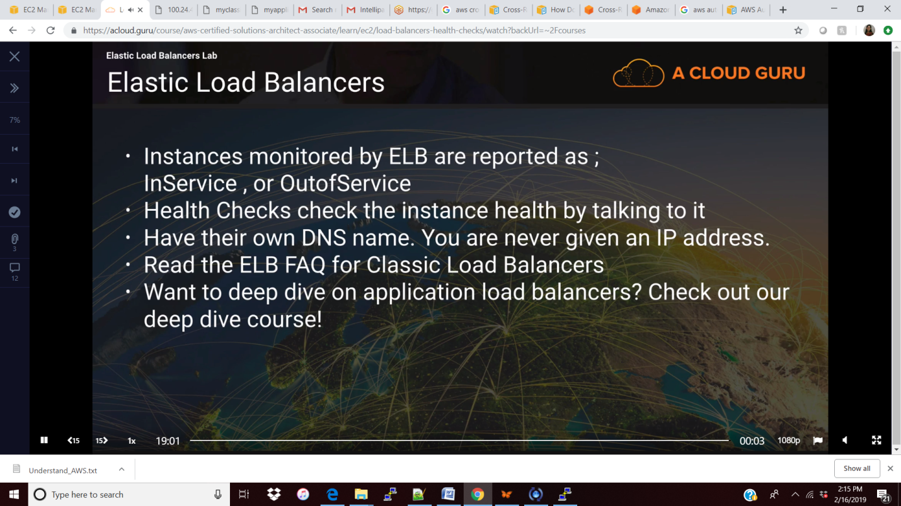

**Auto Scaling**

**What: Auto scaling is used to increase or decrease the instance scaling automatically.**

**Why: to make sure we are not having any downtime in the application.**

**How:**

**Step 1: Create or select the launch configuration.**

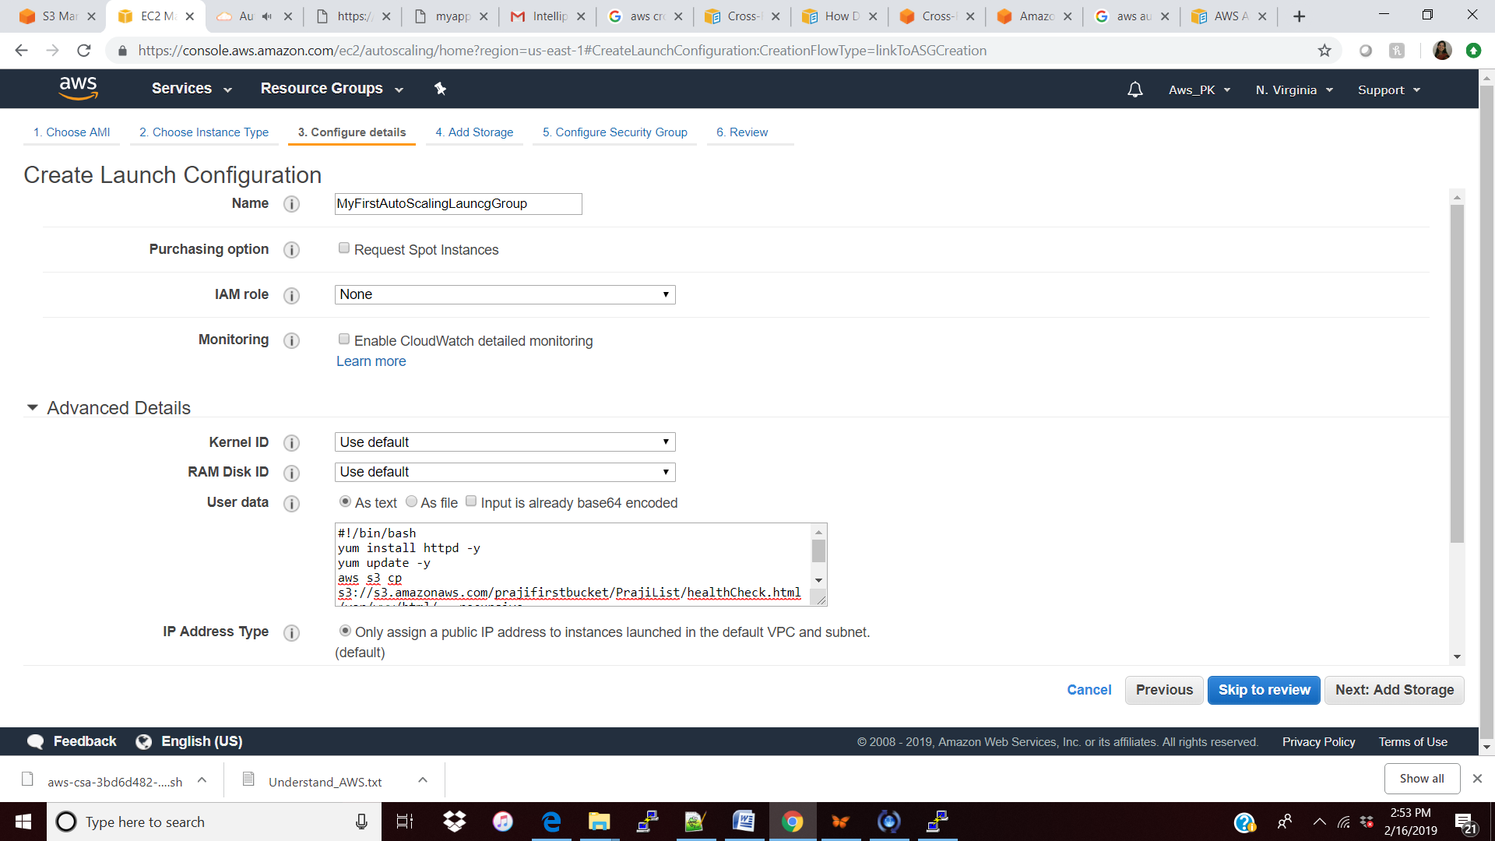

**Step 2: Create Auto scaling group**

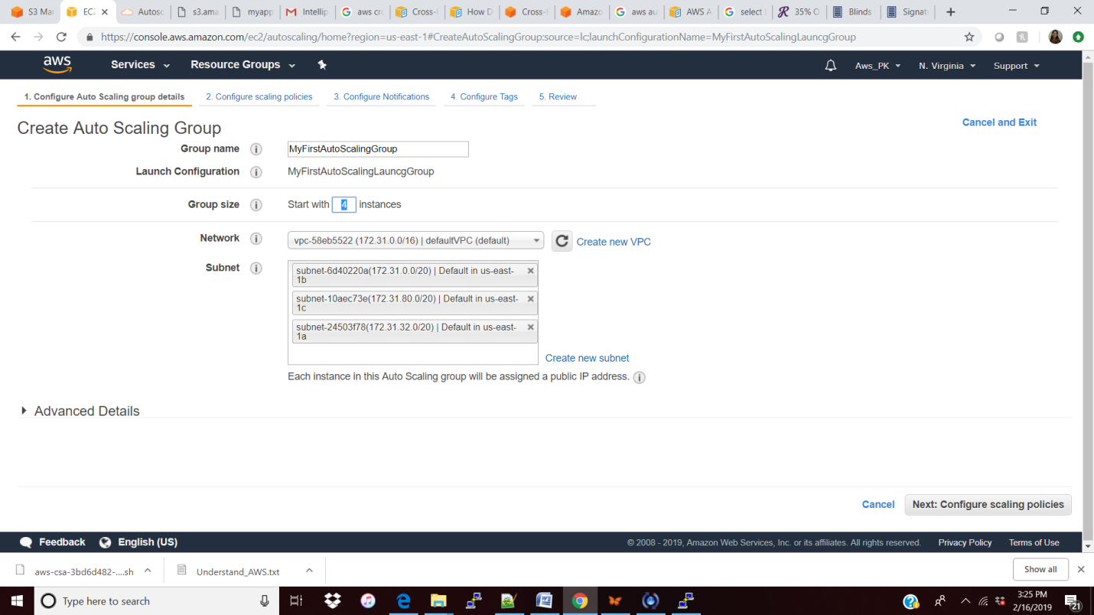

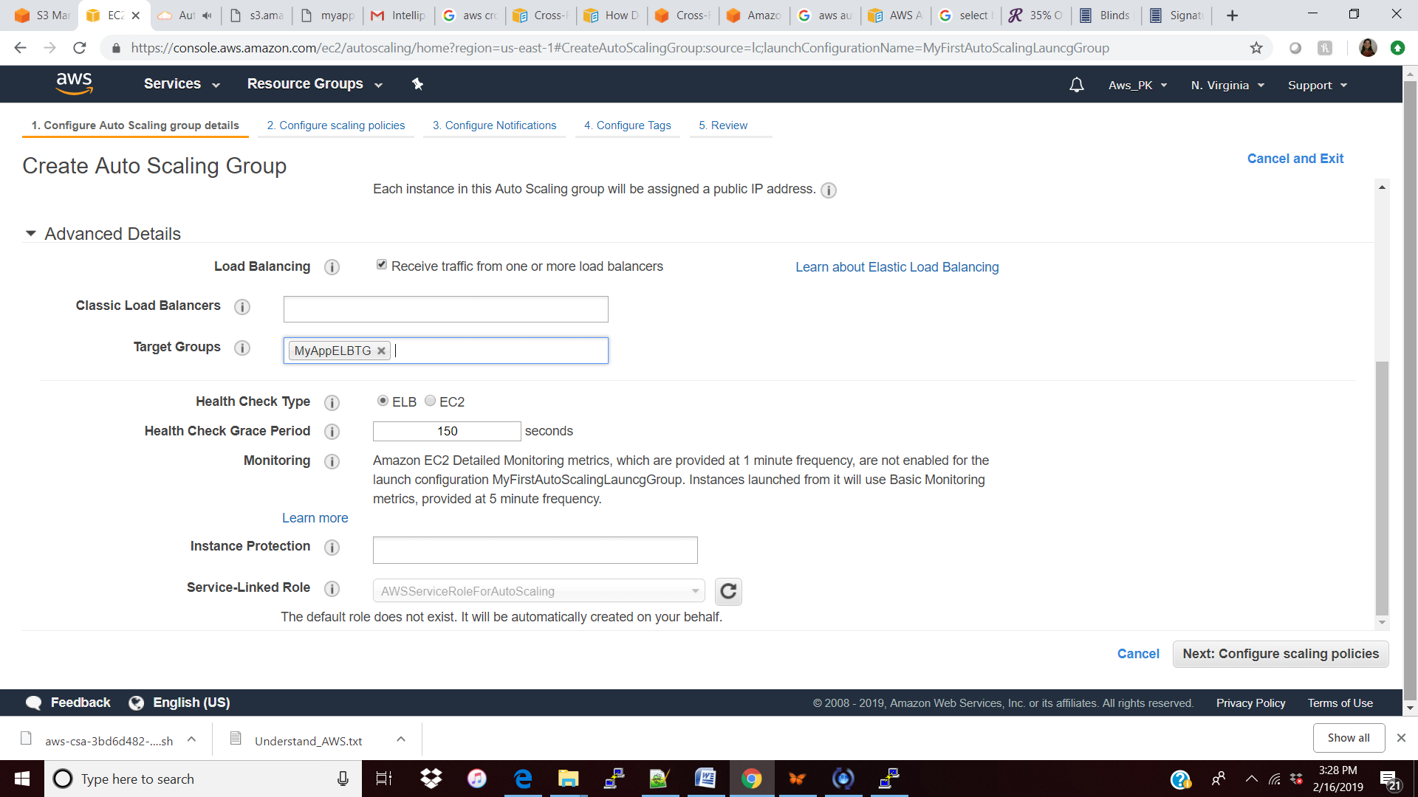

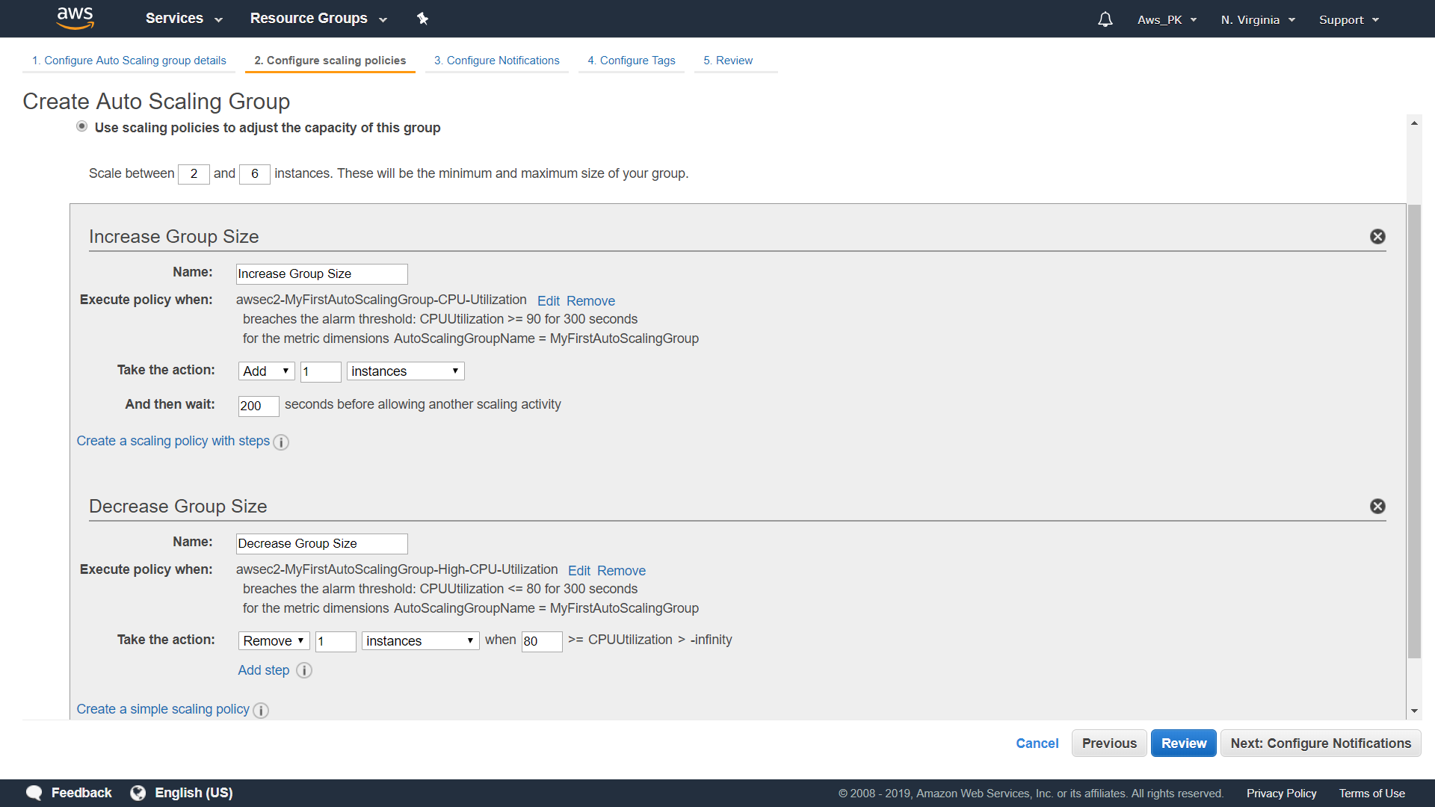

**Failed:**

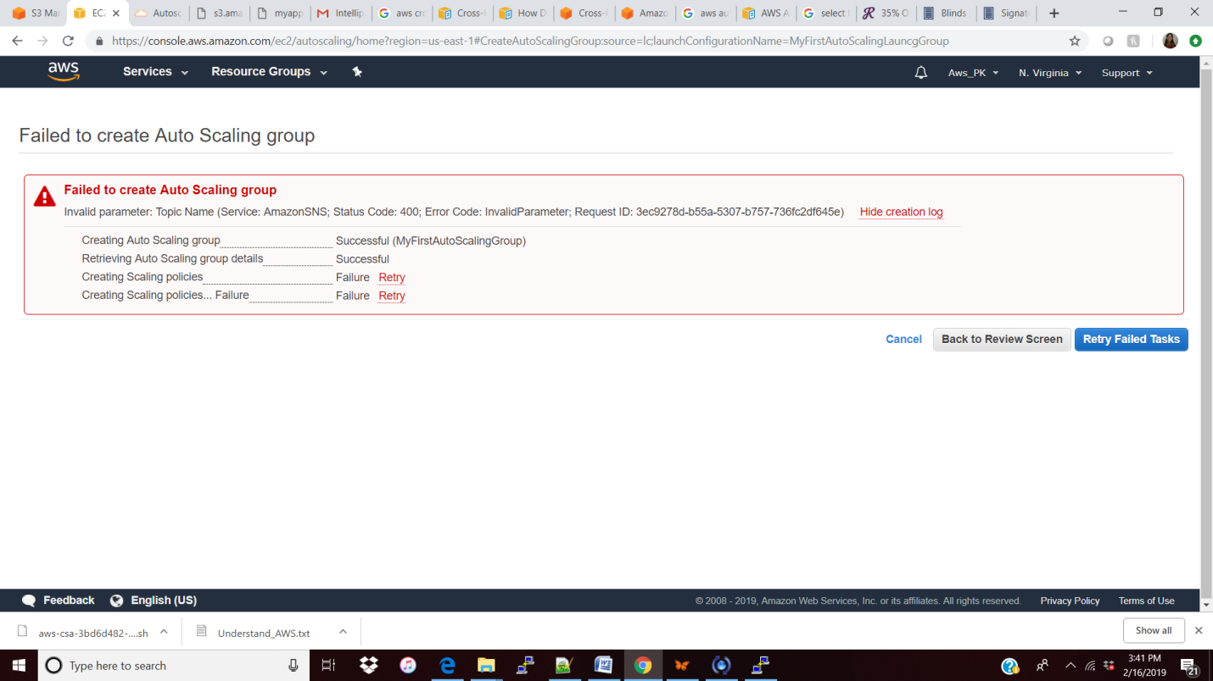

**Removed the notification and it worked , the reason is I have configure the SNS successfully yet.**

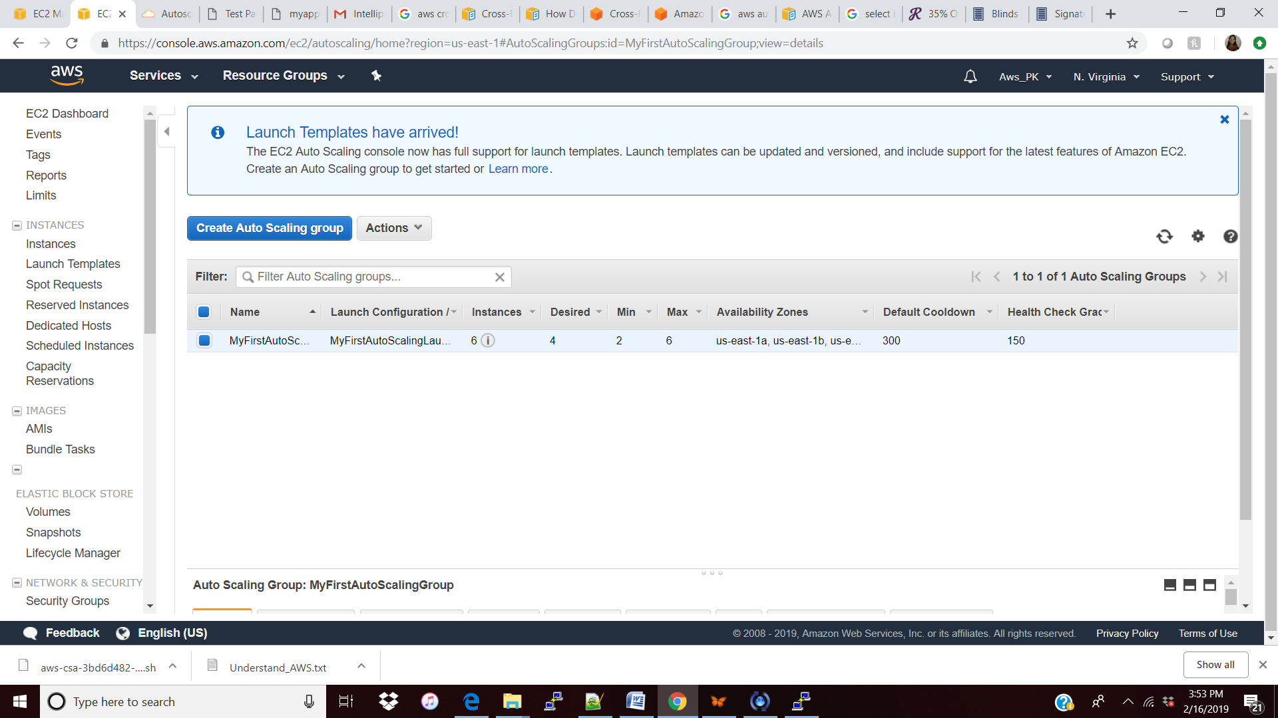

**Four instance got created when I stopped 2 instance again 2 more instance created automatically.**

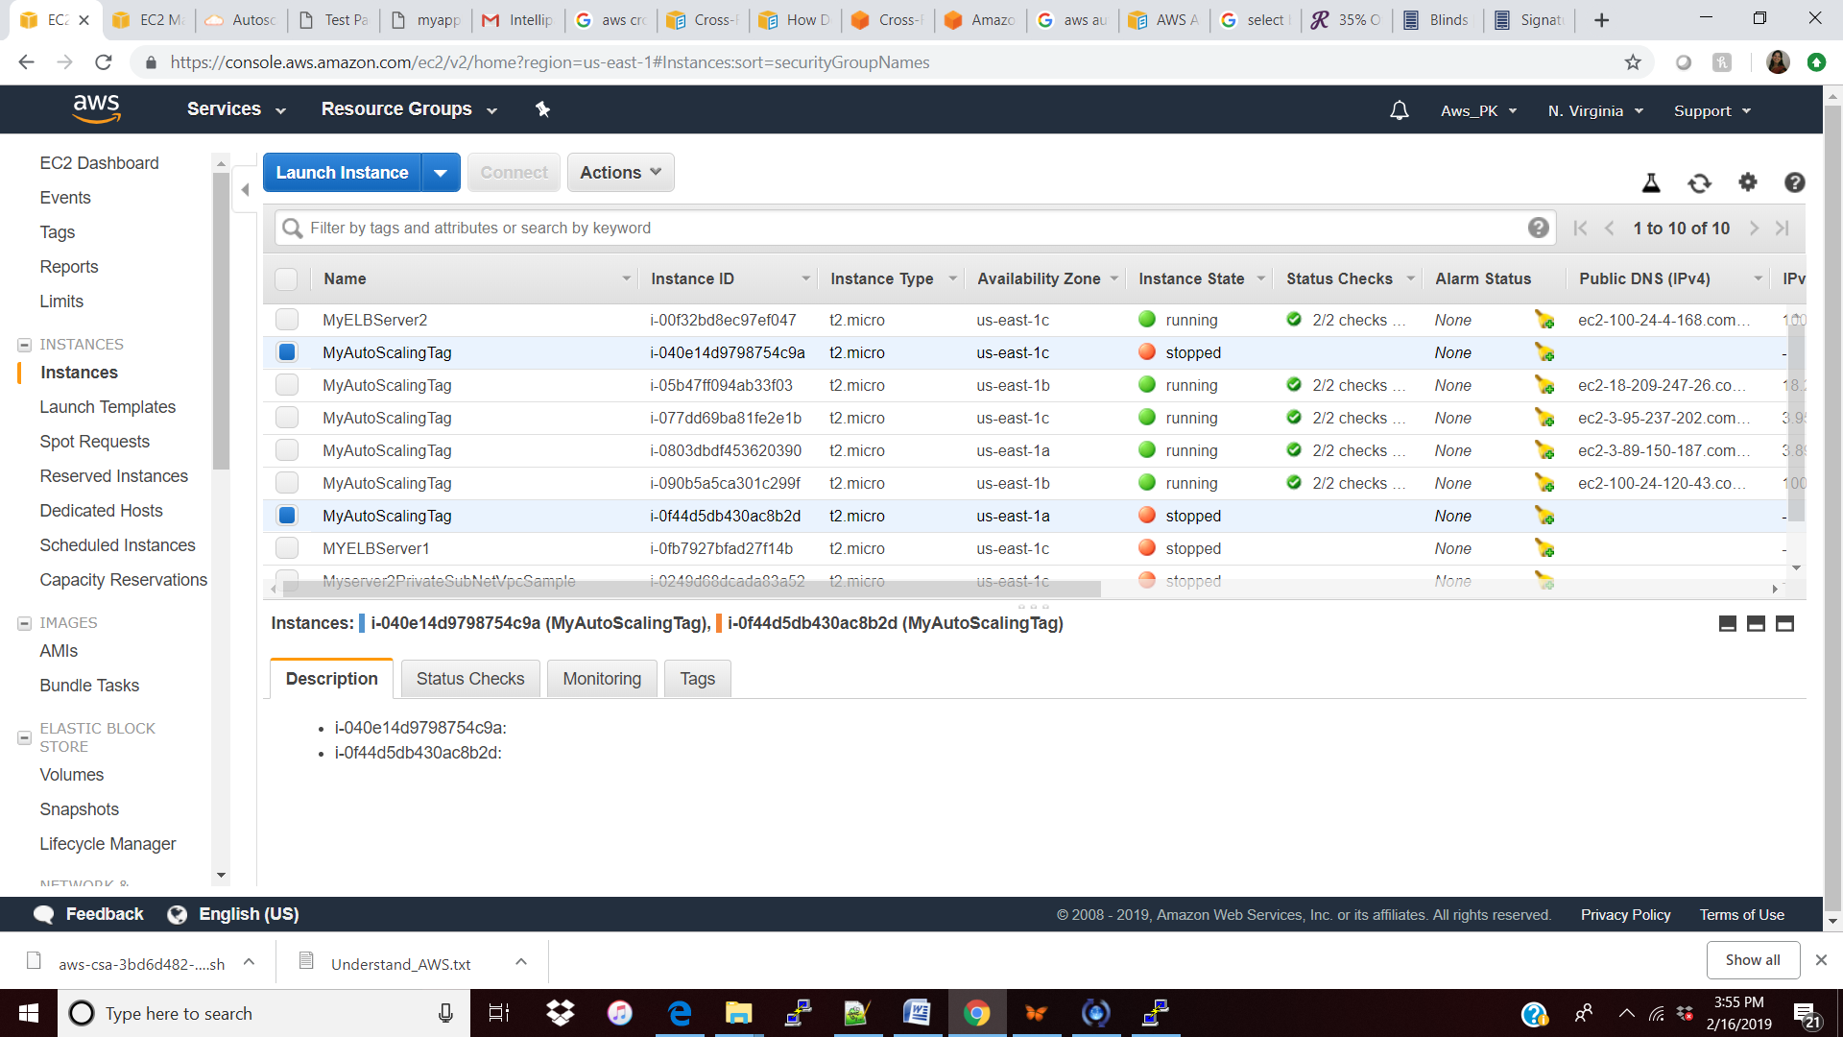

**Increase: when I select 2 insatnce its throws error because the configuration is more than 5 ( 4+2=6) so its not allowing me to start itself , if I start one its allowing, see below**

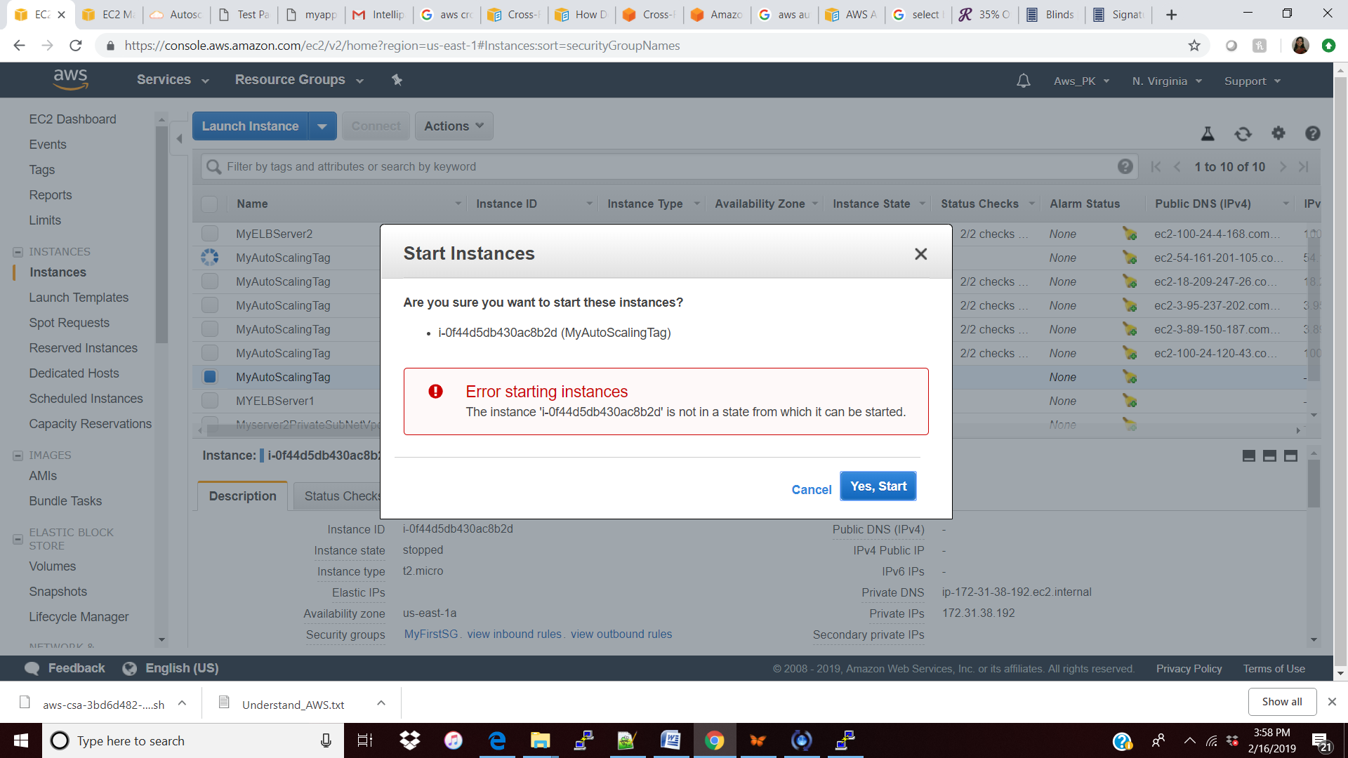

**So totally 5 instances**

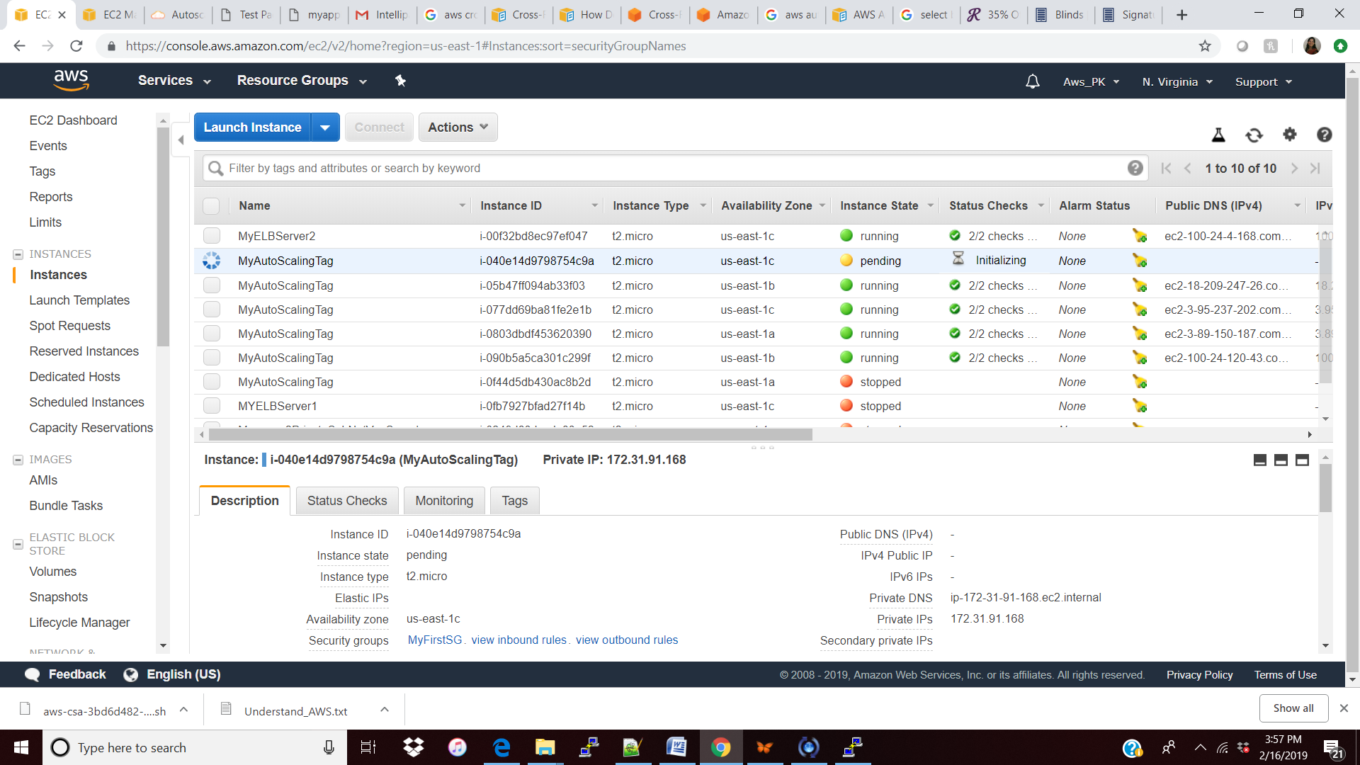

**After sometime where the CPU is less utilization then reducing the instance here actually terminated.**

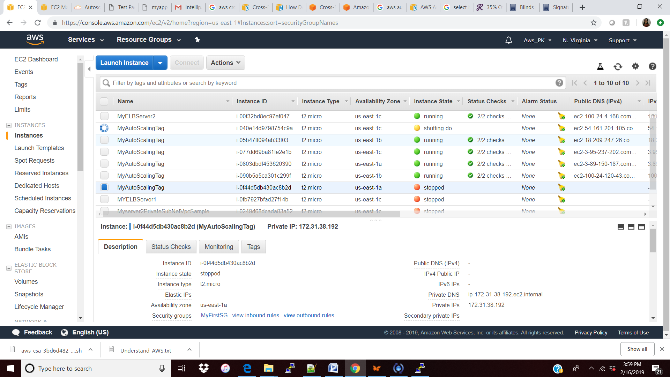

Cloud Watch:

What: is to **monitor** what is going on in the environment either CPU/RAM/Network utilization etc.

Why: to get the feel/ troubleshooting/ALARM etc.

How:

Features:

Dashboard: to create the dashboard and monitor how the resource (CPU/Disk/Network/Graphics)

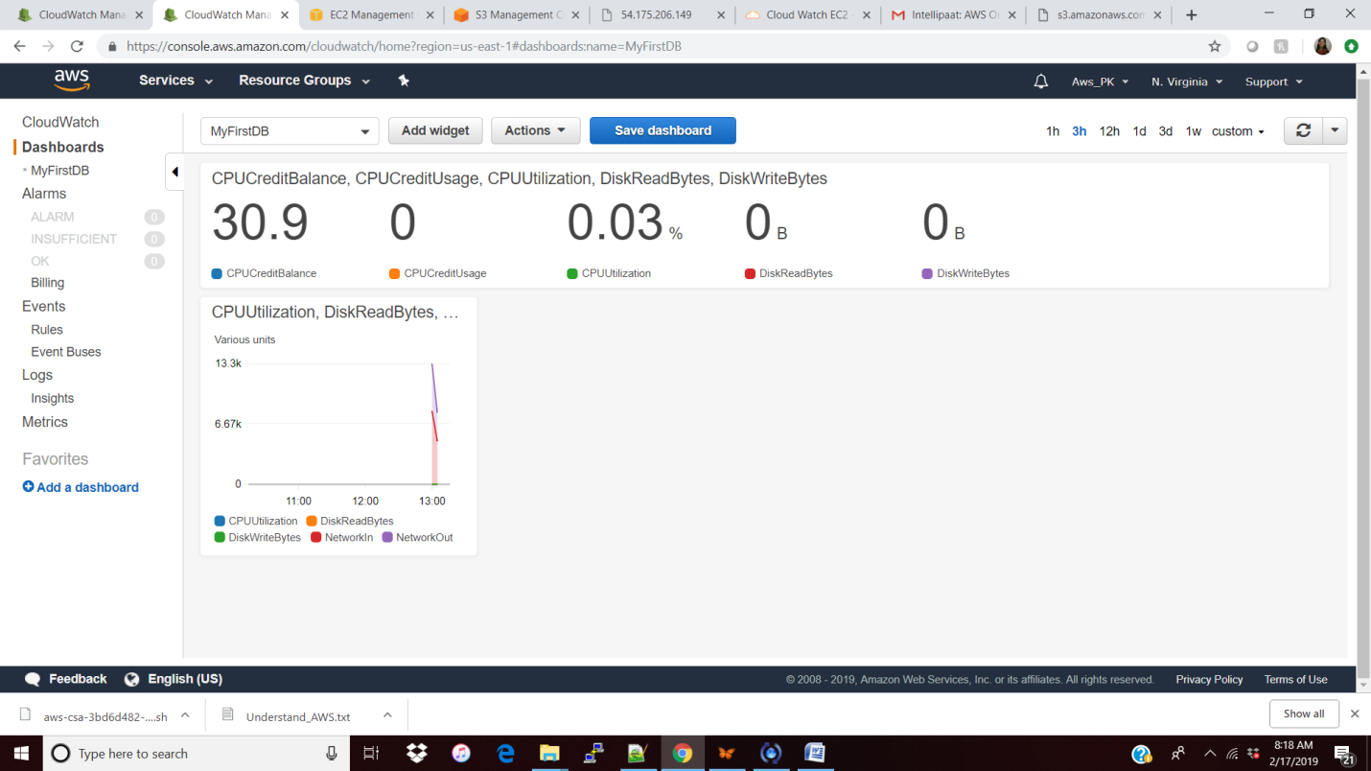

Alarm: to react based on some threshold hit.

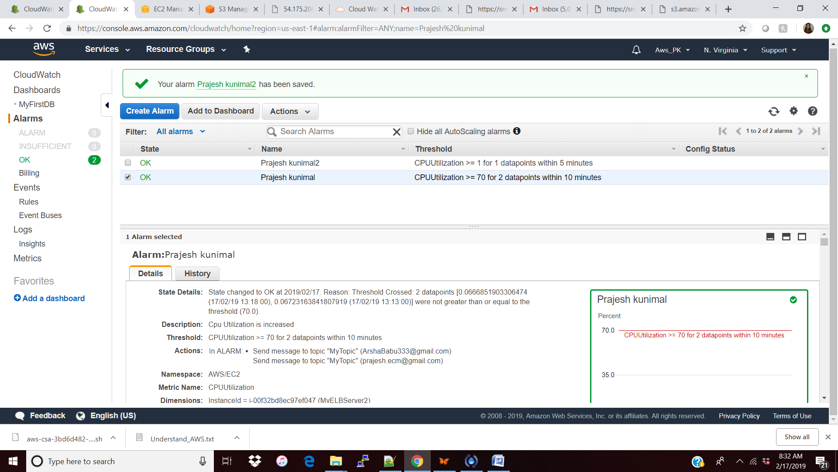

Events: to monitor all the state change for AWS resources. Let Say my EC2 instance is changing the state then I will get the notification to myTopic. This event is configured in many places/events Ec2/ to Topic/SMS/Lamba/

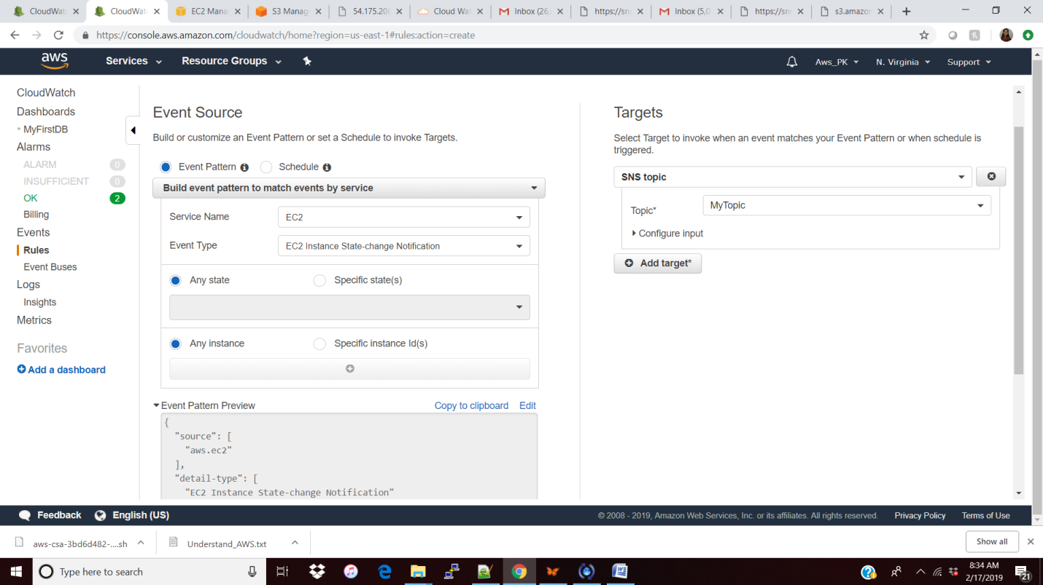

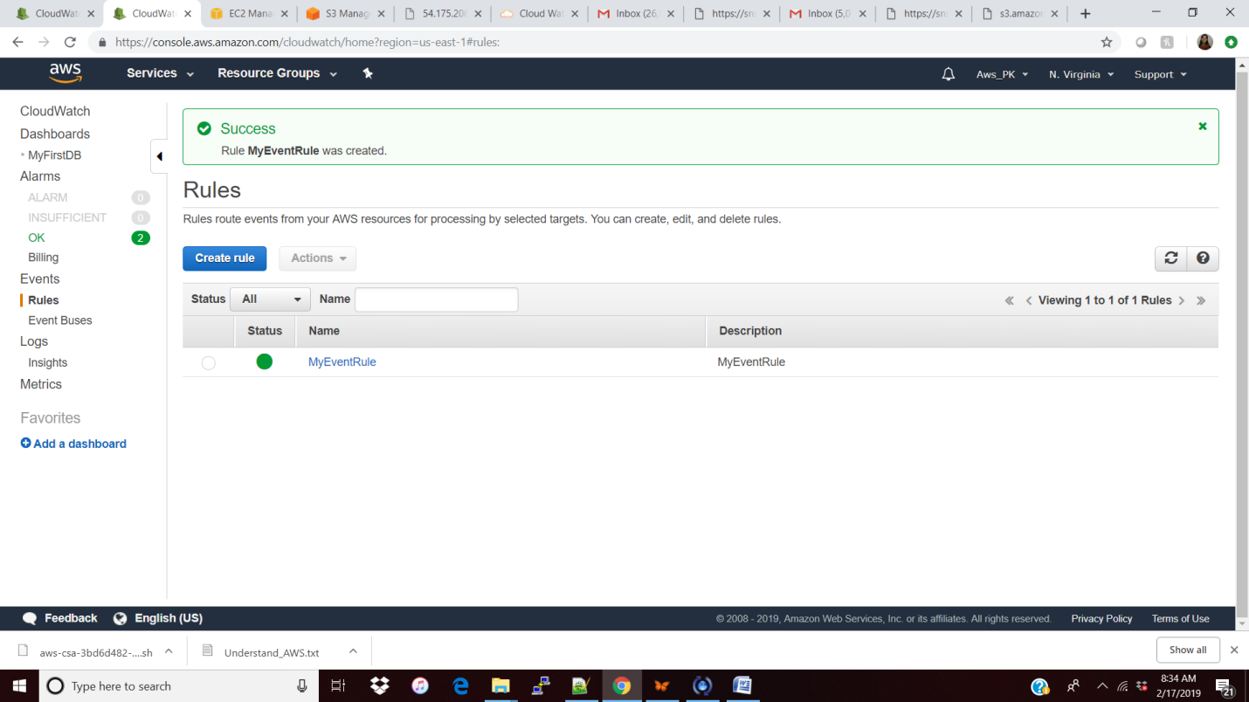

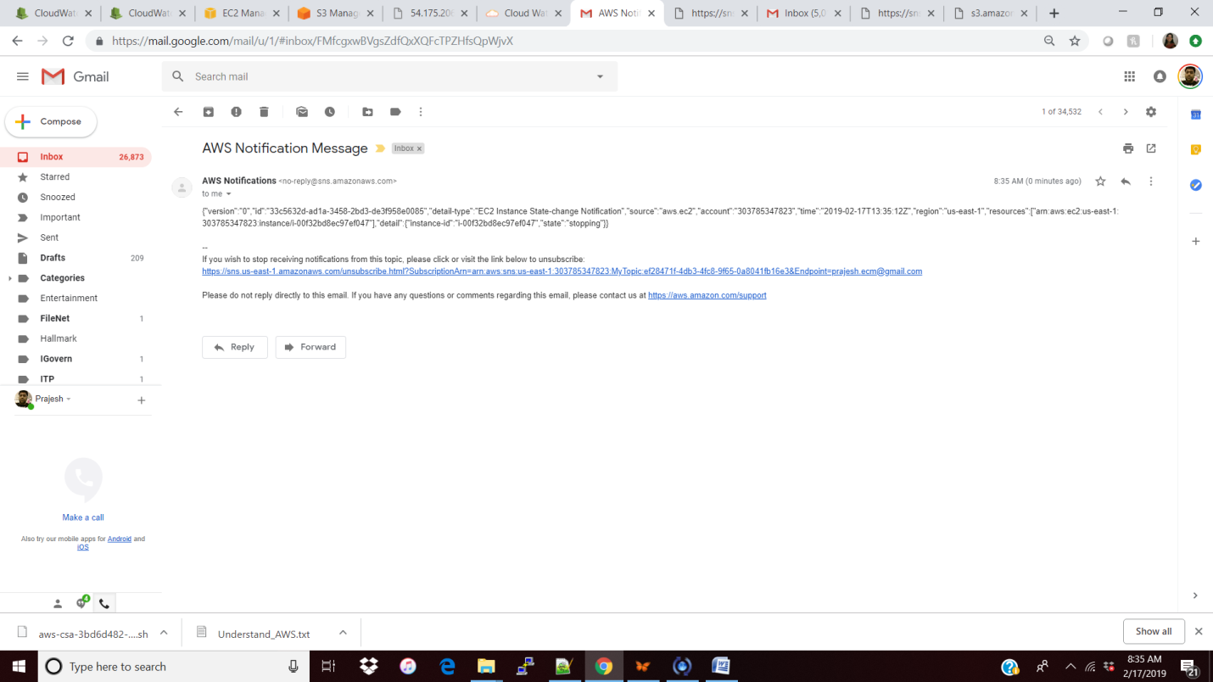

Logs (install Agent): sudo yum install -y awslogs / sudo service awslogs start / sudo systemctl start awslogsd

Metrics:

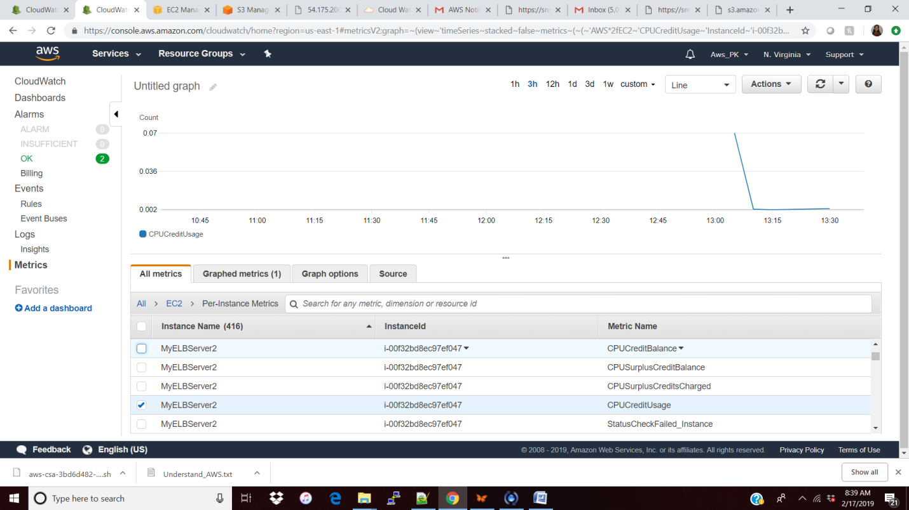

Note:

**Custom Metrics**: we can also do some custom metric apart from the out of box metrics let say we need to monitor the RAM usage that also we can do but we need to customize our metrics.

Cloud trail: will be used for **audit trailing** where as cloud watch is to monitoring the environment with all the above features.

Other services which we can implement cloud watch (ELB/Ec2/S3/EBS/VPC)

You need to save the dashboard/rule/Alarm else will be lost.

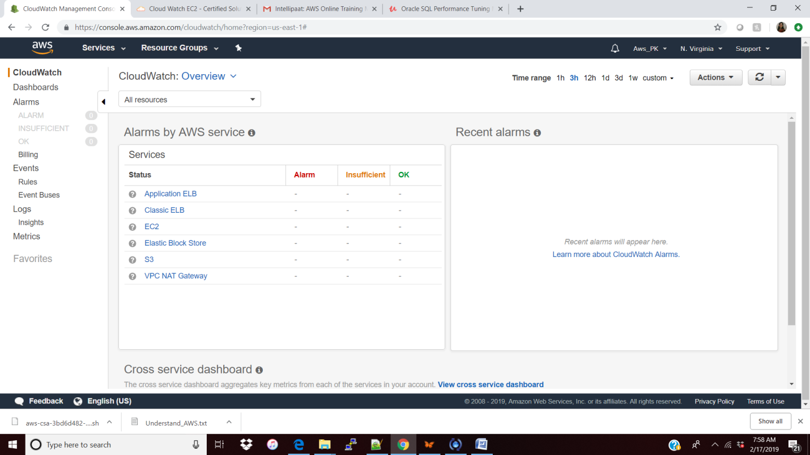

**EFS (Elastic File System)**

This is a shared network where we can place the file as object and access across the multiple A.Z EC2. The main difference between the EFS and EBS is EBS has to be in same A.Z where EC2 exists like CPU and motherboard has to be in same place for better latency. But EFS can supply or share across different A.Z/Subnet but with same security group.

Below EFS created in three different subnet.

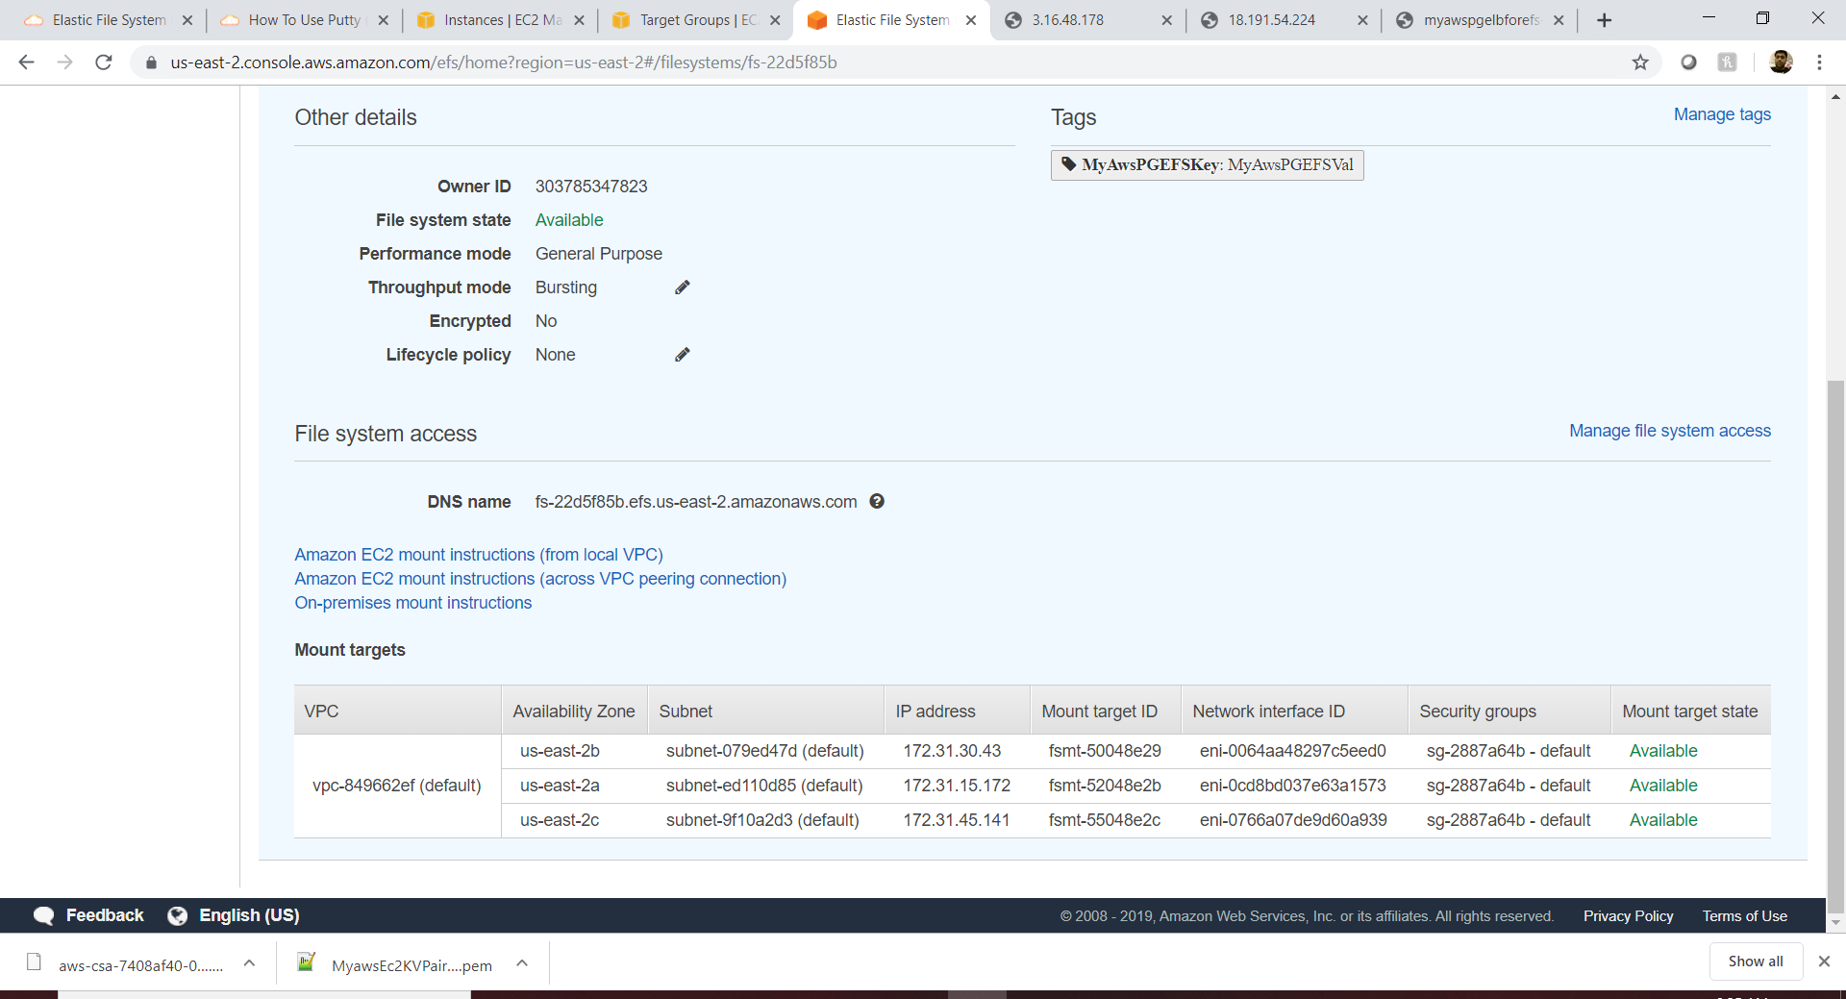

Step 3 : Mount EFS to my ECS var/www/html directory

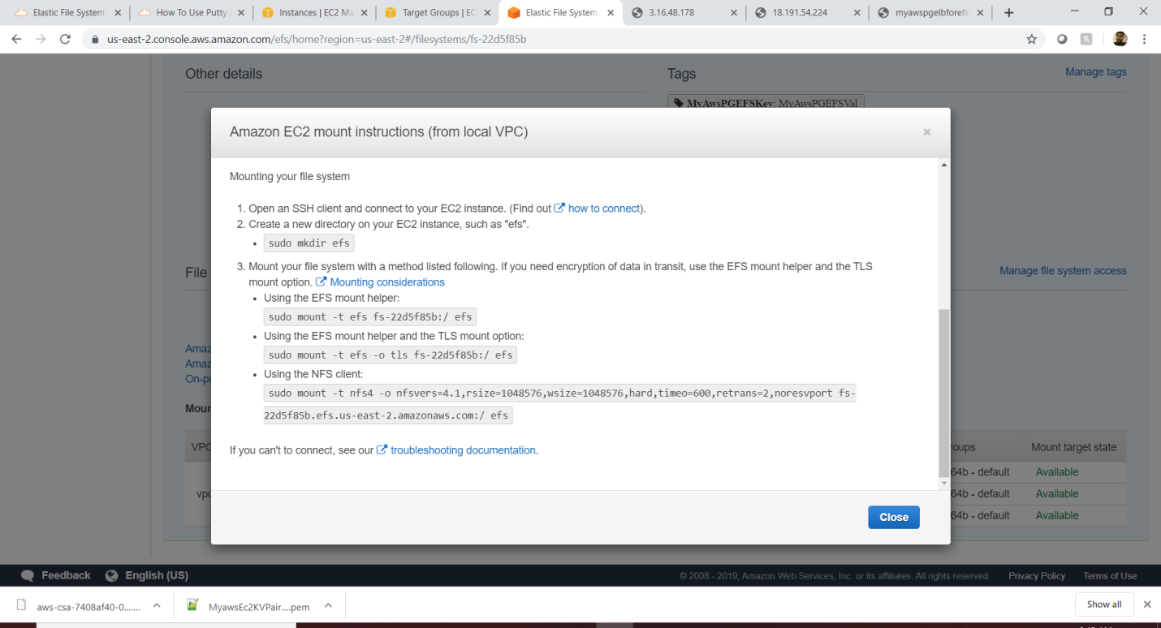

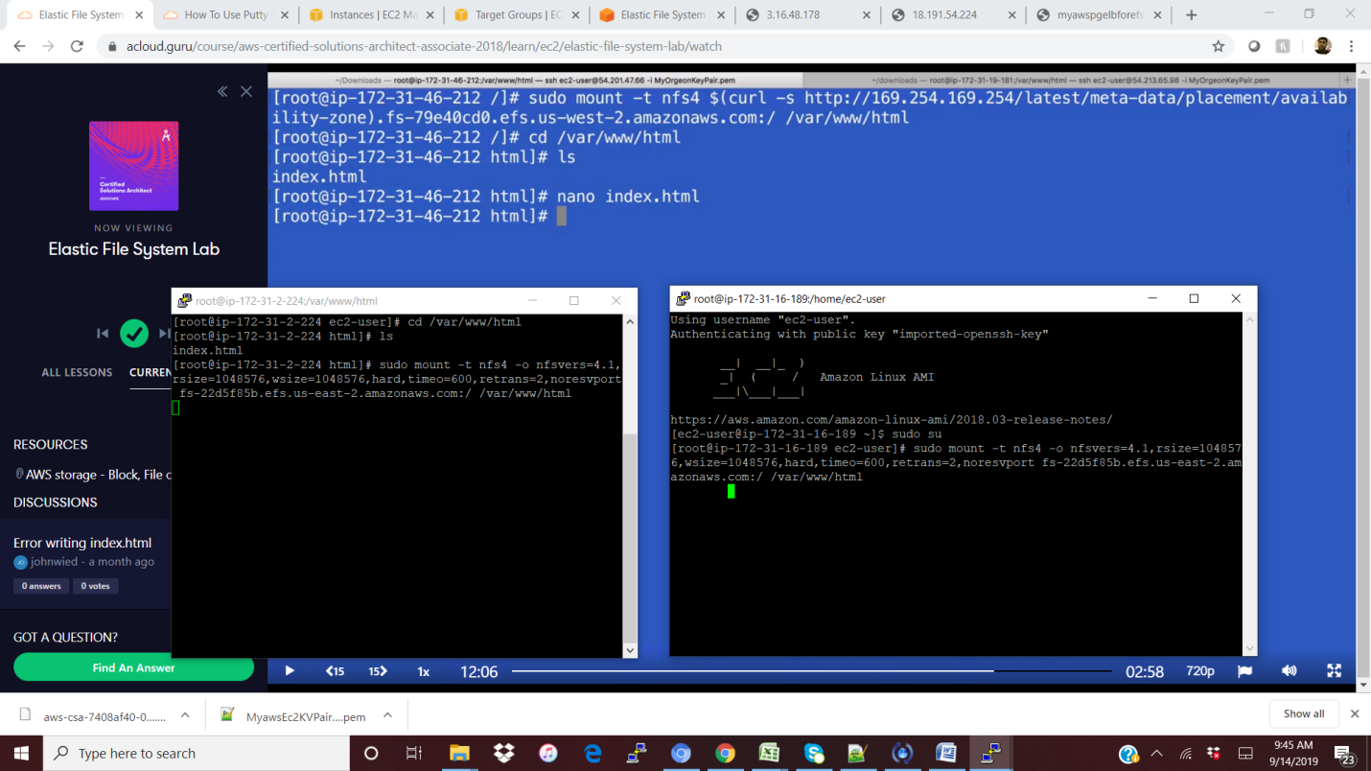

Add file in one of the mounted EC2 and it will get accessed from the other one as well.

Note: Make sure all Ec2 and EFS are in same security group.

**S3 (Simple Storage Service)**

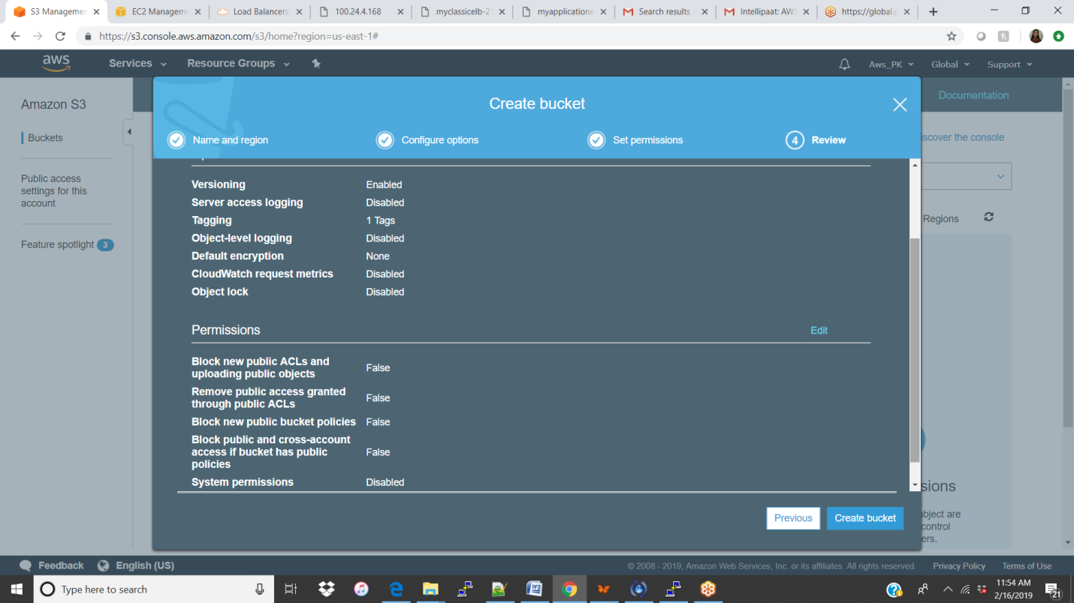

To view the documents in the S3 we have to give the public for both folder and files.

<regionName>/s3/folder/filename.

<https://s3.amazonaws.com/prajis3test/prajifolder/UnderStand_YourKit.txt>

**Static Webpage:**

Just add 2 index page in the bucket and hit the URL (<http://prajis3test.s3-website-us-east-1.amazonaws.com/>) <bucketName.s3-website-<regionName>

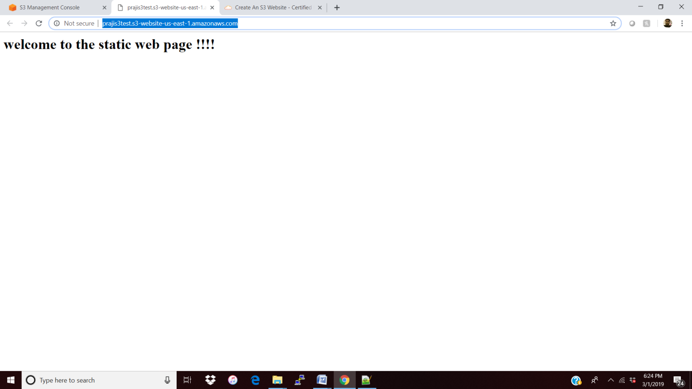

**If I deleted the index.html**

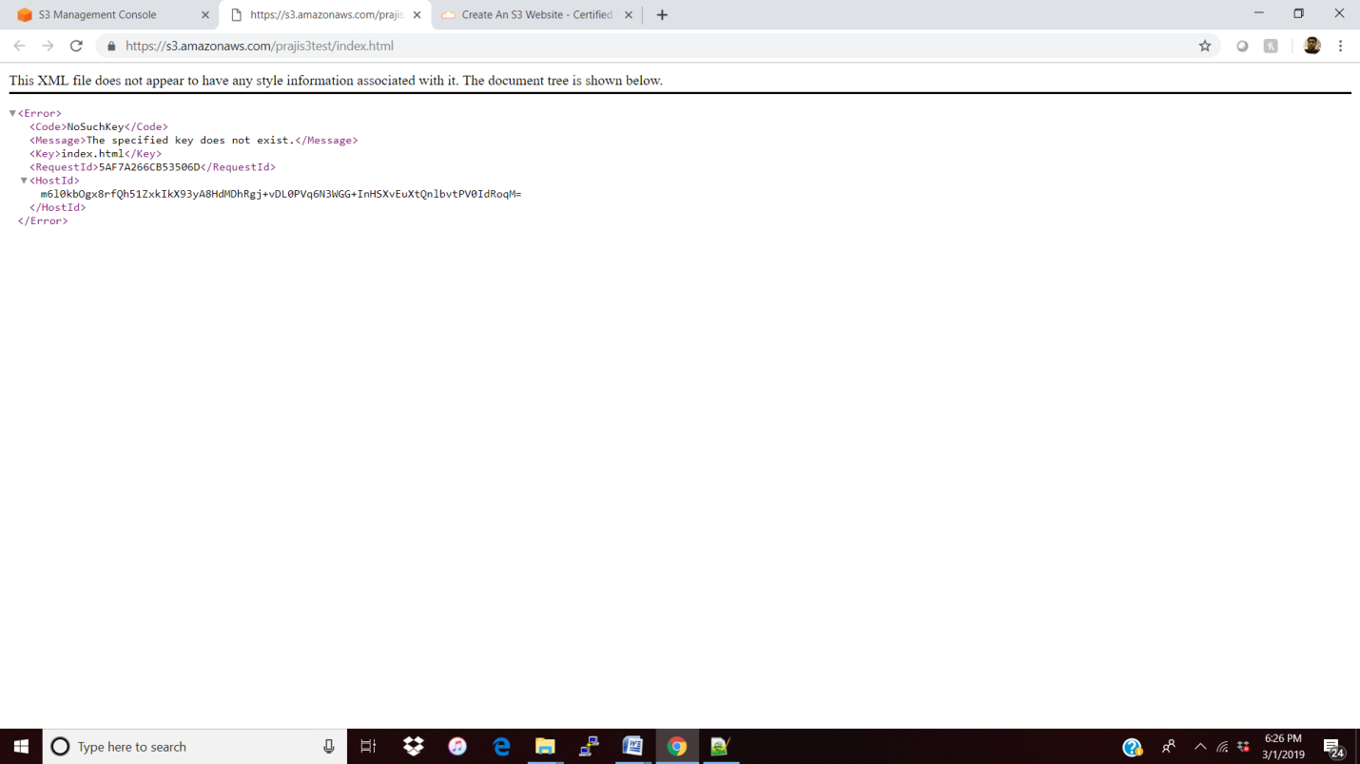

**CORS (Cross Origin Resource Sharing)**

Created 2 buckets with index/error in bucket 1 and loading/error in bucket 2.

Check both the buckets files (all four ) are accessing fine from the brower.

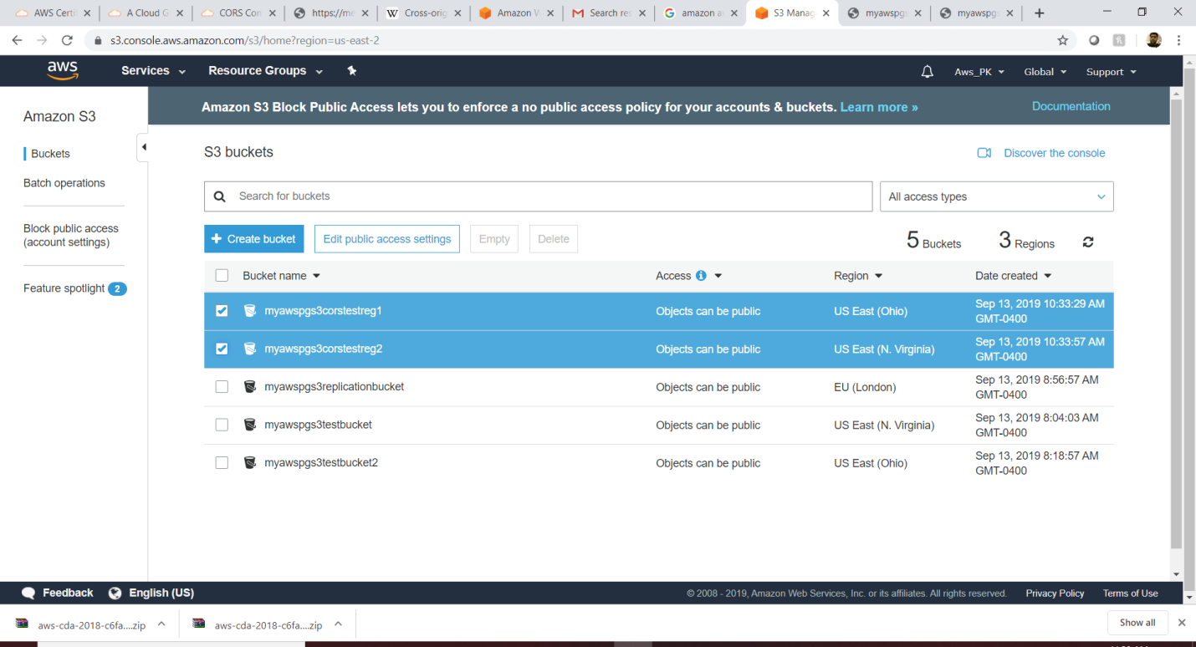

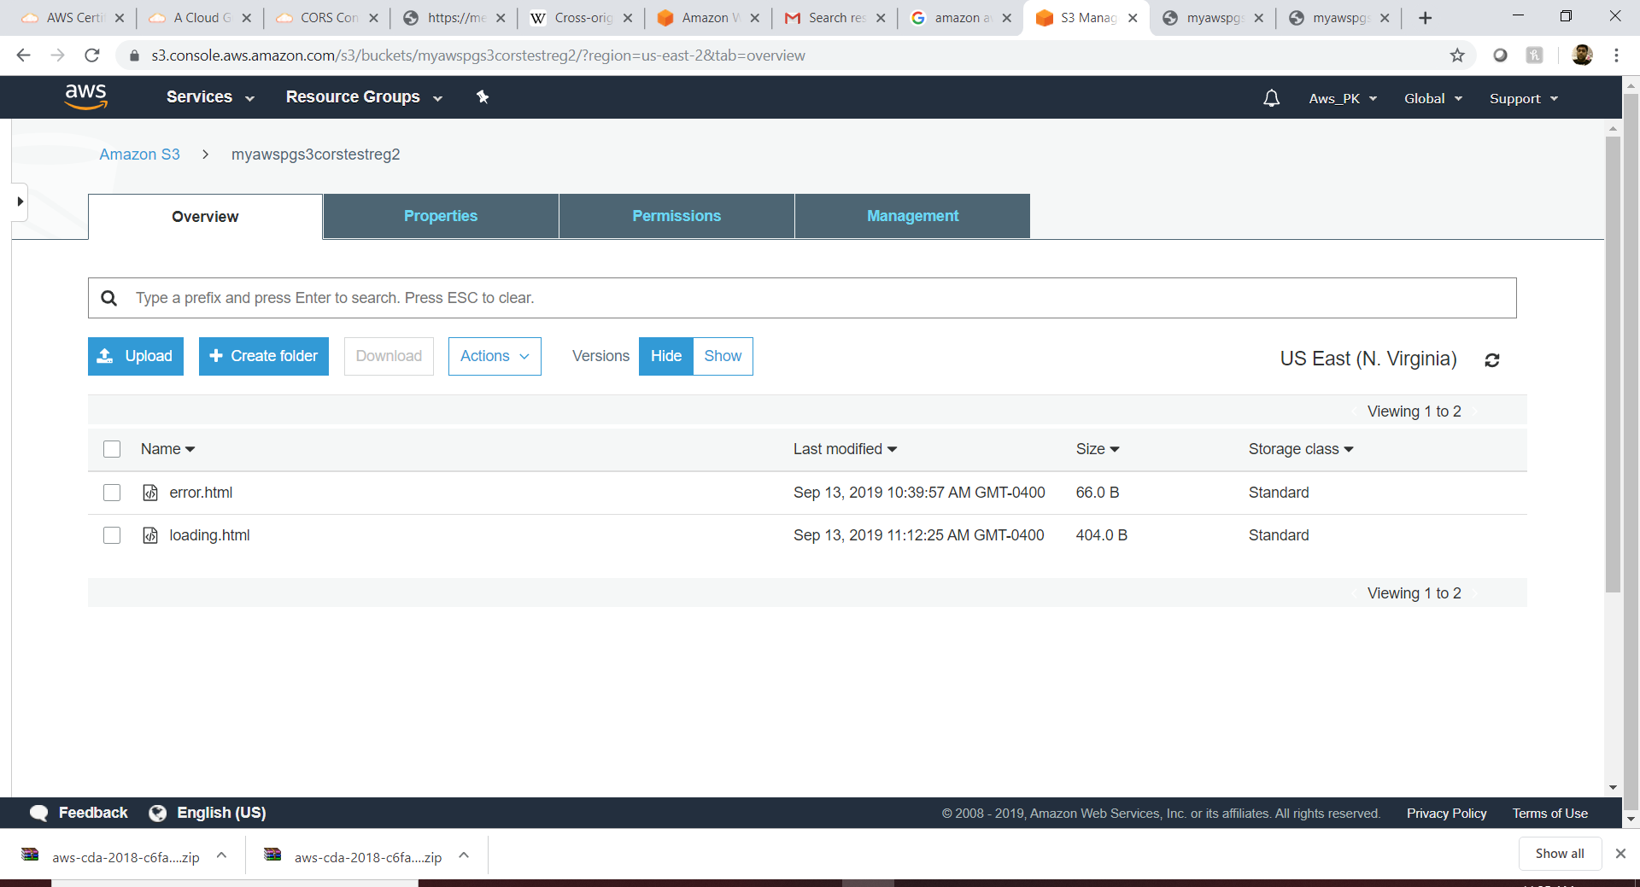 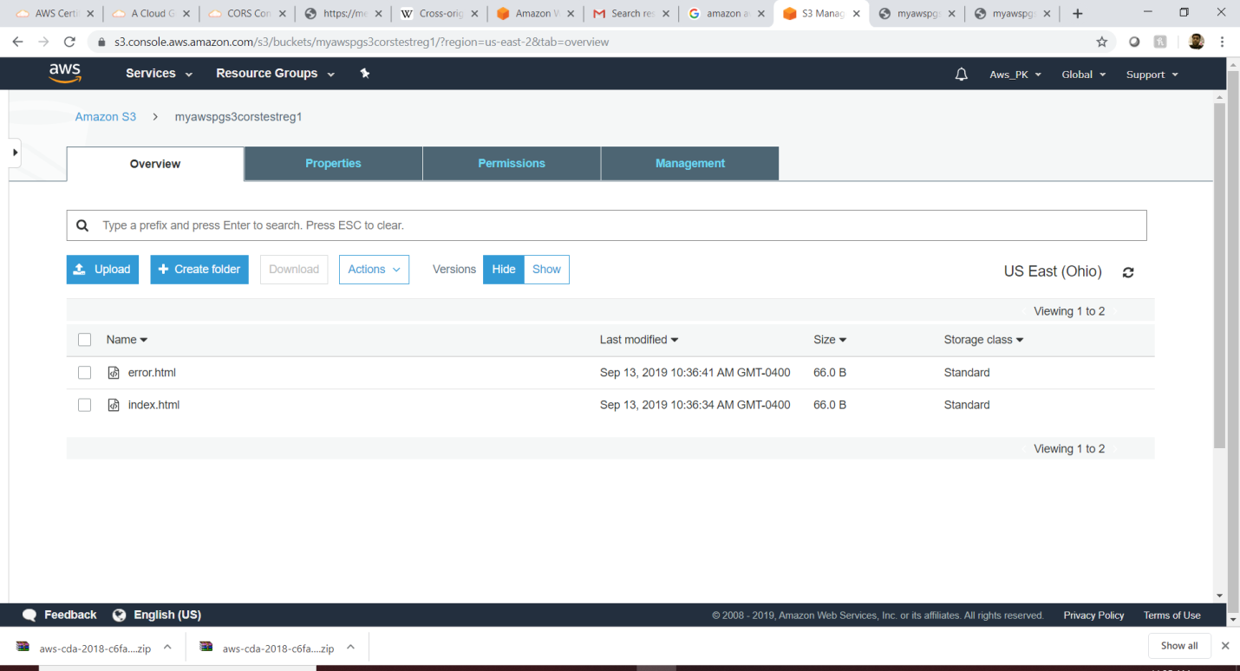

Now, From CORS we need to access the index.html which sits inside the bucket1 from bucket2 cross region.

Step 1:So update the loading .html as below highlighted. Get the index.html path from the bucket 1 and update in load().

|  |
| --- |
| <!--CORS Code - Copyright ACloud.guru-->  <script src="https://code.jquery.com/jquery-1.11.0.min.js"></script>  <script src="https://code.jquery.com/jquery-migrate-1.2.1.min.js"></script>  <html><body><h1>Welcome to the Loading Page!</h1>  <div id="get-html-from-other-s3"></div>  <script>  $("#get-html-from-other-s3").load("https://myawspgs3corstestreg1.s3.us-east-2.amazonaws.com/index.html")  </script> |

Step 2: update the CORS in bucket 1.

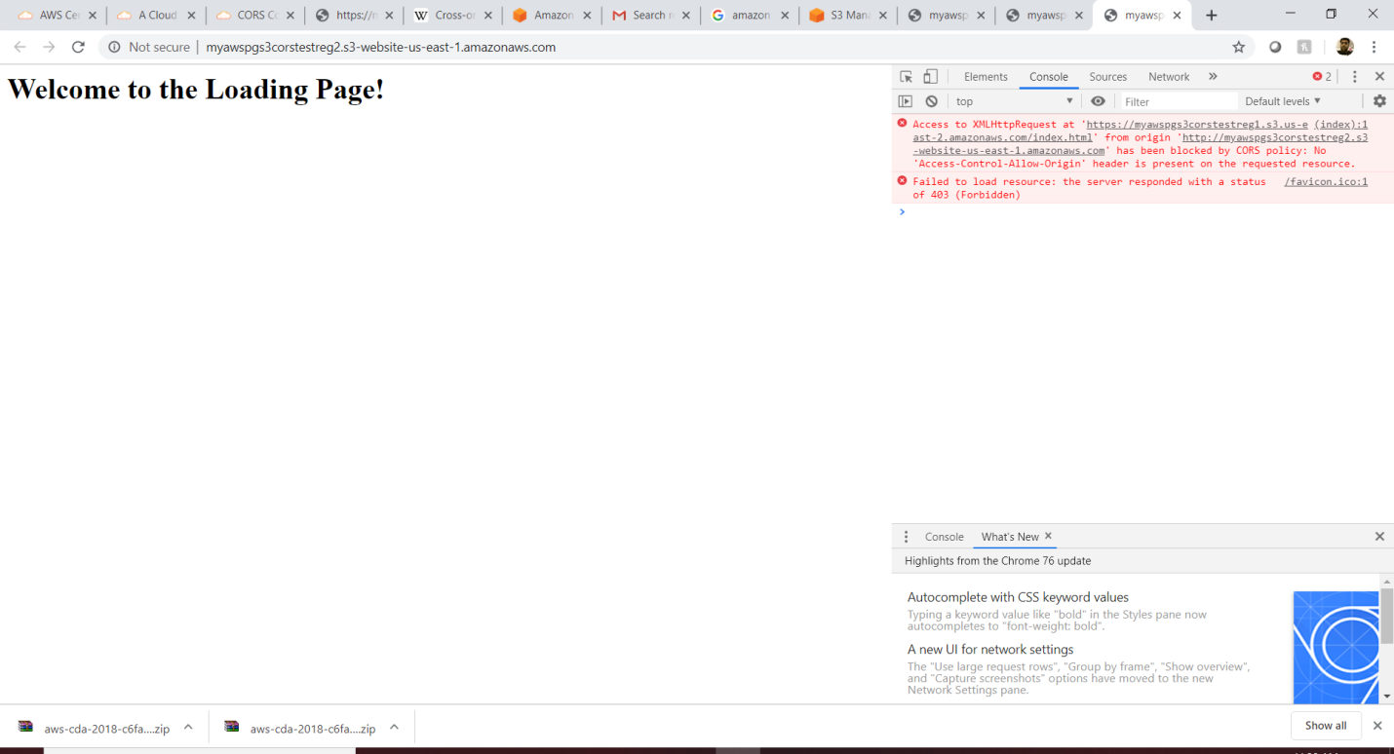

From the above error is clear , the **bucket one** is not allowing bucket2 to access the index.html. So have to enable the CORS in the destination bucket (specifying I can access from bucket 1 loading file)

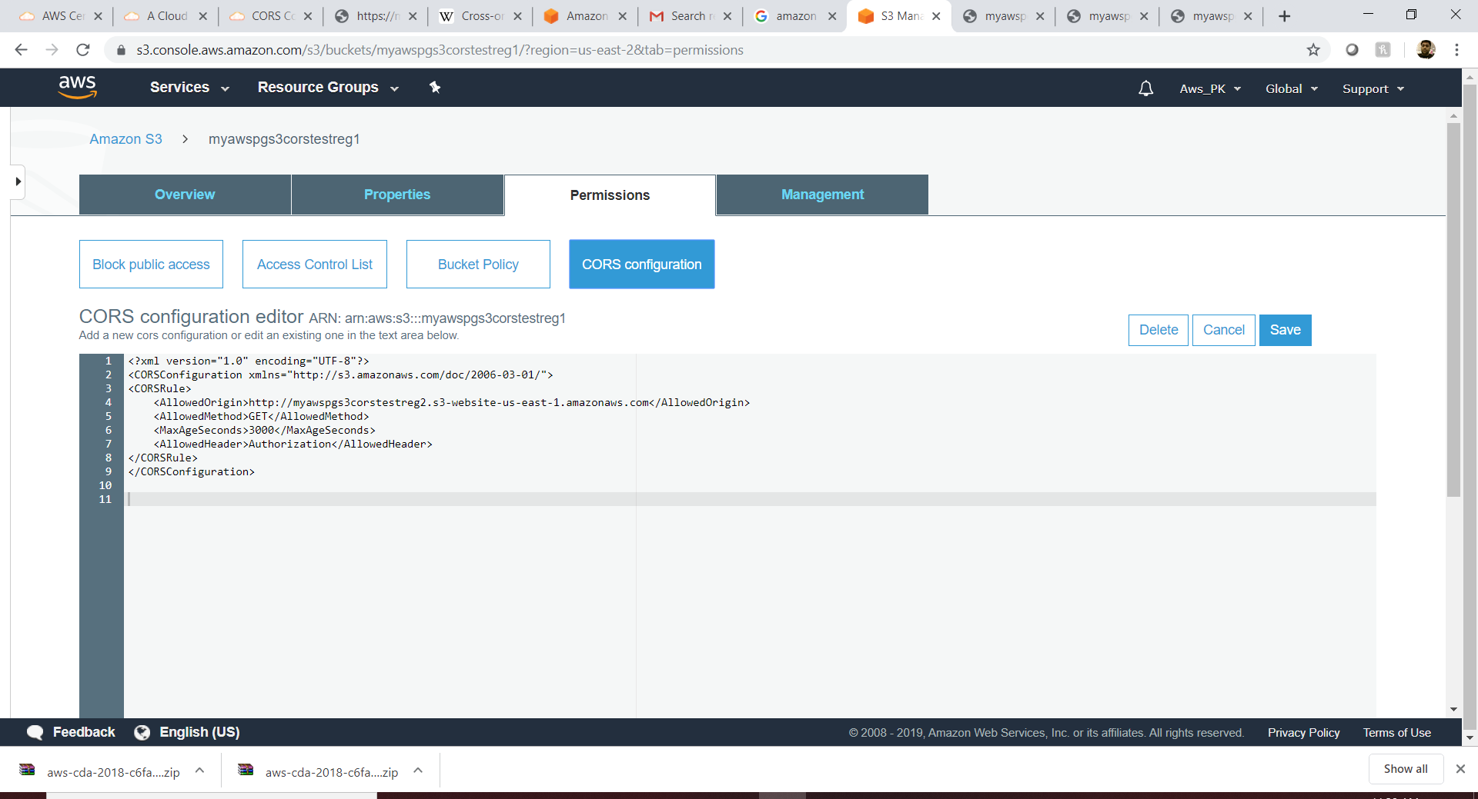

**Output:** After updating the CORS all looks good.

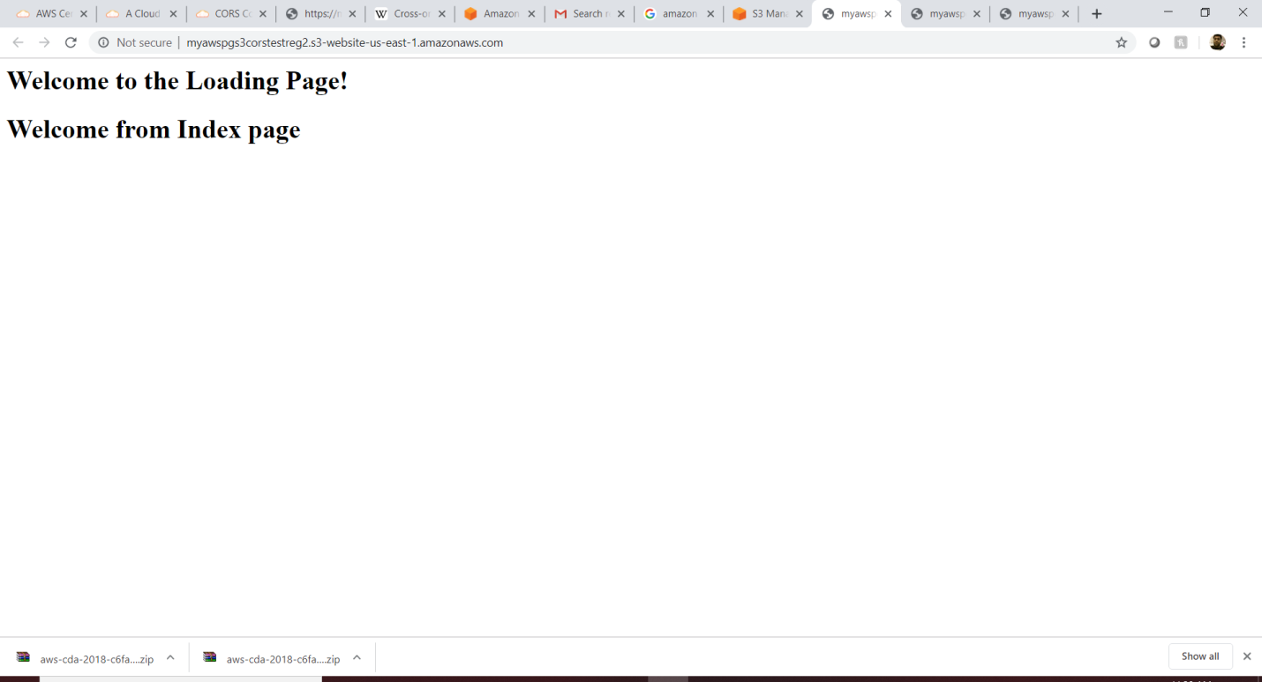

**Replication:** which allows the add the replication feature whereas if I add one file in one bucket then the file will get replicated in the another(destination) bucket which sits in different region.

Step1: go to the **source bucket** -> management (replica) and map the target bucket.

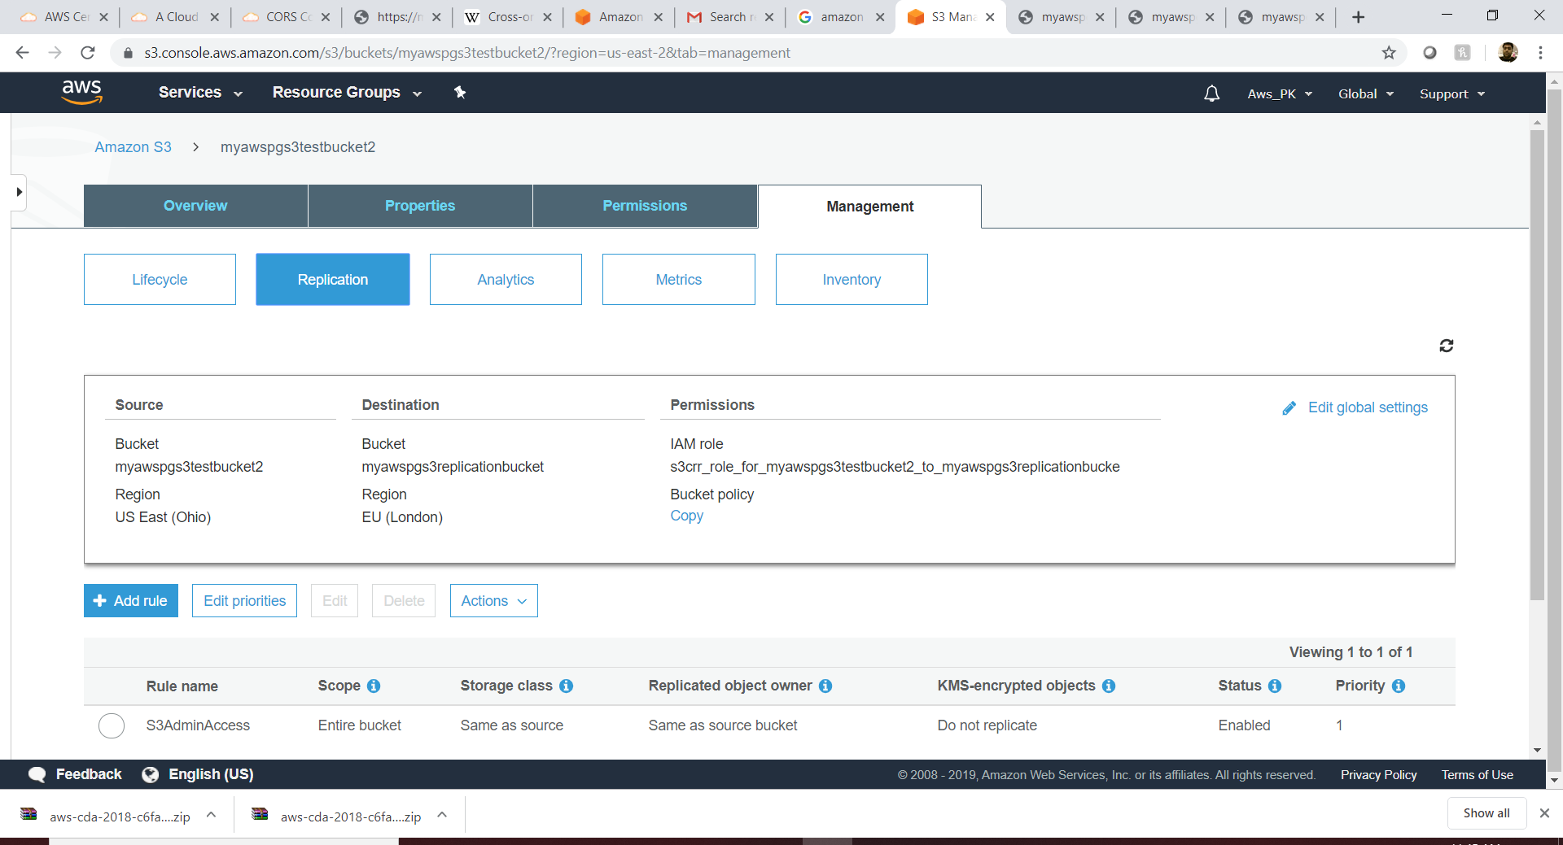

**Bucket Policy:**

To give access the certain bucket to the certain user. Please see below for the bucket we have access for the user praje. So believe if we login into aws console using praje secret key then we can access this bucket as well.

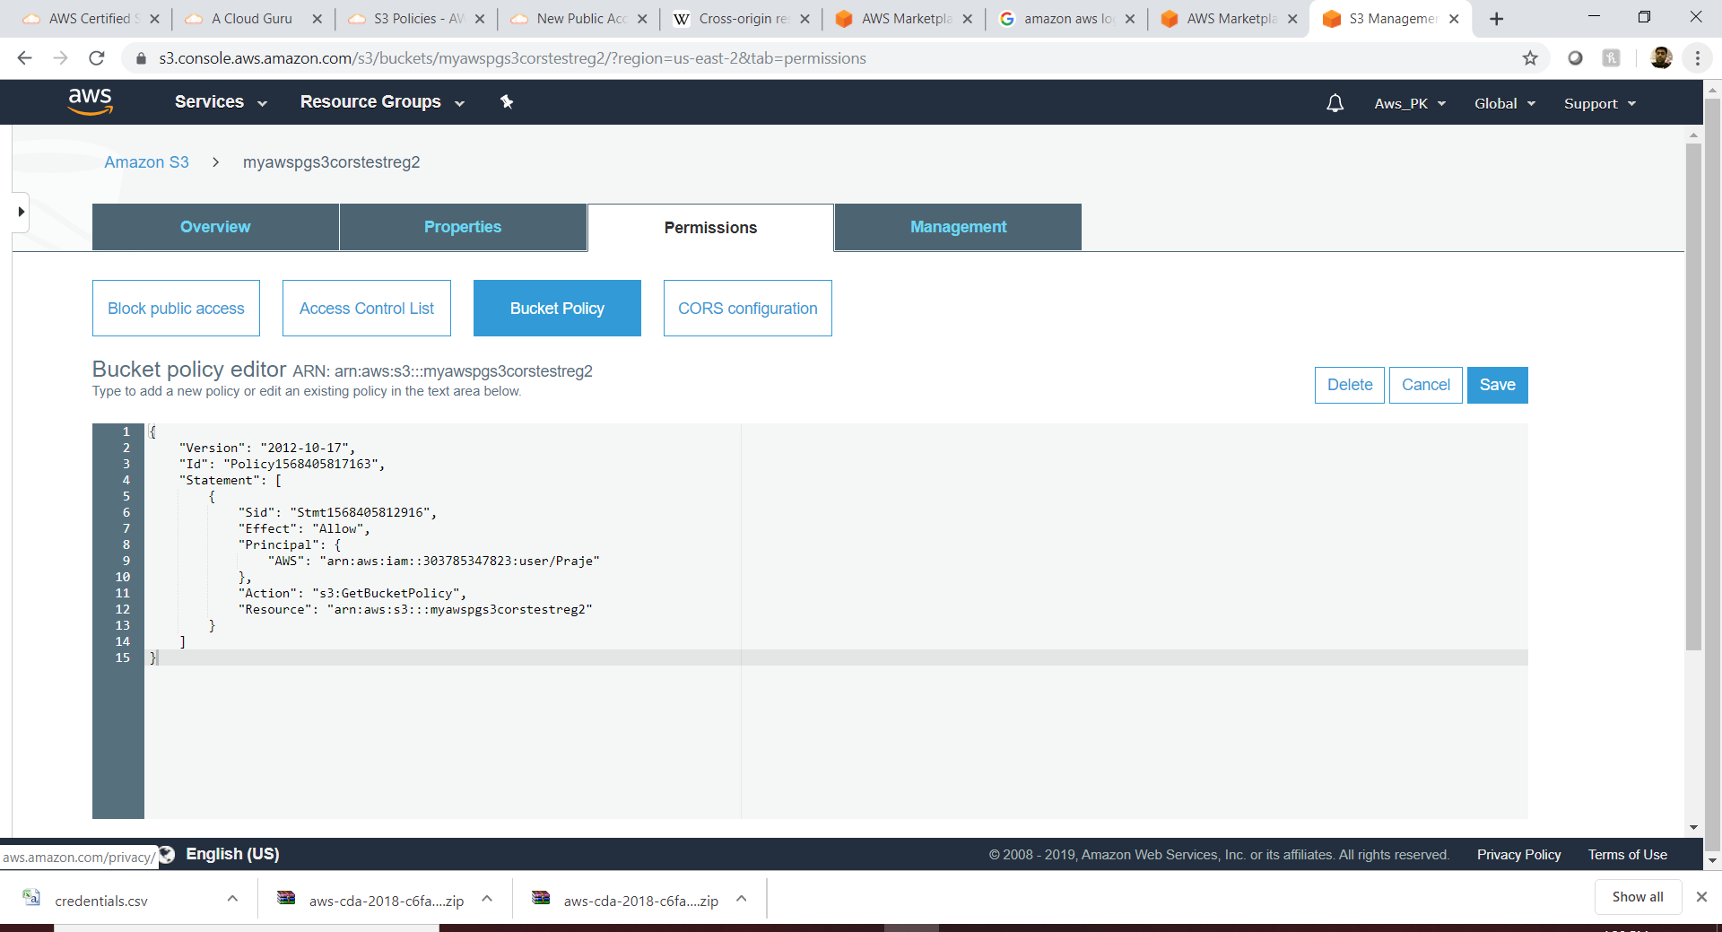

Case 2: Access the s3 document from command prompt **using secret key.**

Step 1: Create a user (i.e , userCLICommand) as “AdminAccess” role from aws console using IAM and download the secret key .csv file.

Step 2: login to putty and do “aws configure” -> give both the key and region .

Note: Please make sure the region name (from s3 browser) is correct else it will have a issue connection to region.

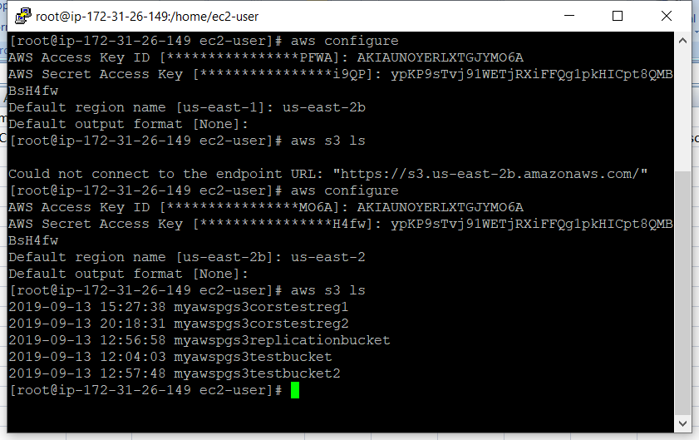

Case 3: Access the s3 document from command prompt **using IAM Role**.

Step 1: Create a role in IAM and set the policy as S3FullAccess, then Attach/update created IAM role to EC2.

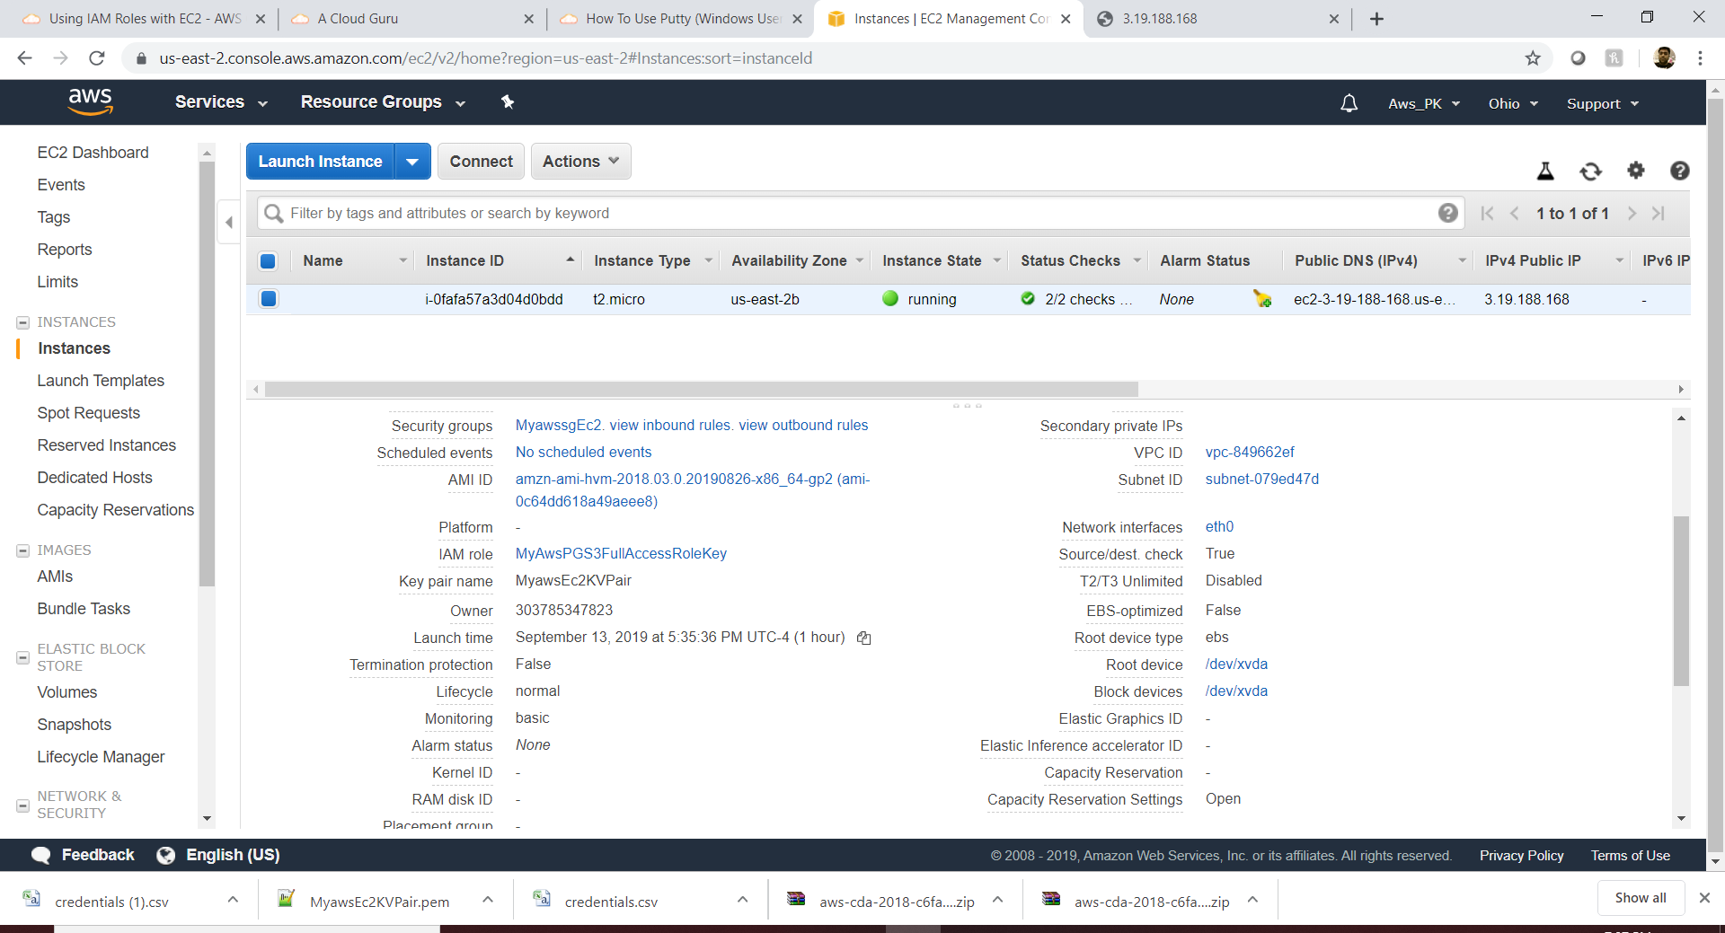

Step 2: login to ec2 terminal , now no need to configure anything (as like we did for security key usecase)as already role is attached with that ec2, we are good with “aws s3 ls”.

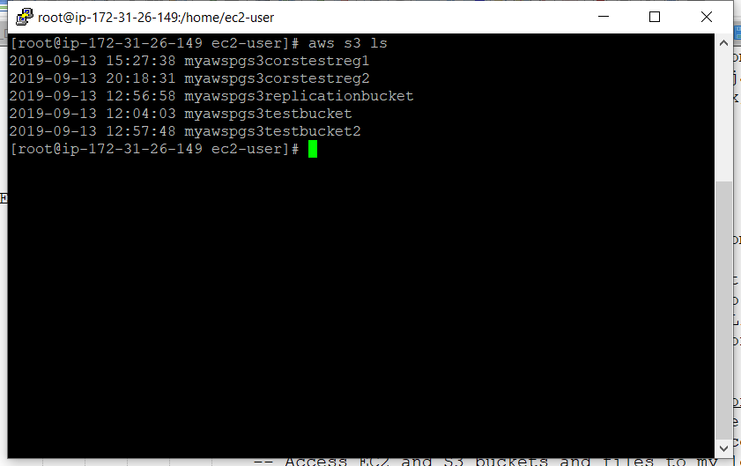

Case 4:Get the documents from S3 and download into ec2 using the terminal command (cp --recursive)

S3 documents list:

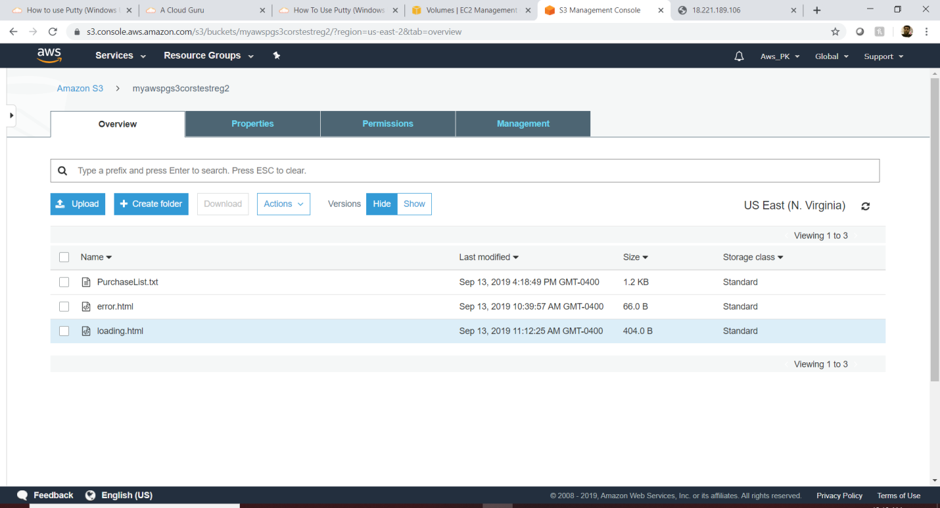

|  |
| --- |
| [root@ip-172-31-26-149 ec2-user]# aws s3 ls  2019-09-13 15:27:38 myawspgs3corstestreg1  2019-09-13 20:18:31 myawspgs3corstestreg2  2019-09-13 12:56:58 myawspgs3replicationbucket  2019-09-13 12:04:03 myawspgs3testbucket  2019-09-13 12:57:48 myawspgs3testbucket2  [root@ip-172-31-26-149 ec2-user]# **aws s3 cp --recursive s3://myawspgs3corstestreg2 /home/ec2-user --region us-east-2**  download: s3://myawspgs3corstestreg2/error.html to ./error.html  download: s3://myawspgs3corstestreg2/PurchaseList.txt to ./PurchaseList.txt  download: s3://myawspgs3corste/loading.html to ./loading.html  [root@ip-172-31-26-149 ec2-user]# |

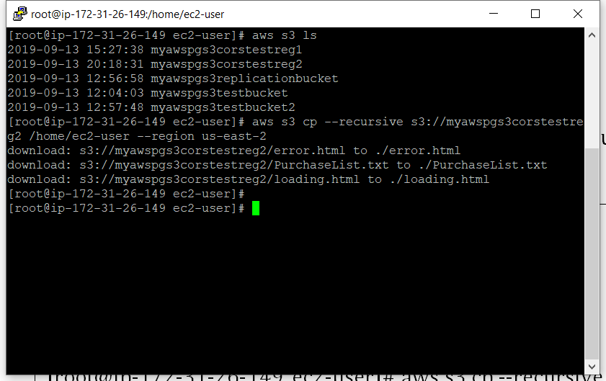

**Cloud Front: (Global based)**

This service helps to distribute the web content from origin (S3/ELB/Ec2/Route53)to the respective client access (based on the geographic location)as edge location in order to increase the performance of the application.

* Origin: Where the server exits.
* Edge-Location: Where the content cached.
* Distribution: Collection of edge location ( cache)

Use case: there is a s3 document which exist in Sydney region and the user from London is accessing that document which normally take more latency because of the distance. So we need to cache the document from the s3 server to London edge location and when the user hits the document from the second time on-wards it will be more fast.

Note: there is also an option to “Object Invalidation” which allows the object to retract from the cache. But it’s contains a charge.

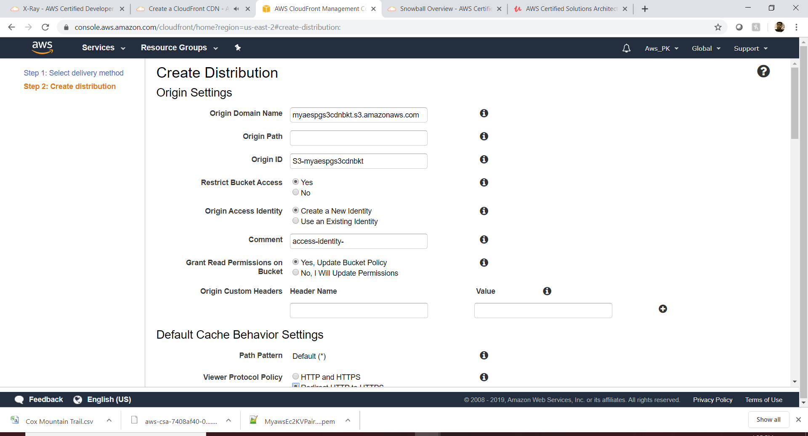

Default Value

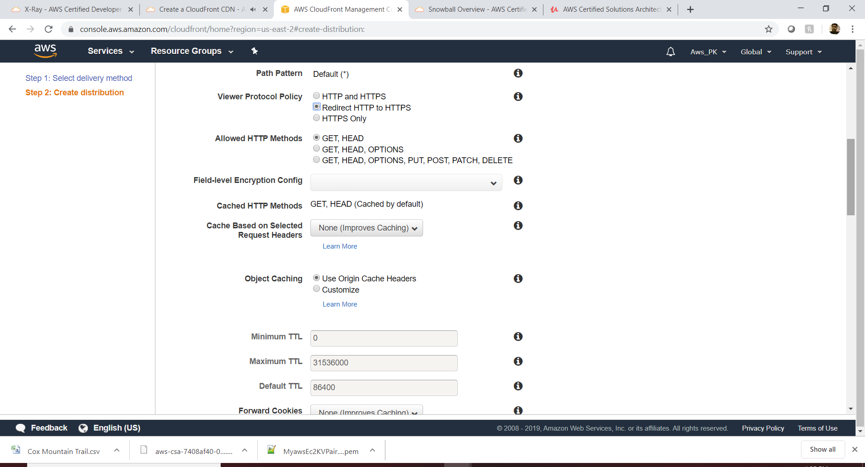

Default Value

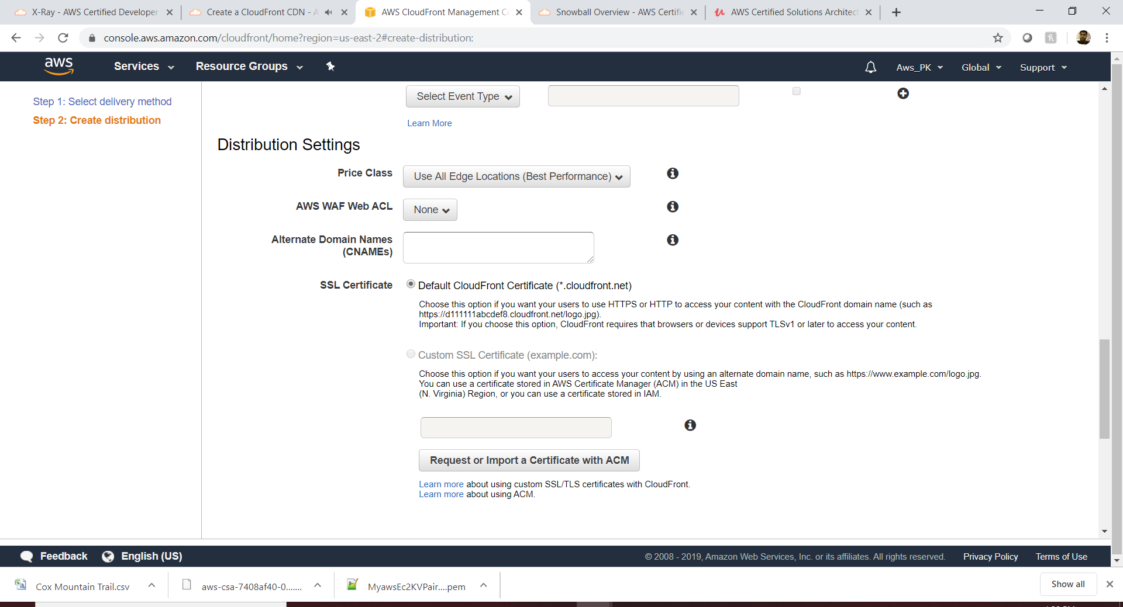

Create it and see the distribution will be in progress.

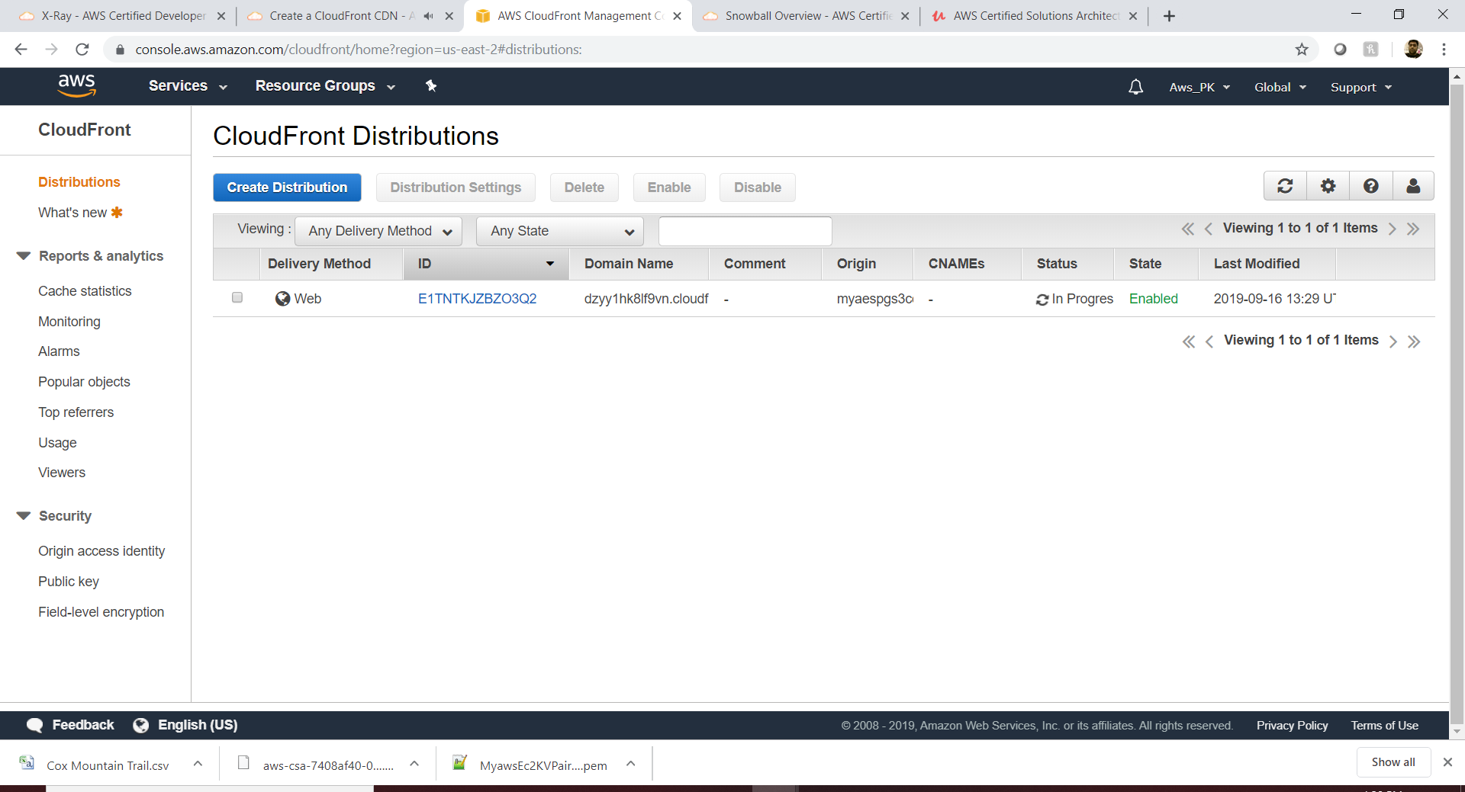

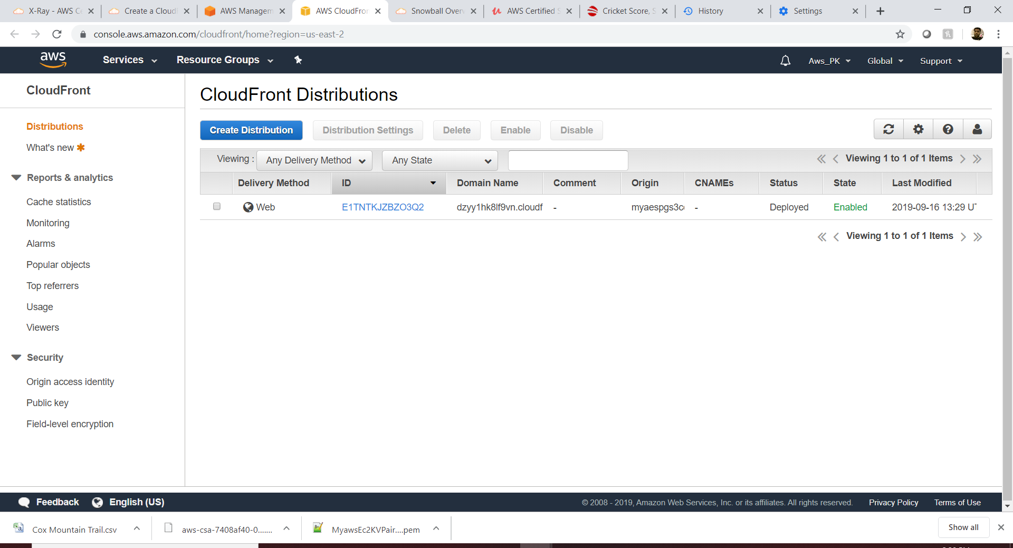

See the SSL

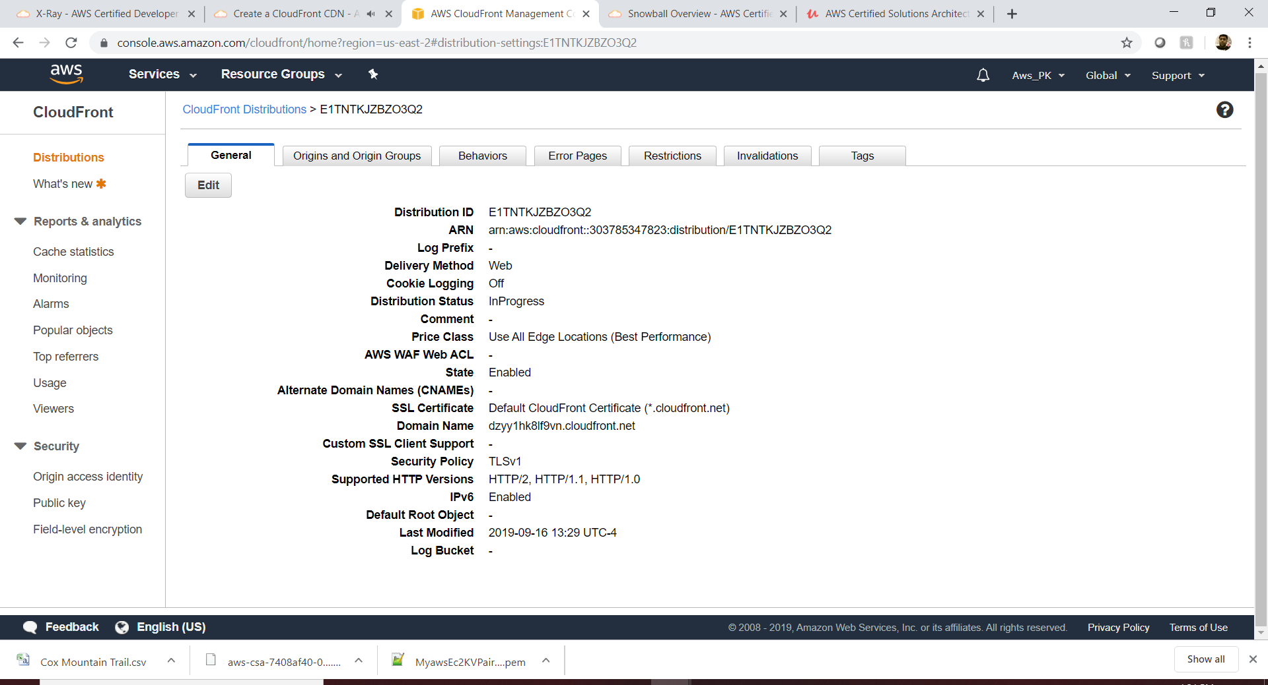

Right now , only one origin

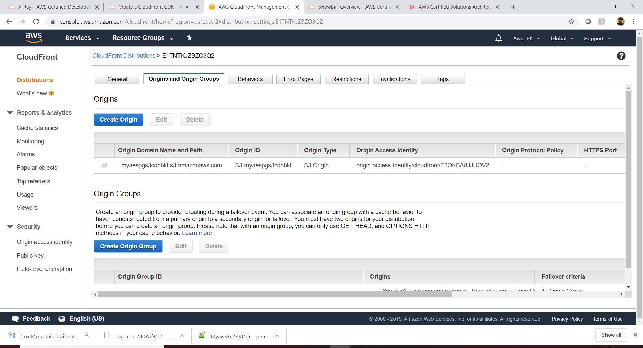

Object invalidation

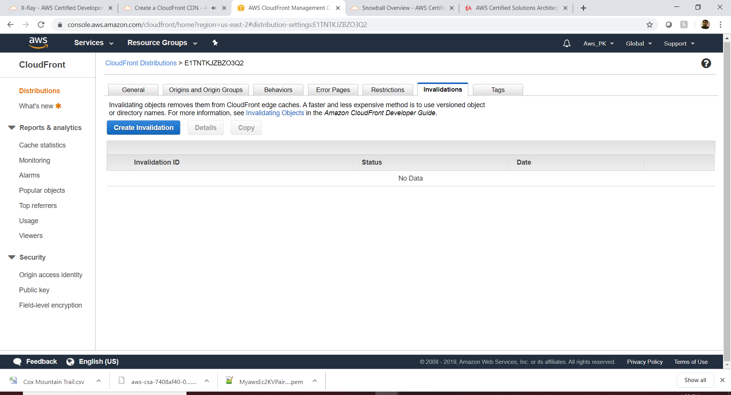

Geo Based Restriction (whitelist/Blacklist)

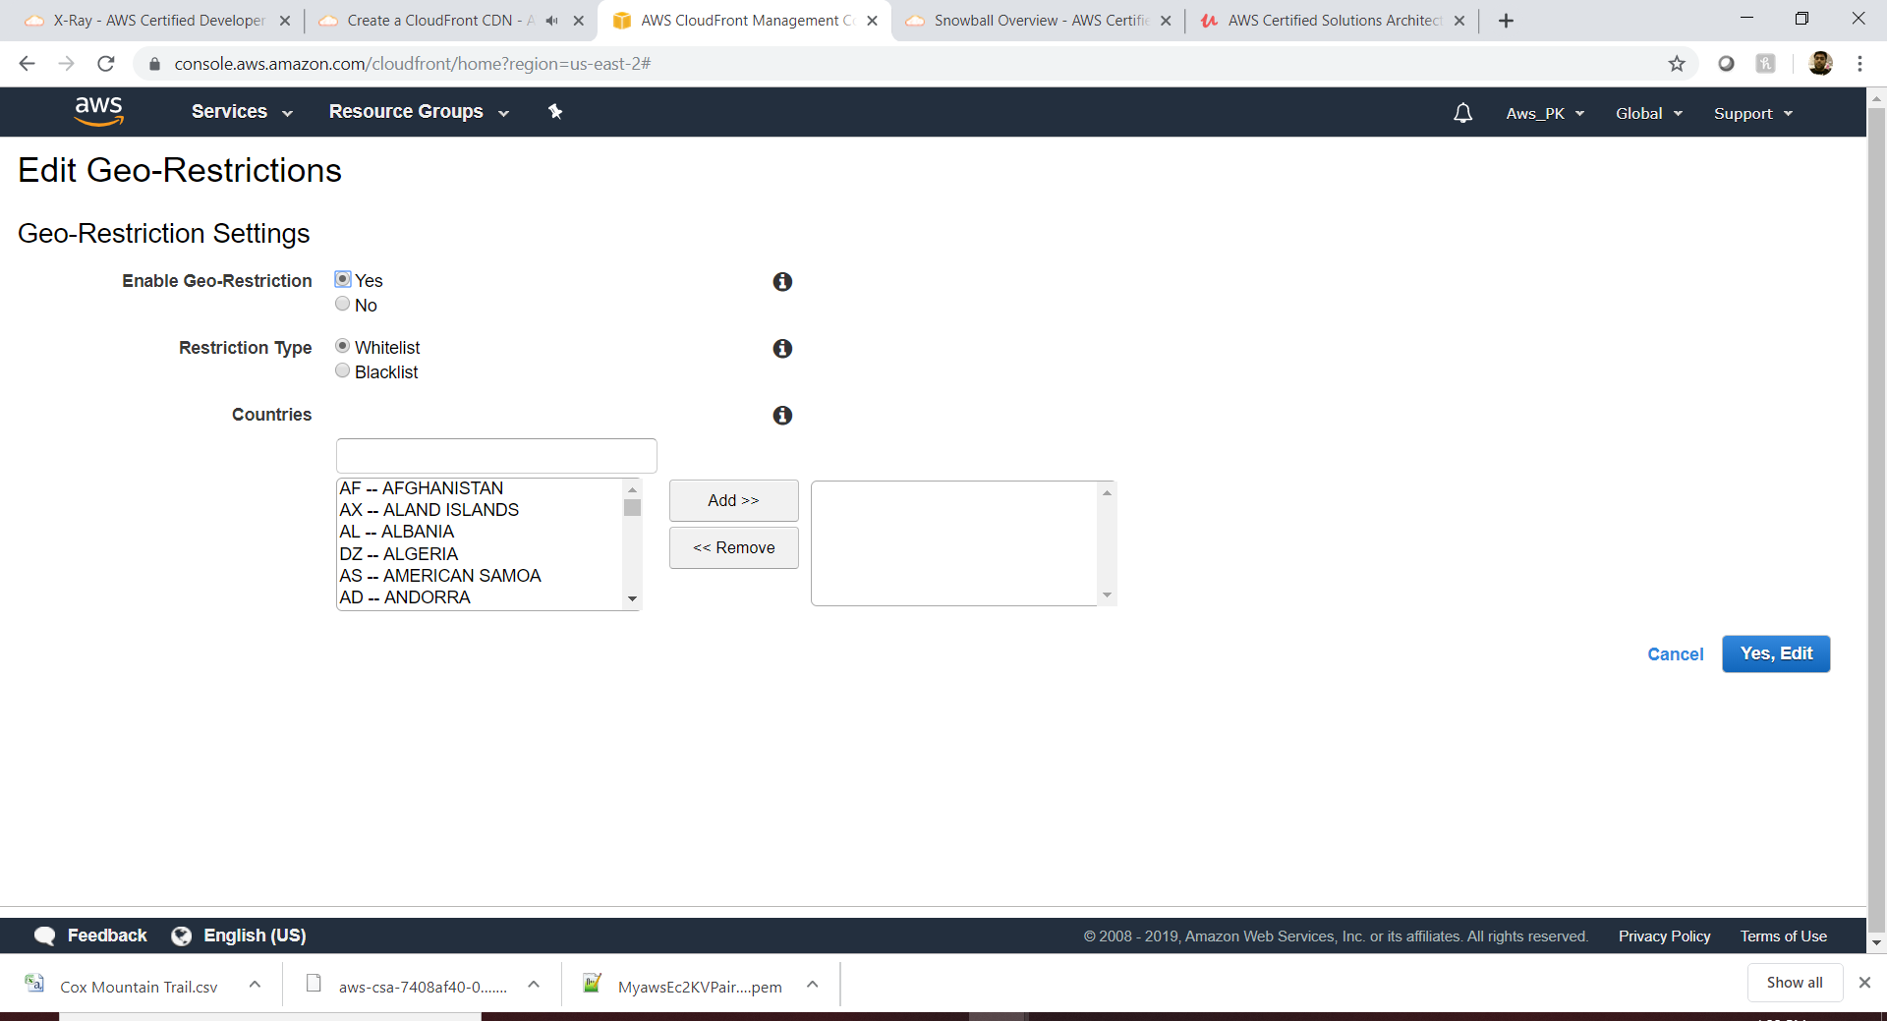

Behavior (right now only behavior is redirect from http to https)

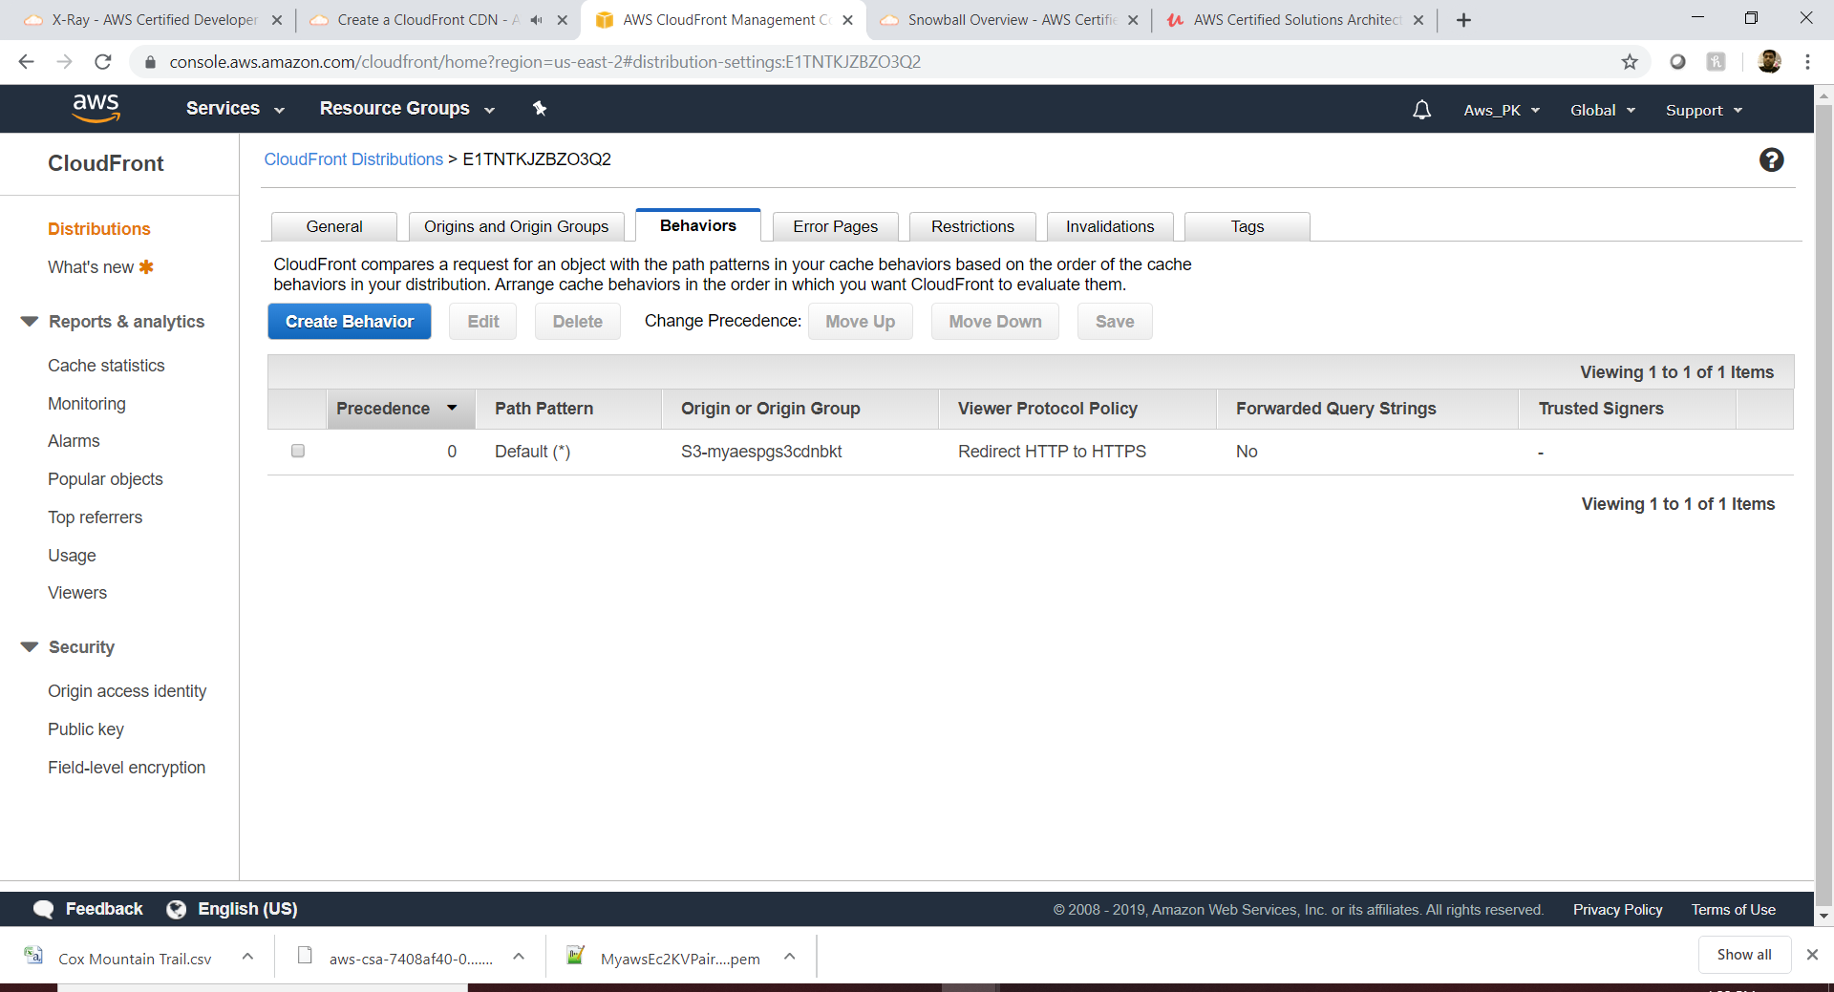

Hit the url (https://dzyy1hk8lf9vn.cloudfront.net/2017-09-06-PHOTO-00000438.jpg)

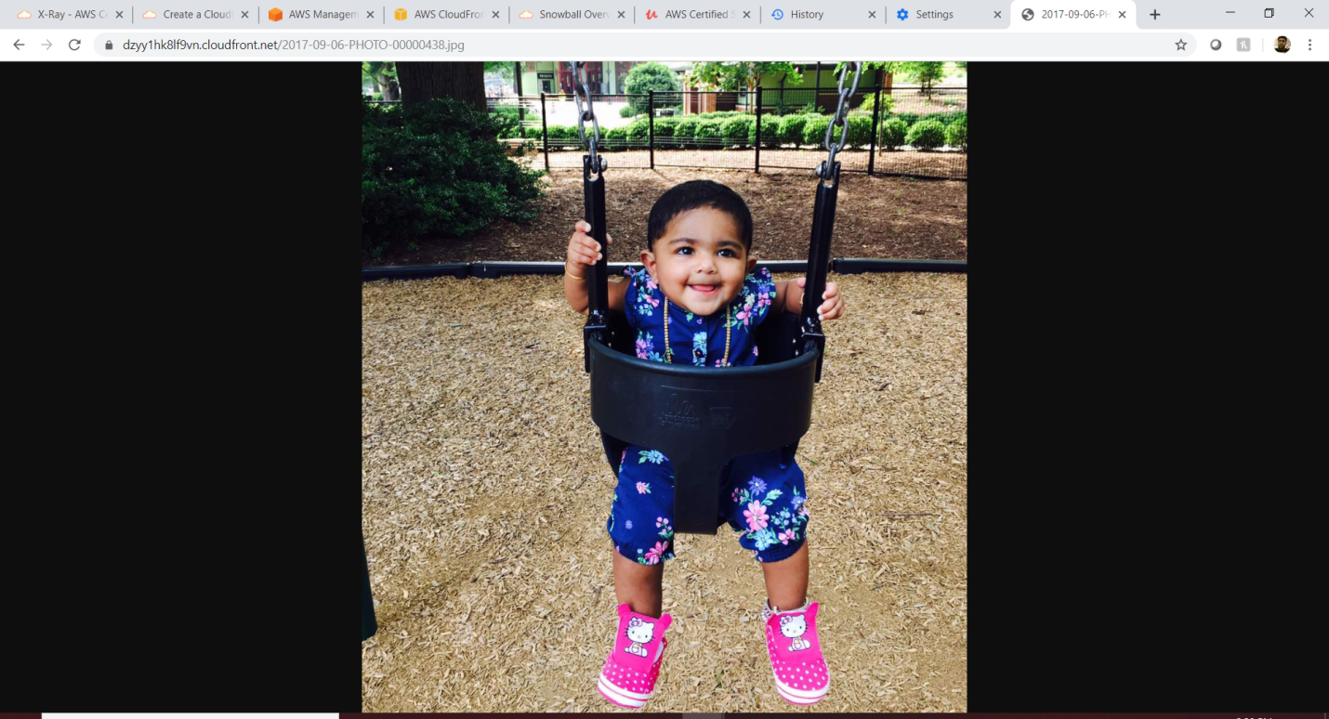

To delete the CDN , we need to disable and delete it.

Lambda:

The purpose of lambda is to host a web application without any server. Example cloud guru is running without server. It has a Angular js and all the request from the Angular will be called by API gateway to the Lambda function, all the videos will be stored in the S3 buckets.

Adv: nothing to pay for server and/or server administrator which is a huge saving. And lambda is automatically scale out.

Use Case: when user Is clicking the “click me” button from the static webpage , then it has to get the lambda function and get response back the user name to the user screen.

Step1: Lambda: Create the lambda function and add the code into it which will return the username back to the caller (API Gateway).

Step 2: Get the API Gateway created for GET method and mapped to lambda, deploy the gateway and validate it.

Step 3: Create the static website with index.html and error.html , where index.html will have the click me button which will call the API gateway , so have to paste the API gateway link here.

Create the lambda function.

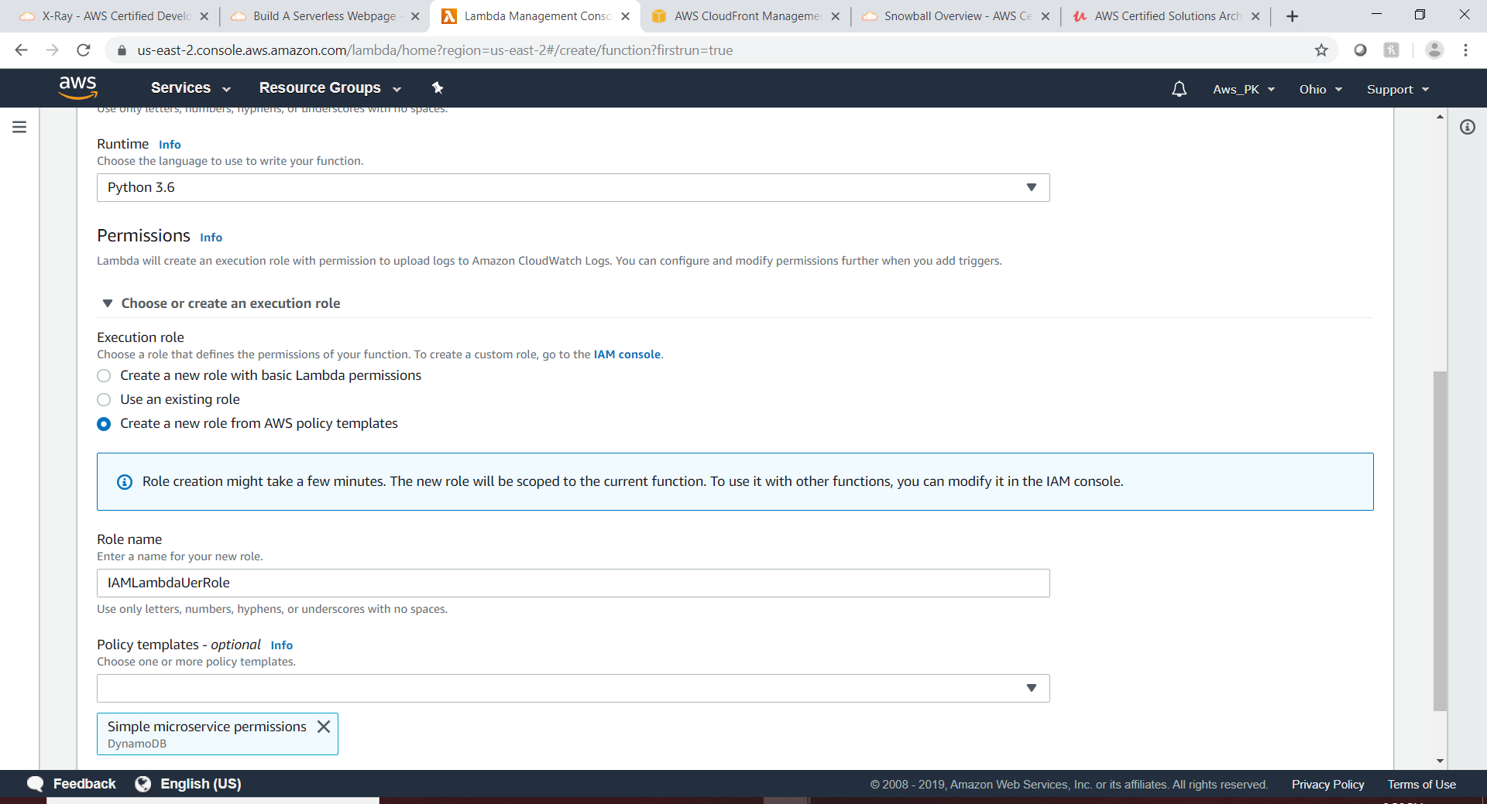

Add the code:

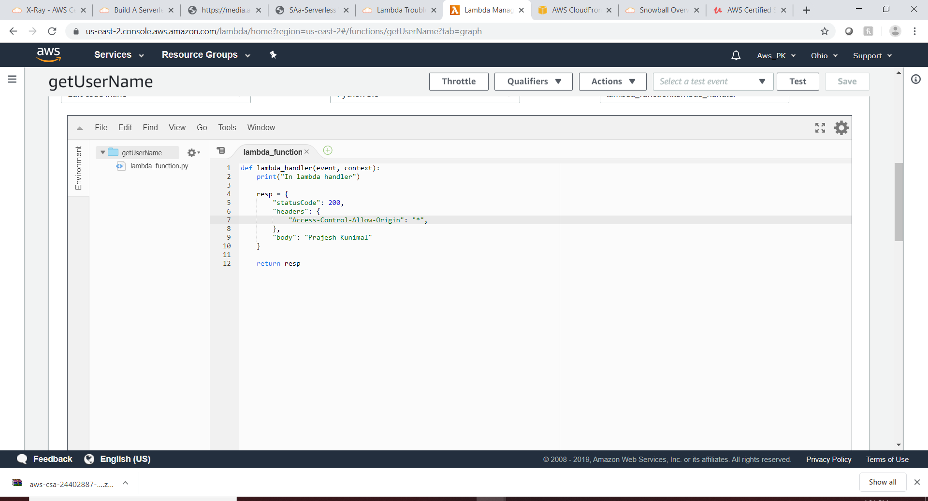

Add the triggers:

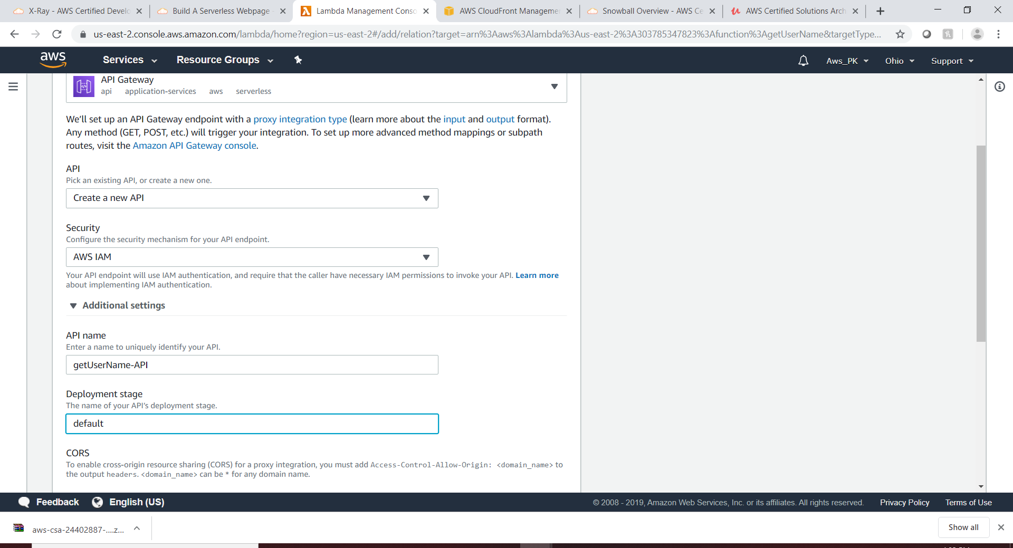

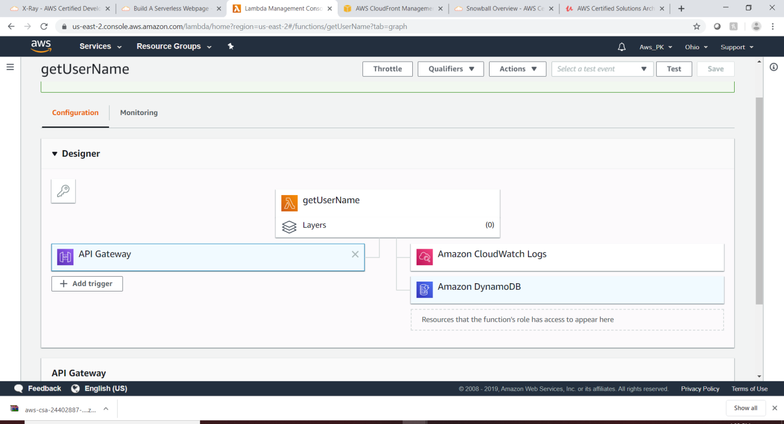

Click “getUserName-API”

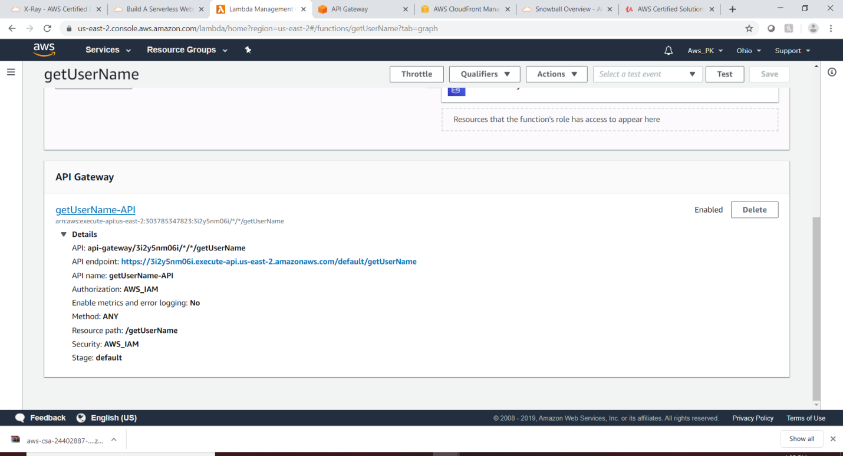

Delete the ANY method which allows all the operation , for this use case we need only “Get”

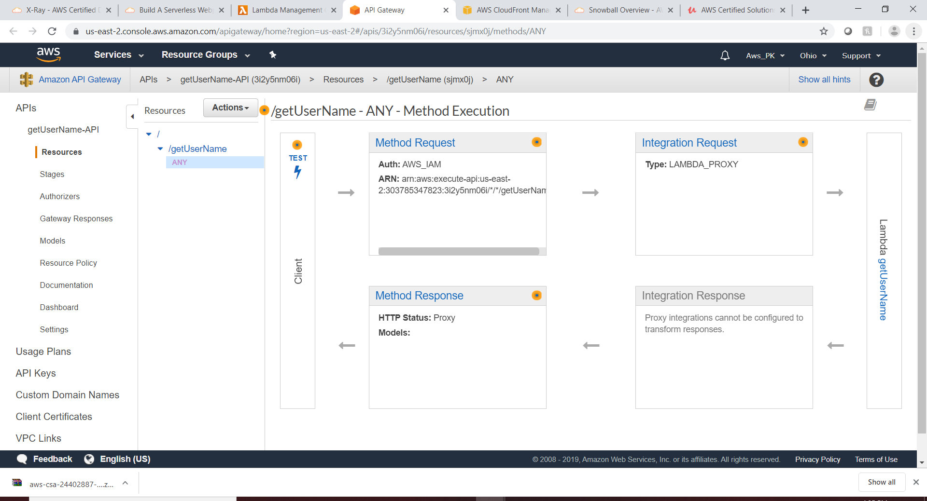

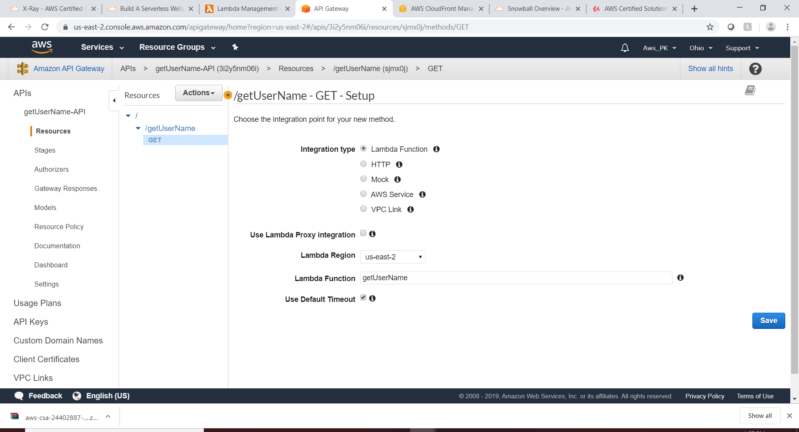

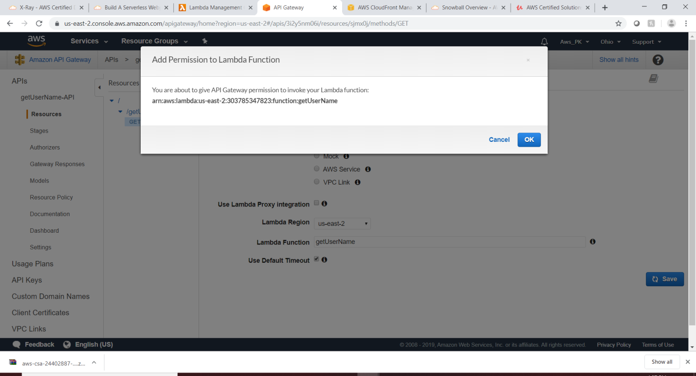

Deploy & validate API Gateway:

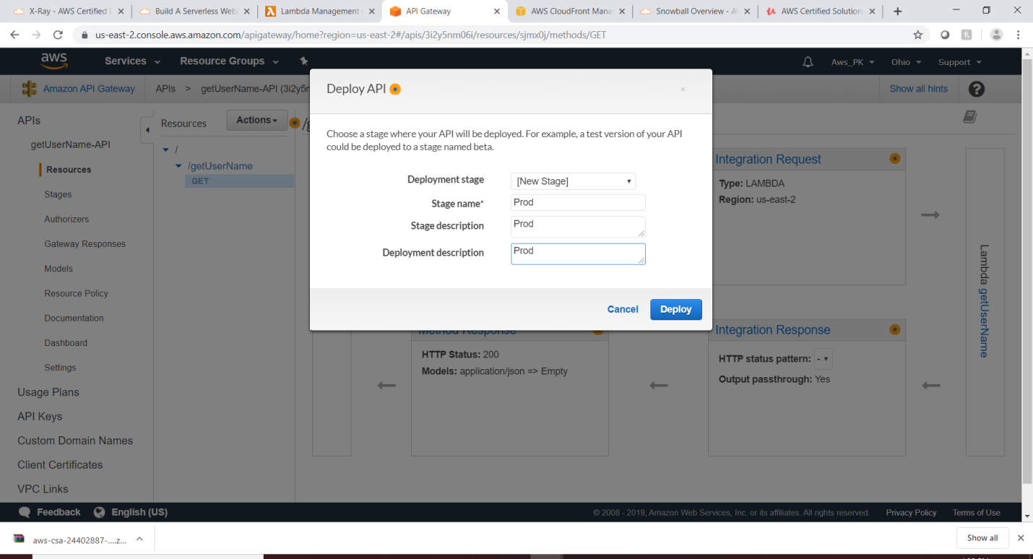

To validate ,Goto the stages then click “Get” then click the link:

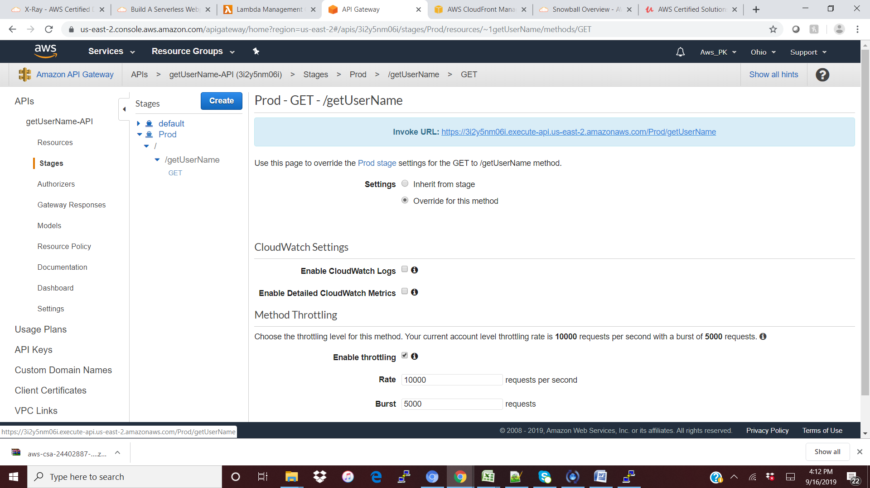

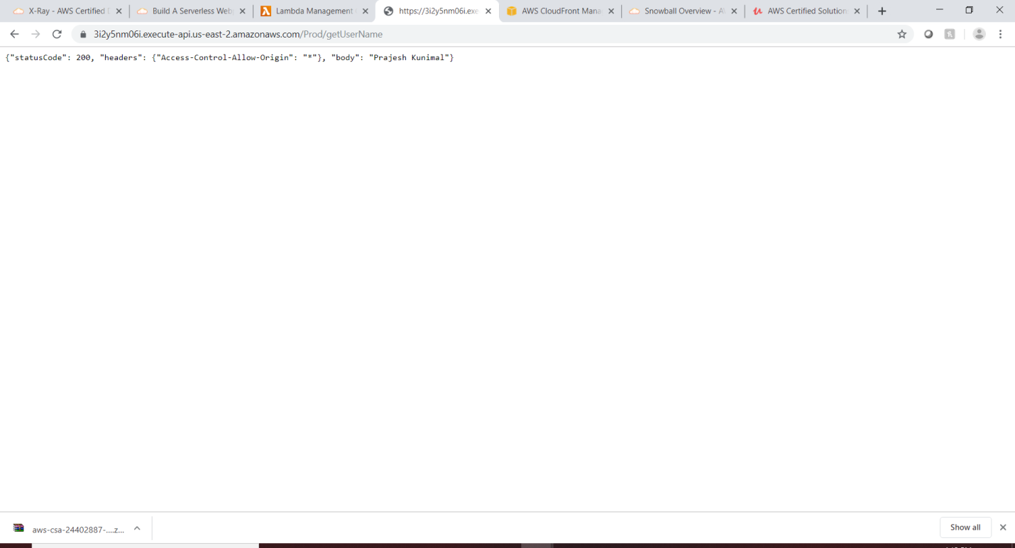

Add the API Gateway link to my index.html

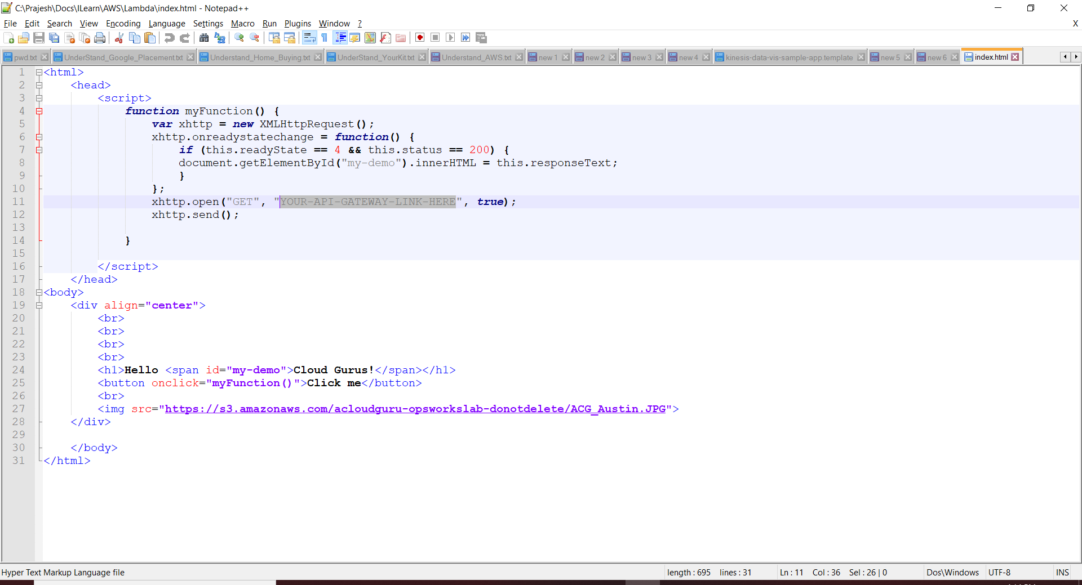

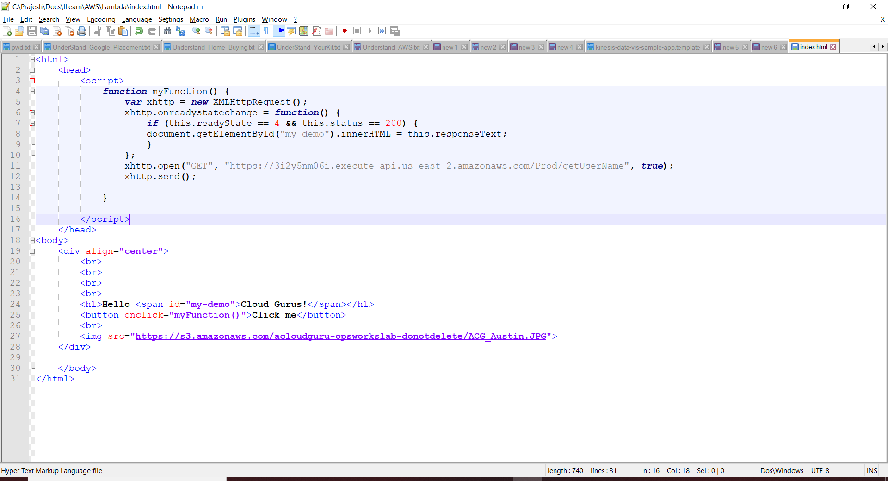

Create a s3 bucket and import both the index/error html and make the static website.

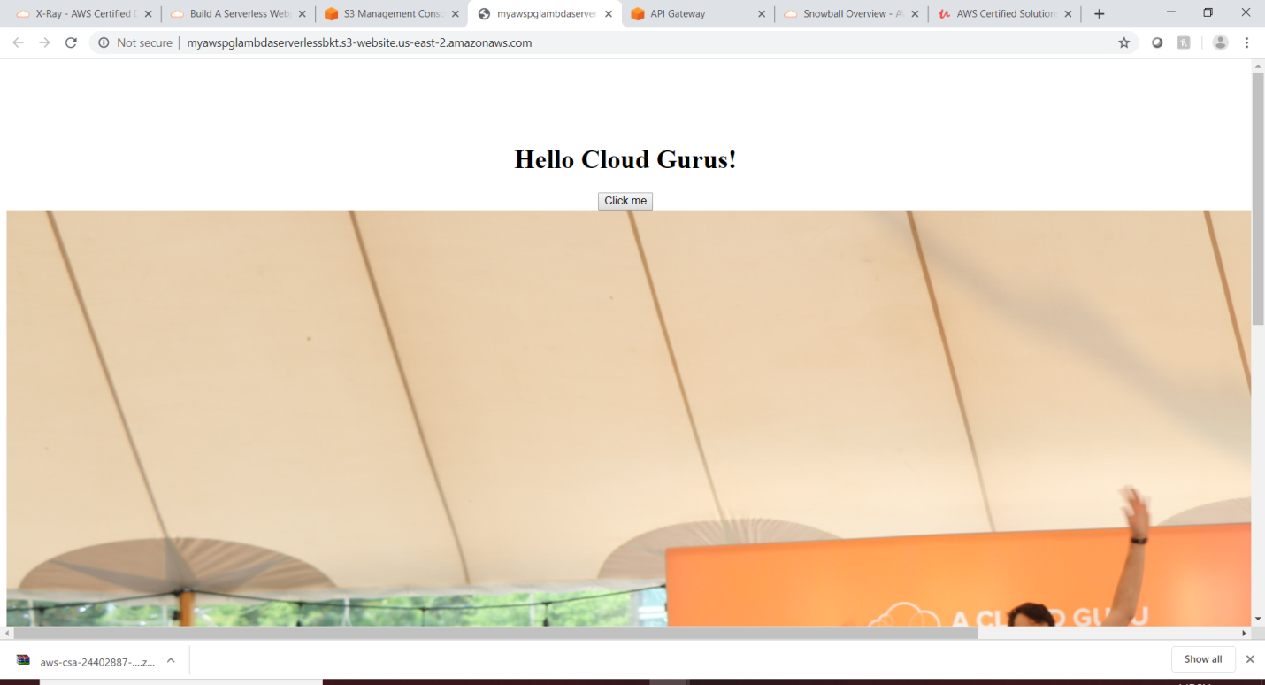

Note: Somehow the response is not working in this use case and I am getting the CORS

|  |
| --- |
| (index):12 Cross-Origin Read Blocking (CORB) blocked cross-origin response https://3i2y5nm06i.execute-api.us-east-2.amazonaws.com/Prod/getUserName with MIME type application/json. See https://www.chromestatus.com/feature/5629709824032768 for more details. |

To fix the above error , we need to enable the CORS in API gateway and the reason is S3 domain name is different in API gateway, so we have to enable the CORS so that API gateway still can access S3 gateway domain name and will not have any access issue and deploy it and test it again.

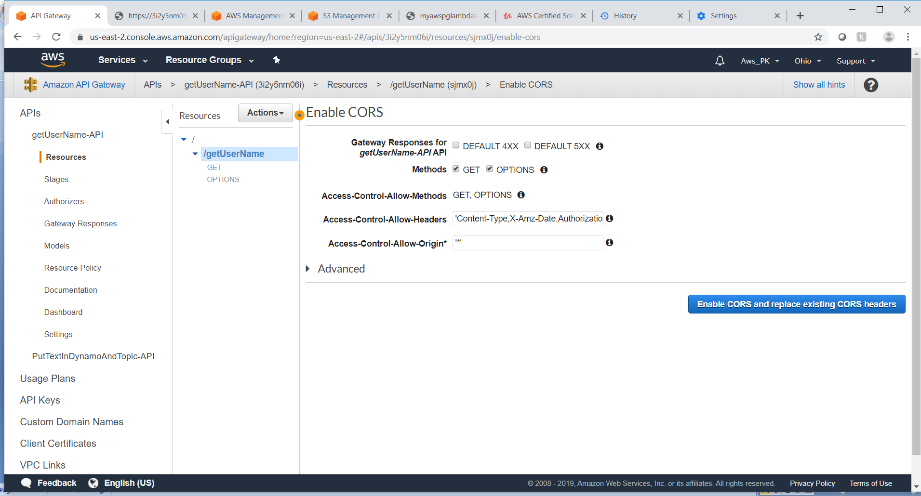

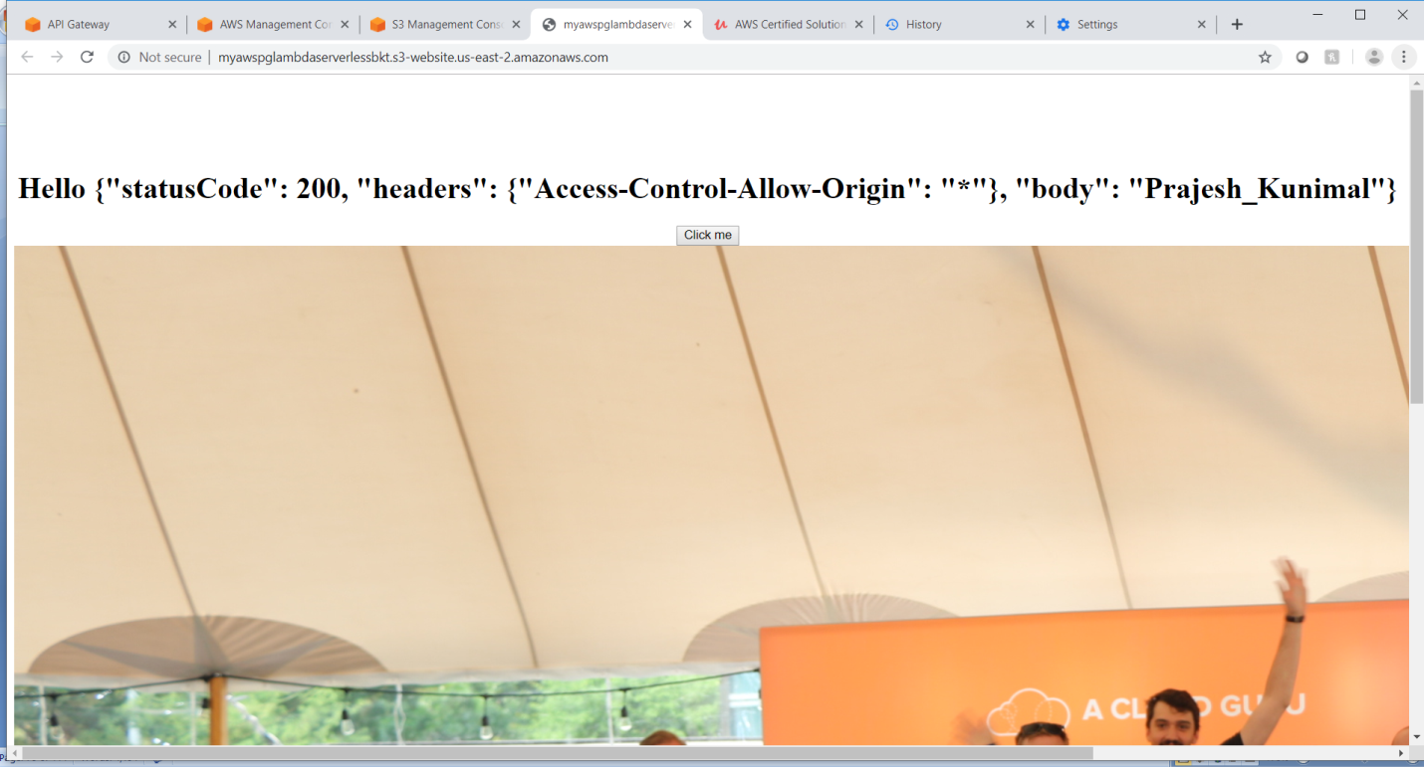

UseCase Polly:

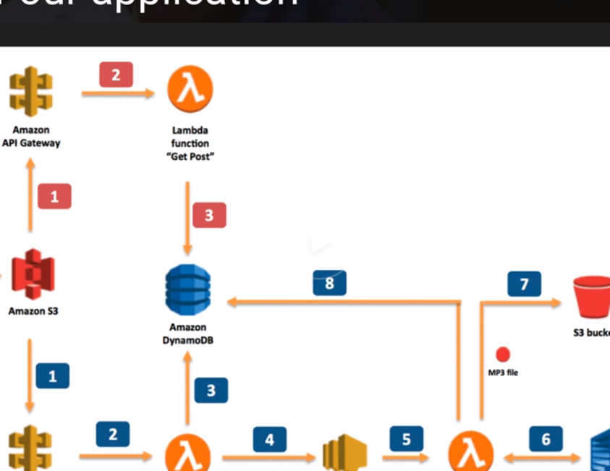

Create 2 S3 Buckets

* + - Bucket 1: To host the static webpage
    - Bucket 2: to store the mp3 files.

Create below Amazon service

* + - Amazon Polly
    - SNS
    - Dynamo DB

Below three Lambda

* + - Lambda 1: to get the text & store it to dynamodb and SNS
    - Lambda 2: Read from SNS and convert the text to voice (polly) and store it in S3 and update dynamoDB
    - Lambda 3: Get the text from API gateway and search in dynaodb and return to S3.

Below 2 API Gateway:

* + - API Gateway 1: Get the text and pass to lambda and store it to dynamodb
    - API Gateway 2: Get the search text and search in the dynamodb & return back to s3 website.

Lambda 1:

Create lambda function and validate the function with the test case (from the acloud kit) and see the record is inserted in dynamoDB and SNS.

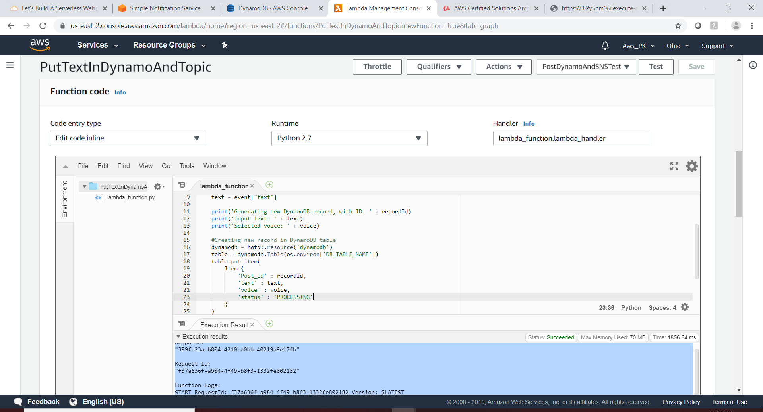

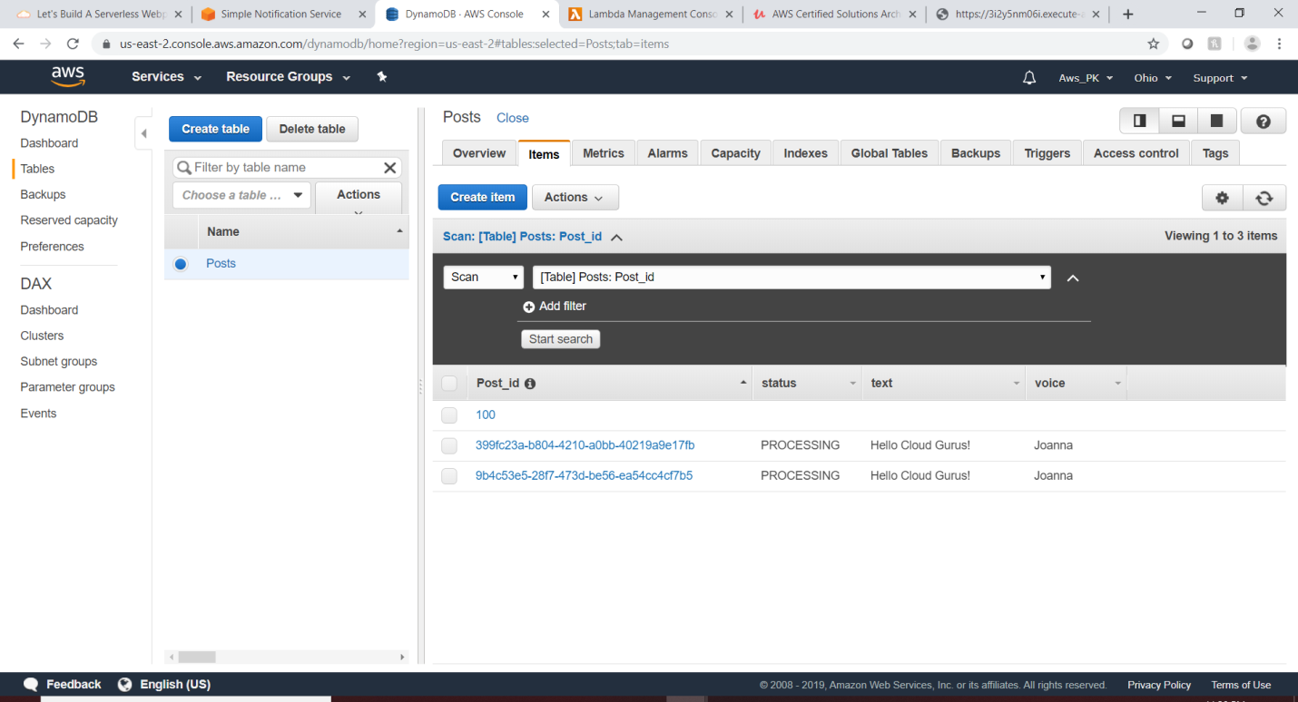

SNS

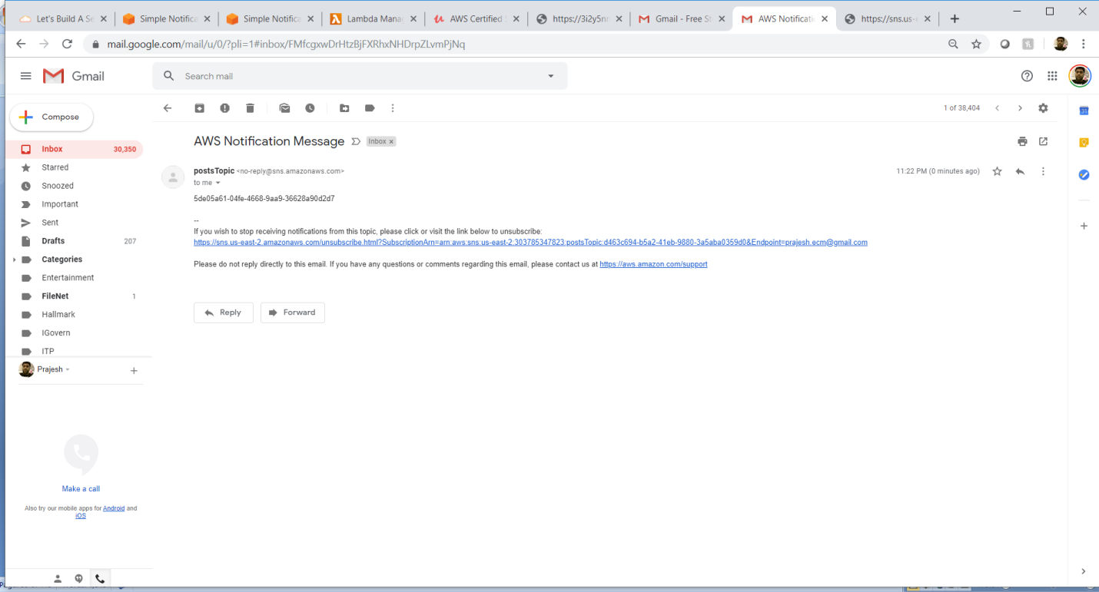

# Lambda 2: create lambda for getSNSAndCovertTextAndStoreinS3AndDynamo

# 

# Lambda 3: create lambda for getTextSearchInDynamoDB and test case to search the post from dynamodb

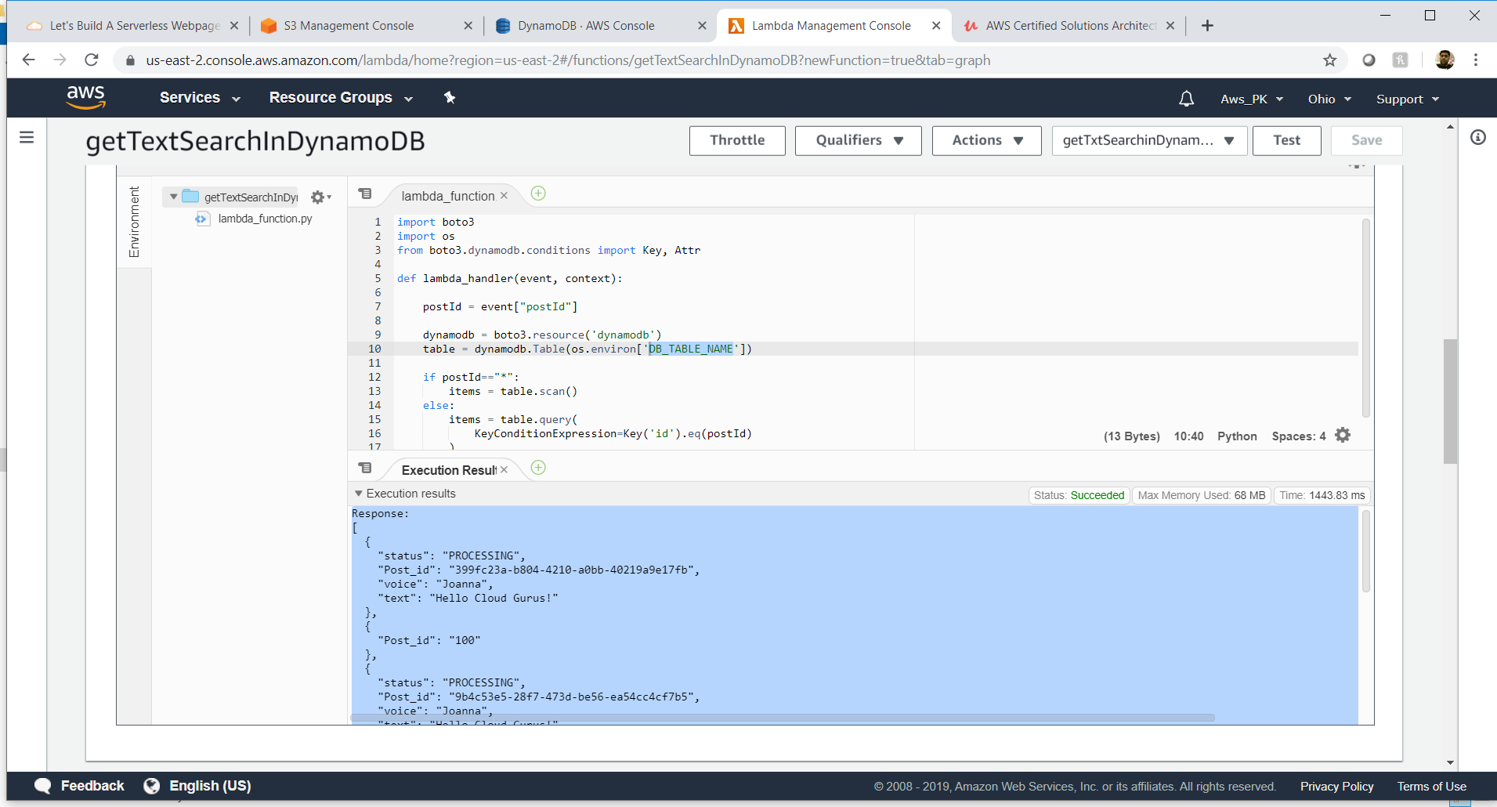

|  |
| --- |
| Response:  [  {  "status": "PROCESSING",  "Post_id": "399fc23a-b804-4210-a0bb-40219a9e17fb",  "voice": "Joanna",  "text": "Hello Cloud Gurus!"  },  {  "Post_id": "100"  },  {  "status": "PROCESSING",  "Post_id": "9b4c53e5-28f7-473d-be56-ea54cc4cf7b5",  "voice": "Joanna",  "text": "Hello Cloud Gurus!"  },  {  "status": "PROCESSING",  "Post_id": "5de05a61-04fe-4668-9aa9-36628a90d2d7",  "voice": "Joanna",  "text": "Hello Cloud Gurus!"  }  ]  Request ID:  "7663608a-f142-4841-9361-dc291ba6dbd8"  Function Logs:  START RequestId: 7663608a-f142-4841-9361-dc291ba6dbd8 Version: $LATEST  END RequestId: 7663608a-f142-4841-9361-dc291ba6dbd8  REPORT RequestId: 7663608a-f142-4841-9361-dc291ba6dbd8 Duration: 1443.83 ms Billed Duration: 1500 ms Memory Size: 128 MB Max Memory Used: 68 MB Init Duration: 117.71 ms  XRAY TraceId: 1-5d8058b3-57e29210b8fd61d04de80a98 SegmentId: 38d2461615adea0e Sampled: false |

**NOTES Section**

Note: for AWS Account Creation

* Just use the Personal Account type
* Map the credit Card and address

|  |
| --- |
| #!/bin/bash  yum install httpd -y  yum update -y  aws s3 cp s3://s3.amazonaws.com/prajifirstbucket/PrajiList/Understand_AWS.txt /var/www/html/ --recursive  service httpd start  chkconfig httpd on  https://s3.amazonaws.com/prajifirstbucket/PrajiList/Understand_AWS.txt  for putty for AWS.  1.Download putty and puttyGen  https://www.chiark.greenend.org.uk/~sgtatham/putty/latest.html  Convert .pem to .ppk using puttyGen as windows support only .ppk (.pem to .ppk)  2.Load the .ppk in putty and start session  3.loginto the session ,  3.1 : move as root user : sudo su  3.1 : update configuration : yum update -y  3.3 : install apache server : yum install httpd -y  : create one html and add some text (i.e , hellow world)and save it.  : cd /var/www/html  :ls  :nano index.html  <html><h1> hi</html></h1>  Ctrl + X , yes , Enter.  3.4 : start service : service httpd start  3.5 : Test ur browser http://<IPv4 Public IP>/ |

Note: for Certification and AWS platform:

Aws certified solutions architect exam blueprint

<https://aws.amazon.com/certification/certified-solutions-architect-associate/> (exam link)

Plarform

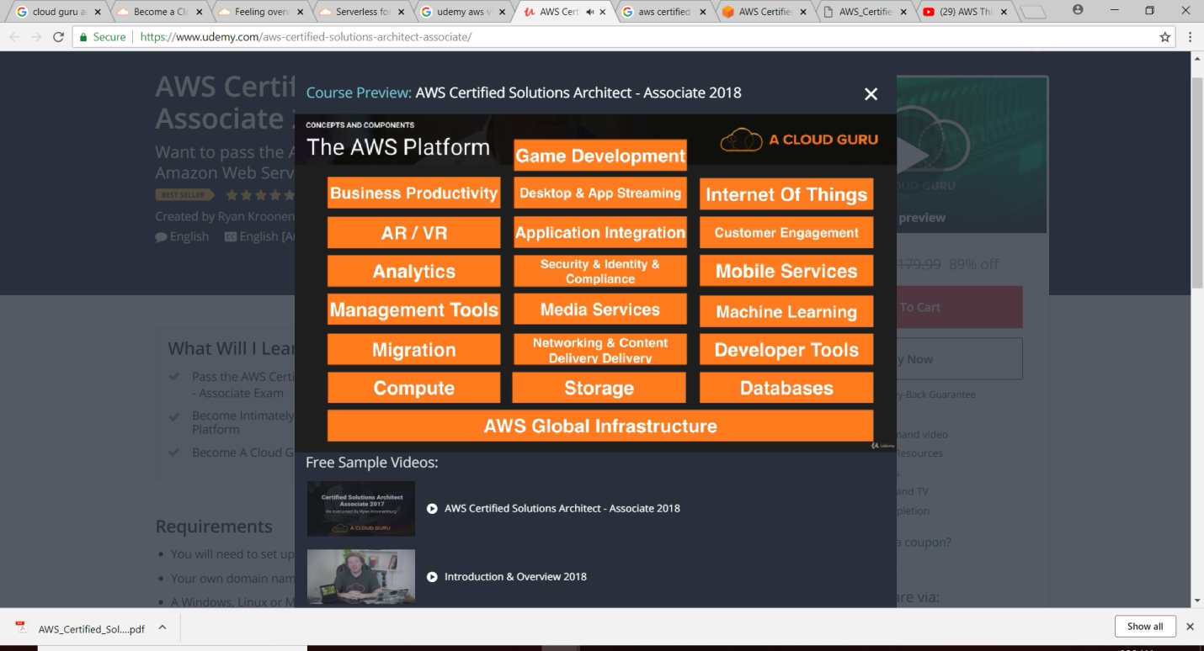

Key Service for Solution Architect Associate

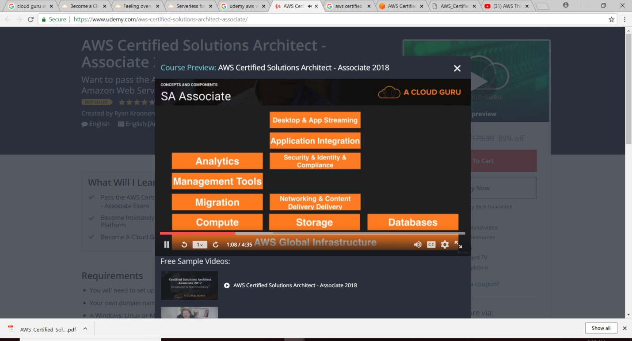

**TroubleShoot**

**TroubleShoot_1:**

[**https://docs.aws.amazon.com/AWSEC2/latest/UserGuide/TroubleshootingInstancesConnecting.html**](https://docs.aws.amazon.com/AWSEC2/latest/UserGuide/TroubleshootingInstancesConnecting.html)

Solution: My .ppk is wrongly mapped with the .pem file.

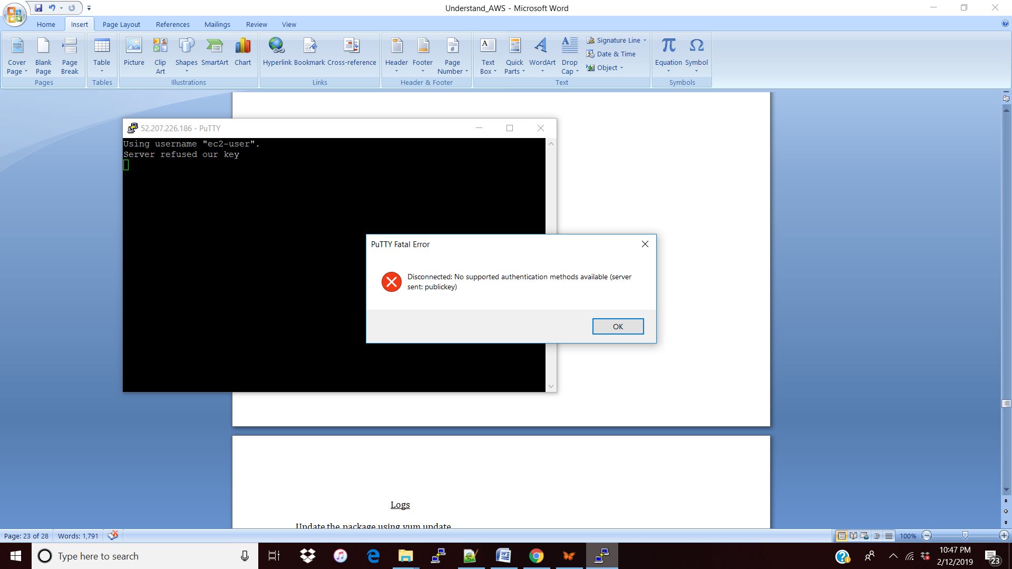

Logs

Update the package using yum update

|  |
| --- |
| Resolving Dependencies  --> Running transaction check  ---> Package amazon-ssm-agent.x86_64 0:2.3.68.0-1.amzn1 will be updated  ---> Package amazon-ssm-agent.x86_64 0:2.3.274.0-1.amzn1 will be an update  ---> Package aws-cfn-bootstrap.noarch 0:1.4-30.21.amzn1 will be updated  ---> Package aws-cfn-bootstrap.noarch 0:1.4-31.22.amzn1 will be an update  ---> Package curl.x86_64 0:7.53.1-16.84.amzn1 will be updated  ---> Package curl.x86_64 0:7.61.1-7.91.amzn1 will be an update  ---> Package glibc.x86_64 0:2.17-222.173.amzn1 will be updated  ---> Package glibc.x86_64 0:2.17-260.175.amzn1 will be an update  ---> Package glibc-common.x86_64 0:2.17-222.173.amzn1 will be updated  ---> Package glibc-common.x86_64 0:2.17-260.175.amzn1 will be an update  ---> Package kernel.x86_64 0:4.14.97-74.72.amzn1 will be installed  ---> Package krb5-libs.x86_64 0:1.15.1-19.43.amzn1 will be updated  ---> Package krb5-libs.x86_64 0:1.15.1-34.44.amzn1 will be an update  ---> Package libcurl.x86_64 0:7.53.1-16.84.amzn1 will be updated  ---> Package libcurl.x86_64 0:7.61.1-7.91.amzn1 will be an update  ---> Package openssl.x86_64 1:1.0.2k-13.111.amzn1 will be updated  ---> Package openssl.x86_64 1:1.0.2k-16.146.amzn1 will be an update  ---> Package python27.x86_64 0:2.7.14-1.123.amzn1 will be updated  ---> Package python27.x86_64 0:2.7.15-1.124.amzn1 will be an update  ---> Package python27-devel.x86_64 0:2.7.14-1.123.amzn1 will be updated  ---> Package python27-devel.x86_64 0:2.7.15-1.124.amzn1 will be an update  ---> Package python27-libs.x86_64 0:2.7.14-1.123.amzn1 will be updated  ---> Package python27-libs.x86_64 0:2.7.15-1.124.amzn1 will be an update  --> Finished Dependency Resolution  Dependencies Resolved  ================================================================================  Package Arch Version Repository Size  ================================================================================  Installing:  kernel x86_64 4.14.97-74.72.amzn1 amzn-updates 21 M  Updating:  amazon-ssm-agent x86_64 2.3.274.0-1.amzn1 amzn-updates 19 M  aws-cfn-bootstrap noarch 1.4-31.22.amzn1 amzn-updates 874 k  curl x86_64 7.61.1-7.91.amzn1 amzn-updates 362 k  glibc x86_64 2.17-260.175.amzn1 amzn-updates 5.8 M  glibc-common x86_64 2.17-260.175.amzn1 amzn-updates 28 M  krb5-libs x86_64 1.15.1-34.44.amzn1 amzn-updates 882 k  libcurl x86_64 7.61.1-7.91.amzn1 amzn-updates 306 k  openssl x86_64 1:1.0.2k-16.146.amzn1 amzn-updates 1.8 M  python27 x86_64 2.7.15-1.124.amzn1 amzn-updates 103 k  python27-devel x86_64 2.7.15-1.124.amzn1 amzn-updates 525 k  python27-libs x86_64 2.7.15-1.124.amzn1 amzn-updates 6.8 M  Transaction Summary  ================================================================================  Install 1 Package  Upgrade 11 Packages  Total download size: 85 M  Downloading packages:  (1/12): aws-cfn-bootstrap-1.4-31.22.amzn1.noarch.rpm | 874 kB 00:00  (2/12): glibc-2.17-260.175.amzn1.x86_64.rpm | 5.8 MB 00:00  (3/12): amazon-ssm-agent-2.3.274.0-1.amzn1.x86_64.rpm | 19 MB 00:02  (4/12): curl-7.61.1-7.91.amzn1.x86_64.rpm | 362 kB 00:02  (5/12): glibc-common-2.17-260.175.amzn1.x86_64.rpm | 28 MB 00:03  (6/12): krb5-libs-1.15.1-34.44.amzn1.x86_64.rpm | 882 kB 00:00  (7/12): libcurl-7.61.1-7.91.amzn1.x86_64.rpm | 306 kB 00:00  (8/12): openssl-1.0.2k-16.146.amzn1.x86_64.rpm | 1.8 MB 00:00  (9/12): kernel-4.14.97-74.72.amzn1.x86_64.rpm | 21 MB 00:02  (10/12): python27-2.7.15-1.124.amzn1.x86_64.rpm | 103 kB 00:00  (11/12): python27-devel-2.7.15-1.124.amzn1.x86_64.rpm | 525 kB 00:00  (12/12): python27-libs-2.7.15-1.124.amzn1.x86_64.rpm | 6.8 MB 00:01  --------------------------------------------------------------------------------  Total 13 MB/s | 85 MB 00:06  Running transaction check  Running transaction test  Transaction test succeeded  Running transaction  Updating : glibc-common-2.17-260.175.amzn1.x86_64 1/23  Updating : glibc-2.17-260.175.amzn1.x86_64 2/23  Updating : 1:openssl-1.0.2k-16.146.amzn1.x86_64 3/23  Updating : krb5-libs-1.15.1-34.44.amzn1.x86_64 4/23  Updating : python27-2.7.15-1.124.amzn1.x86_64 5/23  Updating : python27-libs-2.7.15-1.124.amzn1.x86_64 6/23  Updating : libcurl-7.61.1-7.91.amzn1.x86_64 7/23  Updating : curl-7.61.1-7.91.amzn1.x86_64 8/23  Updating : python27-devel-2.7.15-1.124.amzn1.x86_64 9/23  Updating : aws-cfn-bootstrap-1.4-31.22.amzn1.noarch 10/23  Updating : amazon-ssm-agent-2.3.274.0-1.amzn1.x86_64 11/23  Installing : kernel-4.14.97-74.72.amzn1.x86_64 12/23  Cleanup : python27-devel-2.7.14-1.123.amzn1.x86_64 13/23  Cleanup : curl-7.53.1-16.84.amzn1.x86_64 14/23  Cleanup : aws-cfn-bootstrap-1.4-30.21.amzn1.noarch 15/23  Cleanup : python27-2.7.14-1.123.amzn1.x86_64 16/23  Cleanup : python27-libs-2.7.14-1.123.amzn1.x86_64 17/23  Cleanup : libcurl-7.53.1-16.84.amzn1.x86_64 18/23  Cleanup : 1:openssl-1.0.2k-13.111.amzn1.x86_64 19/23  Cleanup : krb5-libs-1.15.1-19.43.amzn1.x86_64 20/23  Cleanup : amazon-ssm-agent-2.3.68.0-1.amzn1.x86_64 21/23  Cleanup : glibc-common-2.17-222.173.amzn1.x86_64 22/23  Cleanup : glibc-2.17-222.173.amzn1.x86_64 23/23  Verifying : curl-7.61.1-7.91.amzn1.x86_64 1/23  Verifying : libcurl-7.61.1-7.91.amzn1.x86_64 2/23  Verifying : python27-libs-2.7.15-1.124.amzn1.x86_64 3/23  Verifying : python27-2.7.15-1.124.amzn1.x86_64 4/23  Verifying : glibc-2.17-260.175.amzn1.x86_64 5/23  Verifying : 1:openssl-1.0.2k-16.146.amzn1.x86_64 6/23  Verifying : aws-cfn-bootstrap-1.4-31.22.amzn1.noarch 7/23  Verifying : kernel-4.14.97-74.72.amzn1.x86_64 8/23  Verifying : python27-devel-2.7.15-1.124.amzn1.x86_64 9/23  Verifying : amazon-ssm-agent-2.3.274.0-1.amzn1.x86_64 10/23  Verifying : glibc-common-2.17-260.175.amzn1.x86_64 11/23  Verifying : krb5-libs-1.15.1-34.44.amzn1.x86_64 12/23  Verifying : 1:openssl-1.0.2k-13.111.amzn1.x86_64 13/23  Verifying : glibc-2.17-222.173.amzn1.x86_64 14/23  Verifying : libcurl-7.53.1-16.84.amzn1.x86_64 15/23  Verifying : python27-devel-2.7.14-1.123.amzn1.x86_64 16/23  Verifying : glibc-common-2.17-222.173.amzn1.x86_64 17/23  Verifying : aws-cfn-bootstrap-1.4-30.21.amzn1.noarch 18/23  Verifying : amazon-ssm-agent-2.3.68.0-1.amzn1.x86_64 19/23  Verifying : krb5-libs-1.15.1-19.43.amzn1.x86_64 20/23  Verifying : python27-2.7.14-1.123.amzn1.x86_64 21/23  Verifying : python27-libs-2.7.14-1.123.amzn1.x86_64 22/23  Verifying : curl-7.53.1-16.84.amzn1.x86_64 23/23  Installed:  kernel.x86_64 0:4.14.97-74.72.amzn1  Updated:  amazon-ssm-agent.x86_64 0:2.3.274.0-1.amzn1  aws-cfn-bootstrap.noarch 0:1.4-31.22.amzn1  curl.x86_64 0:7.61.1-7.91.amzn1  glibc.x86_64 0:2.17-260.175.amzn1  glibc-common.x86_64 0:2.17-260.175.amzn1  krb5-libs.x86_64 0:1.15.1-34.44.amzn1  libcurl.x86_64 0:7.61.1-7.91.amzn1  openssl.x86_64 1:1.0.2k-16.146.amzn1  python27.x86_64 0:2.7.15-1.124.amzn1  python27-devel.x86_64 0:2.7.15-1.124.amzn1  python27-libs.x86_64 0:2.7.15-1.124.amzn1  Complete! |

Install httpd

|  |
| --- |
| Loaded plugins: priorities, update-motd, upgrade-helper  Resolving Dependencies  --> Running transaction check  ---> Package httpd.x86_64 0:2.2.34-1.16.amzn1 will be installed  --> Processing Dependency: httpd-tools = 2.2.34-1.16.amzn1 for package: httpd-2.2.34-1.16.amzn1.x86_64  --> Processing Dependency: apr-util-ldap for package: httpd-2.2.34-1.16.amzn1.x86_64  --> Processing Dependency: libaprutil-1.so.0()(64bit) for package: httpd-2.2.34-1.16.amzn1.x86_64  --> Processing Dependency: libapr-1.so.0()(64bit) for package: httpd-2.2.34-1.16.amzn1.x86_64  --> Running transaction check  ---> Package apr.x86_64 0:1.5.2-5.13.amzn1 will be installed  ---> Package apr-util.x86_64 0:1.5.4-6.18.amzn1 will be installed  ---> Package apr-util-ldap.x86_64 0:1.5.4-6.18.amzn1 will be installed  ---> Package httpd-tools.x86_64 0:2.2.34-1.16.amzn1 will be installed  --> Finished Dependency Resolution  Dependencies Resolved  ===============================================================================================================================================================================================  Package Arch Version Repository Size  ===============================================================================================================================================================================================  Installing:  httpd x86_64 2.2.34-1.16.amzn1 amzn-main 1.2 M  Installing for dependencies:  apr x86_64 1.5.2-5.13.amzn1 amzn-main 118 k  apr-util x86_64 1.5.4-6.18.amzn1 amzn-main 99 k  apr-util-ldap x86_64 1.5.4-6.18.amzn1 amzn-main 19 k  httpd-tools x86_64 2.2.34-1.16.amzn1 amzn-main 80 k  Transaction Summary  ===============================================================================================================================================================================================  Install 1 Package (+4 Dependent packages)  Total download size: 1.5 M  Installed size: 3.6 M  Downloading packages:  (1/5): apr-util-1.5.4-6.18.amzn1.x86_64.rpm | 99 kB 00:00:00  (2/5): apr-util-ldap-1.5.4-6.18.amzn1.x86_64.rpm | 19 kB 00:00:00  (3/5): apr-1.5.2-5.13.amzn1.x86_64.rpm | 118 kB 00:00:00  (4/5): httpd-tools-2.2.34-1.16.amzn1.x86_64.rpm | 80 kB 00:00:00  (5/5): httpd-2.2.34-1.16.amzn1.x86_64.rpm | 1.2 MB 00:00:00  -----------------------------------------------------------------------------------------------------------------------------------------------------------------------------------------------  Total 2.2 MB/s | 1.5 MB 00:00:00  Running transaction check  Running transaction test  Transaction test succeeded  Running transaction  Installing : apr-1.5.2-5.13.amzn1.x86_64 1/5  Installing : apr-util-1.5.4-6.18.amzn1.x86_64 2/5  Installing : httpd-tools-2.2.34-1.16.amzn1.x86_64 3/5  Installing : apr-util-ldap-1.5.4-6.18.amzn1.x86_64 4/5  Installing : httpd-2.2.34-1.16.amzn1.x86_64 5/5  Verifying : httpd-tools-2.2.34-1.16.amzn1.x86_64 1/5  Verifying : apr-util-1.5.4-6.18.amzn1.x86_64 2/5  Verifying : httpd-2.2.34-1.16.amzn1.x86_64 3/5  Verifying : apr-1.5.2-5.13.amzn1.x86_64 4/5  Verifying : apr-util-ldap-1.5.4-6.18.amzn1.x86_64 5/5  Installed:  httpd.x86_64 0:2.2.34-1.16.amzn1  Dependency Installed:  apr.x86_64 0:1.5.2-5.13.amzn1 apr-util.x86_64 0:1.5.4-6.18.amzn1 apr-util-ldap.x86_64 0:1.5.4-6.18.amzn1 httpd-tools.x86_64 0:2.2.34-1.16.amzn1  Complete! |

Rough

Volume vs Snapshot

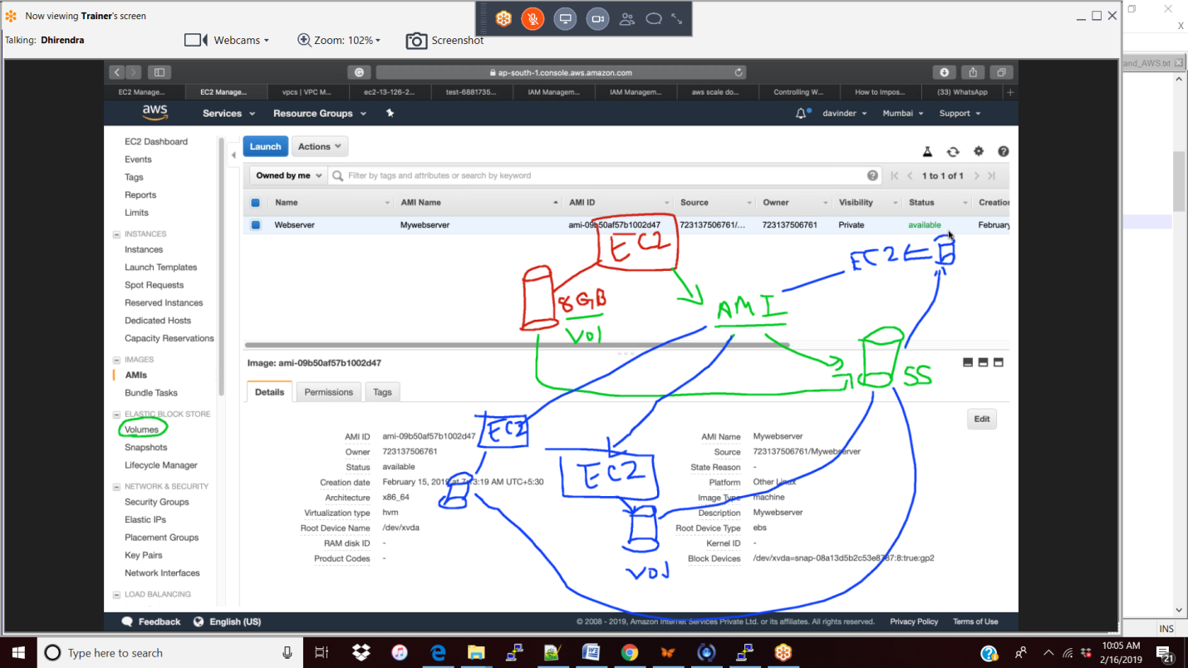

2/16

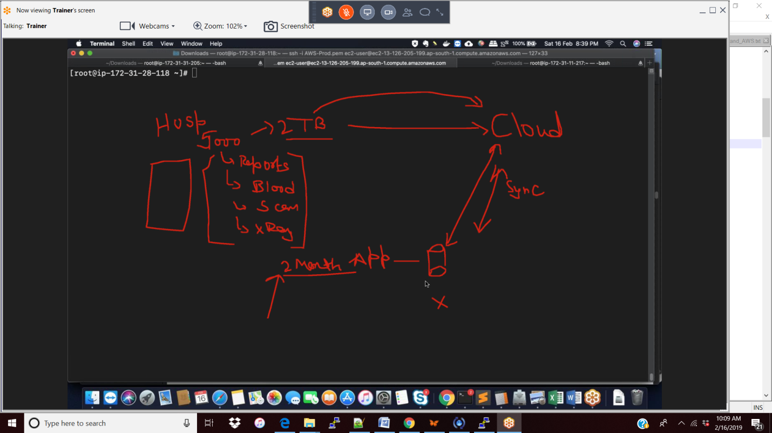

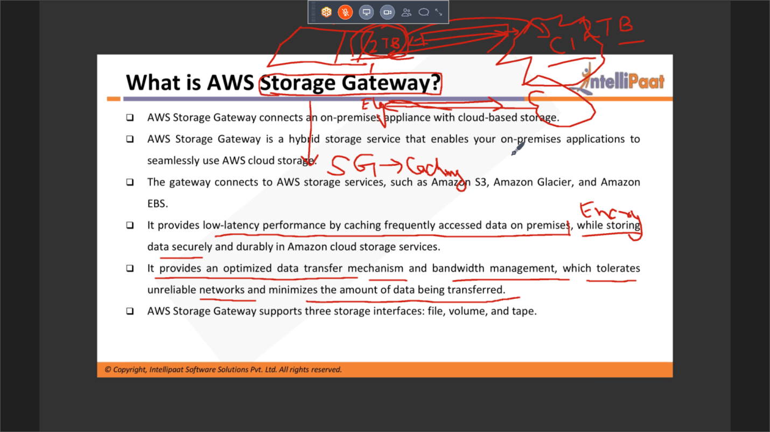

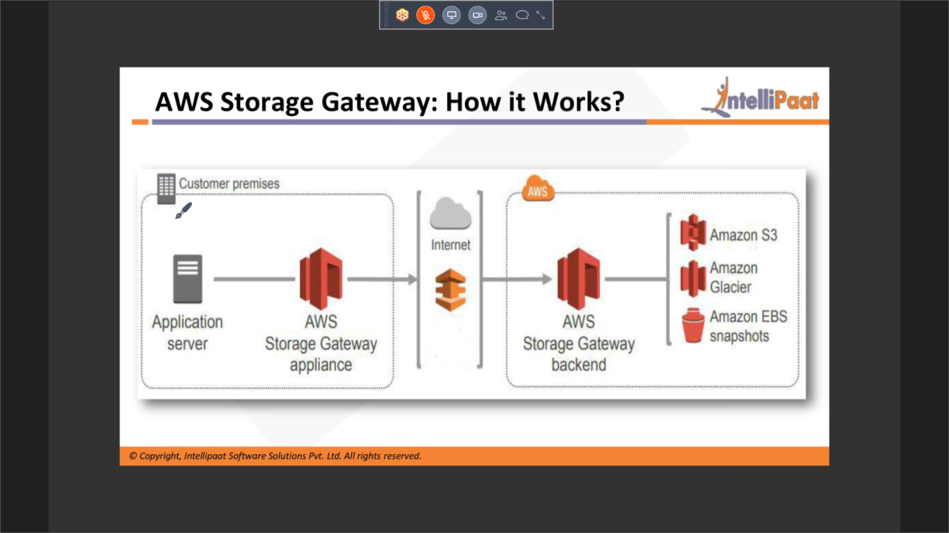

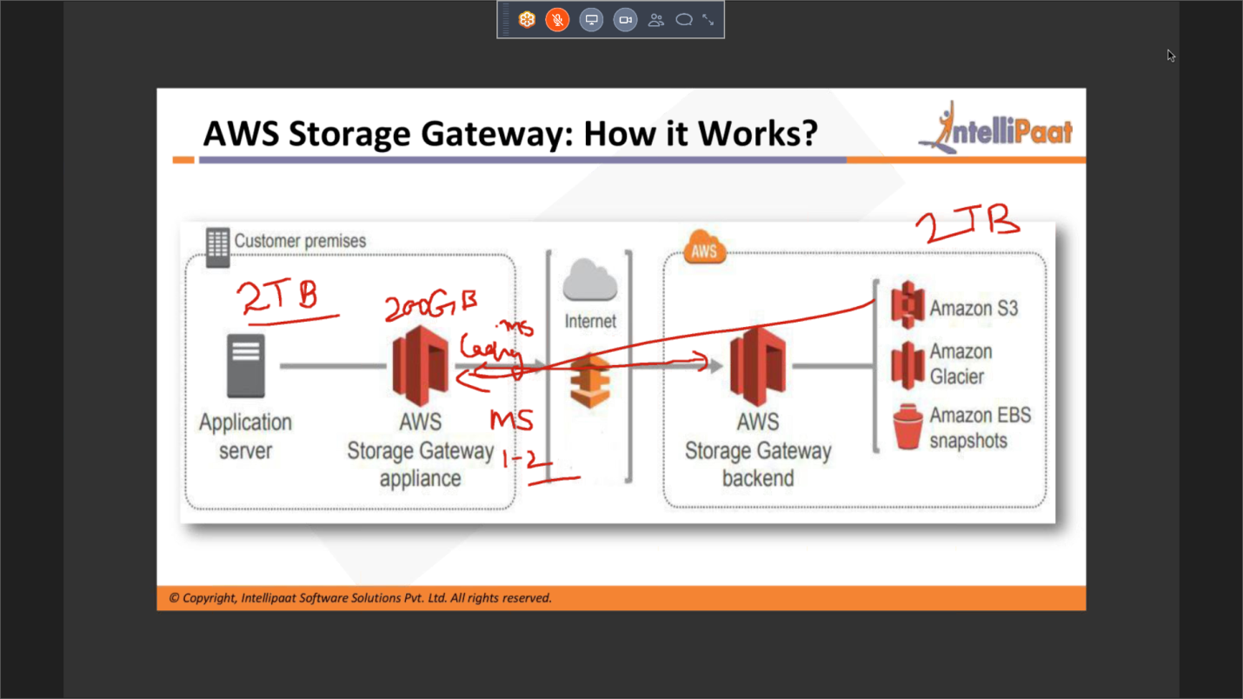

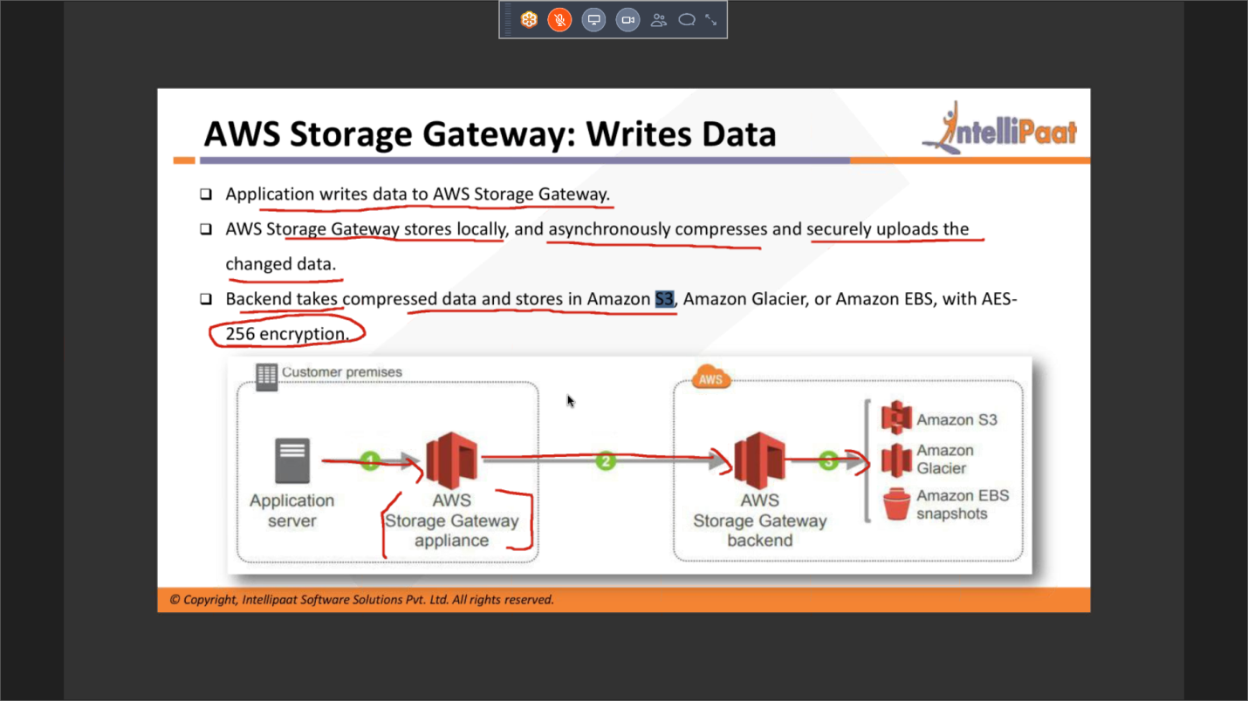

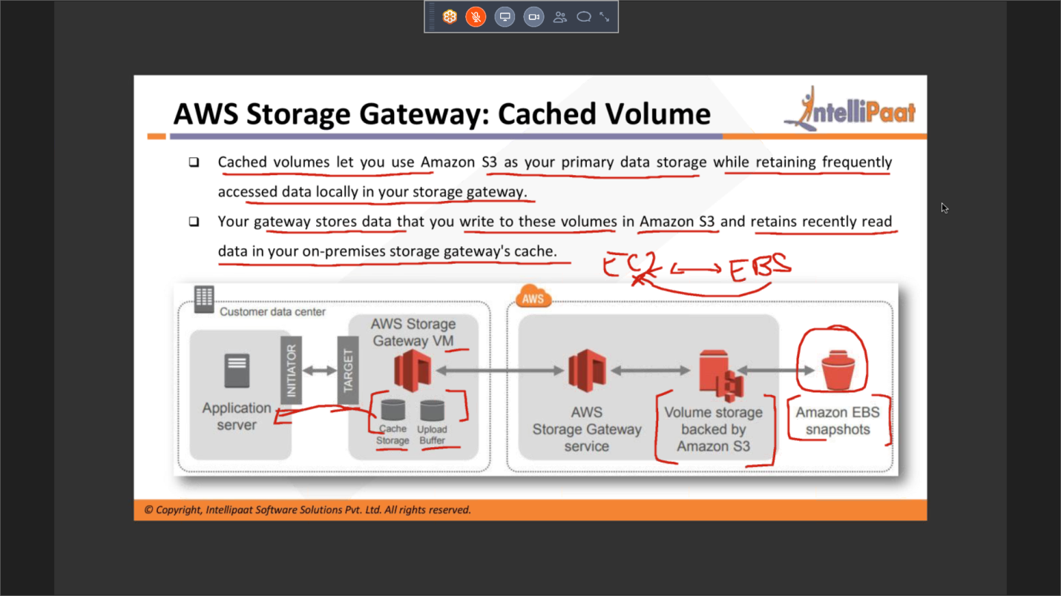

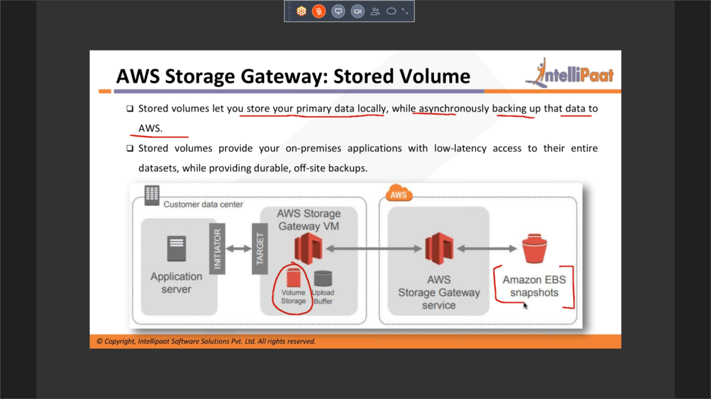

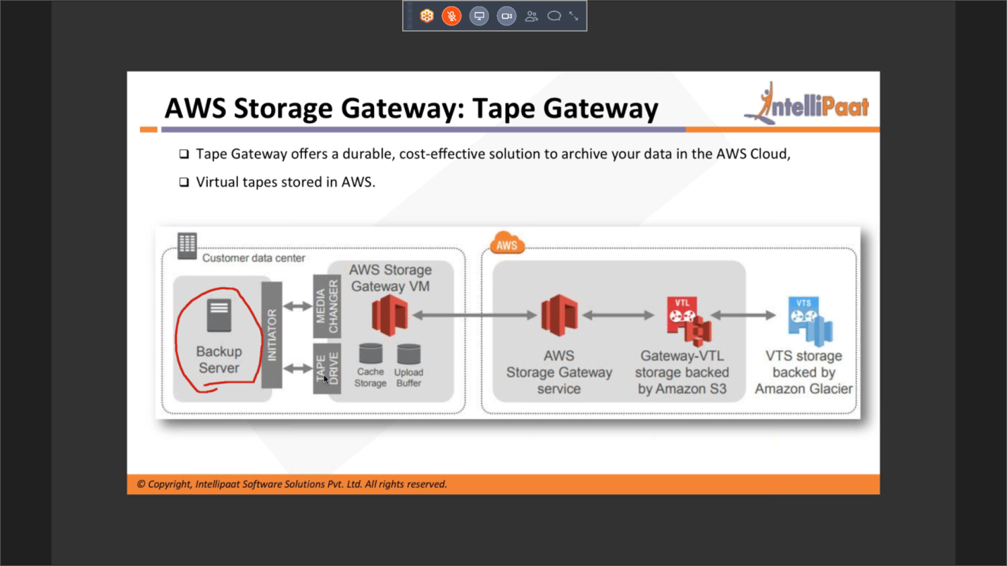

Practical

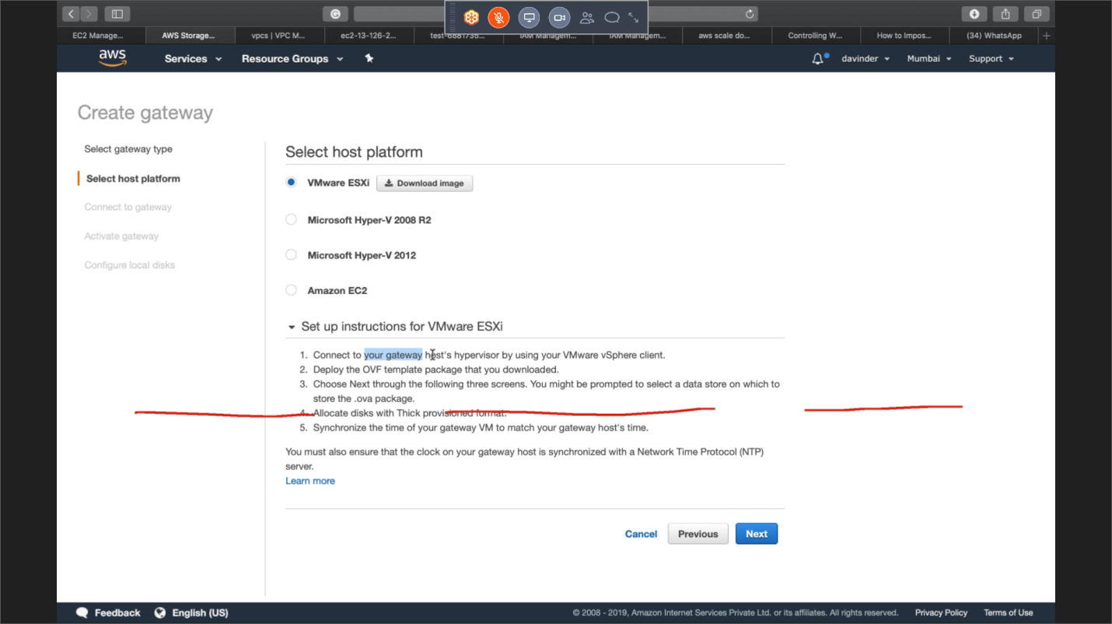

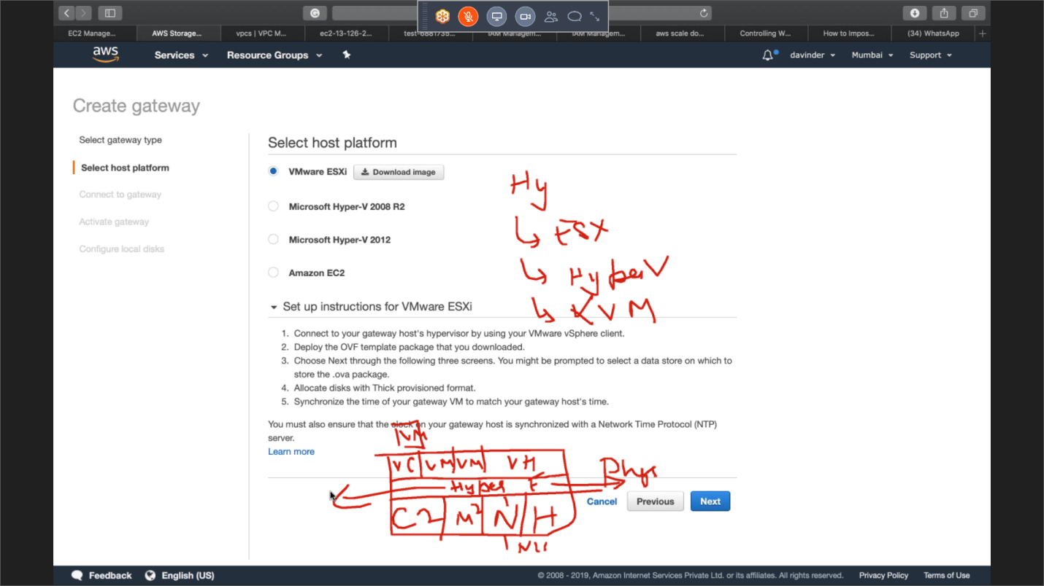

S3:

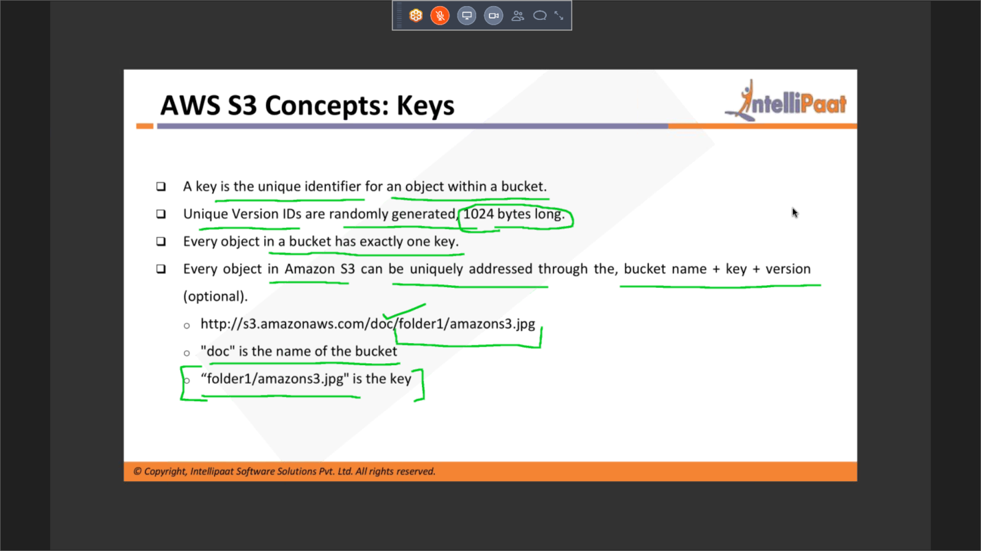

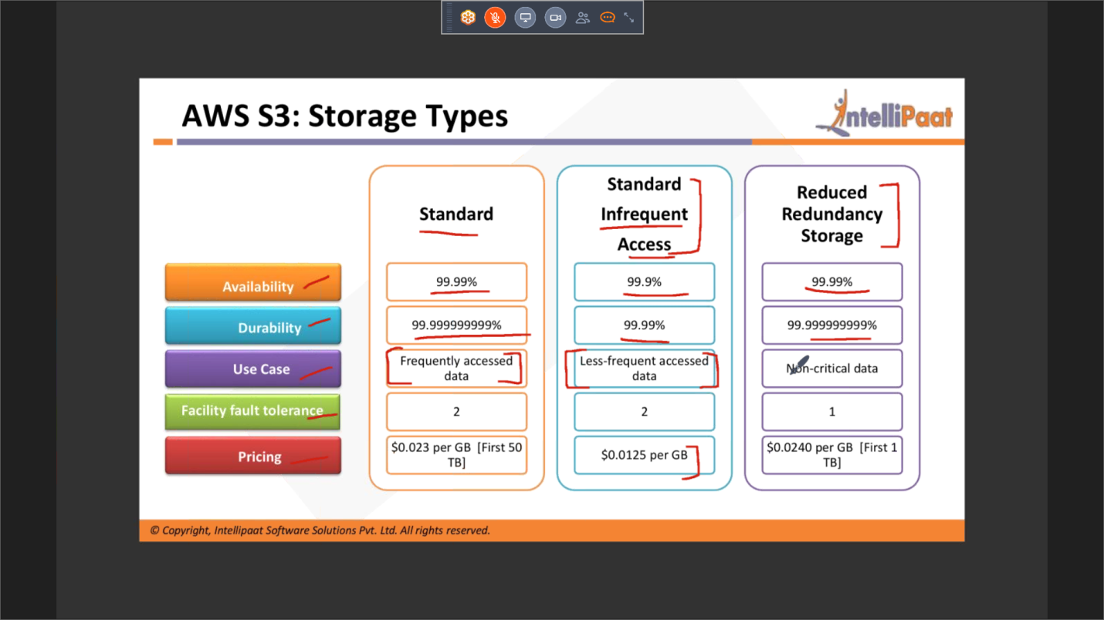

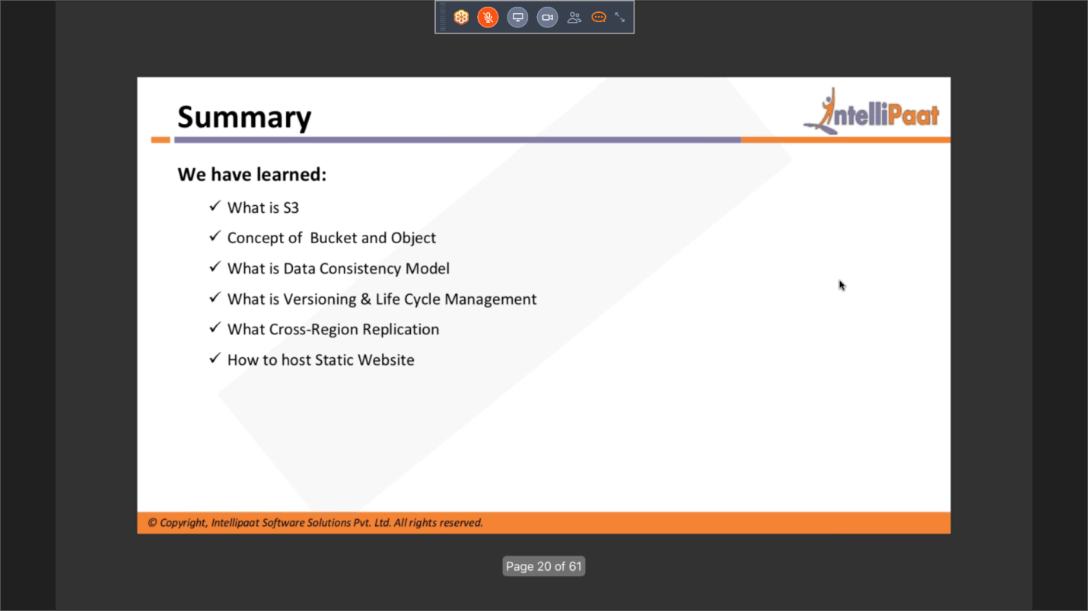

Archieval

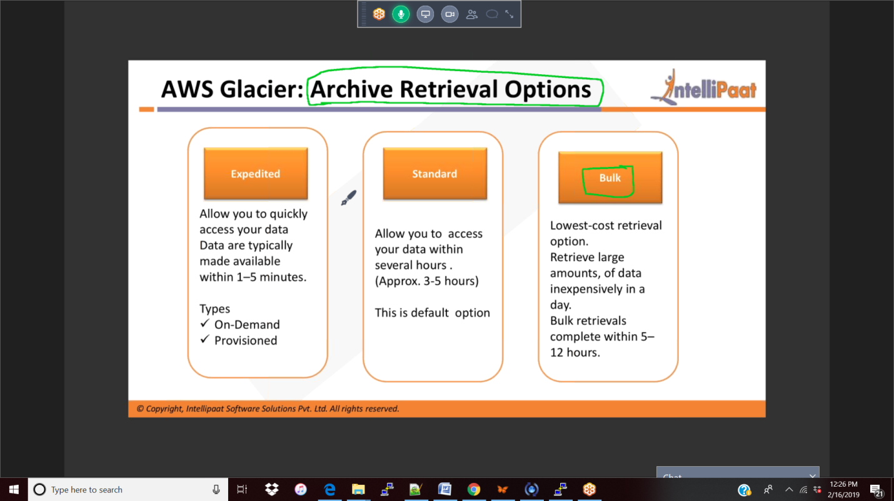

2/17/19:

Glacier:

Snowball:

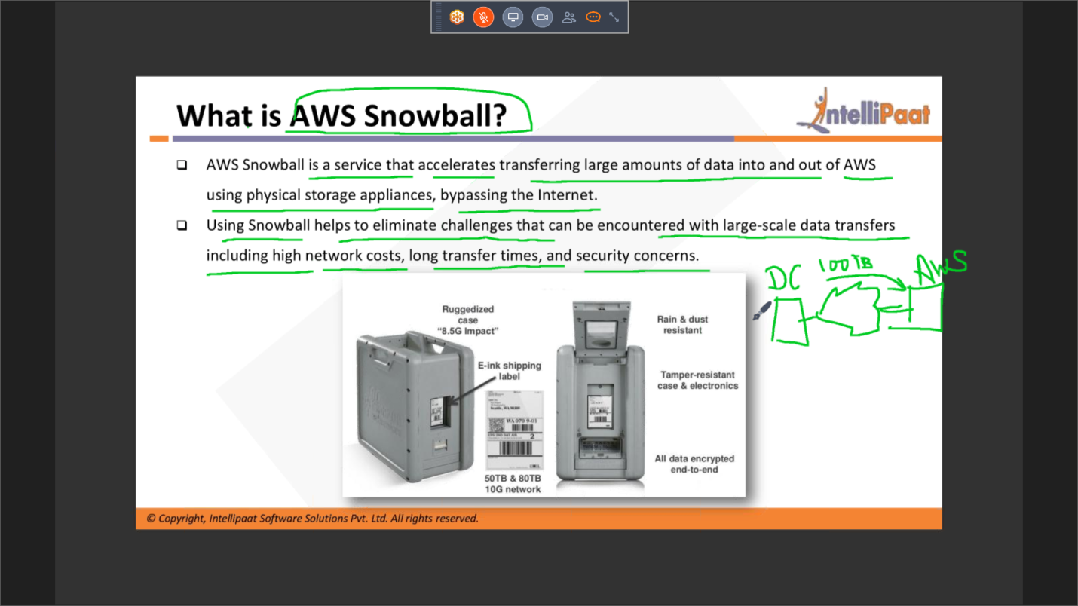

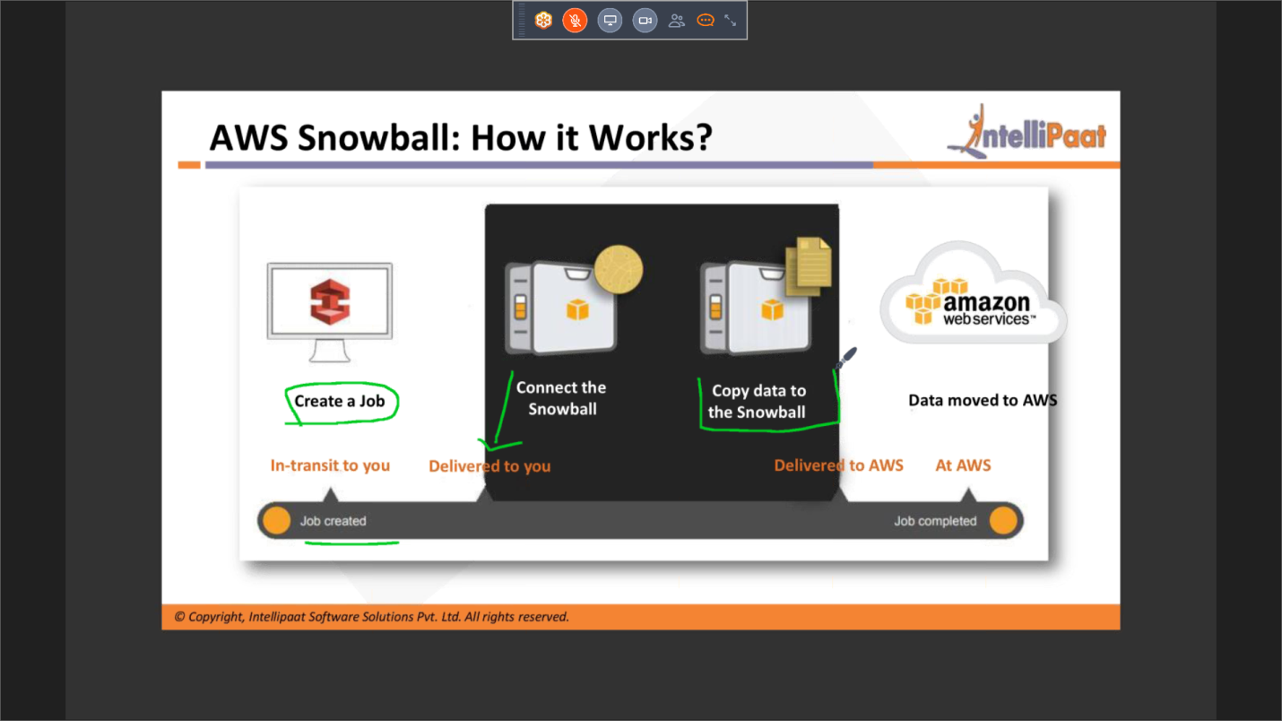

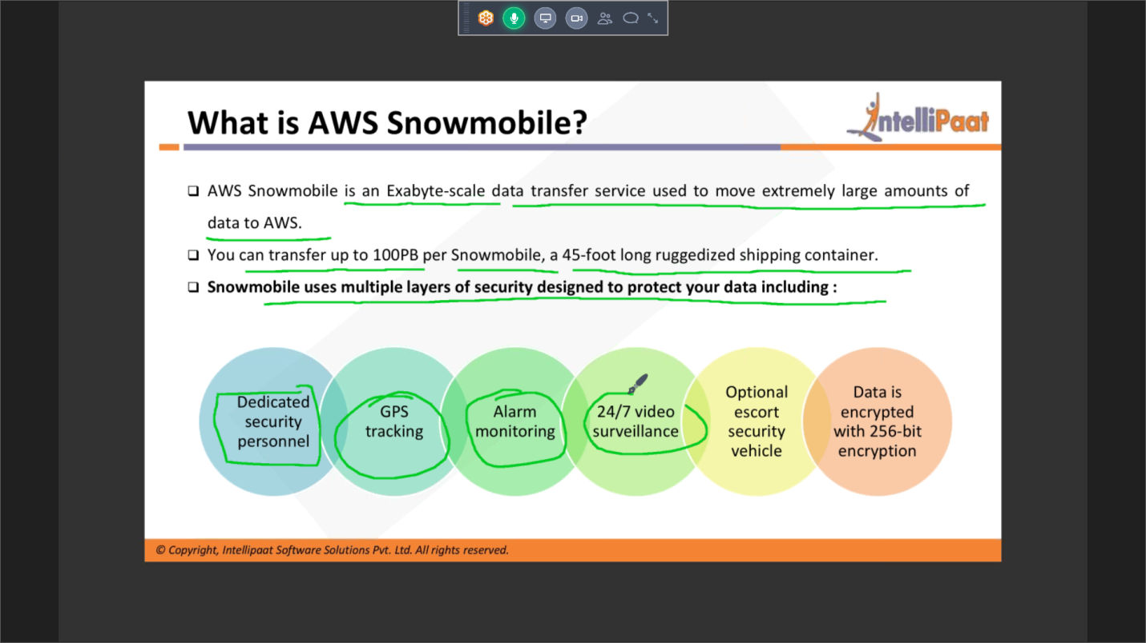

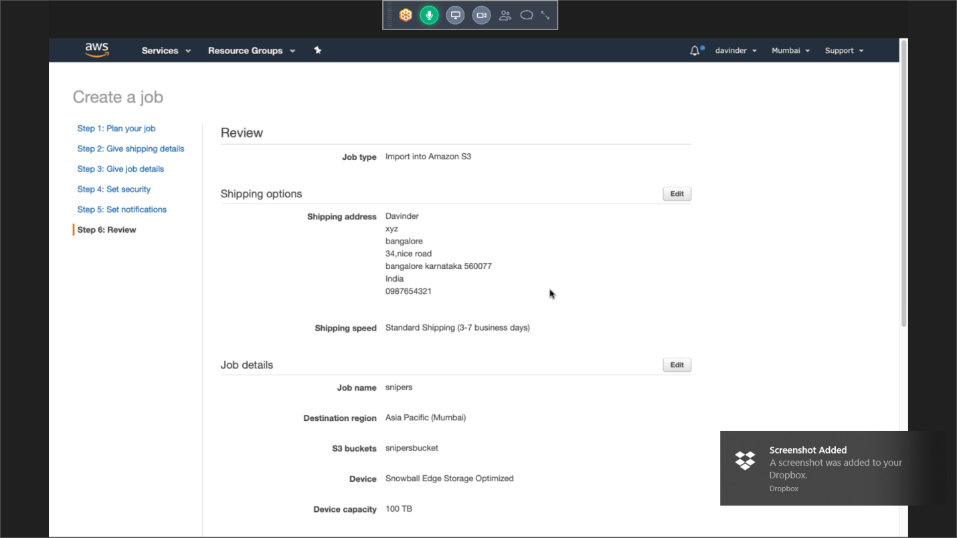

EFS:

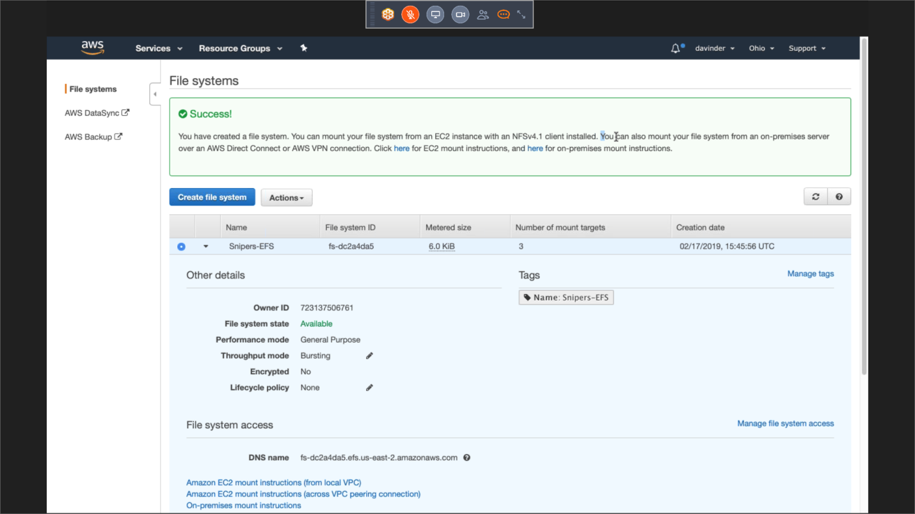

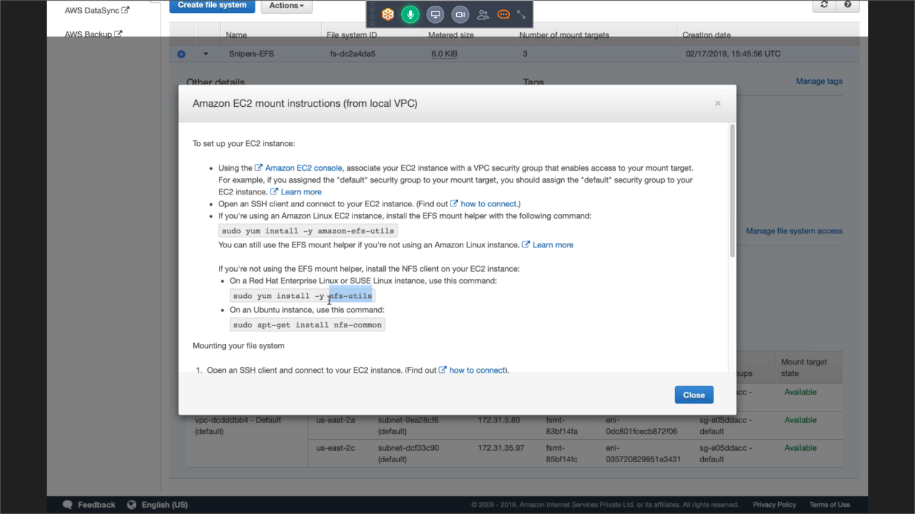

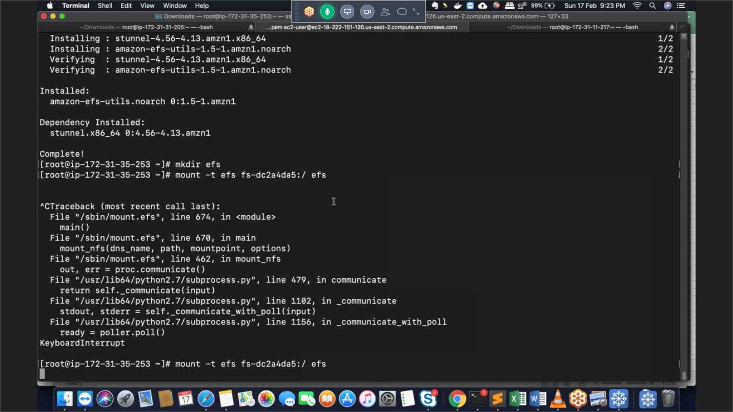

RDS:

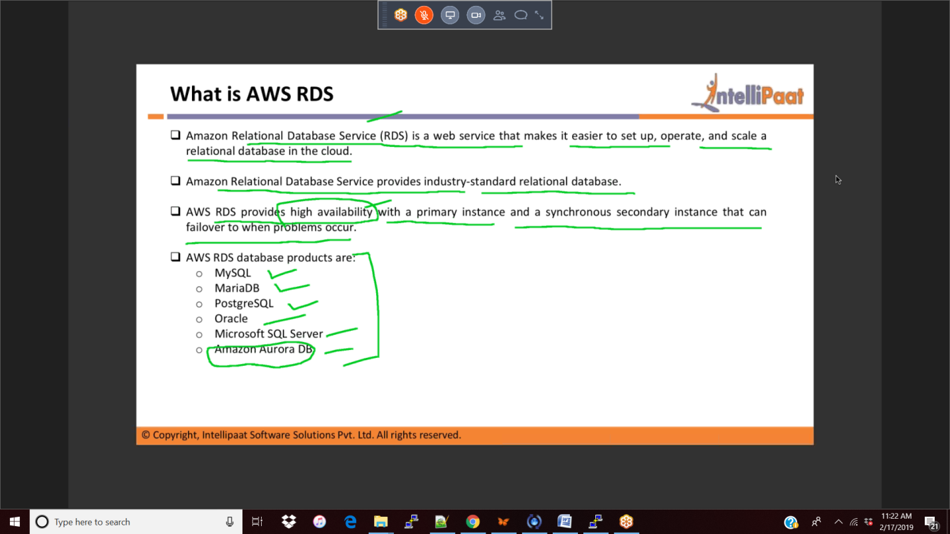

Read Replica

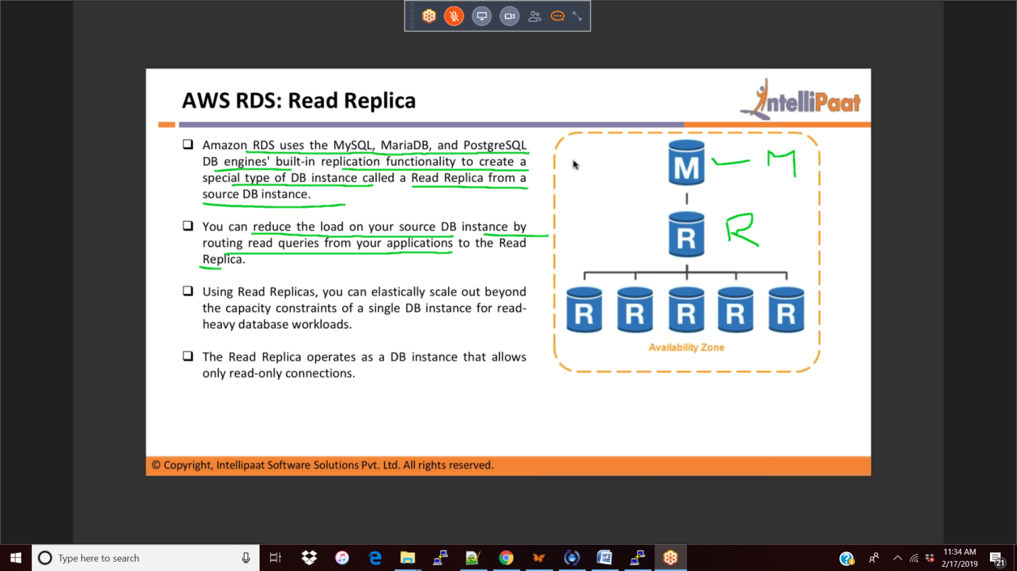

S3 logs:

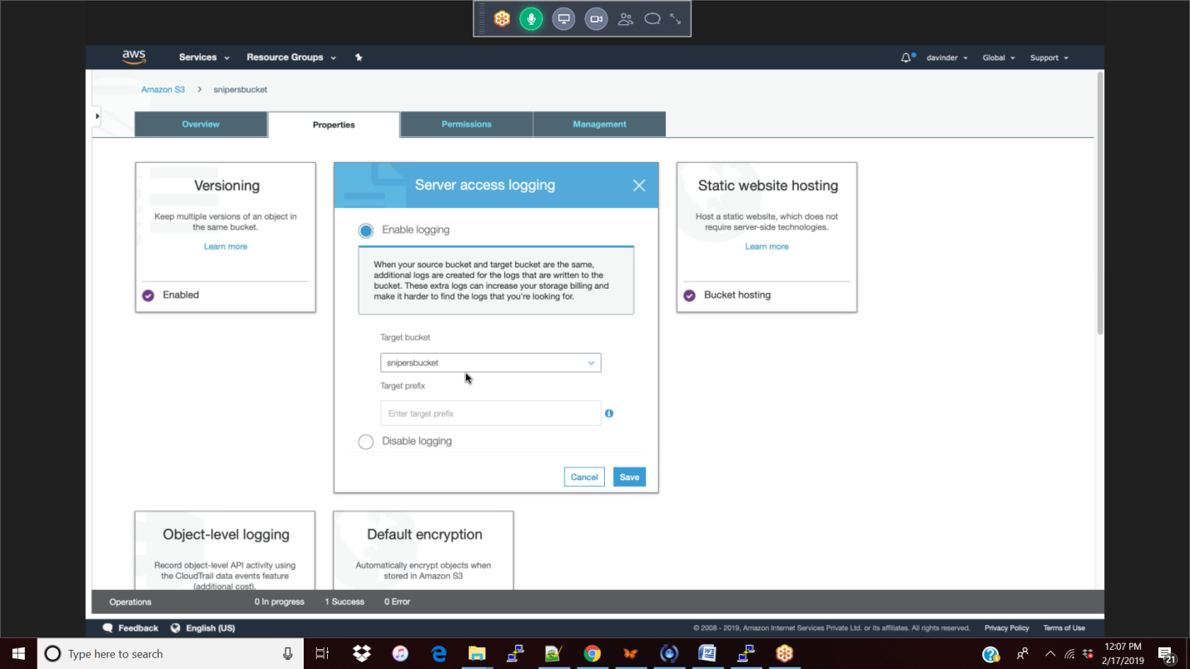

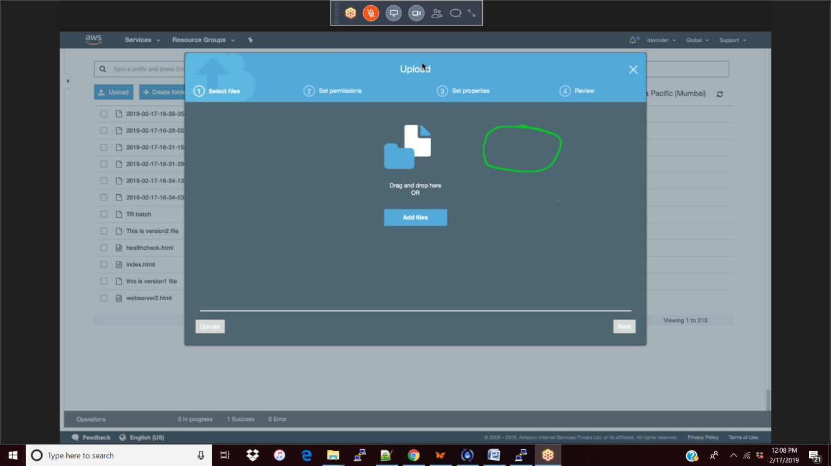

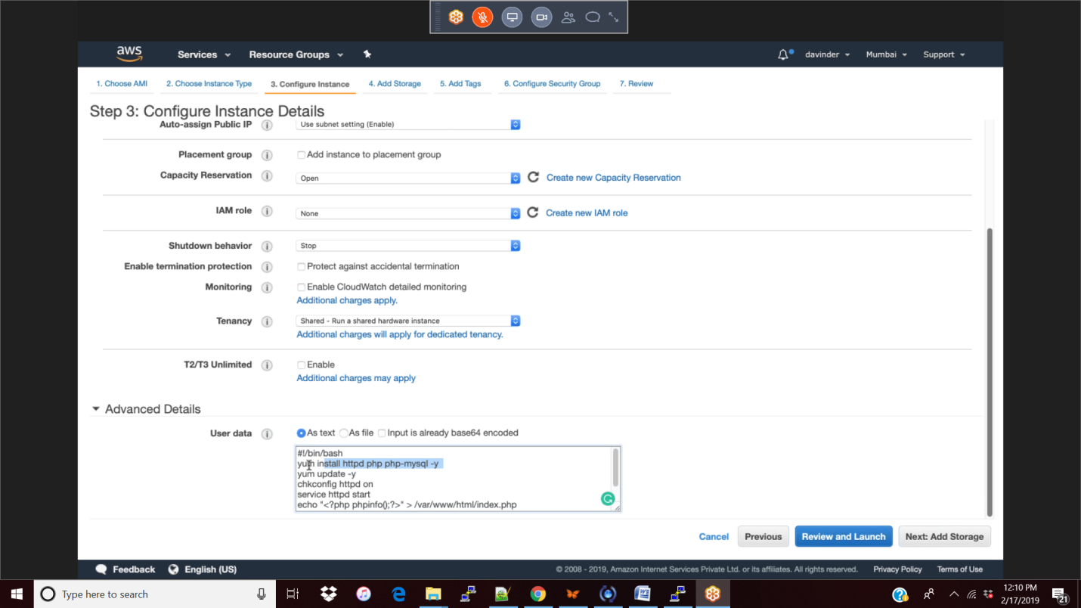

Dynamo DB

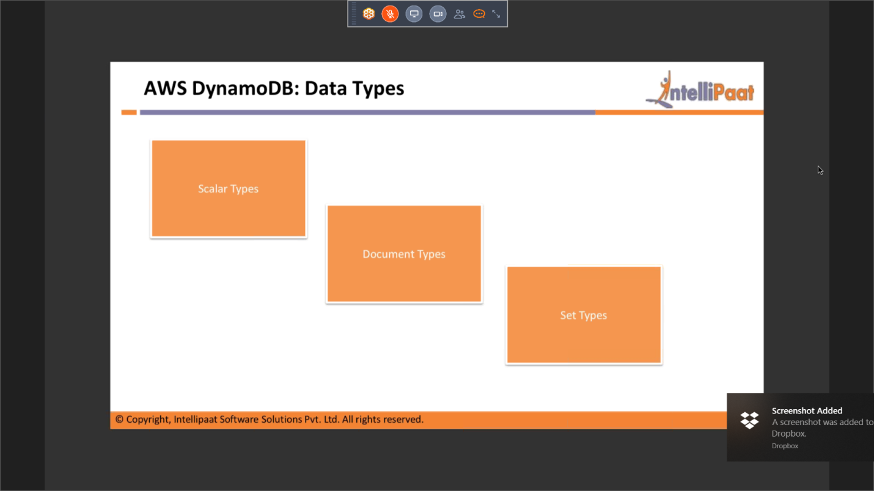

Elastic Cache

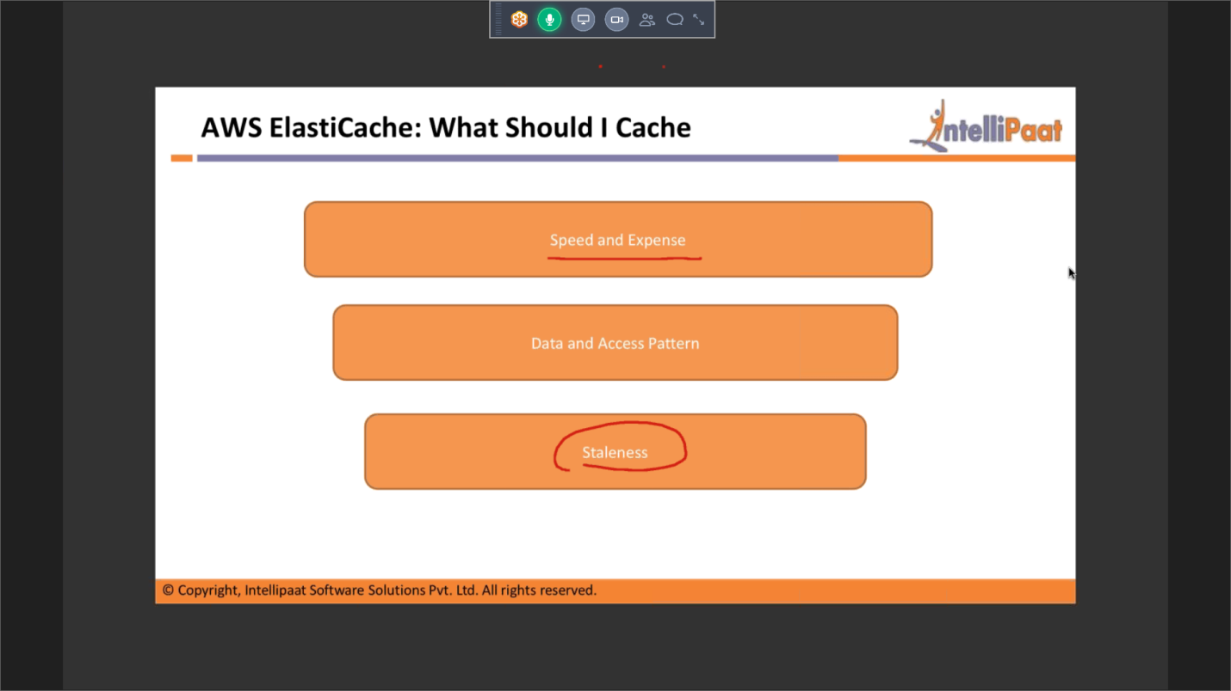

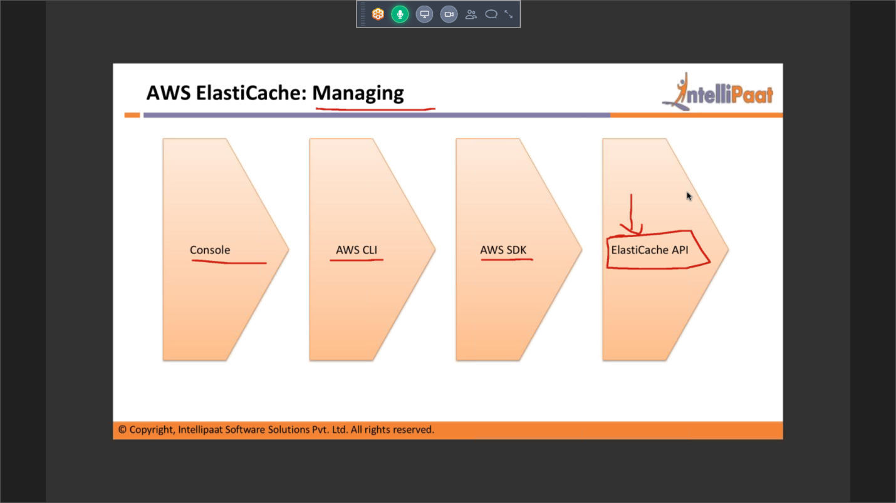

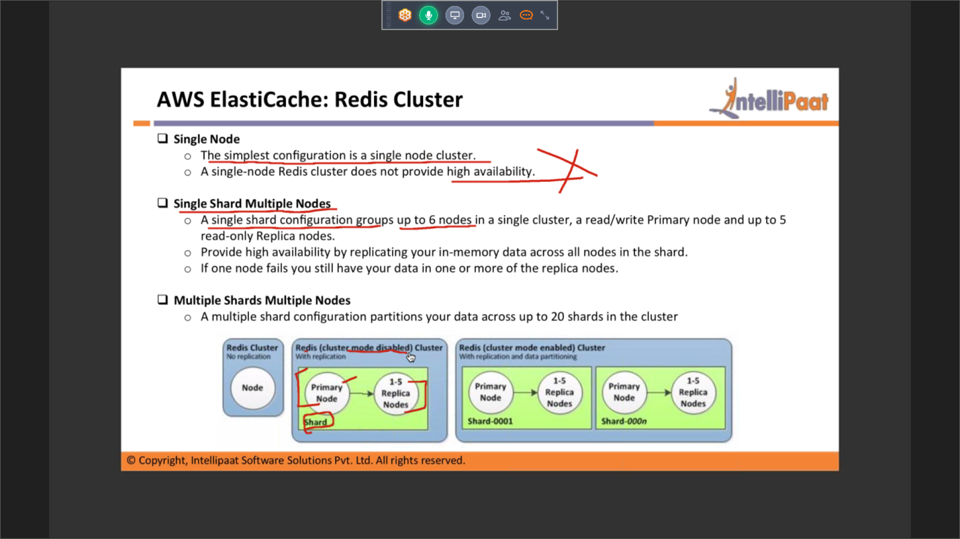

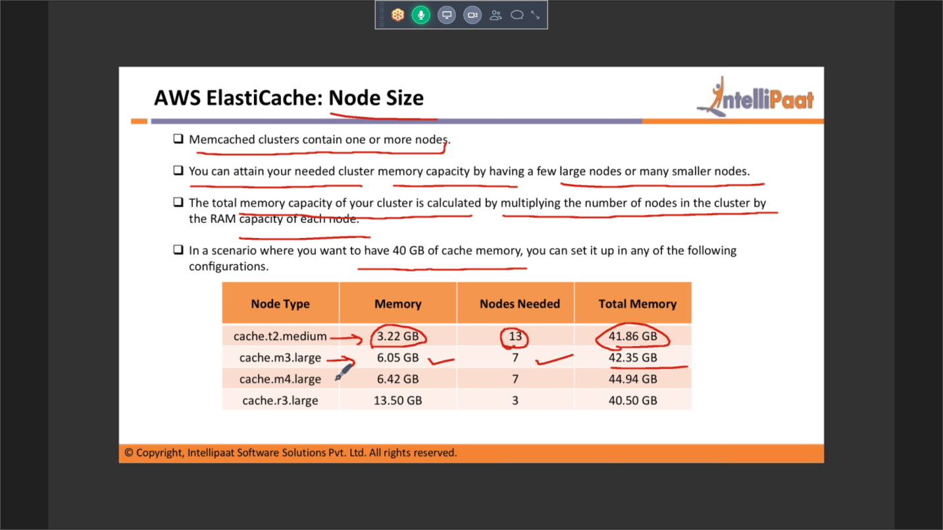

Route53

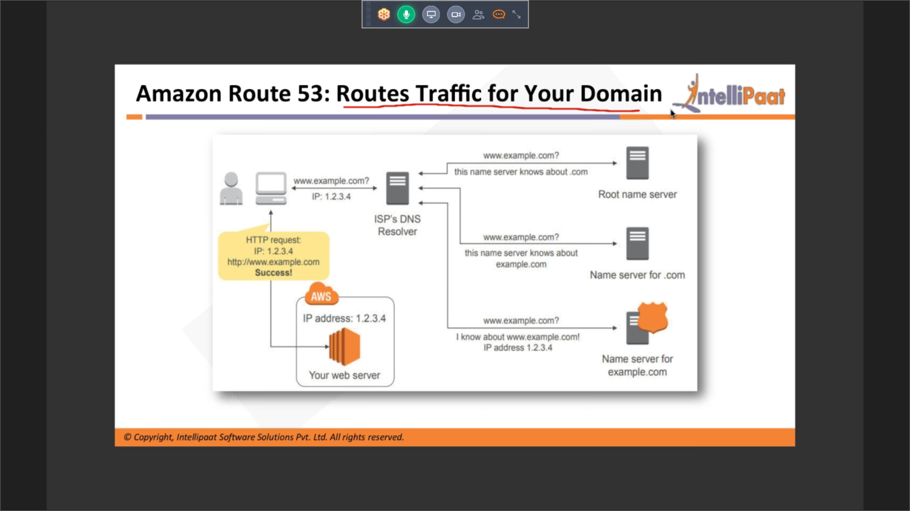

3/2: Route53

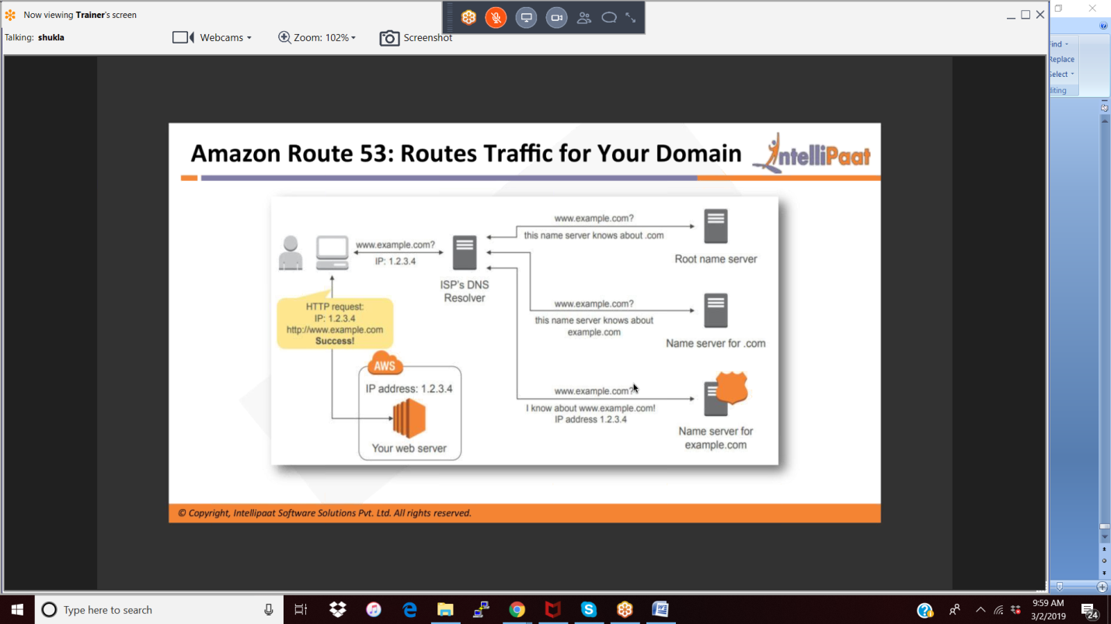

Flow

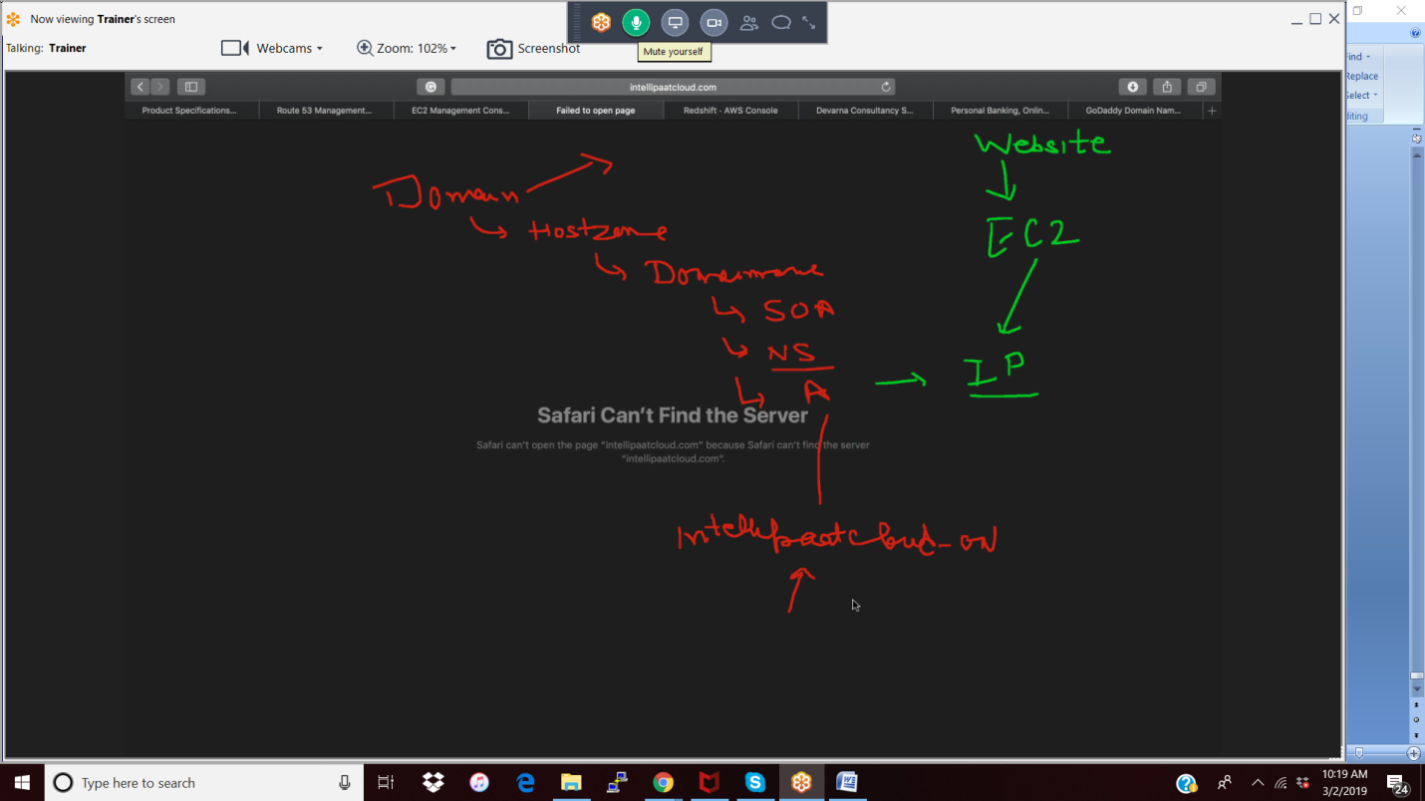

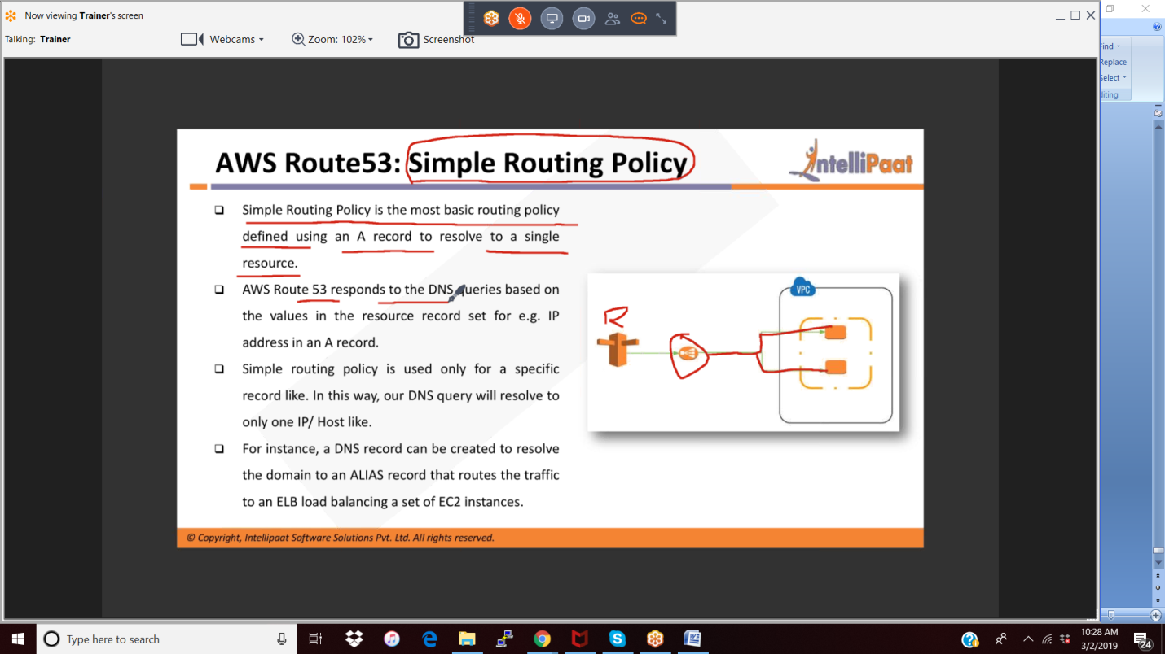

Cloudformation

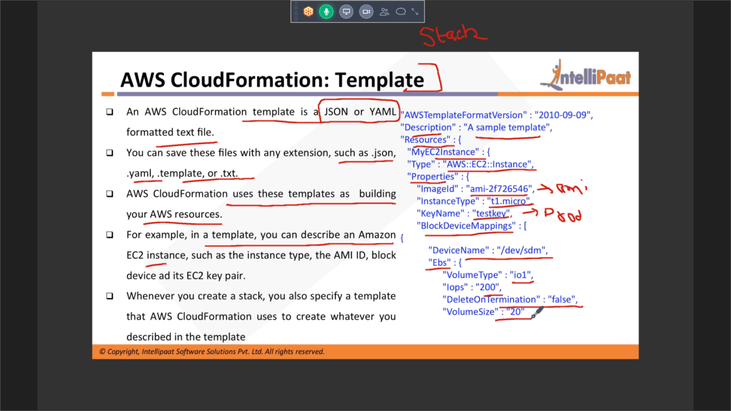

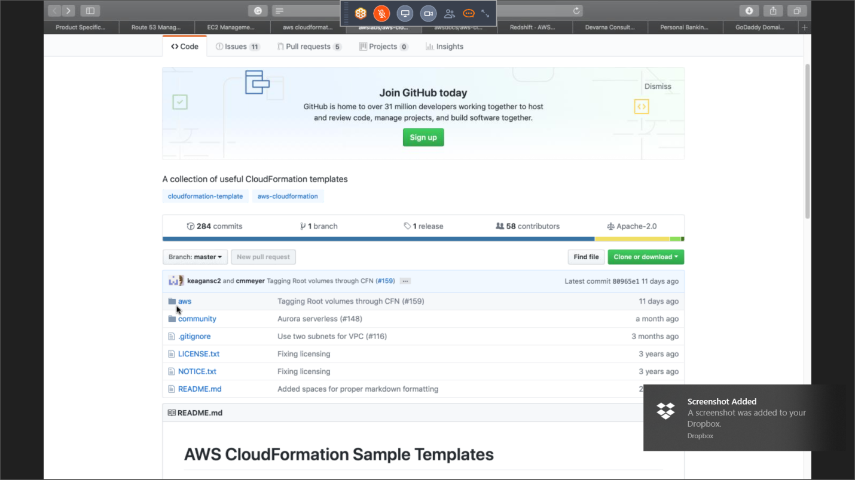

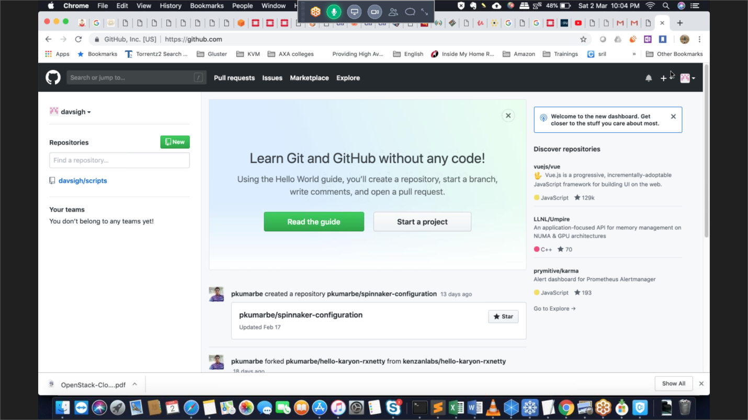

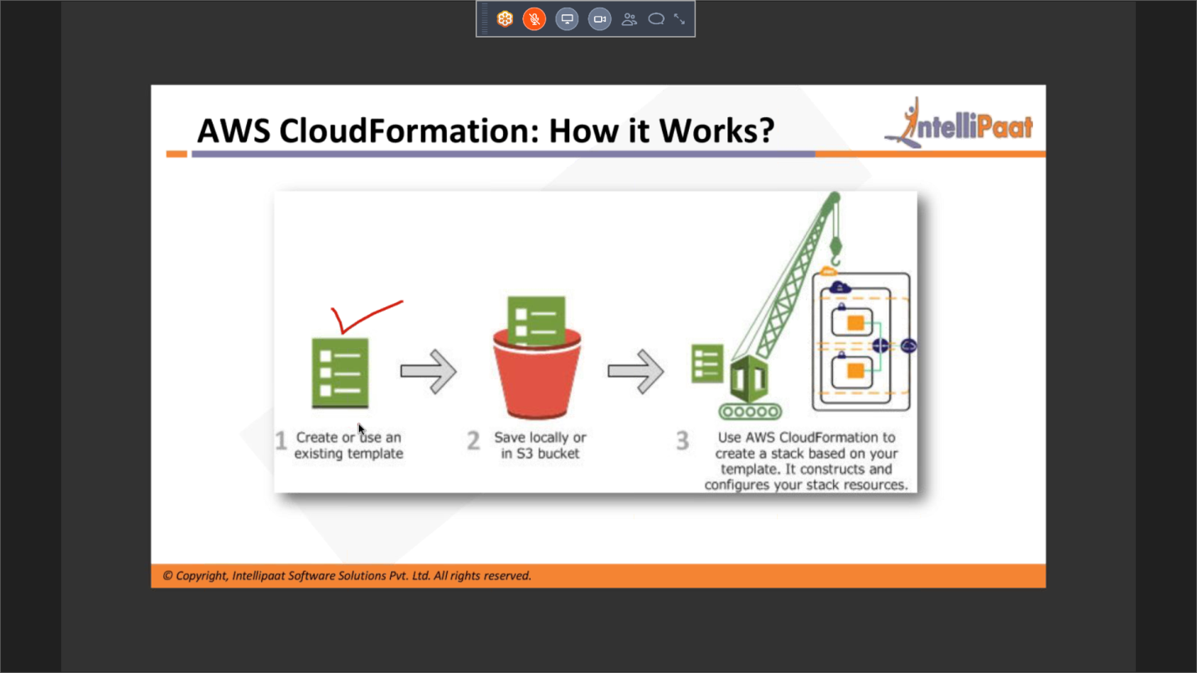

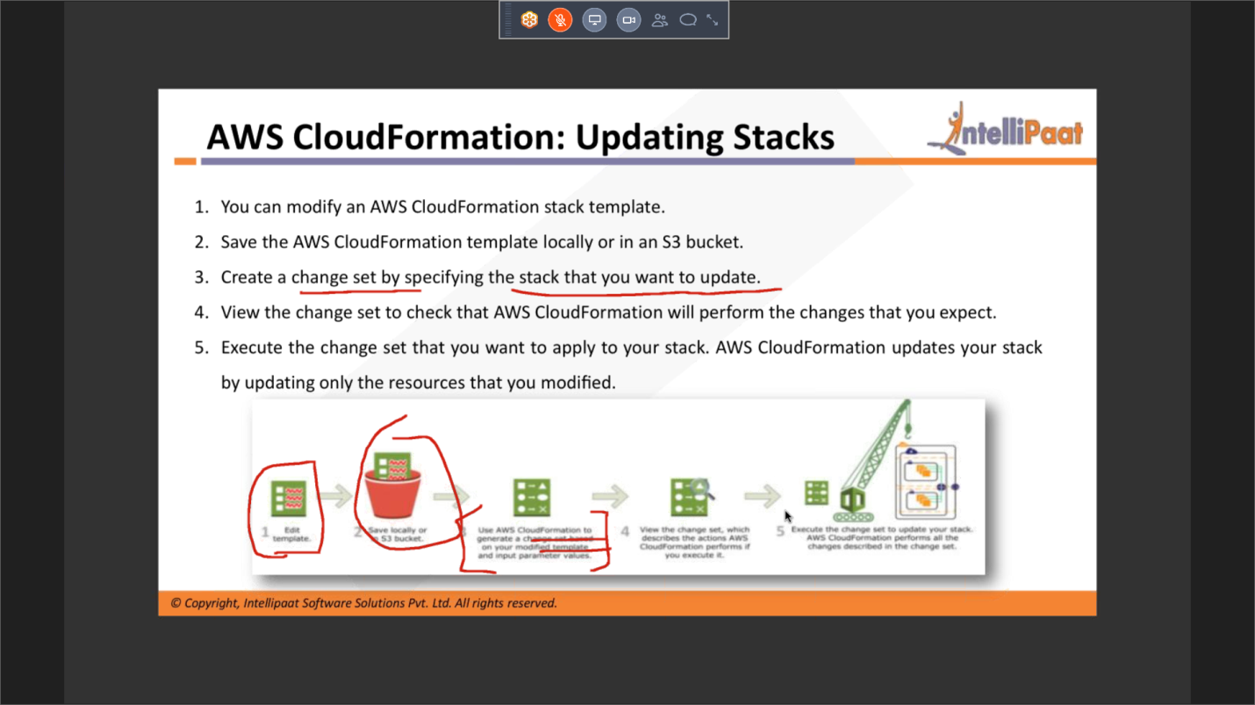

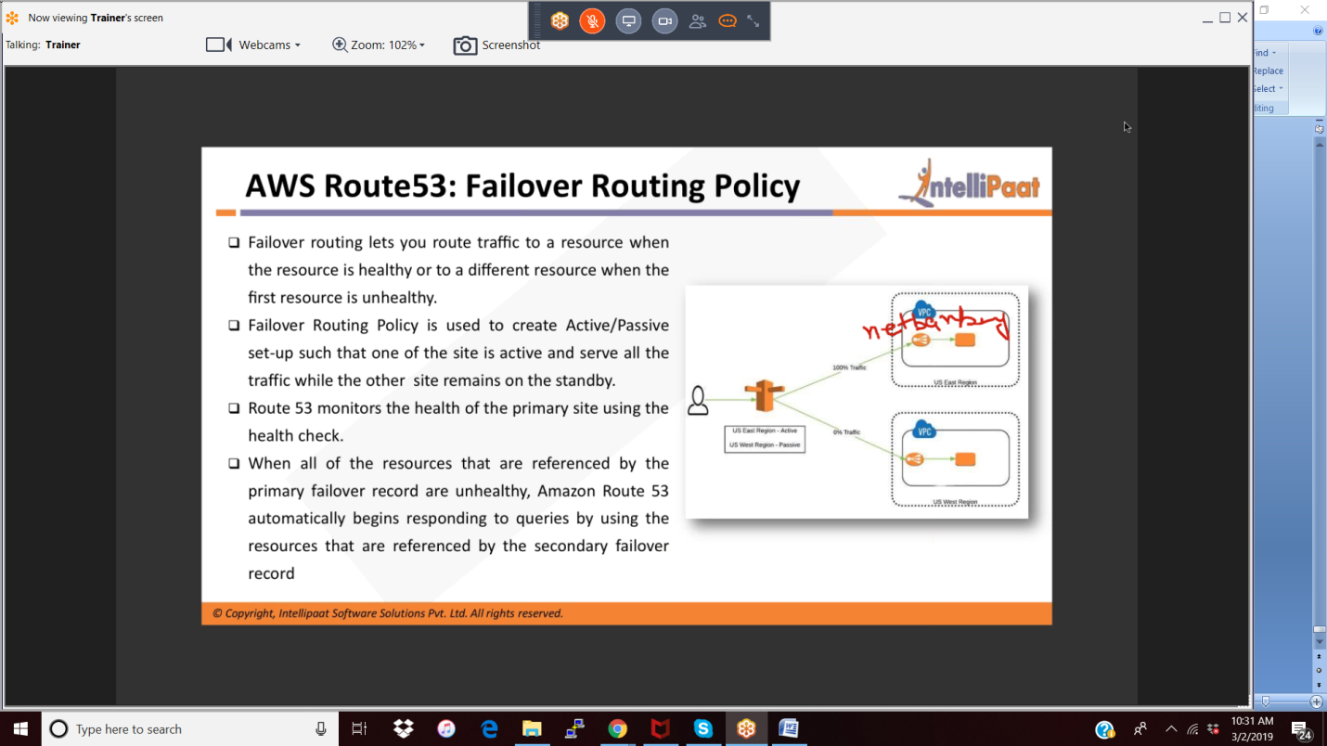

3/3

Elastic beanstalk

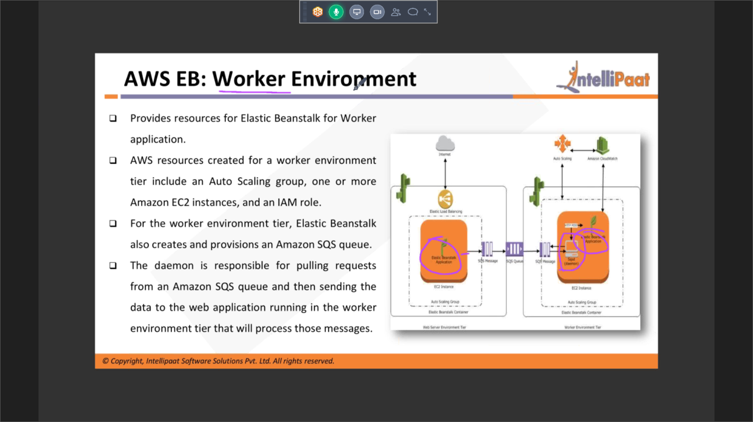

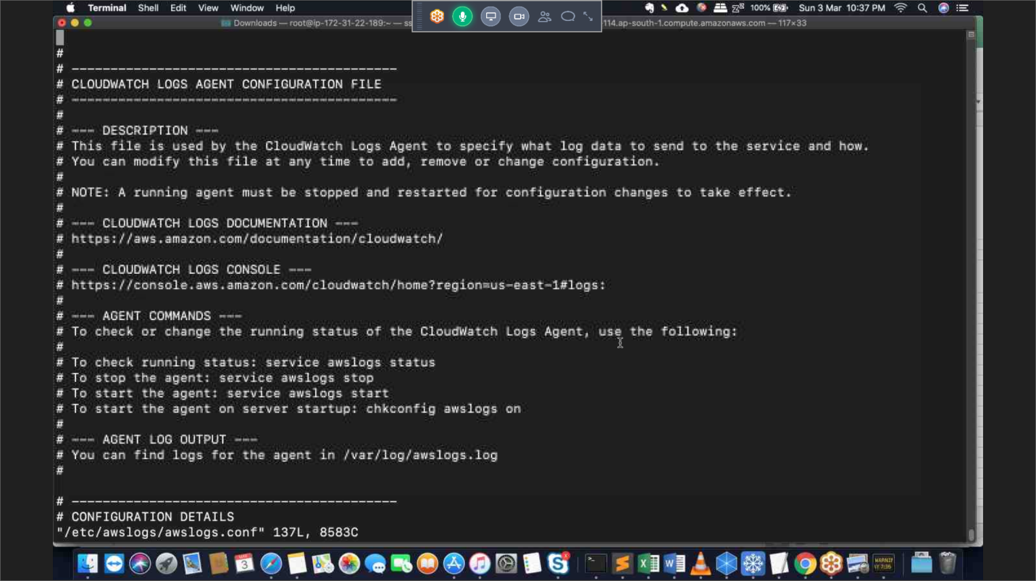

Simulator Exam:

